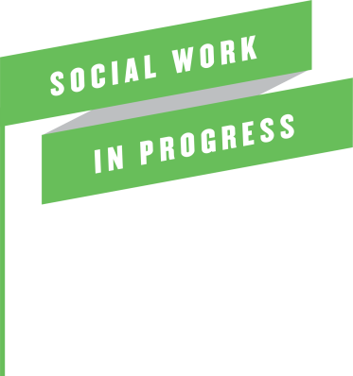

**Briefing in Respect of Providing Statements for the Coroner**

Whilst it is not a common occurrence, there are occasions when workers within Children Services are contacted by the Coroner. It is imperative that there is an understanding of the duties and powers of the Coroner and expectations of workers.

The Coroner has a duty to conduct an investigation and hold an inquest into a child's death if they have reason to suspect the death was due to a violent act or unnatural causes or if the cause of death is unknown. The purpose of the inquest is to ascertain how the death occurred. The inquest is a formal Court process which is governed by specific Court rules.

The Coroner has the power under Schedule 5 of the Coroners and Justice Act 2009 to require a person to provide evidence to the coroner about any matters relevant to the inquest in the form of a written statement and for that person to produce any documents in their control which relate to a matter that is relevant to the investigation. The purpose of the evidence is to assist the Coroner with their investigation and to set out the details of the Council's involvement with the child.

It is an offence under Schedule 6 of the Act for any person to do anything that distorts or alters any evidence or document provided to the Coroner or to intentionally supress or conceal a document that the person knows or believes to be relevant to the investigation.

The Coroner's powers are therefore very wide in terms of requesting information and there are potentially serious penalties if relevant information is not provided.

In light of the above in the event that a worker is approached by the Coroner's Court it will be necessary to ensure that the Team Manager is informed and that contact is made with County Legal Service (Litigation Department) in order to ensure proper advice is offered which will facilitate the Coroner being provided with all documents and factual evidence which is relevant to the investigation. In the first instance and following initial legal advice the worker will ensure that information provided to the Coroner is from records and documents in the control of the Council. It would not usually be appropriate for the Council to comment upon the actions of other agencies within the evidence provided to the Coroner.

The statements will need to be approved by the relevant Team Manager and then Head of Service/Assistant Director before they are finally submitted to the Coroner.

It is important to bear in mind that the statements prepared will be shared with other interested parties to the inquest including the family of the child. The statement is likely to be referred to in the Coroner's Court which is open to the public.