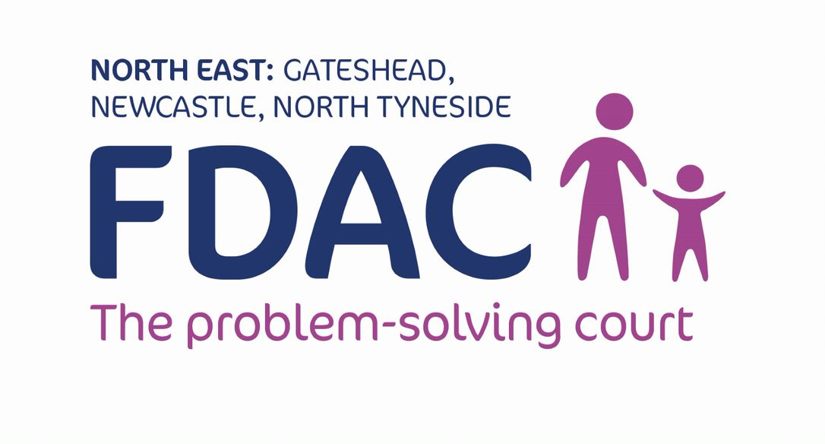
FDAC North East Referral Form
FDAC North East Referral Criteria
Do the local authorities concerns have a basis in parental drug or alcohol use? Yes No

Exclusionary Criteria:

Is the parent(s) capacity to understand care proceedings impacted by learning difficulties?
Yes No

Are concerns reagrding sexual abuse by one/both parent(s) present? Yes No

Does the parent(s) have a diagnosis of psychosis / currently sectioned under the mental health act?
Yes No

Are there issues of intimate terrorism, coercive control or risk to life domestic abuse?
Yes No (*the presence of domestic abuse does not exclude the family from FDAC, please call for a discussion)

Summary of Concerns
Using the space provided, please summarise the concerns of the local authority which have led to threshold for proceedings being met.

Strengths & Motivation to change
Please use this space to describe why you believe this family is sutable for FDAC, commenting upon parents strengths, motvation and capacity for change.

Please provide the followng documents with this referral form:
Chronology Genogram Parenting Assessment Court statement

***If the family have been involved in previous care proceedings please provide the court bundle.***

Local Authority
Gateshead Newcastle North Tyneside
Management agreement to refer to FDAC | Yes No

Parent’s Details:
Parent 1 - name:
Agreed to FDAC referral | Yes No
DOB: | Age:
Gender: | Male Female
Ethnicity:
Home Address:

Email address:
Home Telephone Number:
Mobile Number:
Is it ok to call you or leave a message on these numbers? Yes No
Parent 2 - name:
Agreed to FDAC referral |  | Yes No
DOB: |  | Age:
Gender: |  | Male Female
Ethnicity:
Home Address:

Email address:
Home Telephone Number:
Mobile Number:
Is it ok to call you or leave a message on these numbers? Yes No

Child/ren’s details:
Child 1
Name:
DOB: | Age:
Gender: | Male Female
Ethnicity:
Home Address:

Main Carer
Main Carer’s relationship to child/ren
Main Carer’s telephone Number:
Main Carer’s email address
Child 2
Name:
DOB: | Age:
Gender: | Male Female
Ethnicity:
Home Address:

Main Carer
Main Carer’s relationship to child/ren
Main Carer’s telephone Number:
Main Carer’s email address
Child 3
Name:
DOB: | Age:
Gender: | Male Female
Ethnicity:
Home Address:

Main Carer
Main Carer’s relationship to child/ren
Main Carer’s telephone Number:
Main Carer’s email address
(please repeat section for subsequent children)

Local Authority Solicitor:
Name:
Address:
Postcode:
Telephone Number:
Email:
Solicitor for Mother:
Name:
Address:
Postcode:
Telephone Number:
Email:
Solicitor for Father:
Name:
Address:
Postcode:
Telephone Number:
Email:
Guardian:
Name:
Address:
Postcode:
Telephone Number:
Email:
Child’s Solicitor:
Name:
Address:
Postcode:
Telephone Number:
Email:

Children’s Social Worker:
Name:
Address:
Postcode:
Telephone Number:
Email:

Risk to FDAC staff:
Is there any risk to FDAC staff associated with a home visit to parents | Yes No
If yes please specify level and detail:

For further information please contact FDAC Manager Dominic Wilson 07394 402 522 or email dominicwilson@gateshead.gov.uk

