Guidance
What is the purpose of life story work and life story books?

Many children and young people in care have had profound experiences of loss, separation, abuse and/or neglect. For some children and young people, placement changes will have exacerbated these feelings and experiences- information about their past may be lost, and some of it forgotten. Life story work and the recording of important information in a book can help a child to construct an understanding and integrate their past, make sense of their present and promote a developing sense of identity for their future. It is an invaluable tool in raising awareness of the impact of their earlier experiences on their capacity to express their feelings and needs. The work also assists them in making sense of what they have experienced and how they are experiencing the here and now by providing a structure for talking about their situation. If denied this opportunity, children/young people may believe that they were personably responsible for decisions made. Life story work is an attempt to empower the child/young people to become the author of their own narrative whilst acknowledging that there might be alternative realities or understanding of events. Furthermore it:

- Is the creation of a recorded story that explains the reasons for the child/young person's moves from their birth family, a comprehensive chronology;

- Integrates the past into the future so that childhood and life experience makes sense;

- Helps to gather together treasured objects from the past, which includes photographs and mementos of childhood;

- Provides information about the child’s birth family and other significant relationships in their past and present life;

- Increases a child/young person’s self-esteem and self-worth and in doing so develops a sense of security and permanence for the future.

Life story work is a way of working; it is not a therapeutic model but can support and assist the child/young person at times of key transitions. In challenging circumstances it can help them to understand what is happening, to express their feelings and contribute to decision making and share their story with those people who are important to them.
This life story book template is designed to be developed and adapted to match the individual needs of the child being worked with. The intention is not that this book will be completed in isolation by the social worker and then shared with the child, but to be completed during visits with the child and carer (inclusive of all settings-extended family members, residential setting and foster carers) as an essential part of ongoing life story work. The template is specific in that it starts with the child in the here and now, with their birth and earlier experiences in the middle and concludes with a look to the future. This structure promotes a sense of security and attachment in the current placement.
The only section where the social worker will take a lead is ‘My Story’ which provides the narrative as to why the child came into care. This section should provide factual and age appropriate information about their earlier experiences- providing a realistic sense of their past.
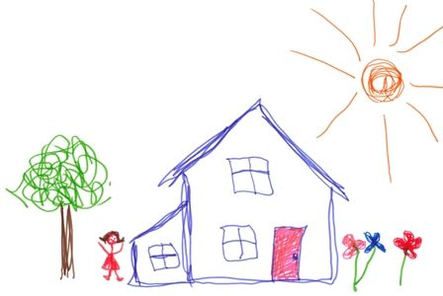
This template has been designed to be completed with children of any age. It can be amended as the child wishes and the more photos, drawings, personalisation the better to enable the child to own their book. It should be stored electronically but can also be printed if necessary.

‘Without a life story, a child is adrift, disconnected and vulnerable’ (Dr Bruce Perry)

Contents
- All About Me-Now
(To be completed by the carer and child/young person)
- About Me
- Special Facts about Me
- Where I live and who I live with
- My Fostering Family
- School
- Awards and Certificates
- My Health
- Important people
- How I Feel
- My Journal- a place to write my thoughts
- Special Days and Memories

- My Family
(To be completed by the social worker and child/young person (carer to be involved if required or work to be shared with the carer after the sessions)
- My Birth
- My Family

- My Story
(To be completed by the social worker and child/young person (carer to be involved if required or work to be shared with the carer after the sessions)

- All About Me-My Future
(To be completed by the social worker and child/young person (carer to be involved if required or work to be shared with the carer after the sessions)

All ABOUT ME-NOW

About Me

- My first Name is:

- My middle name (if I’ve got one) is:

- My last name is:

- My nickname is:

- I am tall:

- My hair is:

- My eyes are:

- My birthday is on:

Photo of the child

- I started this book on:

Special Facts about Me
(E.g. Identity and ethnicity-details of the child’s country of origin, religious beliefs, hobbies, favourite book, best sport, football team, favourite colour, favourite day of the week and why, where I would like to go on holiday, if I had to change my name I’d be called? Who chose my name and what does this mean to me and my family. Favourite/worst food, favourite film, something special about me that people don’t know, what I want to do when I am older etc.)

Where I live and who I live with

- My address is:

Photo of the house
Photo of the child’s bedroom

- I live with:

Photo of the carers

My Fostering Family

(Carers-please include facts about yourselves)

- Hobbies

- Jobs

- What do you like doing as a family?

- Best memories of the child who owns this book

- What do you remember about the first day they came to live with you and how have things changed?

Pets
- Names/ages, characteristics, stories of the child with the pets

Photo of pets
,

School

- My School is called:

Photo of the school and
Teacher if possible

- My teacher is called:

- My favourite subject is:

- My least favourite subject is:

- My best friend is called:

- The best thing about my friend is:

- What I like doing in the school holidays:

Awards and Certificates
(Please photograph any awards or certificates the child receives, including information about what they were for and dates achieved)

My Health
(Please record here any important appointments, health information, hospital trips, key people involved in supporting the child)

Important People
(Include here people the child wants to record in their book-family, friends, teachers, carers-photos, drawings, profile of the individuals)
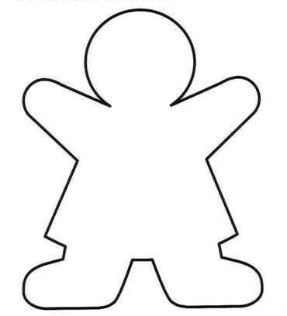

How I Feel

- Things I like:

- Things I don’t like:

- What makes me happy:

- I feel upset when:

- I feel worried when:

- I feel safe when:

- Sometimes I think about:

My Journal- a place to write my thoughts

Special Days and memories
(A space for writing about special days out, important milestones, memories. As many pages as needed can be added. Please include here any special objects the child has either from home or previous placements and a picture of this object if possible. Please include photos and dates)

ME AND MY FAMILY

My Birth

Me as a baby
- Date of my birth:
- Time of my birth:
- How much I weighed:
- Where I was born:

Picture of where I was born.

MY family

(Please complete a genogram/family tree with the child)
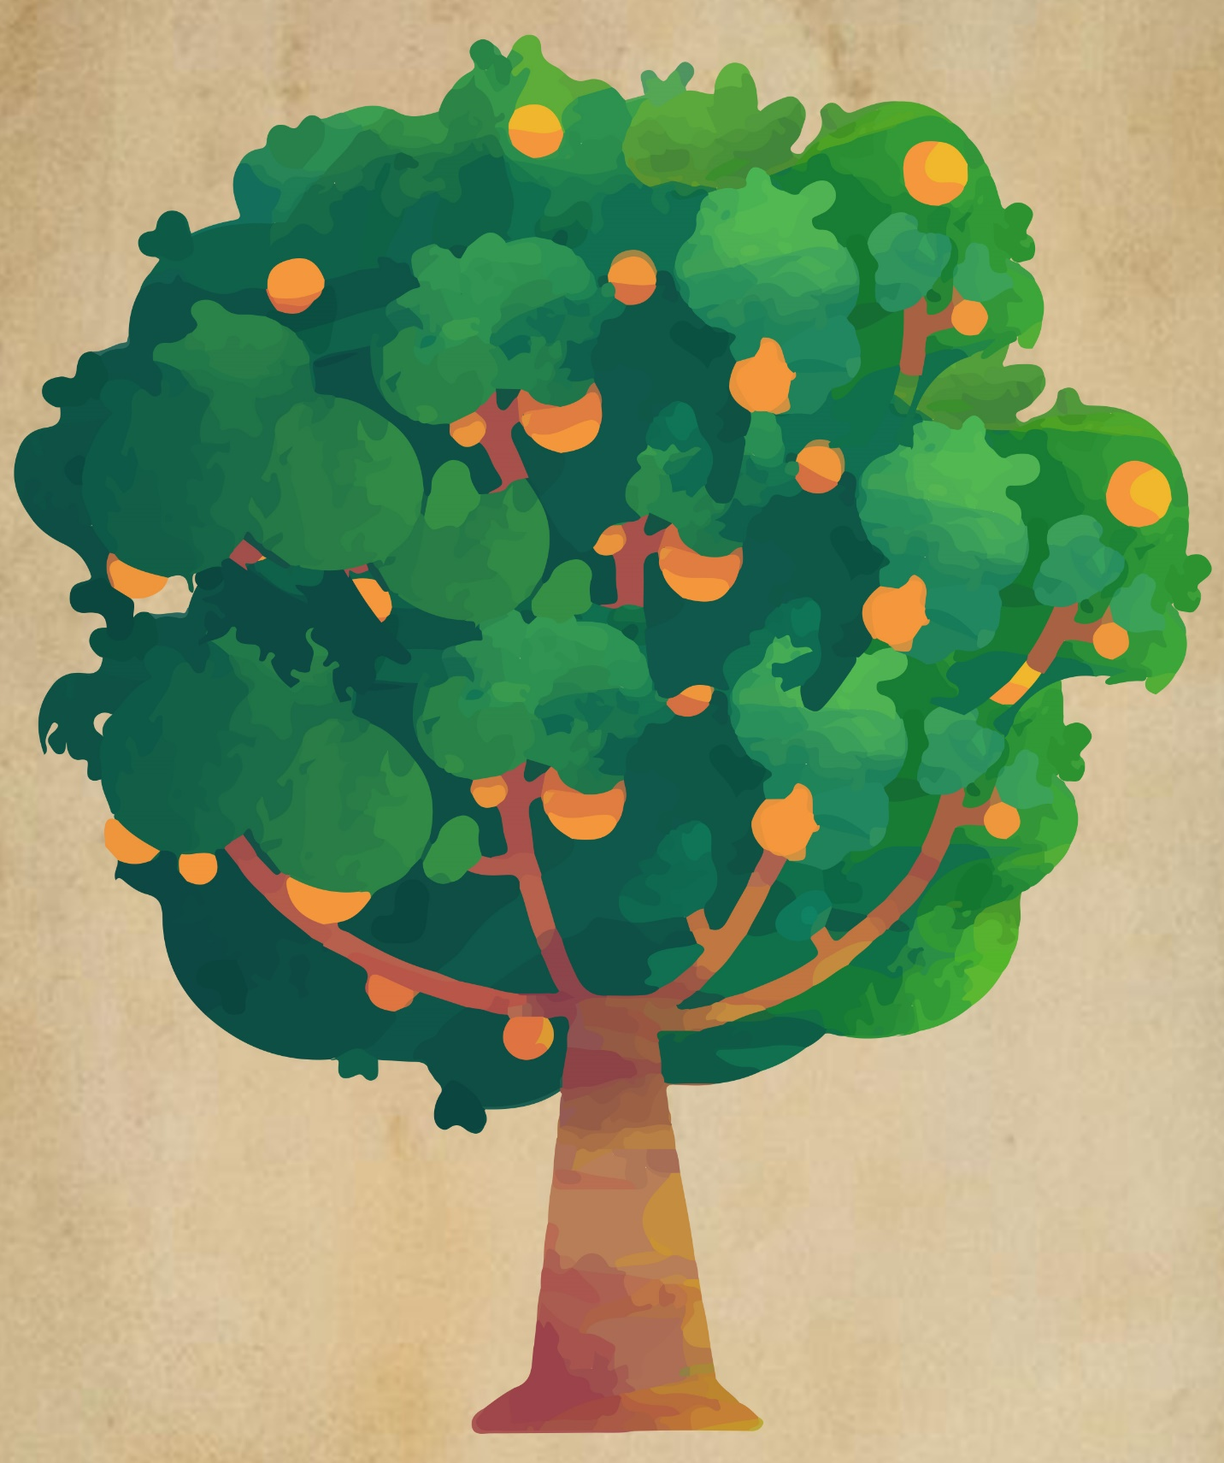

Photos of the child’s family

(Please include details of the family members-names, ages, interests etc.)

- I look like:

- Things that make me similar to my family are:

- Special memories I have of my family are:

- I have family time _________ times a _________ (how often?)

- Who I have family time with:

- Where I see my family:

Picture of where the family time takes place (contact centre etc.)

- Other people who may also be at family time with me are:

- My favourite thing about family time is:

- Things that make me worried/anxious or sad about my family time is:

- What I need from my family to make me feel safe and happy during family time is:

- What I need from my foster carer to make me feel safe and happy after family time is:

MY STORY

(This section needs to provide the narrative of the child/young person’s experiences. Information needs to be written sensitively and in an age appropriate way-whilst ensuring that it provides enough information that the child is not left in doubt as to why they are no longer in the care of their birth family. For younger children, please use illustrations to aid understanding (e.g. picture of a judge, court, meeting room etc.).
Please include the following:
- Information about the needs of a baby/child and the role of the parents to provide this.

- Provide clear explanations (where possible) about the reasons why the children were unable to remain with their birth parents, detailing why they had to be placed with foster carers/other family members. Include information about the support that was put in place by social workers and the efforts taken to try to help the parents. Refer to difficult decisions having to be made and who was involved in these decisions- social worker, court, judge etc. (If the Social Worker who was involved in the court proceedings is preparing the life story work, they may be able to offer more context and detail, If however the proceedings were conducted some time ago with practitioners who are no longer here, the file documents may not offer the wider context which can also be acknowledged. However this should not deter from completion of the work, providing factual information or lead to the narrative creating doubt for the child as to why they could not remain with their birth parents).

- Include the views of the birth parents and family members when constructing the narrative (where possible). This should include their feelings towards the child e.g. they loved the child but were unable to ensure that he/she was kept safe and cared for in a way that they needed to grow up to be healthy and strong. However then include specific facts and concrete examples of what not being kept safe or neglected meant for the child.

- Consider a timeline or visual picture of the moves the child has made. This could be completed with the child as part of a life story work session and photographed to include in the book-
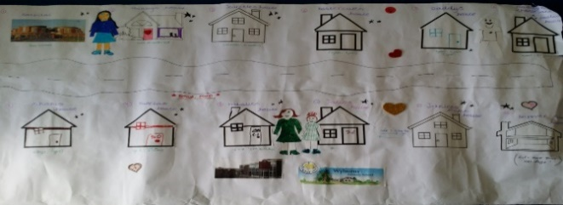

- Include details of the placements they have had. Who did they live with and for how long-any memories of this time-photos if possible.

- Include information about any transitions that have taken place. If the child is in their permanent placement, include important dates such as matching panel/ SGO granted etc. Include matching certificates where available.

- If the child has siblings-where are they now? What contact do they have, and if they are placed elsewhere, why was this decision made and by whom?

- Where there are gaps in important information, make it clear to the child/young person that the information is not fact and cannot be confirmed. Record this uncertainty clearly in the narrative.

- Details of the social worker/s involved and the worker completing this book.

- Acknowledge in writing that reading this part of the book could evoke different feelings (name these) and signpost them to who to talk to for support (carer, social worker, teacher).
ALL ABOUT ME –MY FUTURE

My future:
(Please use these pages to talk to the child about what they want to do in the future- e.g. future career/employment and goals, hobbies they want to try or places they would like to visit. Depending on the age of the child, here you may need to include post 18 goals such as living arrangements. For younger children you may be exploring their future views on contact, school and any challenges that may arise.)

- Things I am excited about for my future:

- Things I am worried about for my future:

- Things I need help with to learn new skills:

- Things I enjoy doing and want to do more in the future:

- The things that are important to me for my future:

- My goals are:

- Things my family can do to help me achieve my future goals:

- Things my foster carer can do to help me achieve my future goals:

- Things my social worker can do to help me achieve my future goals:

- What I have already achieved:

- My foster carer’s thoughts on my achievements:

- My family’s thoughts on my achievements:

- My Social Worker’s thoughts on my achievements:

- when I finish school/college I want to:

- People I want to spend time with in the future are:

Picture of me on ………….. (Date)

