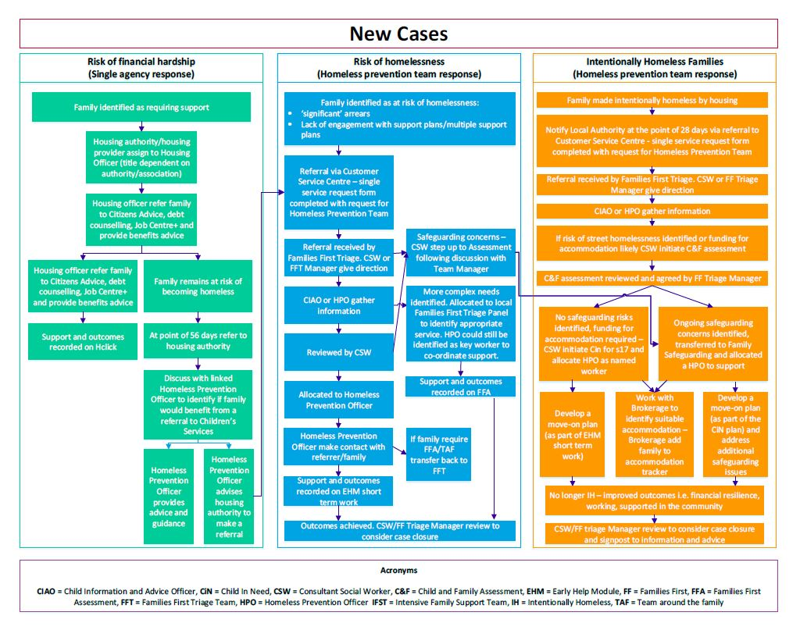
Appendix 3.1:
Full document can be viewed here:-

