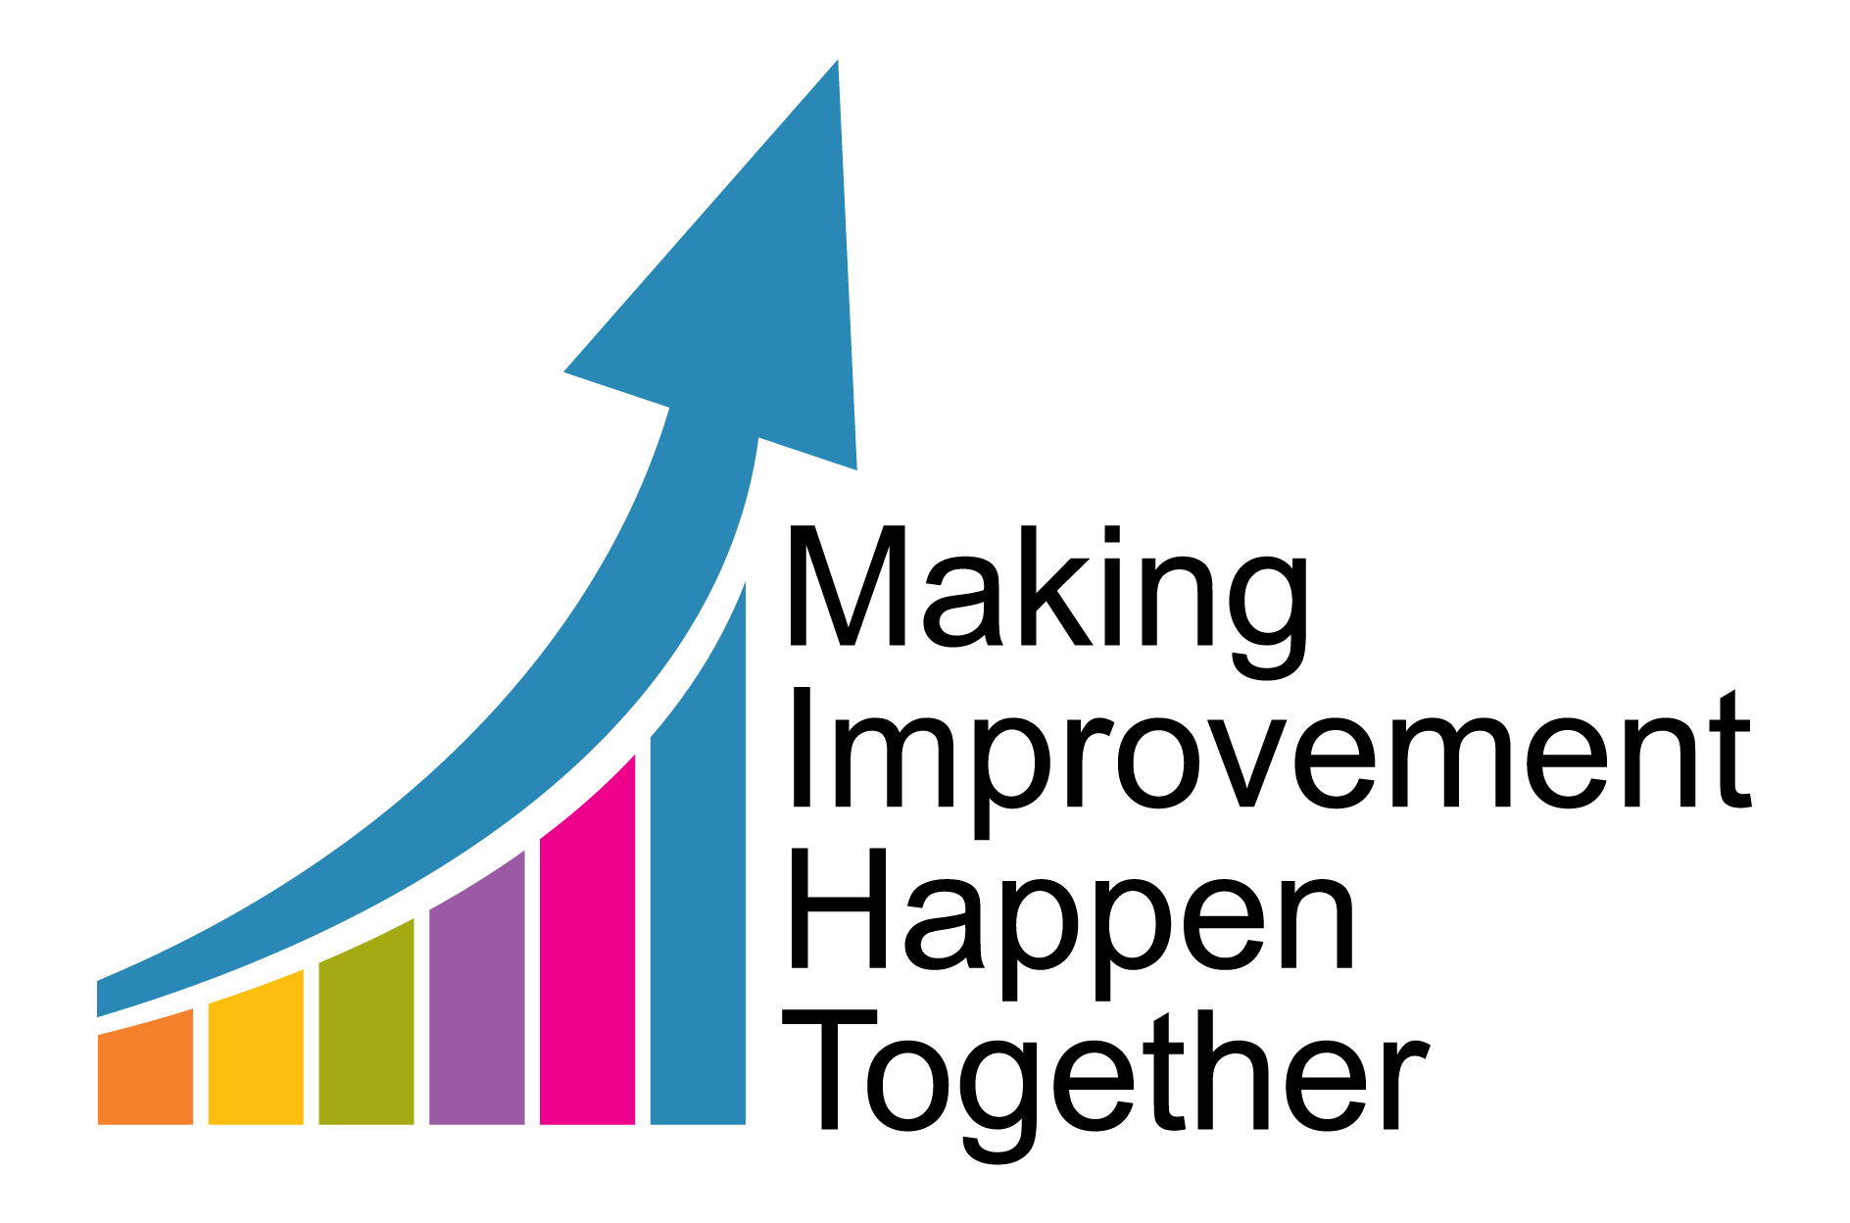

**Vulnerable Exploited Missing and Trafficked Team**

**VEMT**

**Information Guide 2022**

|  |  |
| --- | --- |
| **Report Author** | **Nicola Lynn – Head of Service** |
| **Date** | **February 2022** |
| **Version** | **2** |
| **Date for Review** | **February 2024** |

**Contents**

1. **Introduction**
2. **The VEMT Team**
3. **Principles underpinning the VEMT Team response**
4. **Referral pathway**
5. **Staffing**
6. **Missing Children and Return Home Interviews**
7. **Children/Young people Missing Education**
8. **LERM/MACE process**
9. **Modern day slavery and NRM devolved decision making pilot**
10. **Partnership working and additional activity**
11. **Appendix 1 – Team Structure**
12. **Introduction**

Child exploitation is a crime with devastating and long-lasting consequences for its victims and families. Childhoods and family life can be ruined and this is compounded when victims, or those at risk do not get the right support.

Safeguarding children and young people from exploitation depends on effective joint working between different agencies and professionals e.g. police, schools and colleges, health services including sexual health services and therapeutic mental health services, youth services, children’s social care, together with criminal justice agencies and voluntary sector services supporting children and families. Their full involvement is vital if children and young people are to be effectively supported and action is to be taken against perpetrators of child exploitation. All agencies should be alert to the risks of exploitation and be able to take action and work together when an issue is identified.

Tackling exploitation requires a three-pronged approach: prevention, protection and prosecution and requires cooperation between partner agencies. Action to tackle child exploitation should be proactive, focusing on prevention, early identification and intervention, as well as on disrupting activity and prosecuting perpetrators. The VEMT team and the police ensure that partner agencies work in collaboration and take an active role in tackling child exploitation. It is important that evidence is gathered where possible, to increase the chance of successful criminal prosecutions of their perpetrators, thereby safeguarding potential future victims.

Early intervention is likely to be far more effective than intervention at a later stage when the impact on the child or young person’s health or development is likely to have escalated. The VEMT team work closely with the police, early help, education, youth services and the voluntary sector to identify potential victims of exploitation to engage early through direct intervention in order to promote safeguarding and increase awareness.

Effective measures to safeguard and promote the welfare of children and young people from exposure to child exploitation is a shared responsibility and cannot be achieved in isolation. The VEMT team are available to offer support and advice to professionals in identifying exploitation and managing the risks. Direct support is available via the VEMT consultations, assistance to access resources, and signpost to our partner agencies. Further information can be obtained by emailing: [VulnerableExploited.MissingandTraffickedTeam@hullcc.gov.uk](mailto:VulnerableExploited.MissingandTraffickedTeam@hullcc.gov.uk)

Hull City Council has a wider strategic objective with regards to contextualised safeguarding, of which the work by VEMT is a part, to ensure that there is a consistent and robust response across the city to any concern about child exploitation. The Head of Service for VEMT attends the wider Contextualised Safeguarding Strategic group, part of the Hull Children’s Safeguarding Partnership and the VEMT Team manager attends the Operational Contextualised Safeguarding group to ensure that VEMT activity is fed into and directed by the wider strategic contextualised safeguarding issues across the City.

1. **The VEMT Team**

The Vulnerable, Missing, Exploited and Trafficked Team (VEMT) sits under the umbrella of the Early Help and Safeguarding Hub (EHASH) and Assessment Service. The team are located in the city centre at Kenworthy House, on the 4th floor. This building is well known to young people who are looking to seek support and advice and also houses some local young people’s services. This co-location ensures good communication between key services with regards to prevention and intervention for children and young people who are missing and where exploitation has been identified as a concern. The VEMT Team works closely with Humberside Police, including the Locate Team (missing children) and the Neighbourhood Policing Team (NPT) and more recently a PCSO has joined the team to further enhance partnership working.

The VEMT Team do not hold case responsibility for any child or young person but are instrumental and active participants in undertaking assessments of risk either through completing return home interviews (RHI’s) or via any direct work with children and YP who go missing and/or are considered at risk of exploitation. The VEMT team work with children and young people to build relationships that enable trust and effective intervention. The intervention offered will look to empower the child and parents/carers by adopting a strengths based approach to enable them to develop their own skills in risk identification and management .The Team seeks to educate and to give young people the tools they need to recognise the warning signs, keep themselves safe and know how to report anything they are worried about.

The VEMT team undertake 3 tier mapping exercises for all children and young people open to them and who are open to MACE processes:

* Tier 1 – Map completed with the child/young person to identify the area that they feel safe and where they feel most at risk.
* Tier 2 – Child’s map is then taken to the multi-agency mapping meeting to determine plans and identify support and disruption needed.
* Tier 3- Consideration given to the wider environment - strategic approach.

**The VEMT team is responsible for:**

* Daily Missing Meetings with the Police Locate Team and the East Riding Making a Change Team to ensure that missing children are identified, quickly located and risk management plans put in place. They are also responsible for the coordination and completion of Return Home Interviews for children and young people who are reported missing from home or care and who may, as a result, be vulnerable to child exploitation.
* Chair the weekly missing meeting to look at children who have been identified as having multiple missing episodes or a single episode with identified risk.
* Maintain an overview of children at high risk of exploitation.
* The co-ordination and running of the Multi Agency Child Exploitation meetings (MACE) and LERMS (Locality exploitation risk management meetings – formally known as pre mace).
* The delivery of direct work to children/YP and their families/carers, where appropriate, in order to support the reduction of risk.
* Raising awareness of child exploitation, provision of advice and signposting information and support for Children/YP/families/professionals/partner agencies.
* Chair the National Referral Mechanism panel (NRM) panel (Home Office pilot in Hull)
* Consultations with professionals where there is a worry or concern.
* Attendance at various police meetings including the Police OCG (organised crime group)
* Track and monitor the data around exploitation and the associated risks (links between children going missing and the risks of exposure to exploitation including; violent crime, gang exploitation, criminal/sexual exploitation or drug and alcohol misuse) to inform intervention.
* Targeted training delivery for professionals on child exploitation, missing process, modern day slavery and human trafficking.
* Co-ordinate Tier 2 Contextual Safeguarding multi-agency mapping meetings for children identified as at risk of exploitation.
* Ensuring that the child’s voice is heard to influence service delivery through Snap Survey completions.
* Quality assurance audits on return home interviews, targeted intervention and NRM completions, and ensure that learning is shared and implemented.
* Consultation service to professionals to discuss child exploitation concerns, NRM referrals, resources and VEMT referrals.

1. **Referral Pathways**

Referrals for direct work, advice and support for children/YP who go missing and/or are considered to be at risk of exploitation will be considered within one of 3 pathways.

1. Emerging Risk – Intervention at the earliest stage when potential risk is first identified. This route will offer advice and support to children and their families with signposting to other services as appropriate including: MESMAC/Youth Services/Tigers Trust/REFRESH
2. Moderate Risk – Likely to require planned direct work, advice and support for the child and family/carers. May include allocation to or support from VEMT Youth Engagement Worker or Social Worker, Cornerhouse including CARE Project, HYJS for YP known to this service, REFRESH.
3. Significant Risk – More intensive intervention required in relation to exploitation and other risks associated with going missing. Support that can be offered will be provided by a VEMT Social Worker or Cornerhouse CARE project and by HYJS for YP known to them where there is a CCE risk.

It is imperative that practitioners and those coming into contact with children and young people are alert to the signs and what makes young people vulnerable to exploitation; as a multi- agency partnership we can therefore co-ordinate a timely and effective intervention at the earliest opportunity to prevent young people being placed at further risk of harm.

When Child exploitation concerns are identified and a referral is made to the VEMT team, the young person will be allocated to a Social worker or Youth Worker within the team to work with and support them with targeted intervention. At the onset of the intervention an assessment of needs will be completed which will assist in identifying the risks and areas of need. This assessment will form the baseline for the planning and intervention and will be the subject of regular review periodically in accordance with risk level. At all times the worker within the VEMT team will liaise with the allocated social worker/youth justice worker if the child is already known to services.

At the end of the intervention when the child, parents/carers and allocated worker are satisfied that the risks have been stabilised/ reduced, the allocated worker will provide the child with details of any additional support available and complete a final assessment and closing summary that is uploaded onto Liquid Logic.

The following diagrams are tools to aid practitioners in recognising some of the vulnerability factors which could place young people more at risk of exploitation, as well as some of the risk indicators which can be used in identifying whether a young person may be at risk of, or experiencing exploitation. The list of indicators/vulnerabilities is not exhaustive and their presence may not necessarily mean that a young person is being exploited. However, they assist practitioners in identifying the warning signs which may warrant further assessment and investigation.

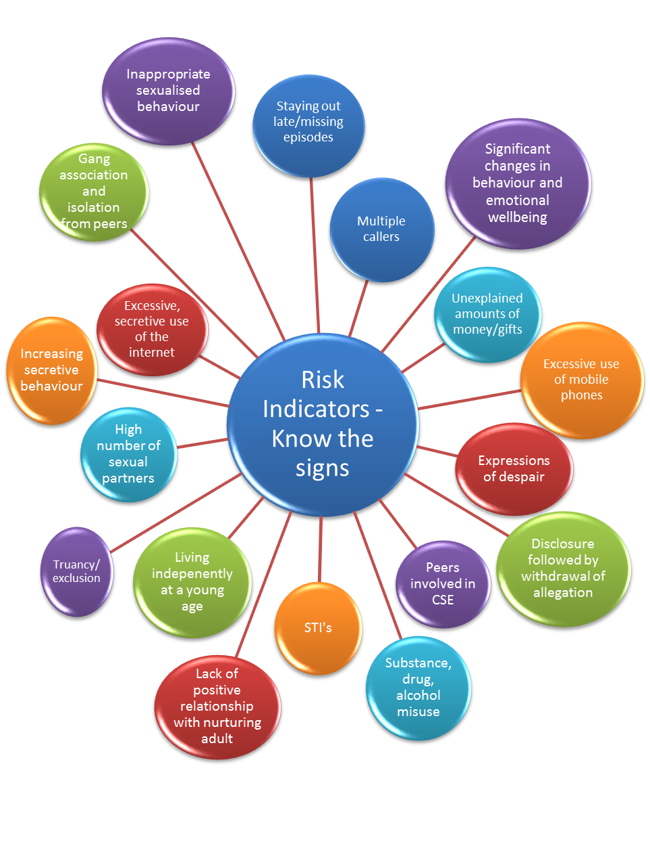

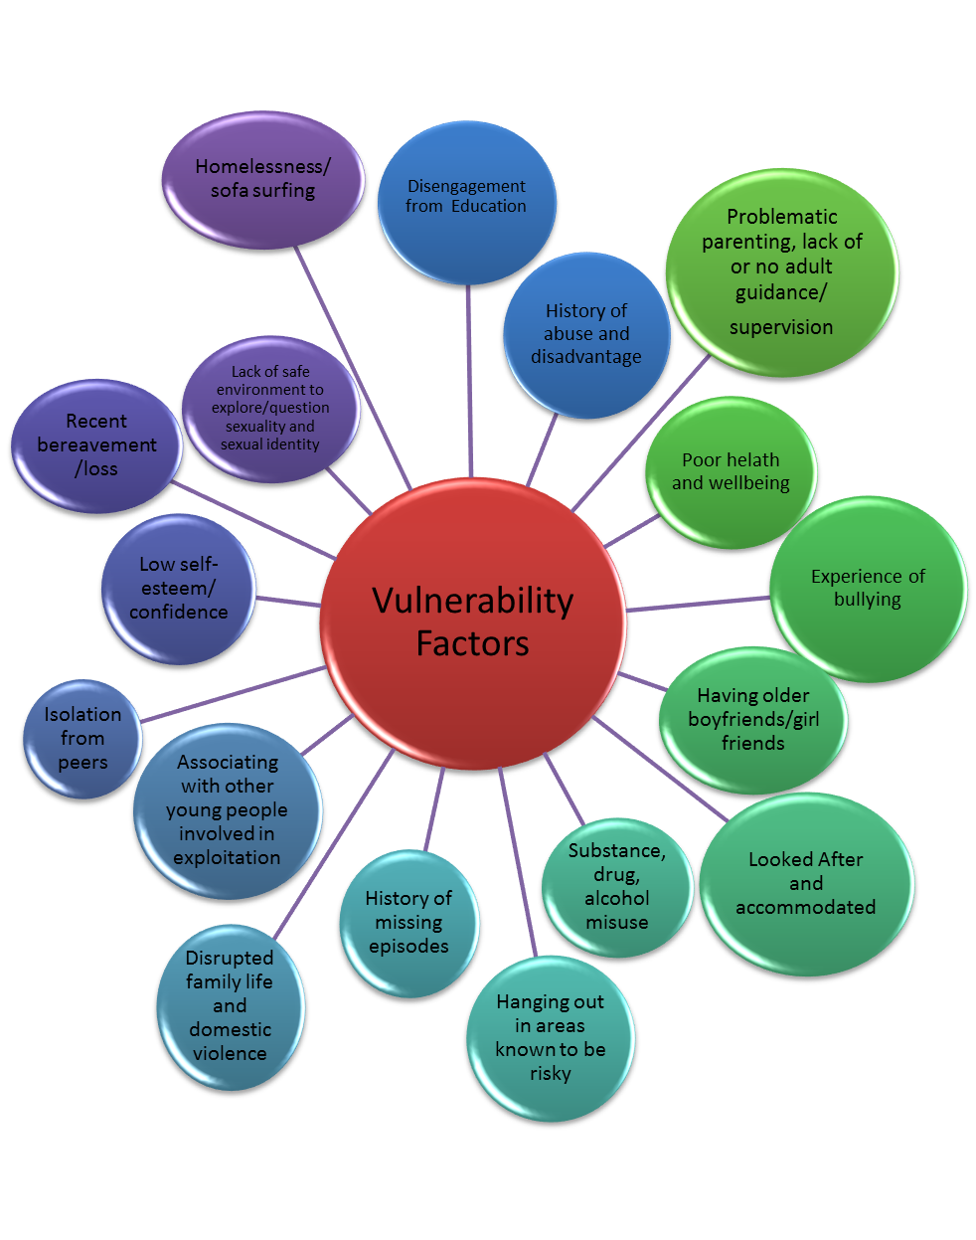

1. **Principles underpinning VEMT Team response**

The team is committed to a strong value base when working with victims of exploitation and believe:

* Sexually/Criminally Exploited children should be treated as victims of abuse not offenders
* Child Exploitation should not be regarded as a lifestyle choice
* Young people do not make informed choices to enter or remain in sexually/criminally exploitative relationships but do so out of coercion, manipulation, enticement or desperation
* Children under 13 cannot consent to sexual activity; this is statutory rape
* Child Exploitation does not always involve physical contact and can occur through the use of technology
* The primary law enforcement effort must be made against the groomers and perpetrators of CSE/CCE
* Regard to age, disability, race, ethnicity and cultural background will be taken into account in undertaking risk assessments

1. **Staffing**

The VEMT Team is made up of 1 Team Manager, 1 Grade 10 Social Worker, 3 Social Workers, 1 Youth Engagement Officer, 1 Missing Child Coordinator , an NRM Assessment Officer and 1 Team Coordinator. The team also have the support of 2 Youth workers who complete Return Home Interviews. All workers have expert knowledge on the services available to meet the needs of the young people and they provide advice and guidance to the social work teams in order to ensure that the most vulnerable children have appropriate and robust plans in place to keep them safe.

1. **Missing children and Return Home Interview’s (RHI’S)**

Every morning the VEMT team have a joint missing meeting with Humberside Police and East Riding Making a Change Team, to consider the children who are missing, share information, identify areas of concern and agree actions with the view of increasing safety for them. During this discussion information and intelligence is gained and shared which is then cascaded to other services involved with the child.

This joined up approach has proven very successful in recognising ‘cross border’ friendships and concerns and working collaboratively to manage risk. Every Friday the VEMT team have a weekly missing meeting with the Locate Team in which they discuss children who have had multiple missing episodes the week before and episodes of concern. The allocated social worker is invited to this meeting to contribute to the recognition of the push and pull factors that are impacting on the child and to agree a plan to reduce further missing episodes.

Three consecutive missing episodes within a 90 day period or a child who has been missing for more than five days meets threshold for a strategy meeting to be convened. The responsibility for convening the strategy meeting lies with the allocated social worker and the VEMT Team Worker should be invited to attend to share relevant information and contribute to the risk reduction plan.

When a child goes missing, a review of the child plan alongside the information provided in the RHI can provide an opportunity to check that it addresses the reasons for an absence. The review should result in the development of a strategy to minimise a repeat of the missing episode. In particular, any issues relating to the vulnerability of the child to exploitation, trafficking, criminal or gang involvement should be identified. Actions to address these needs to ensure the child is kept safe should be clearly set out in the child’s plan. Partner agencies involved with the child should be given the opportunity to contribute to the review.

**Looked**after children are more likely to go missing than their peers (The Children Society, 2019). Children may run away from care for all sorts of reasons. These include wanting to return home to their family; being unhappy or bored in their care placement; feeling like they did not have enough control over their own lives.

The VEMT team work closely with children’s residential homes and the Integrated Looked After Child (ILAC) team in ensuring that return home interviews are offered promptly, by the same person (where possible) to offer consistency of worker and promote an ongoing working relationship with the child.

The VEMT Team seek to reduce further missing episodes through prompt offer of the Return Home Interview (RHI) to rapidly identify the reasons for the child to be going missing and formulate plans/agreements with the young person and family to try and prevent further missing episodes. There is also a follow up intervention for every child that has been reported as missing for the first or second time through the ‘Missing No More’ program. This program is interactive as well as being supportive to encourage the child to think about their own push/pull factors, the dangers of going missing and to inform them of what steps all professionals involved take to find them.

A RHI is an in-depth conversation with a child/young person who has run away. It should be led by an independent, trained professional or the best placed person whom the young person trusts. The statutory guidance states that Hull City Council must offer an independent RHI’s to all children who run away or go missing from their family home or care within 72 hours of being found. Children in care are offered the choice of speaking to a representative or advocate who is independent of their placement.

Independent Return Home Interviews provide an opportunity to capture the child’s voice, understand their lived experience and therefore better inform case planning. The outcome of each RHI is recorded on the child’s case file and shared with the allocated worker and their manager if an open case. The information contained in the RHI should be reviewed and any actions agreed by the allocated worker and their line manager and used to inform case management and risk reduction strategies.

Prior to any Return Home Interview being undertaken with a child, the practitioner will make contact with the parent/carers and explain the purpose of the RHI. If the child is under 14 years of age consent will be discussed and sought from the parent/carer prior to it taking place. If the child is 14yrs and above, whilst consent would still be sought and parent/carers informed, we would accept the consent from the child in their own right. The consent will also cover who the information will be shared with and the purpose of the information sharing.

If the child is unwilling to engage in the RHI, attempts will still be made to speak with the parent/carer to offer advice in respect of preventative approaches. As the RHI is voluntary, some children/young people will refuse the first few times, however, the VEMT team will continue to offer and illustrate consistency so that the child knows that they have the option and access to talk should they wish to. The child and their parents/carers may also be signposted to other agencies that they can speak to anonymously about any concerns they may have. If we are unable to get in contact with a child to make the offer of the RHI for any reason, the VEMT team will send a follow up letter explaining the purpose of the RHI and inviting them to make contact.

The interview and the actions that follow from an RHI should:

* Identify and deal with any harm the child has suffered – including harm that might not have already been disclosed as part of the Police Prevention Interview– either before they ran away or whilst missing;
* Understand and try to address the reasons why the child/young person ran away;
* Explore the ‘Push and Pull’ factors and what needs to be done to minimise the risks
* Help the child feel safe and understand that they have options to prevent repeat instances of them running away;
* Provide them with information on how to stay safe if they choose to run away again, including helpline numbers.

The RHIs are completed on a form that is integrated within the Liquid Logic case management system. Upon completion of the form management oversight is undertaken by the VEMT Team and any safeguarding/welfare concerns raised and actioned. If the child has an allocated Social worker, they are alerted as to the missing episode and then any follow up action needed as a result of the RHI with additional management oversight by the team manager being required.

Where there are repeat episodes of a child/young person going missing the allocated social worker should complete a Philomena missing person’s action plan. The purpose of the plan is to set out an effective multi agency tactical response to safeguard and protect children and young people who are at risk of frequent missing episodes.

It is important to include, where possible an up to date photo of the child/young person. A copy of the Philomena MPAP **MUST** be given to the Police, VEMT Team and all other agencies working with the child and should be kept up to date. The plan should include clear prevention strategies and who have responsibility for completing any task identified within the plan.

**Other Local Authority (OLA) Children/Young People**

The responsibility for coordinating arrangements for the RHI lies with the placing authority. As these young people may already be highly vulnerable due to being in care and being moved away from home, the VEMT Team will liaise with the home authority if necessary, but it is up to that authority to undertake the RHI.

Three missing from home episodes within 90 days or a child missing for more than five consecutive days will trigger a Strategy Meeting in line with ‘Working Together’ 2018 guidance. The responsible Local Authority must be informed by the VEMT team via email and phone that a strategy meeting is required and record this information in case notes on the child’s file. The responsible LA will convene and chair the strategy meeting which will be attended via conference call by the VEMT Team Manager or delegated worker from the VEMT Team to share relevant information and contribute to the safety/risk reduction plan.

1. **Children/young People Missing Education**

Children missing education are children of compulsory school age who are not registered pupils at a school and are not receiving suitable education otherwise than at a school. Children missing education are at significant risk of underachieving, being victims of harm, exploitation or radicalisation, and becoming NEET (not in education, employment or training) later in life.

Children and young people who run away and go missing are also likely to be missing from education. Information will be exchanged with Hull City Council Children Missing Education Officers, the Locality Teams, the VEMT Team and other relevant services to ensure that both a safety plan and risk reduction strategy are in place for the child/young person.

[**https://www.gov.uk/government/publications/children-missing-education**](https://www.gov.uk/government/publications/children-missing-education)

[**https://hullscb.proceduresonline.com/chapters/p_ch_run_home.html**](https://hullscb.proceduresonline.com/chapters/p_ch_run_home.html)

1. **Multi Agency Child Exploitation Meeting (MACE) and Locality Exploitation Risk Meeting (LERM)**

The MACE meeting is a multi-agency arrangement and consists of 2 panels. The model was revised in January 2022 to increase frequency in recognition of levels of risk and the need for timely and robust safety management plans. The LERM Panel, a smaller panel that meets weekly rotating around the three locality areas.

The purpose of the LERM is to discuss the risks/concerns using the Signs of Safety model and Risk Indicator Tool (RIT) to devise a plan which includes disruption and consideration of contextual safeguarding issues. The meeting will agree the plan and a risk rating. Low and medium risk cases will be kept within the allocated social care team to manage with partnership support, high risk cases will be escalated to discuss at MACE.

As all young people being presented at the LERM will have an allocated social worker or youth justice worker it would be expected that they will have included up to date health and education information which should form part of the RIT and any prior assessment (Including any A&E attendances) to inform decisions regarding risk and safety planning.

The full MACE meeting meets every 4 weeks for an in-depth discussion of high risk children and young people. These meetings are chaired by the VEMT Team Manager

**LERM Membership**

* Core membership (mandatory):
* VEMT representative
* Allocated Social worker
* Team Manager
* Police representation
* Youth Justice
* Early Help
* Neighbourhood Policing Team
* Probation

Optional (case by case basis as the social worker will have up to date information)

* Health
* Education

**MACE membership**

Core membership (mandatory):

As above plus:

* Cornerhouse
* Health
* Education
* Tigers Trust
* Refresh (also represent TYS)
* MESMAC
* The Warren
* Reach Out
* Parks/ wardens
* Housing/accommodation

**Benefits of the revised model**

* A timelier process in managing risk with clear oversight
* An increased focus and accountability on risk management and safety plans
* Scheduled meetings which will allow RITs to be completed and submitted on a continual basis.
* Closer working relationships between Localities, VEMT and the police in managing cases involving child exploitation.
* Ensuring the right young people are escalated to MACE, which will allow enhanced focus on further multi-agency intervention and disruption.
* An approach that shadows the East Riding model and therefore allows clear diary management and commitment of all parties to attend.

The MACE meeting provides a multi-agency forum in which cases of suspected or actual child exploitation can be discussed to ensure that all possible actions have been implemented to reduce risk, protect victims, disrupt and prosecute perpetrators.

The MACE meeting highlights patterns and/or trends of child exploitation in Hull and facilitates a sharing of information/intelligence relating to suspected individual/groups of victims/ perpetrators, vulnerable locations etc. The MACE meeting provides support to practitioners who are managing high risk cases and ensures that any identified obstacles/tensions or challenges across the partnership can be resolved.

Further to this the MACE meeting has responsibility for considering any actions that need to be taken as a partnership.

Additionally if any child is identified to be a victim of trafficking or modern day slavery, the worker will be supported to make a referral to the NRM (see below)

**Risk Indicator Tool (RIT)**

Once a concern has been identified that a child/young person is at risk of exploitation the allocated worker should complete the Exploitation (CSE/Criminal Exploitation) Risk Indicator Tool (RIT). The form is available on the Liquid Logic recording system and should be accessible to any practitioner who has access to the system. The VEMT Team can offer advice around the completion of the RIT.

The allocated worker needs to make a professional judgement about the level of risk of child exploitation to the child/young person. There are three categories of risk; Low, medium and high. The allocated worker needs to discuss with their line manager the outcome of the assessment and appropriate next steps in respect of case management and risk reduction. The outcome of the assessment should be used to inform the care plan/case planning in respect of the child/young person.

A copy of the RIT should be sent to the Multi Agency Child Exploitation (MACE) in tray via Liquid Logic, for information to be collated and where appropriate for addition to the LERM meeting agenda. For cases being actively discussed at MACE, the Risk Indicator Tool should be reviewed and updated for every MACE cycle. For cases not open to the MACE process we would recommend the RIT is reviewed 3 monthly until such time as the risk is considered reduced and plans in place are adequately meeting the needs of the child/YP.

This enables the VEMT Team to maintain a clear picture of the number of children/young people vulnerable to exploitation and it enables monitoring of the effectiveness of the strategies that are being employed to reduce risk of harm and for consideration of alternative strategies in the event of the risk increasing.

**Other Local Authority (OLA) Children/Young People**

The responsibility for notifications to Kingston Upon Hull City Council of Children Looked After by other authorities who have been placed in Hull lies with the responsible authority, as per the Care Planning, Placement and Case Review statutory guidance <https://www.gov.uk/government/publications/children-act-1989-care-planning-placement-and-case-review> The guidance stipulates that with regard to children who are known to be at risk of child exploitation communication must occur between the responsible authority and host authority prior to the child being placed. This is to allow information about localised risks to be considered by both authorities.

The responsible authority should make contact with EHASH@hullcc.gov.uk to discuss the individual risks relating to the child and any localised intelligence that may impact on the child. The statutory guidance is that the placing authority must complete and send a notification form to the host authority and MACE representative within 24 hours of the child being placed. An updated Missing Persons Action Plan’ that clearly identifies the risks and responses should accompany the notification.

1. **Modern day slavery and NRM devolved decision making pilot**

The National Referral Mechanism (NRM) is a framework for identifying and referring potential victims of modern slavery and ensuring they receive the appropriate support.

Modern slavery is a complex crime and may involve multiple forms of exploitation. It encompasses:

* human trafficking
* slavery, servitude, and forced or compulsory labour

An individual could have been a victim of human trafficking and/or slavery, servitude and forced or compulsory labour.

Victims may not be aware that they are being trafficked or exploited, and may have consented to elements of their exploitation, or accepted their situation. If someone thinks that modern slavery has taken place, the case should be referred to the NRM so that the NRM Panel can fully consider the case. The referrer does not need to be certain that someone is a victim.

**Consent**

Unlike adult victims, Child victims do not have to consent to be referred into the NRM and must first be safeguarded and then referred into the NRM process.

**Human trafficking**

For a person to have been a victim of human trafficking there must have been:

* action (recruitment, transportation, transfer, harbouring or receipt, which can include either domestic or cross-border movement)
* means (threat or use of force, coercion, abduction, fraud, deception, abuse of power or vulnerability - however, there does not need to be a means used for children as they are not able to give informed consent)
* purpose of exploitation (for example, sexual exploitation, forced labour or domestic servitude, slavery, removal of organs)

**Slavery, servitude and forced or compulsory labour**

For a person to have been a victim of slavery, servitude and forced or compulsory labour there must have been:

* means (being held, either physically or through threat of penalty – for example, threat or use of force, coercion, abduction, fraud, deception, abuse of power or vulnerability. However, there does not need to be a means used for children as they are not able to give informed consent)
* service (an individual provides a service for benefit - for example, begging, sexual services, manual labour, domestic service)

**Signs that young person may be a victim**

It might not be obvious that a child has been trafficked, but signs could include:

* Rarely leaving the house
* Living apart from family or having limited social contact with friends and family
* Living somewhere inappropriate, like a work address or cramped, unhygienic or overcrowded accommodation, including caravans, sheds, tents or outbuildings
* Being seen in inappropriate places (for example factories or brothels)
* Having their movements controlled or being unable to travel on their own
* Lacking personal items
* Consistently wearing the same clothes
* Not being registered with a school or a GP practice
* Having money or things you wouldn’t expect them to have
* Being moved by others between specific locations (e.g. to and from work), which may happen at unusual times such as very early in the day or at night
* Being unsure, unable, or reluctant to give details such as where they live
* Fearful or withdrawn behaviour
* Being involved in gang activity
* Being involved in the consumption, sale or trafficking of drugs
* Having their communication controlled by somebody else and acting as though they are being instructed by another person
* Tattoos or other marks indicating ownership
* Physical ill health, looking unkempt or malnourished
* Physical injury, including the kinds of injuries you might get from a workplace
* Reluctance to seek help, avoidance of strangers, being fearful or hostile towards authorities
* Providing a prepared story (which might be similar to stories given by other children) or struggling to recall experiences
* Inconsistent accounts of their experiences

A Strategy Discussion may well be considered in respect of these young people as their journey is unlikely to have been a safe one and there can often be concerns around the fact that they may well have been trafficked.

**Purpose of the pilot programme**

The Pilot went live in June 2021 and forms part of a wider Transformation Programme of activity to identify sustainable longer-term options for the NRM. The purpose of the Pilot Programme is to test whether determining if a child is a victim of modern slavery within existing safeguarding structures is a more appropriate model for making modern slavery decisions for children. This approach is intrinsically linked to local safeguarding processes and will enable decisions about whether a child is a victim of modern slavery to be made by those involved in their care and ensure the decisions made are closely aligned with the provision of local, needs-based support and any law enforcement response.

Prior to the start of the pilot a series of briefings were given to frontline staff in social care, Police , Health, Education, Courts, Youth Justice, Probation and the voluntary sector to highlight what modern slavery, exploitation and Human Trafficking are, the NRM process and the local panel decision making. The briefings were a joint delivery by the VEMT Team, Wilberforce Institute and HYJS.

**The NRM Panel consists of:**

* Childrens social care
* Police – Operation Wilberforce
* Health
* Education
* Border Control
* Hull Youth Justice Service
* Refugee and Asylum Seeker Team
* Humber Modern Slavery Partnership
* Housing
* Adult Safeguarding

The purpose of the panel is to determine if there conclusive grounds or reasonable conclusive grounds that a child or young person is a victim of modern day slavery.

If a positive conclusive grounds decision is made the young person can request Section 45 Modern Slavery Act 2015 mitigation in the courts for any offences they may have committed because of being trafficked or a victim of slavery. This would ensure the Court has context to the offences which may reduce any sentence given. However, this cannot be applied in violent crimes.

The pilot is due to be reviewed by the Home Office in June 2022.

**Timescales**

A reasonable grounds decision should be made no later than 45 days from the referral. A positive conclusive grounds decision can also be made at the same meeting if there is sufficient evidence to do so.

If further information is required to make a conclusive grounds decision, then a second meeting should take place no later than 45 days (90 days in total). The Hull NRM panel currently has an average of 17 days for a reasonable ground’s decisions and 29 days for conclusive grounds.

**Exploitation**

All NRM referrals are looked at for signs/evidence of exploitation. If this is a concern a referral will be made through to EHASH (if the young person is not already open) to request appropriate support. The allocated social worker (new or existing) will be advised to do a RIT (Risk Indicator Tool) for discussion in the LERM (Local Exploitation Risk Meeting – formally Pre Mace) meeting and subsequent MACE if considered high risk, to ensure that a plan and robust package of support is in place.

**Support and quality assurance**

The Home Office offer’s a package of support to the pilot sites throughout the Pilot Programme which will include funding, training and technical expertise. The programme will be subject to a rigorous evaluation which is being overseen by an independently chaired evaluation panel.

One of the ways the Home Office will ensure the standard and consistency of decisions are upheld is through robust training. It is important that the location of the child has no bearing on the quality of the decision they receive, and therefore individuals who participate in the decision-making will be required to undertake the appropriate training.

The VEMT Team Manager, submits a financial and activity report every quarter which feeds in to the Home Office review. They also attend fortnightly meetings with the Home office SPOC and the monthly steering group meeting with all of the pilot area leads.

|  |  |
| --- | --- |
|  |  |



1. **Partnership Work and additional activity**

The VEMT Team is committed to building relationships within the local community and with partners. The VEMT Team works alongside both internal and external partner agencies to offer a child centred and holistic approach to identify and support vulnerable children and young people who have been, or who are potential victims of exploitation.

The co-location of a youth engagement worker and two youth and community workers from the Youth Development Service strengthen and add capacity to the VEMT team. The youth workers specifically concentrate on RHI’s and follow-up work, enabling young people to gain support to engage with community based provision. Youth workers are connected with the local communities of Hull and the broader provision which exists. Support can take the form of ‘hand-holding’ to youth provision, one to one support sessions and exploring issues as well as making appropriate referrals.

Hull Youth Justice Service attends the LERM meetings, MACE and NRM panel to ensure that information is shared in a timely manner and risk managed accordingly. When a young person has been referred to the HYJS for criminal matters and child criminal exploitation is identified, the VEMT Team will work alongside the Youth Justice Officer to arrange completion of the RIT and NRM referral. When young people come to the attention of HYJS for diversion, the VEMT team offer support with additional resources and guidance.

Information gathered from Return Home Interviews about areas of concern (hot spots) is utilised to inform multi-agency contextual safeguarding walks to identify the risks and look at possible disruption through the Tiered approach. This is done in partnership with the Reach Out project and Tigers Trust.

**Appendix 1**

**VEMT Team Structure**

Nicola Lynn

Head of Service

Sarah Knight

Group Manager

Lisa Finch

Team Manager

Jane Henderson

Contextual Safeguarding Officer

Danielle Robilliard

Social Worker

Sarah Smith

Social Worker

Megan Rangeley

Social Worker

Raveen Ghuman

Missing Child Co-ordinator

Sue Tait

Youth Engagement Worker

Lucy Abbey

NRM Assessment Officer

ment Officer