|  |  |
| --- | --- |
| Children, Young People and Families |  |

**Looked After Children and Care Leavers Service**

**Payments Guidance Notes**

December 2018

**Contents**

**BACS & CHAPS Payments**

1. Weekly and Seasonal Allowances – via BACS
2. Other Payments for LAC & Care Leavers – via BACS
3. Emergency Payments – via CHAPS Faster Payment

**Credit Card and Invoice Payments**

1. Staff Travel and Accommodation – via Credit Card
2. Setting Up Home Grant (SUHG) Payments – via Credit Card
3. Savings Payments – via Credit Card
4. Other Payments for LAC & Care Leavers Service Users – via Credit Card or Invoice

Including: payments for travel: tickets & passes, taxis etc for Service Users & contact visits; payments for ordering items for Service Users (not from SUHG or Savings); payments for services to Service Users (e.g. training courses, driving lessons etc)

1. Management of Credit Cards

**Petty Cash Payments and Food Vouchers**

1. Weekly Allowances / Reimbursement – via Petty Cash
2. Emergency Payments – via Petty Cash
3. Management of the Petty Cash Account
4. Food Vouchers

**AllPay Cards and Allstar Fuel Card**

1. AllPay Cards
2. Allstar Fuel Cards

**Appendices**

1. Petty Cash Imprest Account Request and Authorisation Form
2. Petty Cash Receipt Slip
3. BACS Payment Form
4. Change to Corporate Credit Card Limit Request From
5. Petty Cash Claim Request Form – VAT
6. Payment Request Form
7. Invoice Payment Form
8. AllPay Card Account Authorisation Form
9. New Fuel Card Request Form

**1. Weekly and Seasonal Allowances – via BACS**

**Summary of Process**

A report of all upcoming payments due to be made in the coming month is sent by Business Support staff to all Workers in the LAC and Care Leavers Team. This report lists each Service User, what forecast BACS weekly allowances they are due to receive, and which Worker is expected to provide a response as to whether the payment can be made.

**Authorisations of new BACS Weekly Allowances**

**Risk:** Without authorisation, there is a risk that weekly allowances are being allocated to individuals that do not require them or who do not meet the eligibility criteria used by the Team.

**Ongoing Authorisation and Review of BACS Weekly Allowances**

**Risk:** Without regular assessment and agreement of weekly allowances there is a risk that individuals that no longer require such support, or who would benefit from alternative arrangements, are not identified.

**Audit Recommendations:**

* It is recommended that all new weekly allowances for care leavers are authorised by appropriate managers and that evidence in support of this authorisation is retained.
* It is recommended that the monthly confirmation reports are responded to by all applicable officers to confirm agreement with and authorisation of ongoing weekly allowance payments.

**Key Messages:**

* **Primary Worker** requests in writing (email) rolling BACS weekly/seasonal allowance payments to commence or end.
* Written (email) **Managerial** approval is required before **Business Support** can process setting up or cancelling or ending rolling BACS weekly/seasonal allowance payments.
* **Workers** must ensure BACS details are requested from the Service User in order to set-up BACS payments to them and that the Service User’s BACS bank details are updated with Business Support should they change.
* **Business Support** compile a list of weekly/seasonal allowance payments for the forthcoming month to be included in the ***LAC & Care Leavers Batch Upload Spreadsheet***.
* **Workers** (email) confirmation of weekly/seasonal allowance payments for their Service Users to be included in the monthly batch upload spreadsheet.
* **Business Support** send the monthly ***LAC & Care Leavers Batch Upload Spreadsheet*** to Oracle Fusion for processing in time for payments to be set up for the forthcoming month.

**Process:**

Requesting Rolling BACS Weekly Allowance Payments Commence for a Service User

1. The **Primary Worker** of the Service User sends an email to **Business Support** (lac.admin@bournemouth.gov.uk) and the **Practice** and/or **Team** **Manager** to request that rolling BACS Weekly Allowance payments commence for the Service User. The **Primary Worker** provides the following details in the email:
   * Name of Service User
   * Mosaic Person ID Number of Service User
   * Date that Weekly Allowance payments will Start
   * Date that Weekly Allowance payments will End or will be Reviewed.
   * Amount of weekly allowance to be paid and on which weekday(s) each week – the standard payment is £60 paid every Wednesday to the Service User’s bank account. However, payments could be split, for example: half paid to the Service User’s bank account and half paid to their Carer to give to the Service User as appropriate during the week or as a contribution to living expenses. Exact details of proposed arrangements to be given in the email in full.
   * If the Service User has not been set-up as a Supplier to receive BACS payments, then the **Worker** will need to get the Service User to complete and sign a BACS form (available from Business Support). The completed form is returned to **Business Support** who will send the form to Oracle Fusion for processing.
2. The **Manager** replies to the email to both the **Worker** and **Business Support** (lac.admin@bournemouth.gov.uk) to confirm their authorisation of the requested payment arrangement to be set-up or confirmation that it is not authorised.
3. **Business Support** records a **Case Note** of the **Managerial decision** to authorise the weekly allowance request or not, as follows:

|  |
| --- |
| **Case Note:**  Recorded on Service User’s Mosaic record by Business Support:   * ***Case Note Title (100 characters max):*** Weekly Allowances via BACS - Managerial Approval* / Non-Approval* (*delete as appropriate) * ***Type of Note:*** Correspondence: Email * ***Case Note Body Text:*** Summarise details of weekly allowance BACS payment arrangements (how much, days paid, start and end date of rolling allowances, who is paid etc). Then copy and paste below the summary the full email conversation from the managerial decision email chain to include the Worker’s initial request. |

1. **Business Support** records the details of the rolling weekly allowance BACS payment on the INFO tab of the Forecasting Spreadsheet. The information is to be ready for inclusion in the next monthly email to the LAC & Care Leavers Teams of the confirmation report for the forthcoming month’s BACS allowance payments.
2. **Business Support** replies to the Managerial decision email; sending their reply to the **Manager**, the **Worker** who made the request and Cc to **LAC Admin**. The reply will confirm that the managerial decision email has been recorded in a Case Note. **Business Support** also advise in the reply email how initial payments can be made: if the first weekly allowance payments requested fall within the next 10 days then these cannot be paid via BACS as Creditors need 10 days’ from receiving an authorised BACS payment request before a BACS payment is made into a supplier’s bank account. Therefore, an option may be for the payments affected to be paid via Petty Cash instead.

Monthly Confirmation Report of Forthcoming BACS Weekly Allowance Payments

1. Around the 10th of each month **Business Support** creates a Confirmation Report of forthcoming Weekly Allowance payments. This information is taken from the INFO tab of the Forecasting Spreadsheet which details the list of approved rolling weekly allowance BACS payments for service users. The confirmation report will list for each Worker the forecast of weekly allowance payments for their Service Users for the forthcoming month.
2. **Business Support** sends the Confirmation Report via email to the **LAC & Care Leavers Teams** (Cc **LAC Admin**) asking each Worker to check and confirm, within a week, in writing (via return email to LAC Admin) the forecasted weekly allowance payments listed for their service users for the forthcoming month.
3. The **Worker** emails their response to Business Support (lac.admin@bournemouth.gov.uk) by the required deadline and confirms for each Service User listed whether or not the forecasted weekly allowance BACS payments for the forthcoming month should be paid. If rolling payments are to end for a service user, this should be stated along with the reason (for example: the Service User starts full-time work or turns an age where their weekly allowance entitlement would stop).
4. **Business Support** saves the response emails from each worker into the Monthly Upload Payments folder (located in L:\2. Admin\2. Finance\3. Forecasts and Upload Sheets) for the month in question. The responses are collated onto the Confirmation Report saved in the same Monthly Upload Payments folder. Any missing responses are chased with a follow up email to the worker and their manager. Where the worker has confirmed that rolling monthly bacs weekly allowance payments are to stop, **Business Support** ensure those future payments are not then requested and update the INFO tab of the *Forecasting Spreadsheet* accordingly to show rolling payments are stopping for that service user.
5. Around 20th of the Month **Business Support** finishescompiling the ***LAC & Care Leavers Batch Upload Spreadsheet*** and prints the ***Invoice Batch Authorisation & Summary Details*** and passes this to a **Team Manager** for sign-off. **Business Support** emails both the approved ***LAC & Care Leavers Batch Upload Spreadsheet*** and a scanned copy of the signed ***Invoice Batch Authorisation & Summary Details*** to **Oracle Fusion** (oracle.fusion@bournemouth.gov.uk) for processing, **Cc LAC Admin** and **Creditors**. **Oracle Fusion** will confirm via email once the details from the spreadsheet have been uploaded or indicate any errors or queries which **Business Support** then check and respond to.
6. **Business Support** update the *Forecasting Spreadsheet* to detail the payments that have been requested on the tab for the applicable month and update the INFO tab to confirm payments have been requested for that month for the service users concerned and also update any changes to details for service users (e.g. incorrect supplier information flagged by Oracle Fusion).

Seasonal Allowances (Clothing and Christmas) and Birthdays Allowance Payments

1. Around the 10th of each month when **Business Support** emails the Confirmation Report of forthcoming Weekly Allowance payments to the **LAC & Care Leavers Teams, Business Support** will also request in that email or a follow up email that **Workers** confirm any **Birthdays Allowances**, **Clothing Allowances** (for March and October only) or **Christmas Allowances** (for December).
2. The **Worker** emails their response to Business Support (lac.admin@bournemouth.gov.uk) by the required deadline to request any Birthday, Clothing or Christmas Allowances as appropriate for their Service Users.
3. **Business Support** saves the response emails from each worker into the Monthly Upload Payments folder for the month in question. The responses are collated onto the Confirmation Report saved in the same Monthly Upload Payments folder.
4. Around 20th of the Month **Business Support** finishescompiling therequestedBirthday, Clothing or Christmas Allowances on the ***LAC & Care Leavers Batch Upload Spreadsheet*** and prints the ***Invoice Batch Authorisation & Summary Details*** and passes this to a **Team Manager** for sign-off. **Business Support** emails both the approved **LAC *& Care Leavers Batch Upload Spreadsheet*** and scanned PDF copy of the signed ***Invoice Batch Authorisation & Summary Details*** to Oracle Fusion for processing. Oracle Fusion will confirm via email once the details from the spreadsheet have been uploaded or indicate any errors or queries which **Business Support** then check and respond to.
5. **Business Support** update the Forecasting Spreadsheet to detail the payments that have been requested on the tab for the applicable month.

**2. Other Payments for LAC & Care Leavers – via BACS**

**Summary of Process**

Sometimes a Worker may wish to organise a payment to a Service User via BACS which is not a weekly or seasonal allowance. This may be a university or travel allowance payment or a reimbursement to the Service User for money they have spent themselves for a service or goods which the service would normally cover the cost of.

**Audit Trails in Support of BACS Payments**

**Risk:** Without a complete audit trail assurance cannot be provided that BACS payments are being procured appropriately. As such, there is a risk of funds being misspent, of payments being made when they are not necessary and of expenditure breaching council policy without challenge.

**Verbal Authorisation of Expenditure**

**Risk:** Complete audit trails protect staff by confirming that due process has been followed. Verbal authorisations undermine this and if accepted there is a risk that inappropriate expenditure will be processed without the means of identifying why and for whom.

**Recommendations:**

It is recommended that a full audit trail is retained in support of all BACS expenditure, including without exception;

* a formal request from the **Worker**
* a confirmation of authorisation from the applicable **Manager**

It is recommended that under no circumstances are 'verbal authorisations' for expenditure either made or processed.

**Key Messages:**

Payment Methods

* **When to use BACS payment** - BACS payment should only be used if a payment is being made to a **Service User** for an allowance or reimbursement to the **Service User** for money, they have spent themselves for something which the service would normally cover the cost of.
* **When not to use BACS payment** - BACS payment should not normally be used as the payment method if the payment is going directly to a company/business providing a service or goods to a **Service User** (which the LAC & Care Leavers Service is paying for on behalf of the Service User). In this instance payment should be made via credit card or invoice instead.

**For payments via Credit Card or Invoice see: *Section 7. Other Payments for LAC & Care Leavers Service Users – via Credit Card or Invoice***

Requesting a BACS Payment and Authorisation

* The **Worker** emails Business Support and the applicable **Manager** to request a payment be made via BACS to a Service User (see notes regarding Payment Methods above).
* The **Worker** needs to ensure that for a BACS payment, the request is emailed in a timely manner in order to give the Manager time to respond, to give **Business Support** time to process the request and send it to the Creditors, and finally to allow for the 10 days required, from their receipt of the authorised payment request, for the Creditors (in line with their service agreement) to process and make the payment to the Service User’s bank account.
* Therefore, it is recommended that BACS payments requests are initiated by the **Worker** ***14 days*** ***before the payment is required*** to be paid into the Service User’s bank account.
* Before making a request for a payment to be made to a Service User via BACS the **Worker** must be sure that the Service User has previously been set-up as a Supplier with the council with BACS payment arrangements in place. The Worker can check with Business Support if this is the case.
* The **Manager** considers the request for a BACS (or credit card or invoice) payment and confirms their decision in writing (via email) to the **Worker** and **Business Support**.
* **Business Support** will not process the payment request until written (email) authorisation is received from the applicable **Manager**.
* Given that it can take 14 days from the initial request for a BACS payment to be made, **Workers** are responsible for managing the expectations of the Service User about when the payment will be made and if necessary to liaise with **Business Support** and the appropriate **Manager** (for guidance and payment method authorisation) to look at alternative payments arrangements (such as via Petty Cask) for payments that need to be made within less than 14 days.
* **Workers** are responsible for obtaining completed and signed BACS forms for the Service User to receive payment via BACS and for ensuring BACS details are updated (via completion of a new BACS form) if the Service User’s bank account details change.
* **Workers** send the completed and signed BACS form to **Business Support** who in turn send the form to Oracle Fusion for processing to set-up, amend or update a Service User’s BACS payment arrangements.

**Process:**

1. The **Worker**: 14 days before a BACS payment is required to be made to a Service User’s bank account and confident that the Service User is already set up as a supplier with BACS payment arrangements in place; the Worker sends an email to **Business Support** (lac.admin@bournemouth.gov.uk) and the applicable **Manager** to request a BACS payment. The **Worker** provides the following details in the email:
   * Name of Service User
   * Mosaic Person ID Number of Service User
   * Date that the BACS payment is required to be paid
   * Amount to be paid
   * What the payment is for and rationale for the Manager’s consideration
2. The **Manager** replies to the email to both the **Worker** and **Business Support** (lac.admin@bournemouth.gov.uk) to confirm their authorisation of the requested payment arrangement to be set-up or confirmation that it is not authorised.
3. **Business Support** records a **Case Note** of the Managerial decision to authorise the BACS payment request or not, as follows:

|  |
| --- |
| **Case Note:**  Recorded on Service User’s Mosaic record by Business Support:   * ***Case Note Title (100 characters max):*** Payment via BACS - Managerial Approval* / Non-Approval* (*delete as appropriate) * ***Type of Note:*** Correspondence: Email * ***Case Note Body Text:*** Summarise details of BACS payment arrangements (how much, date of payment, what payment is for / reason etc). Then copy and paste below the summary the full email conversation from the managerial decision email chain to include the worker’s initial request. |

1. **Business Support** completes an Excel Payment Request Form, prints it and passes this to the applicable **Manager** for sign-off. **Business Support** emails a scanned PDF copy of the signed Payment Request Formto the **Creditors** for processing.
2. **Business Support** records a **Case Note** of the payment request sent, as follows:

|  |
| --- |
| **Case Note:**  Recorded on Service User’s Mosaic record by Business Support:   * ***Case Note Title (100 characters max):*** BACS Payment Request sent to Creditors today for [*payment amount*] for [*what the payment is for*] * ***Type of Note:*** Correspondence: Email * ***Case Note Body Text:*** Summarise the details of BACS payment request (how much, requested date of payment, what the payment is for / reason etc). Then copy and paste below the summary the full email sent to the Creditors. * ***Case Note Attachment:*** attach a scanned PDF copy of the signed Payment Request Form that has been sent to the case note. |

1. **Business Support** saves the completed Excel Payment Request Form and the scanned PDF copy of the signed Payment Request Form to the appropriate folders in the LAC/Admin/Finance shared folder.
2. **Business Support** updates the Forecasting Spreadsheet to detail the payment that has been requested on the tab for the applicable month.

**3. Emergency Payments – via CHAPS Faster Payment**

**Summary**

The Team sometimes need to make an emergency payment to a Service User, Carer or External Agency/Service. CHAPS Faster Payment allows for a payment to be made, normally within 48 hours, to an individual or company that is already set-up with the council as a supplier with BACS payment arrangements in place. CHAPS Faster Payments incur an additional charge/fee and therefore, should only be used in emergency situation where other payment methods (such as via petty cash, credit card payment or invoice) are not viable or possible.

**Audit Trails in Support of CHAPS Payments**

**Risk:** Without a complete audit trail assurance cannot be provided that CHAPS payments are being procured appropriately. As such, there is a risk of funds being misspent, of inappropriate use of CHAPS payments being made when they are not necessary and of expenditure breaching council policy without challenge.

**Verbal Authorisation of Expenditure**

**Risk:** Complete audit trails protect staff by confirming that due process has been followed. Verbal authorisations undermine this and if accepted there is a risk that inappropriate expenditure will be processed without the means of identifying why and for whom.

**Recommendations:**

It is recommended that a full audit trail is retained in support of all CHAPS expenditure, including without exception;

* a formal request from the **Worker**
* a confirmation of authorisation from the applicable **Manager**

It is recommended that under no circumstances are 'verbal authorisations' for expenditure either made or processed.

**Key Messages:**

* CHAPS payments should only be used in an emergency situation (where a payment is to be made within 48 hours) and after all other payment methods have been considered and ruled out as non-viable options.
* The **Worker** emails Business Support and the applicable **Manager** to request a payment be made via CHAPS to a Service User, to be paid within 48.
* Before making a request for a CHAPS payment to be made, the **Worker** must be sure that the Service User has previously been set-up as a Supplier with the council with BACS payment arrangements in place. The Worker can check with Business Support if this is the case.
* The **Manager** considers whether it is necessary for the CHAPS payment method to be used in this particular instance and will decide whether to authorise the CHAPS payment and additional charge or otherwise and confirm their decision in writing (via email) to the **Worker** and **Business Support**.
* **Business Support** will not process the payment request until written (email) authorisation is received from the applicable **Manager**.

**Process:**

1. The **Worker**: the day before a CHAPS payment is required to be made to a Service User’s bank account and confident that the Service User is already set up as a supplier with BACS payment arrangements in place; the Worker sends an email to **Business Support** (lac.admin@bournemouth.gov.uk) and the applicable **Manager** to request a CHAPS Faster Payment. The **Worker** provides the following details in the email:
   * Name of Service User
   * Mosaic Person ID Number of Service User
   * Date/time that the CHAPS payment is required to be paid
   * Amount to be paid
   * What the payment is for and rationale for emergency payment for the Manager’s consideration
2. The **Manager** replies to the email to both the **Worker** and **Business Support** (lac.admin@bournemouth.gov.uk) to confirm their authorisation of the requested payment arrangement to be set-up or confirmation that it is not authorised.
3. **Business Support** records a **Case Note** of the Managerial decision to authorise the CHAPS payment request or not, as follows:

|  |
| --- |
| **Case Note:**  Recorded on Service User’s Mosaic record by Business Support:   * ***Case Note Title (100 characters max):*** Payment via CHAPS - Managerial Approval* / Non-Approval* (*delete as appropriate) * ***Type of Note:*** Correspondence: Email * ***Case Note Body Text:*** Summarise details of CHAPS payment arrangements (how much, date/time of payment, what payment is for / emergency rationale etc). Then copy and paste below the summary the full email conversation from the managerial decision email chain to include the worker’s initial request. |

1. **Business Support** completes an Excel Payment Request Form, prints it and passes this to the applicable **Manager** for sign-off. **Business Support** emails a scanned PDF copy of the signed Payment Request Formto **Finance Officer for CHAPS** (Cc the **Creditors**), for processing.
2. **Business Support** records a **Case Note** of the payment request sent, as follows:

|  |
| --- |
| **Case Note:**  Recorded on Service User’s Mosaic record by Business Support:   * ***Case Note Title (100 characters max):*** CHAPS Payment Request sent to Creditors today for [*payment amount*] for [*what the payment is for*] * ***Type of Note:*** Correspondence: Email * ***Case Note Body Text:*** Summarise the details of CHAPS payment request (how much, requested date of payment, what the payment is for / reason etc). Then copy and paste below the summary the full email sent to the Finance Officer for CHAPS (Cc the Creditors). * ***Case Note Attachment:*** attach a scanned PDF copy of the signed Payment Request Form that has been sent to the case note. |

1. **Business Support** saves the completed Excel Payment Request Form and the scanned PDF copy of the signed Payment Request Form to the appropriate folders in the LAC/Admin/Finance shared folder.
2. **Business Support** updates the Forecasting Spreadsheet to detail the payment that has been requested on the tab for the applicable month.

**4. Staff Travel and Accommodation – via Credit Card**

**Summary**

Staff Travel and Accommodation is booked for staff who are visiting Service Users or attending relevant meetings where long distance travel or overnight accommodation is required.

**Audit Trails in Support of Travel and Accommodation Expenditure**

**Risk:** Without a complete audit trail assurance cannot be provided that travel and accommodation is being procured appropriately. As such, there is a risk of funds being misspent, of bookings being made when they are not necessary and of travel expenditure breaching council policy without challenge.

**Verbal Authorisation of Expenditure**

**Risk:** Complete audit trails protect staff by confirming that due process has been followed. Verbal authorisations undermine this and if accepted there is a risk that inappropriate expenditure will be processed without the means of identifying why and for whom.

**Recommendations:**

It is recommended that a full audit trail is retained in support of all travel and accommodation expenditure, including without exception;

* a formal request from the **Worker**
* a confirmation of authorisation from the applicable **Manager**
* a booking form or similar document in support of the transaction

It is recommended that under no circumstances are 'verbal authorisations' for expenditure either made or processed.

**Key Messages:**

* The **Worker** requests in writing (email) with completed booking request form (as appropriate).
* Written (email) **Managerial** confirmation of authorisation is required before **Business Support** can process the travel or accommodation booking.
* The exception is Car Hire where **Business Support** will forward the request to the **Fleet Management Team** who will then email the appropriate **Manager** for authorisation which is required before the **Fleet Management Team** will confirm the booking.
* Car Hire is booked for **Worker** business travel (such as visits to Service Users) where the round-trip journey is over 130 miles.

**Process:**

Care Hire Booking Requests (to be booked via the Fleet Services Team)

1. TheWorker sends an email with the details of their booking request to **Business Support** who in turn email the **Fleet Services Team** to request that the booking be made. The **Worker** must include the following completed Car Hire Request Form within the body of their booking request email (a template can be found at: L:\4. Templates\2. Bookings):

|  |  |  |
| --- | --- | --- |
| Car Hire Request Form |  | |
| Name(s) of Driver(s) |  | |
| Contact Number | **01202 458893** | |
| Drivers Service Area | **LAC and 16+** | |
| Star Date + Time |  |  |
| End Date + Time |  |  |
| Deliver hire care to |  | |
| Collect hire care from |  | |
| Destination |  | |
| Car size (A3 is Standard) |  | |
| Manual or Automatic |  | |
| Cost Code *(*LAC = CC0180 or 16+ = CC0192)* | **\*CC0180 or CC0192 -3111-10000**  ***(*amend as appropriate)*** | |
| Additional Information |  | |

1. The **Fleet Services Team** emails **Business Support** and the **Worker** to confirm the booking and provides a booking reference.
2. The Car Hire company delivers the Hire Car to the requested location for the start of the booking. If this is the Town Hall, then the member of staff delivery the car may report to reception who will phone Business Support to request that a member of staff come and check the car and sign for it and collect the keys.

Travel Bookings for: Flight, Taxi, Train, Coach and Ferry Booking Requests

1. The **Worker** sends an email with their booking request to Business Support (for processing the booking) and to the appropriate **Manager** (to approve the booking) with completed booking request form.
2. Written (email) Managerial confirmation of authorisation is required before Business Support can process the travel or accommodation booking.
3. The **Worker** must include the following completed Travel Booking Form within the body of their booking request email (template can be found at: L:\4. Templates\2. Bookings):

|  |  |  |  |
| --- | --- | --- | --- |
| Travel Booking Form | |  | |
| Name(s) of passenger(s) |  | | |
| No of Adults (16+) |  | | |
| No of Children (0-15) |  | | |
| Contact Number of main passenger |  | | |
| Outbound Travel | | | |
| Departing from |  | | |
| Going to |  | | |
| Date and time |  | |  |
| Via/Avoid |  | | |
| Return Travel | | | |
| Returning from |  | | |
| Returning to |  | | |
| Date and Time |  | |  |
| Via/Avoid |  | | |
| One Way (Y/N) |  | | |
| Anytime Same Day Return (Y/N) | *(Anytime Same Day Return = passenger can choose to travel at any time that day, they don’t have to stick to the times initially booked)* | | |
| Off-peak Same Day Return (Y/N) | *(Off-peak Same Day Return = passenger can choose to travel on any* ***off-peak*** *journey that day, they don’t have to stick to the times initially booked)* | | |
| Return within one month (Y/N) |  | | |
| Railcard (type) |  | | |
| Overnight accommodation booking (YN) | *(If overnight accommodation is required to be booked for this trip, please complete and return an Accommodation Booking Form)* | | |
| Additional  Information |  | | |

1. The **Business Support Officer** dealing with the booking request makes the booking using their corporate credit card. They then email confirmation of the booking to the **Worker** (attaching any confirmation or the purchase initially supplied by the supplier).
2. The **Business Support Officer** who made the purchase saves a copy of the **Manager’s** Authorisation Email for the purchase and the Receipt for the purchase to their Credit Card Reconciliation folder for the current Month in the LAC/Admin/Finance shared folder. They then update their Credit Card Reconciliation Spreadsheet for the current month with the details of the purchase they have made on the Corporate Credit Card.

Accommodation Bookings for: Overnight Hotels or B&B Accommodation

1. The **Worker** sends an email with their booking request to Business Support (for processing the booking) and to the appropriate **Manager** (to approve the booking) with completed booking request form.
2. Written (email) Managerial confirmation of authorisation is required before Business Support can process the travel or accommodation booking.
3. The **Worker** must include the following completed Accommodation Booking Form within the body of their booking request email (a template can be found at: L:\4. Templates\2. Bookings):

|  |  |
| --- | --- |
| Accommodation Booking Form |  |
| Name(s) of Guest(s) |  |
| Contact number of main guest |  |
| Number of bedrooms |  |
| Type of bedroom (e.g. double for single occupancy) |  |
| Number of adults and/or children in each bedroom | *(for any children please specify the age of each child)* |
| Name of hotel / B&B if known | *(if fully booked then another hotel/B&B nearby will be booked instead)* |
| Location |  |
| Postcode |  |
| Specific Area  (if Required) |  |
| Arrival Date |  |
| Departure Date |  |
| Number of Nights Stay Required |  |
| Breakfast Required (Y/N) |  |
| Additional Information |  |

1. The **Business Support Officer** dealing with the booking request makes the booking using their corporate credit card. They then email confirmation of the booking to the **Worker** (attaching any confirmation or the purchase initially supplied by the supplier).
2. The **Business Support Officer** who made the purchase saves a copy of the **Manager’s** Authorisation Email for the purchase and the Receipt for the purchase to their Credit Card Reconciliation folder for the current Month in the LAC/Admin/Finance shared folder. They then update their Credit Card Reconciliation Spreadsheet for the current month with the details of the purchase they have made on the Corporate Credit Card.

**5. Setting Up Home Grant (SUHG) Payments – via Credit Card**

**Audit Trail and Authorisation**

The grant is available to care leavers when they move into their first flat and the Team makes purchases on behalf of care leavers to avoid any misspend of funds. Expenditure of SUHG monies requires formal authorisation from an applicable manager prior to being processed. However, testing confirmed that the evidence available to support the authorisation of SUHG payments is inconsistent, with several transactions having no authorisations documentation available for review.

**Risk:** Without evidence of SUHG payments having been authorised there is a risk that grant funds are spent on unnecessary or inappropriate items.

**Recording Transaction on SUHG Monitoring Spreadsheet**

The Team makes use of a monitoring spreadsheet to record SUHG payments that have been made for each individual service user. Reconciliation of the transaction evidence held by the Team with the SUHG monitoring record confirmed that a small number of transactions were not included within it.

**Risk**: the monitoring spreadsheet is used to assess the rolling total of each individual's grant - if transactions are not added then there is a risk that payments in excess of the limit could be processed.

**Key Messages:**

Monitoring of Service Users’ SUHGs

* **Business Support** maintains an SUHG Monitoring Spreadsheet to record SUGH payments that have been made for each individual **Service User** and calculate how much of their SUGH has been spent and the amount that is left.
* The first time that the Team are notified

Requests and Authorisation of SUHG purchases/payment on behalf of/to Service Users

* The **Worker** receives a request from a **Service User’s** for a purchase to be made from their SUHG.
* The **Worker** must check how much SUHGthe **Service User** has left to see whether sufficient is available to make the purchase in question.
* The **Worker** emails **Business Support** and the applicable **Manager** to request a payment from a **Service User’s** SUHG be made.
* The **Manager** considers the request and confirm their decision in writing (via email) to the **Worker** and **Business Support**.
* **Business Support** will not process the request until written (email) authorisation is received from the applicable **Manager**.

**Process:**

1. The **Worker** sends an email to **Business Support** (lac.admin@bournemouth.gov.uk) and the applicable **Manager** to request a payment be made in order to purchase a service or item for a **Service User**. The **Worker** provides the following details in the email:
   * Name of Service User
   * Mosaic Person ID Number of Service User
   * Details of the Item or Service that is required to be purchased. This might include a link to the applicable web-site, webpages for the item or service.
   * The actual publicised cost or a quote for the cost of the item or service.
   * Any rationale or explanation for the requested purchase for the Service User.
2. The **Manager** replies to the email to both the **Worker** and **Business Support** (lac.admin@bournemouth.gov.uk) to confirm their authorisation of the requested purchase to be action or confirmation that it is not authorised.
3. **Business Support** records a **Case Note** of the Managerial decision to authorise the purchase request or not, as follows:

|  |
| --- |
| **Case Note:**  Recorded on Service User’s Mosaic record by Business Support:   * ***Case Note Title (100 characters max):*** SUHG purchase of *[item]* - Managerial Approval* / Non-Approval* (*delete as appropriate) * ***Type of Note:*** Correspondence: Email * ***Case Note Body Text:*** Summarise details of SUHG purchase requirement (Details of the Item or Service that is required to be purchased, actual or quoted cost of purchase, rationale/explanation for purchase etc). Then copy and paste below the summary the full email conversation from the managerial decision email chain to include the worker’s initial request. |

1. A **Business Support** **Officer** completes the SUHG purchase, using their Corporate Credit Card, of the required item or service and receives or requests a confirmation of the purchase of the item or service. Where VAT is charged a VAT receipt will be sought.
2. **Business Support** ensures that the SUHG Monitoring Spreadsheet is updated to reflect the details of the purchase that has been made from the SUHG and uses the spreadsheet to calculate the new Amount of SUHG Remaining for the **Service User** in question.
3. **Business Support** emails confirmation of the SUHG purchase to the **Worker** (attaching any confirmation or the purchase initially supplied by the supplier) and also confirms in the new calculated Amount of SUHG Remaining for the **Service User** in question.
4. **Business Support** records a **Case Note** of the purchase, as follows:

|  |
| --- |
| **Case Note:**  Recorded on Service User’s Mosaic record by Business Support:   * ***Case Note Title (100 characters max):*** SUHG purchase costing [*cost of item or service*]. SUHG left = [*new calculated Amount of Savings Remaining*]. * ***Type of Note:*** Correspondence: Email * ***Case Note Body Text:*** Summarise details of SUHG purchase requirement (Details of the Item that is required to be purchased, actual or quoted cost of purchase, rationale/explanation for purchase etc). Then copy and paste below the summary the full email confirmation of the purchase sent to the Worker. * ***Case Note Attachment:*** attach a PDF copy of the SUHG purchase confirmation or receipt if applicable. * ***Case Note Attachment:*** attach a PDF copy or Screenshot of the SUHG Spreadsheet tab for the Service User in question showing the running list of SUHG purchases and new calculated Amount of SUHG Remaining. |

1. The **Business Support Officer** who made the purchase saves a copy of the **Manager’s** Authorisation Email for the SUHG purchase and the Receipt for the purchase to their Credit Card Reconciliation folder for the current Month in the LAC/Admin/Finance shared folder. They then update their Credit Card Reconciliation Spreadsheet for the current month with the details of the purchase they have made on the Corporate Credit Card.

**6. Savings Payments – via Credit Card**

**Summary**

When a Looked After Child turns 18 and leaves care they are entitled to access any savings put aside for them by their carers whilst they were in care. The 16+ and Care Leavers Team act as gatekeepers for the Service User’s savings. Service User’s can request their savings or part of be paid to them (for example via BACS) or be spent on their behalf by the Team to purchase items or services for the Service User.

**Risk:** Without evidence of Savings payments having been authorised there is a risk that the Service User’s savings are spent on unnecessary or inappropriate items.

**Recording Transaction on SUHG Monitoring Spreadsheet**

The Team makes use of a monitoring spreadsheet to record Savings payments that have been made for each individual service user.

**Risk**: the monitoring spreadsheet is used to assess the rolling total of each individual's Savings - if transactions are not added then there is a risk that payments in excess of the Service User’s remaining Savings could be processed.

**Key Messages:**

Monitoring of Savings of Service Users

* **Business Support** maintains a Savings Spreadsheet to record Savings payments that have been made for each individual **Service User** and calculate how much Savings have been spent and the amount that is left.
* The first time that the Team are notified

Requests and Authorisation of Savings purchases/payment on behalf of/to Service Users

* The **Worker** receives a request from a **Service User’s** for a purchase or payment to be made from their Savings.
* The **Worker** must check how much Savings the **Service User** has left to see whether sufficient is available to make the purchase or payment in question.
* The **Worker** emails **Business Support** and the applicable **Manager** to request a payment from a **Service User’s** Savings be made.
* The **Manager** considers the request and confirm their decision in writing (via email) to the **Worker** and **Business Support**.
* **Business Support** will not process the request until written (email) authorisation is received from the applicable **Manager**.

**Process:**

1. The **Worker** sends an email to **Business Support** (lac.admin@bournemouth.gov.uk) and the applicable **Manager** to request a payment be made in order to purchase a service or item for a **Service User**. The **Worker** provides the following details in the email:
   * Name of Service User
   * Mosaic Person ID Number of Service User
   * Details of the Item or Service that is required to be purchased. This might include a link to the applicable web-site, webpages for the item or service.
   * The actual publicised cost or a quote for the cost of the item or service.
   * Any rationale or explanation for the requested purchase for the Service User.
2. The **Manager** replies to the email to both the **Worker** and **Business Support** (lac.admin@bournemouth.gov.uk) to confirm their authorisation of the requested purchase to be action or confirmation that it is not authorised.
3. **Business Support** records a **Case Note** of the Managerial decision to authorise the purchase request or not, as follows:

|  |
| --- |
| **Case Note:**  Recorded on Service User’s Mosaic record by Business Support:   * ***Case Note Title (100 characters max):*** Savings purchase/payment of *[item or service]* - Managerial Approval* / Non-Approval* (*delete as appropriate) * ***Type of Note:*** Correspondence: Email * ***Case Note Body Text:*** Summarise details of Savings purchase requirement (Details of the Item or Service that is required to be purchased, actual or quoted cost of purchase, rationale/explanation for purchase etc). Then copy and paste below the summary the full email conversation from the managerial decision email chain to include the worker’s initial request. |

1. A **Business Support** **Officer** completes the Savings purchase, using their Corporate Credit Card, of the required item or service and receives or requests a confirmation of the purchase of the item or service. Where VAT is charged a VAT receipt will be sought.
2. **Business Support** ensures that the Saving Spreadsheet is updated to reflect the details of the purchase / payment that has been made from Savings and uses the spreadsheet to calculate the new Amount of Savings Remaining for the **Service User** in question.
3. **Business Support** emails confirmation of the Savings purchase to the **Worker** (attaching any confirmation or the purchase initially supplied by the supplier) and also confirms in the new calculated Amount of Savings Remaining for the **Service User** in question.
4. **Business Support** records a **Case Note** of the purchase, as follows:

|  |
| --- |
| **Case Note:**  Recorded on Service User’s Mosaic record by Business Support:   * ***Case Note Title (100 characters max):*** Savings purchase/payment costing [*cost of item or service*]. Savings left = [*new calculated Amount of Savings Remaining*]. * ***Type of Note:*** Correspondence: Email * ***Case Note Body Text:*** Summarise details of Savings purchase requirement (Details of the Item or Service that is required to be purchased, actual or quoted cost of purchase, rationale/explanation for purchase etc). Then copy and paste below the summary the full email confirmation of the purchase sent to the Worker. * ***Case Note Attachment:*** attach a PDF copy of the Savings purchase confirmation or receipt if applicable. * ***Case Note Attachment:*** attach a PDF copy or Screenshot of the Savings Spreadsheet tab for the Service User in question showing the running list of Savings purchases and new calculated Amount of Savings Remaining. |

1. The **Business Support Officer** who made the purchase saves a copy of the **Manager’s** Authorisation Email for the Savings purchase and the Receipt for the purchase to their Credit Card Reconciliation folder for the current Month in the LAC/Admin/Finance shared folder. They then update their Credit Card Reconciliation Spreadsheet for the current month with the details of the purchase they have made on the Corporate Credit Card.

**7. Other Payments for LAC & Care Leavers Service Users – via Credit Card or Invoice**

Sometimes a payment will be required to be paid directly to a company/business providing a service or goods to a **Service User** (which the LAC & Care Leavers Service is paying for on behalf of the Service User). In this instance payment should be made via credit card or invoice.

* + 1. **Payment for a service or goods via Credit Card**

**Key Messages:**

* The **Worker** emails Business Support and the applicable **Manager** to request a payment be made via credit card in order to pay for a service or goods for a **Service User**.
* The **Manager** considers the request and confirms their decision in writing (via email) to the **Worker** and **Business Support**.
* **Business Support** will not process the request until written (email) authorisation is received from the applicable **Manager**.

**Process:**

1. The **Worker** sends an email to **Business Support** (lac.admin@bournemouth.gov.uk) and the applicable **Manager** to request a payment be made in order to purchase a service or goods for a **Service User** via credit card. The **Worker** provides the following details in the email:
   * Name of Service User
   * Mosaic Person ID Number of Service User
   * Details of the Goods or Service that is required to be purchased via credit card. This might include a link to the applicable web-site, webpages for the goods or service.
   * The actual publicised cost or a quote for the cost of the goods or service.
   * Any rationale or explanation for the requested purchase for the Service User.
2. The **Manager** replies to the email to both the **Worker** and **Business Support** (lac.admin@bournemouth.gov.uk) to confirm their authorisation of the requested purchase to be action or confirmation that it is not authorised.
3. **Business Support** records a **Case Note** of the Managerial decision to authorise the purchase request or not, as follows:

|  |
| --- |
| **Case Note:**  Recorded on Service User’s Mosaic record by Business Support:   * ***Case Note Title (100 characters max):*** Purchase of *[goods or service]* - Managerial Approval* / Non-Approval* (*delete as appropriate) * ***Type of Note:*** Correspondence: Email * ***Case Note Body Text:*** Summarise details of purchase requirement (Details of the Goods or Service that is required to be purchased, actual or quoted cost of purchase, rationale/explanation for purchase etc). Then copy and paste below the summary the full email conversation from the managerial decision email chain to include the worker’s initial request. |

1. A **Business Support** **Officer** completes the purchase, using their Corporate Credit Card, of the required goods or service and receives or requests a confirmation of the purchase of the item or service. Where VAT is charged a VAT receipt will be sought.
2. **Business Support** emails confirmation of the purchase to the **Worker** (attaching any confirmation or the purchase initially supplied by the supplier)
3. **Business Support** records a **Case Note** of the purchase, as follows:

|  |
| --- |
| **Case Note:**  Recorded on Service User’s Mosaic record by Business Support:   * ***Case Note Title (100 characters max):*** Purchase of [goods or service] costing [*cost of item or service*] * ***Type of Note:*** Correspondence: Email * ***Case Note Body Text:*** Summarise details of purchase requirement (Details of the Goods or Service that is required to be purchased, actual or quoted cost of purchase, rationale/explanation for purchase etc). Then copy and paste below the summary the full email confirmation of the purchase sent to the Worker. * ***Case Note Attachment:*** attach a PDF copy of the purchase confirmation or receipt if applicable. |

1. The **Business Support Officer** who made the purchase saves a copy of the **Manager’s** Authorisation Email for the purchase and the Receipt for the purchase to their Credit Card Reconciliation folder for the current Month in the LAC/Admin/Finance shared folder. They then update their Credit Card Reconciliation Spreadsheet for the current month with the details of the purchase they have made on the Corporate Credit Card.
   * 1. **Payment for a service or goods via Invoice**

For payment via invoice the company/business will be requested to submit an invoice for payment to the **LAC and Care Leavers Service**.

**Key Messages:**

* Before an invoice can be paid by the council the company/business will need to be set up as a supplier of the council if not already. The council standard invoice payment terms are 30 days.
* The **Worker** will need to check whether the company/business to be paid via invoice is already set up as a Supplier of the council. The **Worker** can email **Business Support** who can check whether this is the case.
* If the company/business is not set up a supplier and it is a one person company / sole individual trading as a company, then the **Worker** may be required to obtain a completed BACS form from the individual and also complete a new supplier risk assessment and tax determination form in order that HR can approve for individual to be set up as a supplier of the council.
* The **Worker** emails Business Support and the applicable **Manager** to request a payment be made in order to pay for a service or goods for a **Service User**.
* The **Manager** considers the request and confirm their decision in writing (via email) to the **Worker** and **Business Support**.
* **Business Support** will not process the request until written (email) authorisation is received from the applicable **Manager**.

**Process:**

1. Before making a request for a payment to be made via Invoice the **Worker** must be sure that the company/business being paid to supply goods or a service has previously been set-up as a Supplier with the council with BACS payment arrangements in place. The Worker can check with Business Support if this is the case.
2. The **Worker** sends an email to **Business Support** (lac.admin@bournemouth.gov.uk) and the applicable **Manager** to request a payment be made via Invoice in order to purchase a service or goods for a **Service User**. The **Worker** provides the following details in the email:
   * Name of Service User
   * Mosaic Person ID Number of Service User
   * Details of the Goods or Service that is required to be purchased. This might include a link to the applicable web-site, webpages for the item or service.
   * The actual publicised cost or a quote for the cost of the item or service.
   * Any rationale or explanation for the requested purchase for the Service User.
3. The **Manager** replies to the email to both the **Worker** and **Business Support** (lac.admin@bournemouth.gov.uk) to confirm their authorisation of the requested purchase to be action or confirmation that it is not authorised.
4. **Business Support** records a **Case Note** of the Managerial decision to authorise the purchase request or not, as follows:

|  |
| --- |
| **Case Note:**  Recorded on Service User’s Mosaic record by Business Support:   * ***Case Note Title (100 characters max):*** Purchase of *[item or service]* - Managerial Approval* / Non-Approval* (*delete as appropriate) * ***Type of Note:*** Correspondence: Email * ***Case Note Body Text:*** Summarise details of purchase requirement (Details of the Goods or Service that is required to be purchased, actual or quoted cost of purchase, rationale/explanation for purchase etc). Then copy and paste below the summary the full email conversation from the managerial decision email chain to include the worker’s initial request. |

1. A **Business Support** **Officer** completes the purchase arrangements to be paid via invoice and requests that the company/business in question provides an invoice for payment. Invoices should be requested to be addressed to the LAC and Care Leaver Service for payment. As it will already have been confirmed that the company has been setup with the council as a supplier then the supplier will have received from Procurement as part of the set-up process information about the council requirements for the format of an invoice. However, should the supplier have any queries then guidance from the following Biz pages can be provided to them:

<http://biz/BusinessUnits/SF/AP/Pages/GuidesforSuppliers.aspx>

BIZ Home > Service Units > Strategic Finance > Creditors (Accounts Payable) > Guides for Suppliers

* Working with the Council Guide
* Good Invoicing Practice Guide
* Invoice Template

1. **Business Support** emails confirmation of the purchase to the **Worker** (attaching any confirmation or the purchase initially supplied by the supplier)
2. **Business Support** records a **Case Note** of the purchase, as follows:

|  |
| --- |
| **Case Note:**  Recorded on Service User’s Mosaic record by Business Support:   * ***Case Note Title (100 characters max):*** Purchase of [item or service] costing [*cost of item or service*] * ***Type of Note:*** Correspondence: Email * ***Case Note Body Text:*** Summarise details of purchase requirement (Details of the Item or Service that is required to be purchased, actual or quoted cost of purchase, rationale/explanation for purchase etc, details of the invoice that has been requested). Then copy and paste below the summary the full email confirmation of the purchase sent to the Worker. * ***Case Note Attachment:*** attach a PDF copy of the purchase confirmation or receipt if applicable. |

1. The **Business Support Officer** who made the purchase saves a copy of the **Manager’s** Authorisation Email for the purchase via invoice, in the following folder in the applicable folder for the month and year the invoice is to be paid:

L:\2. Admin\2. Finance\6. Forms\Invoice Payment Forms

1. When the invoice is received then **Business Support** will need to request that it is processed by the Creditors. Before sending the invoice to the Creditors Business Support should check that the invoice meets the following minimum requirements to be accepted by the Creditors for processing:

* It is clearly labelled that it is an Invoice
* A unique identifying ‘Invoice Number’ is shown on the Invoice
* An ‘Invoice Date’ is shown on the Invoice.
* Where a Purchase Order is issued for the supply, that this Purchase Order number is clearly displayed on the Invoice.
* The descriptions of what has been supplied is clear and accurately reflects what has been delivered.
* A clear breakdown of the Invoice value is provided. Invoices that are calculated incorrectly will be returned by the Creditors and will not be processed.

1. **Business Support** completes an Invoice Payment Form with the details from the invoice and then ensure that the completed Invoice Payment Form is signed by the appropriate **Budget Holder** (usually a **Practice** or **Team** **Manager**).
2. **Business Support** emails a scanned PDF copy of the signed Invoice Payment Form and a PDF/electronic copy of the Invoice to the Creditors, Cc LAC Admin and also saves the documents to thein the following folder, in the applicable folder for the month and year the invoice is to be paid:

L:\2. Admin\2. Finance\6. Forms\Invoice Payment Forms

1. **Business Support** updates the Forecasting Spreadsheet to detail the invoice payment that has been sent for processing on the tab for the applicable month.
2. **Business Support** records a **Case Note** of the invoice sent to the Creditors for payment, as follows:

|  |
| --- |
| **Case Note:**  Recorded on Service User’s Mosaic record by Business Support:   * ***Case Note Title (100 characters max):*** Invoice for [item or service] sent to Creditors [date invoice emailed to Creditors for processing] * ***Type of Note:*** Correspondence: Email * ***Case Note Body Text:*** Copy and paste the contents of the email to the Creditors asking them to process the invoice * ***Case Note Attachment 1:*** attach a PDF copy of the Invoice * ***Case Note Attachment 2:*** attach a PDF copy of the signed Invoice Payment Form |

**8. Management of Credit Cards**

Process for Requesting and Authorisation for a Corporate Credit Card

* The Senior Business Support Officer in liaison with Business Support Manager will ensure that there is an appropriate number or corporate credit cards and card limits within the Business Support team to ensure the needs of the service are met.
* Managerial authorisation for a corporate credit card request is signed off by the Service Manager.
* Normally each council employed Business Support Officer in the Business Support team will need to have their own corporate credit card.

**Process:**

1. The Senior Business Support Officer in liaison with Business Support Manager will identify the Business Support Officers in the Business Support Team who would be required to have a corporate credit card.
2. The Business Support Officer identified to have a corporate credit card will complete a New Corporate Credit Card Holder Request Form.

Guidance for Users of a Corporate Credit Card

**Key Messages from the Guidance for Corporate Credit Card Holders**

Corporate Credit Card Holders must ensure that:

* Their card is only used by them (the official card holder) when making purchases.
* All purchases must be authorised by an appropriate **Manager** before a purchase is made.
* Their card is only used whilst on the official business of the Council
* In no circumstances must their card be used for private purchase.
* Any purchases on the card must still comply with the council’s Financial Regulations.

Corporate Credit Card holders are required to read and follow the Council’s Corporate Credit Card Guidance located on Biz at:

BIZ Home > Service Units > Strategic Finance > Strategic Procurement Team > Corporate Credit Cards

<http://biz/BusinessUnits/SF/SPT/Pages/CorporateCreditCards.aspx>

The following guidance documents are available on this page:

* Emergency Guidance - for reporting a lost or stolen card
* Guidance - Corporate Credit Card
* Guidance - Requesting a New Credit Card
* Guidance - Increasing or Decreasing Credit Card Limit
* Guidance - Changing Credit Card Details
* VAT Guidance
* VAT Guidance flowchart
* Guidance - Complete the Statement Return

In addition to the above there is an ‘HSBC -MiVision - Cardholder Guide’ saved in the following folder:

L:\2. Admin\2. Finance\2. Credit Cards\Guidance for corporate credit card holders

Good Practise Guide for Credit Card Use

Credit Card Reconciliation Process

1. Each **Business Support Officer** issued with a corporate credit card is responsible for monthly reconciliation the payments made on the credit card.
2. Reconciliation should be carried out once an end of month statement becomes available. The **Business Support Officer** should download their statement from the HSBC website and then reconcile all transactions listed on the statement against the receipts they have retained.
3. For reconciliation the latest version of the ***Credit Card Reconciliation Spreadsheet*** template needs to be used. The ***Credit Card Reconciliation Spreadsheet*** has hidden tabs and formulas accessible only by the Strategic Finance team. In order to maintain the integrity of the formulas in the spreadsheet workbook no additional tabs should be inserted into the workbook and no rows or columns should be inserted or deleted in the spreadsheet.
4. The **Business Support Officer** fills out the spreadsheet to match the transaction on the statement of for the month in question to include details of: date of transaction, payee, details of transaction who for and why, what the service or goods being purchased were, net, VAT (if applicable) and total expenditure, the cost code, and tick if there is a receipt. Only if a payment or refund appears on the monthly statement should it be included on the ***Credit Card Reconciliation Spreadsheet*** for that month.
5. A maximum of 25 transactions can be recorded on one ***Credit Card Reconciliation Spreadsheet*** template. Therefore, further separate ***Credit Card Reconciliation Spreadsheets*** will should there be more than 25. The filenames of the spreadsheets should be numbered sequentially.
6. The **Business Support Officer** finds each receipt per transaction (or refund email for a refund) and make sure they have obtained a valid VAT receipt where VAT was payable, puts the receipts in the order they appear on the statement and numbers the receipts sequentially and then scans the receipts into a single PDF file.
7. The **Business Support Officer** prints out the completed ***Credit Card Reconciliation Spreadsheet*** and signs it as the credit card holder and then gets the budget holder (normally the Service Manager) to sign it off. The budget holder will need to view the sequentially numbers receipts in order to check and sign off the reconciliation.
8. The **Business Support Officer** scans the signed ***Credit Card Reconciliation Spreadsheet*** to PDF and send it along with the PDF of the receipts via email to Sue Hargie, Financial Accountant in the Strategic Finance Team. The email should be copied to LAC Admin and then the email archived in the LAC Admin Inbox in the ‘Finance’ category.
9. The **Business Support Officer** saves the original completed Excel version of ***Credit Card Reconciliation Spreadsheet*** and also the signed scanned PDF version to their Credit Card Reconciliation folder for the month in question (located on the LAC drive in the Admin > Finance > Credit Card folders). They also save the PDF of the sequentially numbered receipts and a copy of the email they sent to Sue Hargie that contained the PDF files of the completed reconciliation paperwork.

**9. Weekly Allowances / Reimbursement – via Petty Cash**

**Authorisation of Petty Cash for Weekly Allowances**

Petty cash is sometimes used for weekly allowances, due to individuals not having bank accounts, or because BACS arrangements have not yet been put in place, or because it is more appropriate to give the Service User petty cash in order to help them manage their spending.

**Risk:** Without a full audit trail, including a signatory separate to the requesting social worker, there is a risk that petty cash could be used inappropriately or provided when it is not necessary.

**Audit Recommendations**

It is recommended that the use of petty cash is reviewed to ensure the following:

• All petty cash vouchers are signed by both the receiving and authorising persons;

• All imprest forms are signed by both the requesting and authorising officers;

• All imprest forms include the applicable expenditure code.

**Key Messages:**

* The **Worker** must complete a ***Petty Cash Imprest Account Request and Authorisation Form*** (see Appendices and Process below for an example form) to request a petty cash payment.
* The **Worker** is responsible for finding an appropriate **Manager** and asking them to authorise and sign the ***Petty Cash Imprest Account Request and Authorisation Form***.
* **Business Support** will not process a petty cash request until the **Worker** has provided to **Business Support** a fully completed ***Petty Cash Imprest Account Request and Authorisation Form*** which has been authorised and signed by an appropriate **Manager.**
* All ***Petty Cash Imprest Account Request and Authorisation Forms*** must be signed by both the receiving and authorising persons;
* All ***Petty Cash Imprest Account Request and Authorisation Form*s** must include the applicable expenditure code.
* All ***Petty Cash Vouchers*** are signed by both the **Authorising Person** and the **Service User/Payee** or **Worker** receiving the petty cash;

**Process:**

1. The **Worker** completes a ***Petty Cash Imprest Account Request and Authorisation Form*** (available from the Business Support team). The form looks like this:

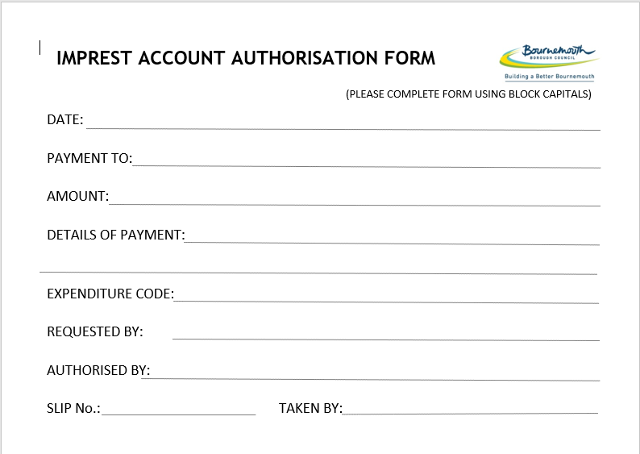

1. The following information should be provided on the ***imprest*** form by the **Worker**:

* DATE: the date that the form is being filled out by the Worker ready for managerial consideration for authorisation.
* PAYMENT TO: name of the person who is to receive the petty cash payment:
  + If the cash is to be given directly to a Service User, this will be the service user’s name.
  + If the payment is to be given to a Third Party who is receiving the money on behalf of the Service User, for example to help manage when, how the Service User spends the money. This could be a Carer of a Service User, in which case the Carer’s name should be stated and then state their relationship to the Service User and the Service User’s name e.g. Mrs Jane Smith carer of Joe Bloggs.
  + If the payment is a reimbursement to the Worker, for example for money they have spent on a Service User, then the Worker’s name should be stated and receipts provided for the payment the Worker wishes to be reimbursed for.
* AMOUNT: the petty cash amount in pounds and pence being requested.
* DETAILS OF PAYMENT: clearly state what the cash payment will be used for. For example: a full or partial weekly allowance being paid to a Service User, or a reimbursement to the Worker for money they have already spent on goods or a service for a Service User.
* EXPENDITURE CODE: the applicable cost code (the worker can check with business support if unsure of the code to use). Note that if the cash payment is to be paid from a service user’s Savings then the Savings cost code must be used.
* REQUESTED BY: the name of the Worker making the payment request. If the Worker is requesting a reimbursement this will be themselves.

1. The **Worker** must then ensure that the ***Petty Cash Imprest Account Request and Authorisation Form*** is signed by an appropriate **Manager**. The **Manager** signs the ‘AUTHORISED BY:’ section of the form to confirm their authorisation of the petty cash payment. Petty cash will not be issued by **Business Support** until they are in receipt of a fully completed ***Petty Cash Imprest Account Request and Authorisation Form*** signed by an appropriate authorising **Manager**. It is the responsibility of the **Worker** to find an appropriate **Manager** to authorise and sign the ***Petty Cash Imprest Account Request and Authorisation Form***. If a **Manager** is unfamiliar with the case, then the **Worker** may be required by the **Manager** to provide further explanation and evidence of previous petty cash payments to the payee; if for example this is a regular allowance payment then there would be a log of previous payments which can be provided by Business Support from the ***Petty Cash Spreadsheet***.
2. Where a **Worker** is requesting reimbursement, they must provide receipts for the money they have spent.
3. **Business Support** will, on receipt of a fully completed, authorised and signed ***Petty Cash Imprest Account Request and Authorisation Form,*** take the amount of cash requested from the petty cash tin and complete a ***Petty Cash Voucher***. On the voucher the **Business Support Officer** will record the details of the payment that were provided on the ***Imprest*** form and the cash amount being paid. They will record the number of the ***Voucher*** on the ***Imprest*** form in the ‘SLIP no.’ section and then initial the ***Imprest*** with their own initials in the ‘TAKEN BY:’ section o confirm they were the officer taking the cash from the tin. The Officer will then ensure the next blank ***Petty Cash Voucher*** slip in the petty cash tin is numbered in sequence. They will then update the ***Petty Cash Spreadsheet*** with the details of the payment and put the ***Imprest*** form in the financial document’s drawer where completed ***imprest*** forms are kept until the associated completed and signed ***Petty Cash Voucher*** is returned by the ***Worker*** to ***Business Support***.
4. The **Business Support Officer** will give the cash and ***Petty Cash Voucher*** to the **Worker** who made the request.
5. Completion and sign off of the ***Petty Cash Voucher*** *at the point where the cash is handed to the payee (below is an illustration of a blank Petty Cash Voucher)*:

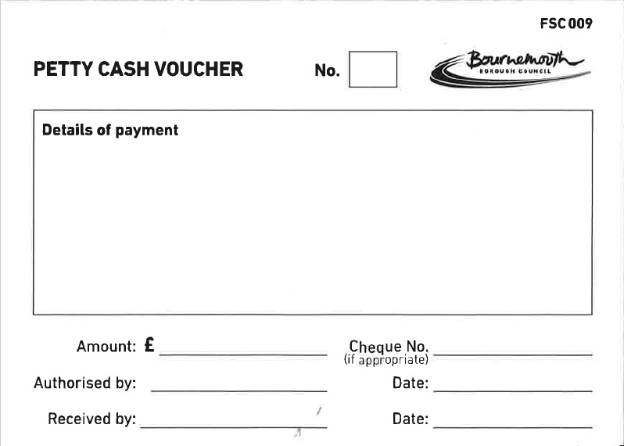

* If the cash payment is to be a ***reimbursement*** to the **Worker,** then the **Business Support Officer** signs and dates the ‘Authorised by:’ section of the voucher to confirm they are the person who has handed the cash to the **Worker**. The Worker signs and dates the ‘Received by:’ section of the voucher to they have received the reimbursement cash payment.
* If the cash payment is to be taken ***straight away by the Worker in order to give to a Service User/Payee,*** then the Worker will be given by Business Support the petty cash and Petty Cash Voucher in envelope with the Service User’s or Payee’s name on.

The **Worker** will take the envelop to give to the **Service User / Payee**. At the point when the **Worker** hands the cash over to the **Service User / Payee** the **Worker** signs and dates the ‘Authorised by:’ section of the ***voucher*** to confirm they are the person who has handed the cash to the **Service User / Payee**. The **Worker** will then get the **Service User / Payee** to sign and date the ‘Received by:’ section of the ***voucher*** to confirm their receipt of the cash payment.

The **Worker** must then ensure the signed ***voucher*** is returned to **Business Support** who will match up the voucher with the original ***imprest*** form.

If the petty cash payment ***is to be retained until the*** **Service User / Payee** ***user comes to Welcome Point*** at the Town Hall Extension to collect it, then: the cash and voucher should be kept in the envelope (labelled with the Service User / Payee’s name) and the envelope kept in the petty cash tin, in the safe until the **Service User / Payee** arrives to collect the cash payment. If the **Worker** of the **Service User / Payee** is unavailable at the time they arrive to collect the cash payment from the **Worker**, then normally a **Duty Worker** will take the envelope containing the cash and voucher to the **Service User / Payee** at Welcome Point. When the **Duty Worker** hands the cash payment to the **Service User / Payee** then the **Duty** **Worker** signs and dates the ‘Authorised by:’ section of the ***voucher*** to confirm they are the person who has handed the cash to the **Service User / Payee**. The **Duty** **Worker** will then get the **Service User / Payee** to sign and date the ‘Received by:’ section of the ***voucher*** to confirm their receipt of the cash payment.

The **Duty** **Worker** must then ensure the signed ***voucher*** is returned to **Business Support** who will match up the voucher with the original ***imprest*** form.

1. All completed ***imprest*** forms, signed ***petty cash vouchers*** and any associated ***receipts*** will be matched together on receipt by **Business Support** from the **Worker** and then retained in the petty cash plastic envelope file for that month, until the end of the month when the paperwork is to be processed for that month’s petty cash reconciliation**.**

**10. Emergency Payments – via Petty Cash**

**Authorisation of Petty Cash for Emergency Payments**

Petty cash is sometimes used for emergency payments to care leavers, often as a short-term support measure. The Team requires social workers to submit an initial imprest record, signed by the social worker and manager, authorising the expenditure and a separate petty cash voucher evidencing receipt.

**Risk:** Without a full audit trail, including a signatory separate to the requesting social worker, there is a risk that petty cash could be used inappropriately or provided when it is not necessary

**Audit Recommendations**

It is recommended that the use of petty cash is reviewed to ensure the following:

• All ***petty cash vouchers*** are signed by both the receiving and authorising officers;

• All ***imprest*** forms are signed by both the requesting and authorising officers;

• All ***imprest*** forms include the applicable expenditure code.

**Key Messages:**

* The **Worker** must complete a ***Petty Cash Imprest Account Request and Authorisation Form*** (see Appendices and Process below for an example form) to request a petty cash payment.
* The **Worker** is responsible for finding an appropriate **Manager** and asking them to authorise and sign the ***Petty Cash Imprest Account Request and Authorisation Form***.
* **Business Support** will not process a petty cash request until the **Worker** has provided to **Business Support** a fully completed ***Petty Cash Imprest Account Request and Authorisation Form*** which has been authorised and signed by an appropriate **Manager.**
* All ***Petty Cash Imprest Account Request and Authorisation Forms*** must be signed by both the receiving and authorising persons;
* All ***Petty Cash Imprest Account Request and Authorisation Form*s** must include the applicable expenditure code.
* All ***Petty Cash Vouchers*** are signed by both the **Authorising Person** and the **Service User/Payee** or **Worker** receiving the petty cash;

**Process:**

The process is the same as the process under section **9. Weekly Allowances / Reimbursement – via Petty Cash.** Please follow the process in that section but note in addition:

1. If the **Worker** seeking **Managerial** approval for the emergency petty cash payment is not able to get an appropriate **Manager** to sign the ***imprest*** form in person, because the **Manager** is off site but has access to their email. Then it will in this instance be acceptable for the **Worker** to request authorisation via email to the **Manager** and copy the request email to **Business Support** (lac.admin@bournemouth.gov.uk). The **Manger** can then give approval or otherwise via return email to the **Worker** and **Business Support**. On receipt of a managerial approval email for the emergency petty cash request, **Business Support** will print off the email and attach it to the ***imprest*** form and then in the ‘AUTHORISED BY:’ section of the ***imprest*** form they will write “see attached managerial authorisation email”.
2. **Business Support** **will not** issue petty cash without having received from the **Worker** a completed ***Petty Cash Imprest Account Request and Authorisation Form*** that has either been **signed by an appropriate Manager** or received a managerial authorisation email (to Business Support via the [lac.admin@bournemouth.gov.uk](mailto:lac.admin@bournemouth.gov.uk) email account) and attached the managerial authorisation email to the ***Imprest*** form.

**11. Management of the Petty Cash Account**

Petty Cash Reconciliation Process

It has been confirmed that although regular petty cash reconciliations are undertaken within the Team, the evidence available in support of this is limited to a monthly summary document that is reviewed and agreed by the LAC Team Manager.

Risk: Without such a record there is a risk that the reconciliation process is not being undertaken effectively and that the summary document presented for sign-off is not an accurate representation of the fund.

**Audit Recommendations**

It is recommended that a full audit trail in support of the regular reconciliation of the petty cash account is retained, including:

• the date reconciliations have been carried out;

• the signature of the officer who has undertaken the reconciliation;

• a record of each transaction checked and whether this agreed with a supporting petty

a record of any highlighted errors and what actions have been undertaken to address them.

**Process:**

1. All petty cash payments will be recorded by Business Support on the Petty Cash Spreadsheet located on the LAC drive in the Admin > Finance > Petty Cash folder. The following information is recorded on the spreadsheet: date of petty cash payment, the initials the Worker who requested the payment, the Petty Cash Voucher number, the initials of the Business Support Officer who issued the petty cash, name of payee and details of payment and reason as stated on the imprest from in the DETAILS OF PAYMENT, net, VAT (if applicable) and total expenditure, the cost code.
2. Reconciliation should be carried out by **Business Support** at the end of month. All transactions listed on the Petty Cash Spreadsheet should be matched against all the imprest forms, petty cash vouchers and receipts. A record of each transaction is checked on the Petty Cash Spreadsheet.
3. For reconciliation the latest version of the ***Petty Cash Claim Request Form*** should be completed. There are two versions of the form, one for VAT petty cash claim and one for NON VAT claims. The appropriate form should be used.
4. The **Business Support** **Officer** undertaking the reconciliation sorted the payment into two groups: one for payments with VAT receipts and one for NON-VAT payments. They total the amounts for each cost code and then fills out a VAT Petty Cash Claim Request Form and a NON-VAT Petty Cash Claim Request Form accordingly. On the VAT form should there be any receipts where the VAT amount quoted is not 20% of the gross then a note of this should be given on the VAT Petty Cash Claim Request Form so that the Creditors Team know why VAT fore that cost code was not 20%. Any errors should be highlighted and notes provided of what actions have been undertaken to address them.
5. The **Business Support** **Officer** will then sign and date the completedPetty Cash Claim Request Forms they have produced and then get the budget holder (normally the LAC or the 16 & Care Leavers **Team Manager**) to sign off a hard copy of each form. The **Business Support Officer** will then email a scanned PDF copy of the signed forms to the Creditors Team for processing and save the original Excel versions and scanned PDF copies of the completed signed forms to the Petty Cash Reconciliation Folder for the month in question on the LAC Drive.

**12. Food Vouchers**

**Summary**

A **Service User** who is entitled to receive a Weekly Allowance can be given a food voucher or vouchers for a local supermarket as an alternative to them being given their full or part Weekly Allowance in spending money. This arrangement is agreed between the **Service User’s Worker** and appropriate **Manger / Supervisor**.

**Process:**

1. The **Worker** sends an email to **Business Support** and the appropriate **Manager** to requests a food voucher be provided for the service user.
2. The **Manager** replies to the email to both the **Worker** and **Business Support** (lac.admin@bournemouth.gov.uk) to confirm their authorisation of the requested payment arrangement to be set-up or confirmation that it is not authorised.
3. If the request is authorised by the **Manager,** then on receipt of the authorisation email **Business Support** then provides the requested vouchers to the worker and then updates the ***Voucher Spreadsheet*** to record:

* Name of the **Service User** the voucher or vouchers is for;
* Name of the **Worker** who requested voucher or vouchers;
* Name of the **Manager** authorising the payment of the voucher or vouchers;
* Value of the voucher or vouchers given to the **Worker** for the service user;
* Date the voucher or vouchers given by **Business Support** to the worker;
* Name of the **Business Support** **Officer** who gave the voucher or vouchers to the **Worker**.

**13. AllPay Cards**

**Monitoring of AllPay Card Expenditure**

Members of the LAC and Care Leavers Service have been allocated AllPay cards. These cards are effectively ‘cash cards’ that can be used for minor expenditure when card holders are performing duties outside of the Town Hall.

**Risk:** The nature of AllPay cards means that the standard controls around expenditure, requiring two separate officers to agree spend, do not apply to them. As such it is important that compensatory controls are in place to allow expenditure to be reviewed and challenged, such as the assessment of monitoring reports on a regular basis. Without such checks there is a risk that inappropriate or fraudulent use of AllPay cards will not be identified or challenged.

**Top-Ups of AllPay Cards**

In order for additional funds to be added to AllPay cards, authorisation is required from applicable managers.

**Risk:** If AllPay cards are processed without the necessary authorisation there is a risk staff can request additional monies without oversight.

**Audit Recommendations**

It is recommended that managers responsible for the oversight of AllPay cards receive monthly monitoring reports detailing what purchases have been made.

Business Support will run a monthly report for Management.

The requirement for managers to check AllPay card expenditure

It is recommended that any reimbursements, or 'top ups', of AllPay cards are authorised by an applicable manager prior to being processed.

No AllPay cards will be ‘topped up’ without prior authorisation from Management.

**Key Messages:**

* A **Manager** must authorise for an All Pay card be ordered for a **Worker** before **Business Support** will arrange for the card to be ordered.
* The **Worker** must complete an ***AllPay Card Account Authorisation Form*** (see Appendices for an example form) to request a top-up of their AllPay Card.
* The **Worker** is responsible for finding an appropriate Manager and asking them to authorise their top-up request and sign the AllPay Card Account Authorisation Form.
* **Business Support** will not process a request to top-up a **Worker’s** AllPay card until the Worker has provided to **Business Support** a fully completed ***AllPay Card Account Authorisation Form*** which has been authorised and signed by an appropriate Manager.
* The **Team Managers** responsible for the oversight of AllPay cards will receive monthly monitoring reports detailing what purchases have been made.
* On a monthly **Business Support** will run a report for each cardholder who has any incoming or outgoing expenditure on their card for the previous month and provide these reports to the appropriate **Team Manager** who willwill check AllPay card expenditure.

**Process:**

Requesting a new AllPay card for a Worker

1. Theappropriate **Manager** sends an email to **Business Support** (lac.admin@bournemouth.gov.uk) to request that an AllPay card be ordered for a **Worker**.
2. **Business Support** emails the **Worker** and request them to provide the following information required in order to request a new card on the AllPay Card website portal:

Title (Miss, Mrs, Mr etc):

First Name:

Last Name:

Date of Birth:

Address:

Postcode:

Authentication question - answer 1 of the following:

Mother’s maiden name:

Name of your first teacher:

Name of your first pet:

Colour of your first vehicle:

Name of your best friend from childhood:

1. **The Worker** returns the required details to **Business Support** who in turn order the new card via the portal. AllPay will post the new card to the address the Worker has provided along with a cover letter which includes information about card customer support.

**14. Allstar Fuel Cards**

**Summary**

Allstar Fuel Cards are used to reduce the cost of travel expenses for business trips as fuel can be purchased with the card at a corporate discount rate. Typically used by staff to fill the tank on a Hire Car before it is returned to or collected by the hire car company.

**Process**

* **Managerial** authorisation is required before a **Worker** may apply to have a Fuel Card or for an existing card to be renewed.
* Once managerial authorisation has been obtained the **Worker** completes a ***New Fuel Card Request Form*** (see example form in the Appendices) and returns it to **Business Support** who order the card.
* The **Worker** is not required to keep and return receipts for fuel payments made with their card as this information is returned in the invoices sent from Allstar to the Finance department.
* On receipt of an invoice the Finance department forwards it to the **Business Support** team who receipt for the invoice and save it in Allstar folder of the Finance admin folder on the LAC shared drive and updates the Allstar invoice and receipting spreadsheet.
* Once receipted the invoice is paid from the LAC Fuel Cards purchase order account. Business Support monitors the amount left on the purchase order and it if runs low requests a top up through Oracle Fusion which is then sent to the applicable **Manager** for their authorisation.
* Should a **Manager** wish to see what is being spent on the account they can access the saved invoices or see an overview of all invoices in the Allstar invoice and receipting spreadsheet. **Business Support** can also supply copies of these documents to **Managers** on request.

**Appendices**

1. **Petty Cash Imprest Account Request and Authorisation Form**



1. **Petty Cash Receipt Slip**



1. **BACS Payment Form**

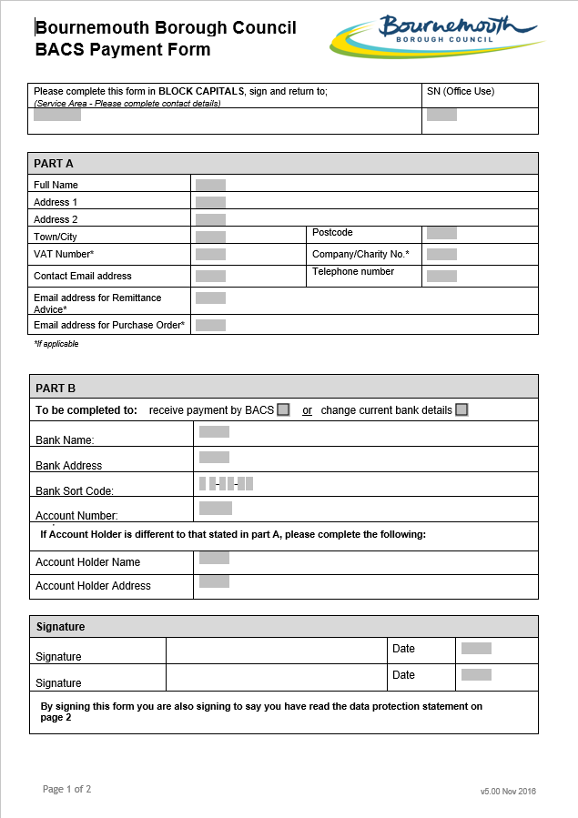

1. **Change to Corporate Credit Card Limit Request From**

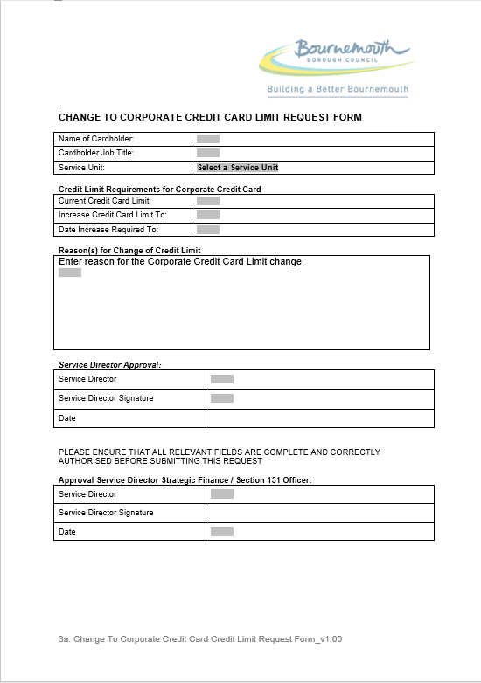

1. **Petty Cash Claim Request Form – VAT**

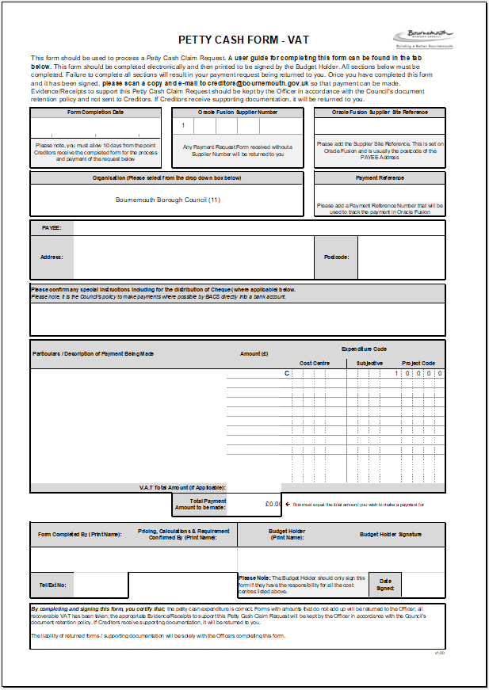

1. **Payment Request Form**

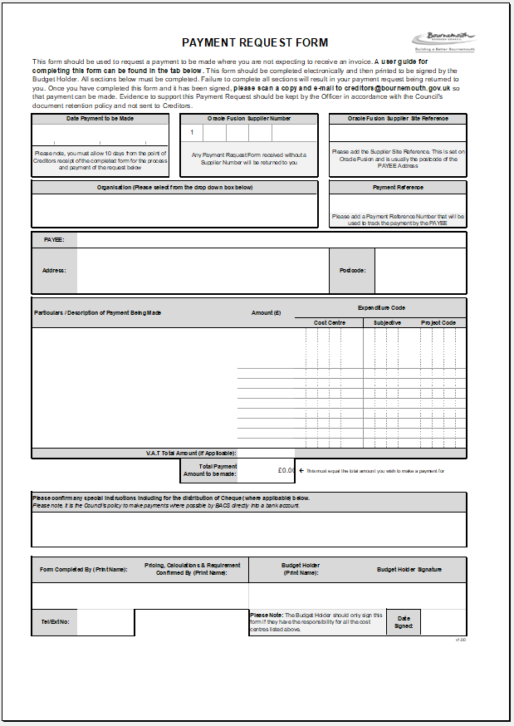

1. **Invoice Payment Form**

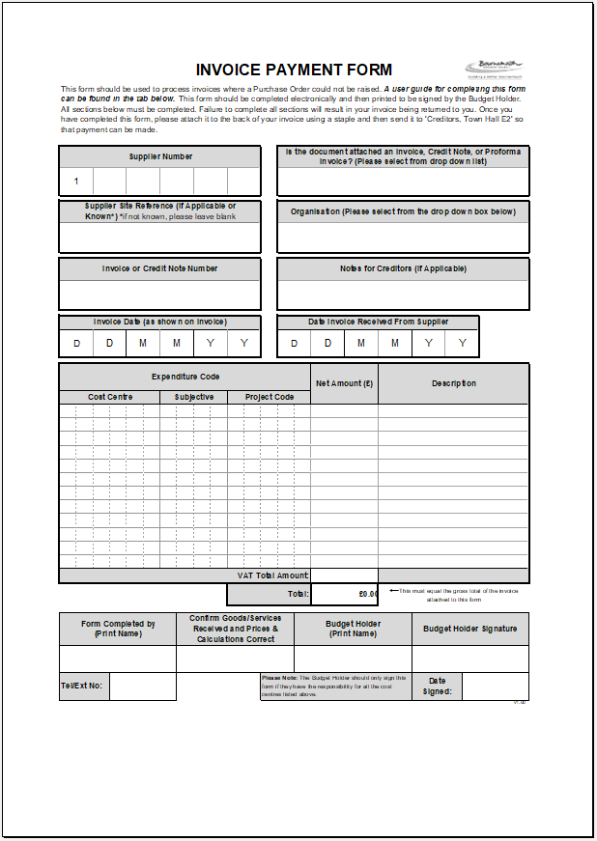

1. **Setting Up Home Grant – Essential Items List**

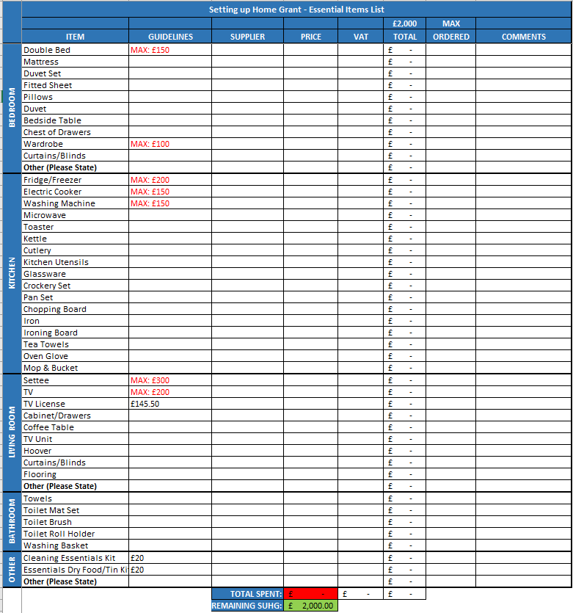

1. **AllPay Card Account Authorisation Form**

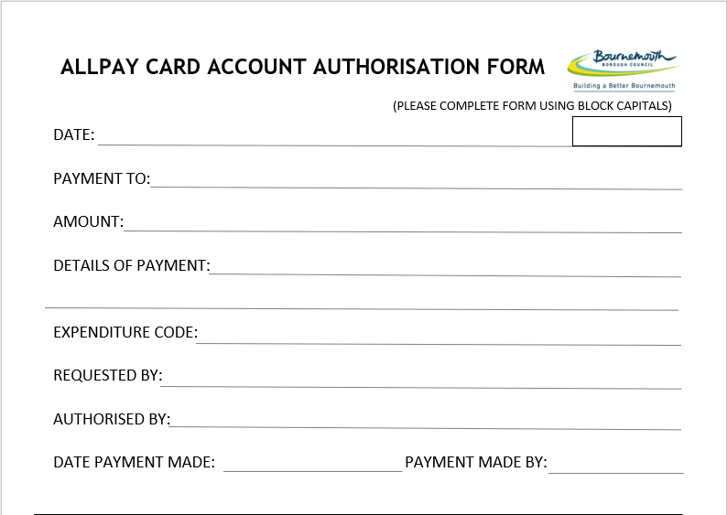

1. **New Fuel Card Request Form**

