
All Teams Supervision Policy
Children’s Social Care

Version 5.12
April 2022

Document name & file location | DORIS CSC Policy Library
Document owner | Sonia Johnson, Assistant Director; Children’s Social Care
Review date | This document is to be reviewed a minimum of every 3 years, the next review to occur no later than January 2023. Incremental reviews may take place as required.
Accessibility | This document can be made available in hard and electronic formats.  No copies in other languages are currently available.
How this document was created | Version 1 | Author and Team; Task & Finish team April 2019
How this document was created | Version 2 | Team / Line Manager
How this document was created | Version 3 | CSMT; May 2019
How this document was created | Version 4 | DMT; June 2019
How this document was created | Version 5 | Public document or Pre-print Design Circulation; Executive sign off
Circulation restrictions | No exceptions,
Version | Detail of change |  | Name & Date
5.1-5.8 | Historical changes on old policy from 2006-2016 |  | Various
5.9 | New Supervision Template |  | Performance & Governance March 2018
5.10 | Complete NEW Policy |  | Co-produced with CSC workforce April 2019
5.11 | Updated by document owner |  | January 2020
5.12 | Review and update |  | April 2022  Flo Landor

Accessibility

This document can be made available in large print, Braille, audio or in electronic format.
Copies in alternative languages may also be obtained.
Please contact:
Children’s Social care
Bracknell Forest Borough Council
Time Square
Market Street
Bracknell
Berkshire RG12 1JD
Email: Childrens.SocialCare@Bracknell-Forest.gov.uk
Telephone: 01344 352020
Minicom: 01344 352045

Table of Contents (Press F9 to refresh)
1 Introduction 1
1.1 The People Directorate Vision – People at the Heart of our Services 1
1.2 Supervision Purpose 2
2 Aim & Scope 2
3 Responsibilities & Principles 3
3.1 Know Your Responsibilities 3
3.2 Use Language that Cares 4
4 Why is Supervision Important? 4
4.1 How Supervision Should Support You 4
5 Our Supervision Framework 5
5.1 How Our Supervision Framework Fits Together 7
5.2 Mandatory Supervision 7
5.3 Standards, Expectations and Supervision Records 8
6 Secure Base Model 9
7 All Team Supervision Contract 9
8 All Team Supervision Record 10

Introduction
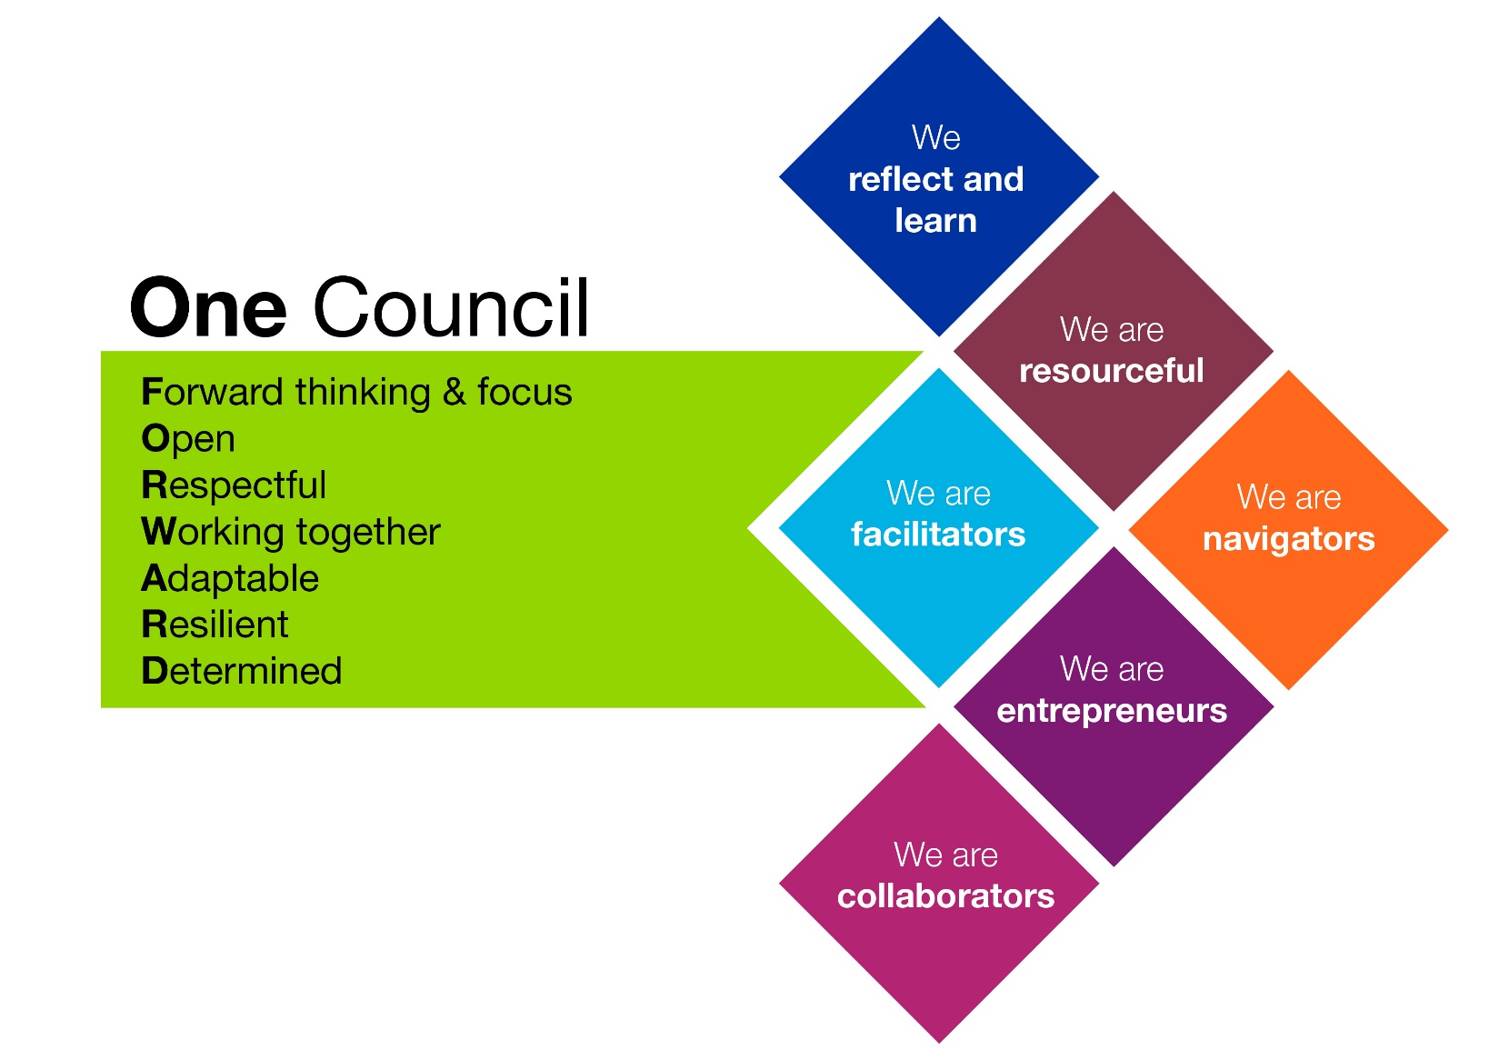
Our values and behaviours underpin the way we interact with colleagues, customers, residents and stakeholders. They are central to our success as One Council.

We can all demonstrate One Council values and behaviours in our work, and specifically within supervision relationships and meetings, no matter what our role is.

The People Directorate Vision – People at the Heart of our Services
- The vision for people who need our services
- Protect you from harm if you need us
- Help you to get support so that you can be physically and emotionally healthy
- Work with you and your community to help you to be independent and resilient

- We’ll do this by:
- Focusing on quality practice
- Integrating services with partners
- Providing information & choice
- Focusing on what is most important

Acknowledgment
This policy was co-created in a task and finish group made up of people within Children’s Social Care who deliver and receive supervision. A thank you is extended to all those people who gave up their time to explore this important area of work and co-produce this policy.

Supervision Purpose
- Supervision is a mandatory core standard in Bracknell Forest Children’s Social Care.

- Key decisions about children’s lives and families’ futures are made in supervision up and down the country every day. The job of those working within Children’s Social Care (CSC) is a challenging one which takes place in a complex adaptive environment where the role of professional judgement is paramount.

- As Bracknell Forest CSC workers we want to support you to be confident, articulate, and professional with highly developed listening, verbal and writing skills. With stamina, emotional resilience and determination.

- Research and practice demonstrate that social workers will be more effective if they receive good quality supervision, both on a one to one basis from a manager and also from peer supervision in teams and networks.

- The Bracknell Forest Departmental Management Team (DMT) are committed to continuous improvement of supervision and support for those working in Children’s Social Care. We want to provide first class support for all CSC workers to do their job well for children and we know that providing the best supervision and support for decision-making is central to this.

- Supervision provides you with a secure base.

Aim & Scope
- To ensure that everyone who works within Children’s Social Care has:
- Effective, timely and accessible supervision
- That enables them to fulfil their role of improving outcomes for children and
- Supports the emotional demands of the work

- This policy outlines what supervisors and supervisees can expect from good supervision in Bracknell Forest Children’s Social Care and how we will meet our responsibility to provide it.
- The value of supervision is applied equally whether a child is:
- CiN – Children in Need
- CP – Child Protection
- CLA – Children Looked After
- YOS – Youth Offending Service
- LCS – Leaving Care Service

- All children benefit from workers who have good and regular supervision and all workers benefit from good supervision.

- The value of supervision is applied equally - whatever the supervisee’s role or responsibility within the organisation regardless of it being permanent, temporary, relief and agency or contracted staff.

- Supervision must provide Managerial oversight and practice reflection i.e. conversations creating reflective thinking.

- For supervision to be effective it needs to combine a performance management approach with a dynamic, empowering and enabling supervisory relationship. Supervision should improve the quality of practice, support the development of integrated working and ensure continuing professional development.

- Supervision should contribute to the development of a learning culture by promoting an approach that develops the confidence and competence of managers in their supervision skills.

- Adherence to this core supervision policy is not negotiable, albeit we encourage flexibility and creativity in delivery.

Note TACT consultation 2019 carried out with Children, tells us that Children Looked After prefer to be referenced as Children and those leaving care as Care experienced.

Responsibilities & Principles

Know Your Responsibilities
- All protected titles, registered with the Health & Care Professions Council (statutory professional regulator body) have to adhere to the legally binding standards to protect the public against risk of poor practice.

- Standard 11 (Reflect & Review Practice) states that the practitioner must:
- Understand the value of reflection on practice and the need to record the outcome of such practice.
- Be able to reflect critically on their practice and consider alternative ways of working.
- Understand models of supervision and their contributions to practice.

- Everyone who is case holding must receive supervision every calendar month.

- Supervision is the process of reflecting on the practice issues to facilitate safe, effective, evidence based and quality assured practice and to explore and contain the relational and emotional impact of the work in relation to the context.

- Supervision is a process by which an organisation provides support and guidance to workers to enable and support workers to build effective professional relationships, deliver and develop good practice, and exercise both professional judgement and discretion in decision-making.

- Supervision of individual cases is a means for helping workers put into practice the critical thinking required to understand their children’s lived experiences holistically, complete analytical assessments, and then to provide an intervention. Guidance will be given, knowledge exchanged, shared decisions made and priorities and actions agreed between supervisee and supervisor.

- Heads of Service are responsible for ensuring this policy is adhered to in their service area.

- If this policy is not working for you tell someone.

Supervision benefits children, their families and those that work within social care

Use Language that Cares
Language is a powerful tool in protecting children – Lets use it well
- Remember to challenge each other to keep your work personalised – children are not ‘episodes’ and ‘outcomes’.

- Ensure supervision retains the focus on people, not processes. The processes help you, not direct you.

- Use supervision to challenge each other to ensure you are listening and understanding what really matters to children and their families.

Why is Supervision Important?
The expectation is that Supervision is a collaborative partnership, reflective, curious and inquisitive

How Supervision Should Support You
- Effective supervision supports:
- Effective workload management
- Management of individual performance and quality of service
- Reflection on the focus of work and methods of intervention
- Commitment to positive outcomes and effective working with others
- Motivation and job satisfaction through clarity on:
- work objectives
- positive feedback
- critical reflection
- personal support and
- continuing personal and professional development
- Positive impact on staff retention and continuity of service

- Supervision should provide:
- A forum for celebrating success.
- A place for discussing personal and practical needs such as a change of circumstances, booking Annual Leave and managing TOIL and health and wellbeing.
- Supervision will provide space for reflection, to enable supervisees to examine and review the quality of all aspects of the service they are delivering. It will be relationship based and will model effective professional social work relationships, where applicable.
- Supervision will be supportive, recognising that supervisees may require help to carry out their role. This may be because of particular situations, specific incidents or personal circumstances. Supervisees will be given the opportunity to reflect on the impact the work has on them and offered support to prevent issues adversely affecting them and their work.
- The supervisor and supervisee are jointly responsible for supporting the continued learning and development of supervisees to ensure they have the relevant skills, knowledge, understanding and attributes to do their job and to progress their career (and in some instances, retain their professional registration). Constructive feedback and observation of practice should be part of this learning process. Supervisors can also use coaching as a tool within supervision.

Our Supervision Framework
Everyone is trained in Motivational Interviewing; use this great strength for supervision
- Group Supervision/Peer Support
Group supervision enables the exchange of information, knowledge and expertise with peers, test out hypotheses, become familiar with each other's cases, and formulate creative solutions to situations that seem stuck, make joint decisions and share responsibility.

Group supervision is an essential component of the Family Safeguarding Model (FSM). This should be attended by all practitioners involved with the family (Children and Adult Practitioners) in order to review progress, feedback on outcomes achieved and agree an overall risk rating. This takes place monthly.

Group supervision and peer support should also be used by other teams as relevant to their context.

- The Whole System
Supervision is part of a whole system approach to achieve the vision. It is the forum for the setting and attainment of individual, team and service-wide performance targets. Supervision will be linked to the Annual Performance Appraisal and six month mid-term review. Appraisal objectives will be monitored and targets for improvement and any key issues such as service gaps can be identified. It is also a tool for ensuring that the Department’s policies and procedures are complied with. Supervision must also always address any capability, disciplinary and grievance issues, with a view to resolving these at the earliest possible stage.

- The Standard
- All Children’s Social Care case holding employees and managers will receive formal one to one supervision sessions, booked at least three months in advance, at a minimum of once every calendar month. Both the supervisor and the supervisees are responsible for ensuring they meet frequency expectations.
- Supervisors are expected to facilitate casework supervision that actively models the principles and values of Motivational Interviewing and signs of safety. This is so that supervisees experience the value of these underpinning practice frameworks directly.
- Supervision will be provided in a safe space without interruptions.
- It will not be cancelled and only be re-arranged if unavoidable.
- Supervision will reflect understanding of and commitment to diversity and equality issues.
- Supervision will support evidence informed practice, with signposting to literature, research, policy and procedures.
- Staff in specialist posts, e.g. Occupational Therapists, will receive additional clinical supervision to support their practice and development and meet the requirements of their particular discipline from a suitably qualified professional.
- All supervisees will have a written supervision contract (see Appendix A), agreed and signed by the supervisor and supervisee within four weeks of joining the Department. The agreement will include how any disagreements may be resolved. This should be reviewed if there is a change of circumstances, something is not working or as a result of a change of supervisor.
- FSM group casework supervision, will be monthly for all FSM cases, with all practitioners (Adult and Children’s attending).
- New starters (at all levels) will receive additional 1-1 sessions in their induction period as required.
- Newly qualified social workers (ASYE) will receive weekly supervision for the first six weeks, then two weekly for first six months. This provision can be shared with the practice educator. The Department will provide the same level (or enhanced level, in accordance with university expectations) of supervision for students as would be the case for other staff undertaking work at the same level. It is the duty of the employer providing student placements to ensure that supervision arrangements for students are safe and appropriate.
- The length of supervision will generally be between one and two hours depending on the agenda.
- New residential care staff must receive one to one supervision at least fortnightly during the first 6 months of their employment. Agency staff and those employed infrequently to cover staff absences will receive one to one supervision no less frequently than after each 8 shifts worked in the home. See National Minimum Standards, Children’s Homes, Standard 28.2.
- When a practitioner is on leave (due to sickness or annual leave) which results in a gap in supervision, this will be clearly recorded on Mosaic and on the subsequent supervision record. Supervisors will consider the impact on children and any need for re-allocating children or tasks due to staff absences.
- Both supervisee and supervisor will prepare for formal supervision sessions.
- The supervisor will prepare by reviewing performance data to check whether children have been seen, whether reviews have taken place and whether plans are in place.
- Practitioners will prepare by prioritising their cases and setting the agenda so that cases requiring in-depth discussions can be prioritised in the meeting. This agenda will be shared with the supervisor at least 24 hours in advance to allow time to familiarise themselves with the cases.
- After each supervision the supervisors will dip sample some case records and record this.
- Supervision should follow the Bracknell Forest Supervision agenda format and be recorded on the set template (see Appendix B).
- It is not expected that each child will be considered at each supervision as there may not have been any significant developments since the last supervision. However, it is expected that at every supervision a case management supervision record will be made for each child that the worker has responsibility for. In these instances, a brief entry along the lines of "No key matters to record since previous supervision” is sufficient. Conversely more complex cases, which require a more in-depth reflective discussion should be recorded in more detail.
- MASH and Referral and Assessment Team hold a weekly Team Brief meeting to provide additional group supervision oversight as work moves through this team at a different pace. Case records must be added to the child's file.

How Our Supervision Framework Fits Together
There are different types of supervision depending on your role and the type of case:
- Group Case Supervision
- Individual Supervision
- Management Supervision
CPD Group
ASYE Resilience Group
Complex with Educational Psychologist
Supervision with Teams/ Pods
Case Discussions
Peer Supervision
Team Brief
Suite of Options

Mandatory Supervision

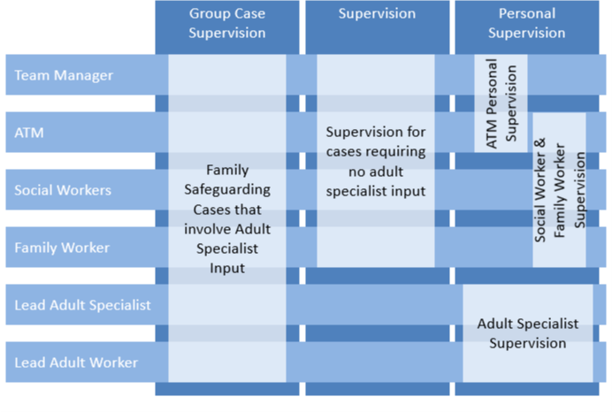

Standards, Expectations and Supervision Records
Everyone must have a supervision contract (attached as Appendix A)
- New starters (at all levels) will receive additional 1-1 sessions in their induction period as required.

- A supervision record of casework reflection and analysis, with decisions and agreed actions will be created on the child’s file within 24 hours for any significant case decisions and/or urgent matters and 48 hrs for all other cases. The supervisor and supervisees will agree who records supervision.

- Emotional health and wellbeing of the worker must be recorded on the individual supervision template by the supervisor.

- It is recognised that informal supervision and management decisions take place between formal supervision meetings. Any significant issues discussed, particularly if they influence a change in direction of the case, should be clearly recorded by the practice supervisor in a timely manner (within 24/48 hrs as above).

- Group casework supervision (GCS) will be recorded by the allocated administrator onto the GCS template on Mosaic.

- Supervision is a work based tool. Whilst there is respect given to the nature of discussions, if it is not data confidential, all matters discussed in supervision will be recorded and may be shared with other members of the leadership team if the needs of children or the service require such. Supervision files may be audited internally and or by Inspectors.

- Each team will maintain a visual calendar of supervision booked.

Keep your records personal
For example; when talking about important people to children, call them by name (reference the role) – this will remind you to do the same when talking directly to children “is Pat picking you up” not “is your foster carer picking you up”.

Additional Opportunities for Supervision
As well as the supervision core offer other opportunities for development and reflection are valuable.

Examples include the following:
- Team meetings/team brief
- Supervision within teams/pods
- Peer supervision
- Case discussions
- Assessed and Supervised Year of Employment (AYSE) resilience group
- Continued Professional Development Group
- Complex case supervision with Educational Psychologist
Any significant issues discussed through these supervision resources, particularly if they influence a change in direction of the case, should be clearly recorded by the practice supervisor in a timely manner (within 24/48 hrs as above).

Supervision records must be stored securely electronically in individual folders on OneDrive and are retained for 7 years.

Secure Base Model

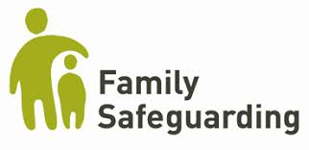
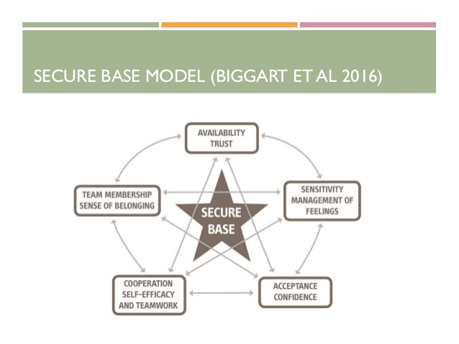

All Team Supervision Contract
https://bfcouncil.sharepoint.com/:w:/r/SiteAssets/SitePages/Childre/Supervision%20contract.docx?d=w7f99146cd08c47b4a9061e9230d0f451&csf=1&web=1&e=HoLNk2

All Team Supervision Record
https://bfcouncil.sharepoint.com/:w:/r/SiteAssets/SitePages/Childre/All%20teams%20supervision%20record.docx?d=wcbb8d798dd7041f4babf1c56f4e2107d&csf=1&web=1&e=ukwW77

