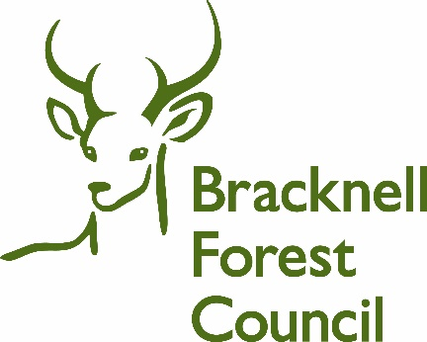
Written Agreement Template (Edit as Appropriate)

This is a written agreement between Bracknell Forest Children’s Social Care,

and

Mother:

Father:

Person with primary care:

This agreement is made on (DATE) regarding the safety and wellbeing of:

Children’s names and D.O.B
- ..
- ..
- ..

The purpose of this agreement is to make clear the concerns the Local Authority has regarding the above children and what we expect you to do as a consequence. We want to work with you to achieve the best possible solutions to your situation.

Grounds for Concern
The Local Authority believes that: (insert concerns here and this could include a safety statement)
Expectations
The following is agreed:

The Local Authority will provide the following support to you:
1.
2.
3.

Consequences of not complying with these expectations:
The Local Authority would like to work alongside you to keep the above children safe.
However, if you fail to keep to this plan, it may be necessary for the Local Authority to seek legal advice in relation to the welfare of the children.

Review of Agreement:
This written Agreement will be reviewed no later than (10 days) ………… but may be reviewed early dependant on the situation. You will be included in that review, and we will listen to your views and wishes which will be taken into account alongside a review of what has happened since we made this agreement.
If you need any further explanation or wish to discuss this agreement further, please contact (child name)’s social worker on (tel number).
If you have concerns about this agreement and social care involvement, there is a complaints procedure of which you have been informed and you can seek your own legal advice.
If out of normal working hours you can contact the Emergency Duty Service on 01344 351999

Signed …………………………………………………………. Date …………………………

Signed …………………………………………………………… Date……………………….

Signed………………………………………………………………Date……………………
Social Worker

Signed………………………………………………………………Date……………………
Team manager

