The FGC Process-Key stages:
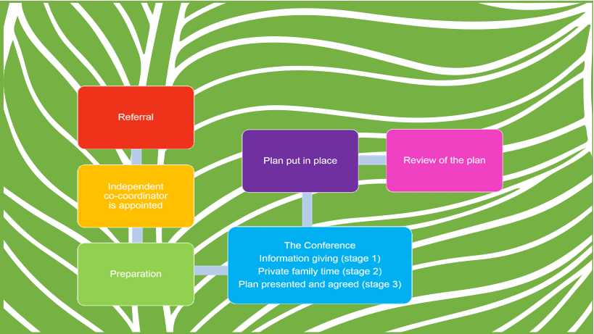

- Referral
The referring professional completes the referral for a FGC.
On receipt of the referral, FGC Coordinator appointed

The referral process
- The referrer/children’s social worker must identify what their agency would consider unacceptable for the child or young person.
- The referral to include background information, the reason why Children’s Social Care Service is involved, and details of the family members to be invited to the FGC.
- The FGC coordinator is to be provided with information on what decisions the referrer/children’s social worker has made and/or could make in relation to the children, for example, consideration of legal steps.

- Preparation stage
Coordinator contacts referrer to clarify the reason for the referral
The coordinator helps the family to prepare. The coordinator will:
- Meet with the child
- Meet with the parents or carers.
- Find out if there is an agreement for the conference to go ahead
- Meet with the wider family and friends’ network
- Explain the family group conference process.
Meeting the wider Family, the Coordinator will:
- Explain to them how the conference will work
- Explain the key concerns that need to be addressed
- Remind all to remain child-focused and to avoid revisiting old arguments.
Agree that the conference can be held.
- Conference takes place
  - Stage 1-Information given
  - Stage 2- private family time
  - Stage 3- plan presented and agreed
  - Stage 4- Implementation of the plan
  - Stage 5- Review (4-6 weeks)

1: Referral Steps – (ref: The Child’s Legal Journey Through Care)
- Referrer / Children’s social worker decides on the need for FGC to create a plan:
- To avoid the need for a Child Protection Plan
- For a child who is subject to a child protection plan
- When considering the commencement of PLO pre-proceedings or court proceedings
- The child has been accommodated
- Where there has been a negative outcome following a pre-birth assessment.
- It is important to note that a FGC may not be appropriate where:
  - There are current criminal investigations or a child protection enquiry, and the FGC process could impact on the evidence
  - Where there is a family history of intergenerational sexual abuse
  - Where no safe adults have been identified within the family network, e.g. Domestic abuse is minimised
  - Isolated asylum-seeking children

2: Preparation Steps
- Parents’ consent must be obtained; if consent is withdrawn before the FGC, the FGC process cannot proceed, and the FGC coordinator will need to be informed.
- The social worker completes the application form for a FGC
- Case allocated to the Independent FGC Co-ordinator
- Extended family members identified and they indicate a commitment to become involved in the FGC process
- Date and venue agreed for the FGC
- FGC co-ordinator engages directly with the child, parents, extended family and professionals in the preparation of the FGC.
- FGC Co-ordinator to organise the venue
- FGC Co-ordinator to ensure necessary additional support is organised, e.g. interpreter, advocate, (if such a service is available independently or via adult social services), child care (this may already have been organised by the child’s allocated social worker)
3: Family Group Conference Meeting- Steps
1: Information sharing by the referrer/children’s social worker presenting
- Introduction/explanation of the process by the co-ordinator
- The co-ordinator agrees on ground rules for the FGC meeting
- Introduction of participants
- Information given by the referrer/children’s social worker includes:
  - Reasons/concerns held by referrer and children’s social care services involvement
  - What plan would not be acceptable to Children’s Social Care Services
  - The issues to be addressed/discussed
  - Children’s views and other key persons if unable to attend
  - What plan would not be acceptable to Children’s Social Care Services
- Resources available from Children’s Social Care Services
This can be done in a short report, which should be shared with participants before the FGC meeting.
- Participants/family members have an opportunity to ask the referrer/children’s social worker questions or seek clarification.
- The coordinator and referrer / children’s social worker leave the FGC meeting.
2: Private Family Time
Family members have 4 tasks:
- To decide whether they disagree with any concerns raised by the referrer/children’s social worker
- Agree a plan
- Agree contingency plans
- Agree how to review the plan
The FGC co-ordinator is available to assist the family members
The plan will include:
- Who in the family will do what.
- Who will check that actions agreed are undertaken.
- Which professionals will have responsibility for ensuring the plan is implemented and to monitor the plan.
- Agree reviewing arrangements
3: Family Plan presented, actions and contingency plan agreed.
- Co-ordinator and referrer / children’s social worker return
- Family members present the plan
- Negotiations undertaken to discuss help / resources
- Plan agreed with referrer / children’s social worker, ensuring the child/ren are not placed at risk of harm. If the plan does place the child/ren at risk of harm family members will be requested to reconsider the plan. If this is not agreed, then the plan can be rejected by the referrer / children’s social worker.
- Contingency plan is considered
- Arrangements for review of the plan will be agreed
4: Implementation of the plan
- Family members are the guardians of the plan
- Family members and children’s social worker agree to ensure all agreed actions are fulfilled – and that all agree to work in partnership to take the plan forward with-in the agreed time scales
- Family members appoint who in the family will be responsible for reviewing the progress of the plan
- FGC co-ordinator types up the family plan and sends out copies of the plan to all family members and the children’s social worker.
Another FCG can be requested if the plan needs changes, or to discuss progress / concerns.
5: Review of the Plan (4-6 weeks)
- Plan reviewed with the family’s agreement
- Support / resources and solutions sought for any actions not fulfilled.

