Portsmouth Children’s Services – Children & Family Practitioner Performance Conversation
The purpose of this self-assessment tool is to help practitioners across Children’s Services to demonstrate how they currently work to support the children and families in our communities in a way that reflects the Portsmouth Model of Family Practice (10x10x10).
Portsmouth Approach to working with children and families
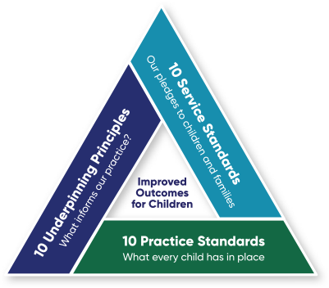

In preparation for the performance conversation, practitioners must reflect on their practice and forward a written version of the document below to their manager a minimum of 1 week before the PDR meeting. Doing so will help lead the conversation with their line manager, who may also make further suggestions or recommendations as to what a practitioner is doing well and what else they should be working towards improving or learning in their practice.
At the initial conversation the practitioner and line manager will set out the learning and development goals for the year ahead. If there was a conversation from the previous year, part of this time will be reviewing the previous year’s goals to review and comment on their progress. Some of the previous goals may inform or link into the current performance conversation.
At the six month review the practitioner and line manager will review and scale the progress towards any identified learning and development goals. This may include discussing what addition support may be required.
At the final review the practitioner and manager will review the ending year’s goals and make final comments on what progress has been made. This may also be used to identify the learning and development goals for the next year, with any uncompleted goals from the previous conversation being forwarded for completion in the new performance year.

Name | Position | Date Updated | Period Covered

Service Standards | My Self-assessment | Manager assessment (standards have been met Yes/No)
- Explain to children and families why we are working with them and what we can and cannot do.
- Listen to children and families and take into account of their wishes and feelings in everything we do
- Take care to ensure children and families understand what we are saying, by using clear and straightforward language.
- Do everything we say and when we say we will do it.
- Be on time for meetings and appointments.
- Keep children and families updated on their progress.
- Keep children and families personal information safe and explain how we are going to use it.
- Try to answer any questions from children and families or find someone who can.
- Work collaboratively with the other services and professionals working with children and families.
- Treat people with respect and dignity.

Wider Contribution (restorative behaviours, demonstrating values and impact)
My Self-assessment | Manager assessment (standards have been met Yes/No)

Professional, young person and family feedback

Learning and Development
 | My Self-assessment | Next Steps & Progress
Portsmouth Model of Family Practice Training
Core knowledge and skills.
Thematics.
Other training relating to your role & other learning opportunities

Enter what you propose to do to and by when to help develop or continually improve on in meeting those practice values relevant to your role and professional development. At each review you will briefly update this to reflect your progress.
Specific Objectives for next year | Next Steps | By When | By Whom

Practitioner’s comments at Initial Conversation (September / October) What's gone well in the last year? Hopes for the next year?
Name of Practitioner |  | Position |  | Date Completed
Comments at Six Month Review (March/April)
Name of Practitioner |  | Position |  | Date Completed
Comments at the Final Review (July/ August)
Name of Practitioner |  | Position |  | Date Completed

Manager comments at Initial Conversation (September/ October)
Name of Manager |  | Position |  | Date Completed
Comments at Six Month Review (March/April)
Name of Manager |  | Position |  | Date Completed
Comments at the Final Review (July/ August)
Name of Manager |  | Position |  | Date Completed

Has the 'Wellbeing Action plan' been completed Yes / No

Signed (Practitioner):
Date:

Signed (Manager):
Date:

