Contextual Safeguarding Child in Need Initial Meeting / Review Meeting
Chair’s summary, and plan
Date of this contextual safeguarding CIN (CS-CIN) meeting:
Date of last CS-CIN meeting:

Basic details
Each child/young person’s name and age
Meeting Chair
Attendees
Apologies
Decision of meeting today – should there be a contextual safeguarding CIN plan?

As well as this summary and plan, please read the reports and consultation forms listed below. Together these form the record of the meeting.

Each child/young person’s views

Each parent/carer’s views

Chair’s summary

Danger Statement

Safety goals

The plan

What are we worried about?  (risk/needs) | What needs to happen?  (action) | Who will do this? | When does it need to be done? | What changes do we want to see (outcome)

Scaling | 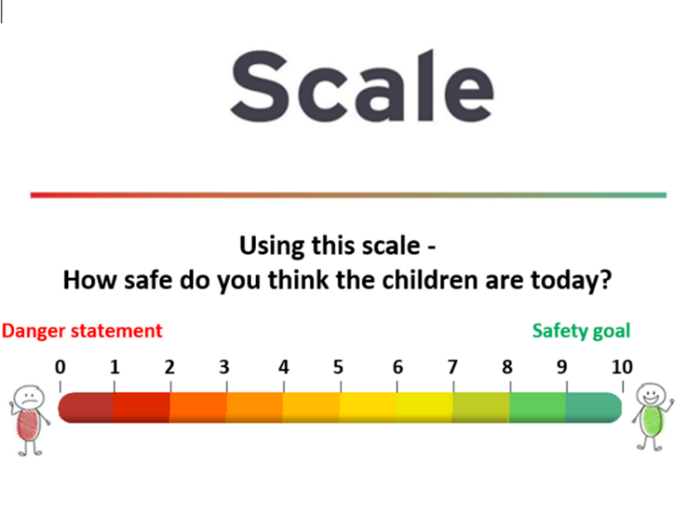
Scaling question:
- Parents’ views
- Professionals’ views
- Young person’s views

Please note below if there is any dissent to the decision.

Contingency plan

Progress meeting membership

Proposed date, time and place  of next progress meeting |  | The plan is brought to each progress meeting. Each action on the plan must be reviewed, so that progress can be seen and any difficulties are resolved. The progress meeting can propose changes.

Proposed date, time and place  of next CS-CIN review meeting |  | Proposed date, time and place of midway review (between chair and social worker)

Date all professionals must share their written report for the next CS-CIN review meeting with parents and young people

