Young person’s conference form
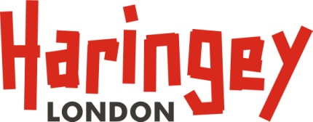

Your name

What is going well / really well?

What are you worried about?

Is anything else making things more difficult for you or your family at the moment?

Are there things you want to know more about?
Are there things or people helping to keep you safe?

If you HAVE a child protection plan already:
- Do you know what this is for?
- What part of the plan do you think has worked so far?

What do you think needs to happen next?
Is there anything you feel would help you or your family? Are there things you think should be part of your safety plan?

Is there anything else you think people at the meeting should know?

Signature |  | Date

