Review Child Protection Conference
Chair’s summary, and plan
Date of this conference:
Date of last conference:

Basic details
Each child’s name and age
Conference Chair
Attendees
Apologies
Decision of conference today
Category if relevant

As well as this summary and plan, please read the reports and consultation forms listed below. Together these form the record of the conference.
EG:
- Social worker’s report by XXXX
- GP report by Dr XXXX.
- School nurse report by XXX

Each child’s views

Each parent/carer’s views

Chair’s summary

Danger Statement

Safety goals

The plan
What are we worried about?  (risk/needs) | What needs to happen?  (action) | Who will do this? | When does it need to be done? | What changes do we want to see (outcome)

Scaling | 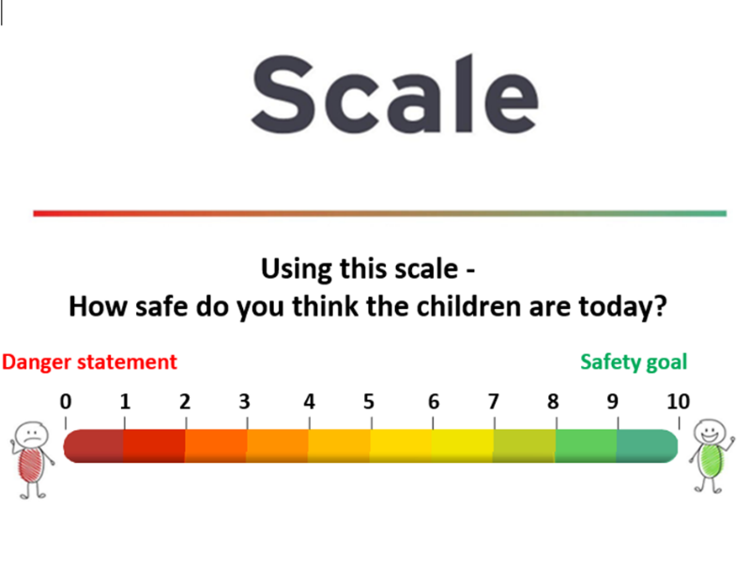
Scaling question:  - Parents’ views  - Professionals’ views  (include category & reasons if appropriate) | Name:  Scale:  Comments:  Name:  Scale:  Comments:  Name:  Scale:  Comments:  Name:  Scale:  Comments:  Name:  Scale:  Comments:  Name:  Scale:  Comments:

Please note below if there is any dissent to the decision (and reasons)

Contingency plan

Core group membership (if applicable)

Proposed date, time, and place  of next core group meeting (if applicable) |  | The CP plan is brought to each core group meeting. Each action on the plan must be reviewed, so that progress can be seen and any difficulties are resolved. The core group can propose changes.

Proposed date, time, and place  of next Review Child Protection Conference. |  | Proposed date, time, and place of midway review between chair and social worker  (if applicable)
Or please note if the next meeting is a Child in Need Review Meeting.

Date all professionals must share their written report for the next conference with parents

