99 Leyton Green Road Welcome Pack

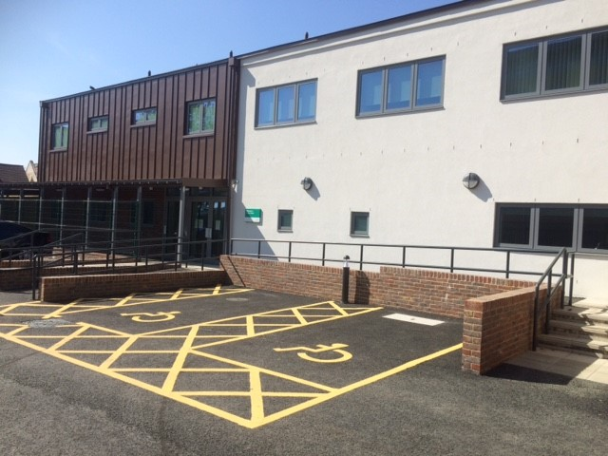

For Children & Young People

May 2022

Welcome to 99 Leyton Green Road

So what’s it all about?


99 Leyton Green Road is a short break and residential service for children and young people with disabilities.
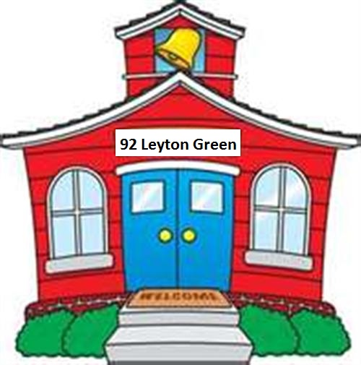

We provide overnight respite and after school clubs 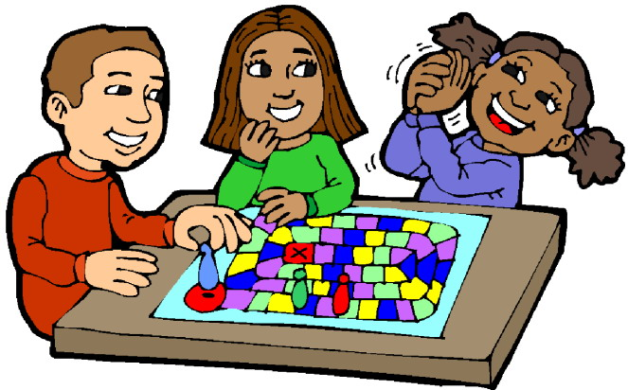in term times and at weekends and in school holidays. We can also provide emergency respite. Your service has been agreed by the  to give  and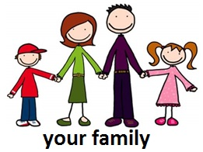 a break.
We aim for you to have a good time when you stay with us. Some of you may be having 99 Leyton Green Road as your home, sharing with children who also have disabilities.
Lester House has 5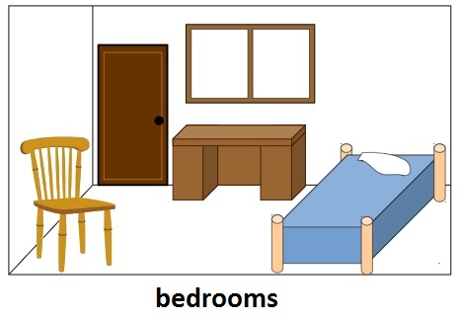 you will never be asked to share a bedroom and we encourage you to bring things to make your room feel homely.

The residential unit at 99 Leyton Green Road has 3
There will always be staff on duty to help , support you and keep you safe.
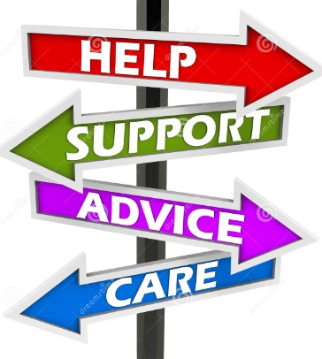

So where is it?
The units are at: 99 Leyton Green Road, Leyton, E10 6DB

We are situated between and tube station.

The local buses to the unit are ,,,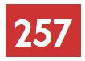, ,and if

If you receive School transport  we can arrange for you to come in on the school bus and to be collected if you are going to school from the unit the next day.
If you are living at 99a Leyton Green Road, you will be taken to and from school in the mini-bus/van or by school transport.
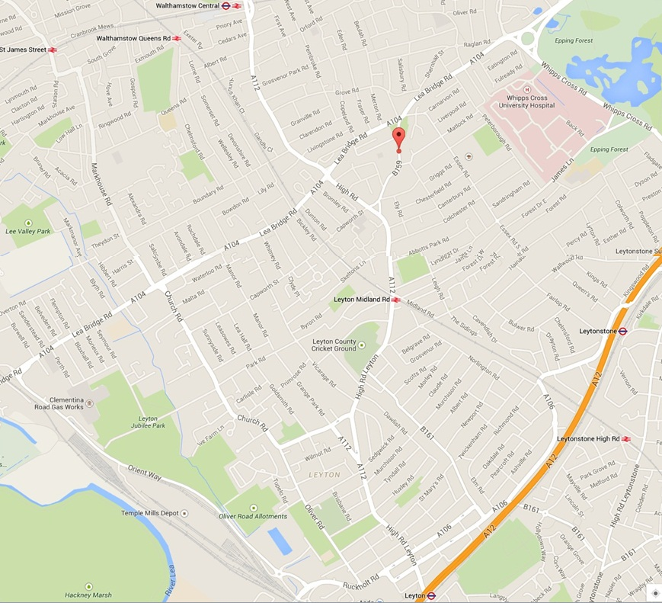

So when will it happen?
After school club run from Monday to Friday, 4pm to7pm. If you are staying overnight you will leave for school the following morning.
At weekends your services are 10:00am to 4pm and 4pm to 9:00am, the following day.

What we want to happen?
We want you to be  when you stay at Lester House and the home.
We do this by having a  to work with and  to build up a picture of how best to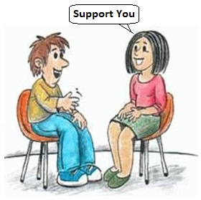 support you and,  and.

We will consult with you through residents meetings and sessions and  you to . We have a PEC (Picture Exchange Communication System) board and our staff to further develop communication with young people that are non-verbal.

We have a phone. The number is 0208 496 1425 (Short Breaks) if you or your parents want to call during office hours. If your parents wish to contact short breaks service during the night (after8pm,) they can call 0208 496 4905. Your parents can call on 0208 496 1417 (residential service).

Complaints & compliments

If you are unhappy about any part of our work with you or how you are treated you have the right to complain.

You can do this in several ways. You can talk to a member of staff, your keyworker or the manager.

You can speak directly to your social worker or the complaints officer by dialling 0208 496 3000.

You can also contact Ofsted on 0300 123 1231
Or Child line 0n 0800 1111

You can also have access to advocacy support: You can call Coram on
0207 520 0300. Their address is 41 Brunswick Square, London WC1N 1AZ

You can also have access to advocacy support the number is: 0808 800 5792 (Freephone) 07758 670369 (Whatsapp and text message)
Email: help@coramvoice.org.uk

You also can contact the Office of the children’s commissioner at Sanctuary Buildings 20 Great Smith Street, London SW1 3BT.
Phone number is 020 77838330

Bullying .

Bullying is not allowed in the unit. If you are being bullied tell your keyworker or any member of staff straight away. So if others threaten you, take your things or upset you, don’t suffer in silence tell the staff.
If you feel you are being bullied by staff then tell other staff and the manager straight away.

House rules

To keep everyone safe at 99 Leyton Green Road we have house rules:
- No violence or physical abuse of others or property.
- No sexist or racist remarks.
- Treat each other with respect and have respect for yourself.
- Look after your room and things and ask for help if necessary.
- Take care of the centre and not damage it on purpose.
- Treat other young people and staff with respect and courtesy

In return we will make sure that…
- You and your privacy are respected. Staff will knock and ask permission to come in your room.
- You have the right to refuse and say no to other children or staff touching or holding you in a way you don’t like.
- You have the right to bring in personal possessions and staff must record your valuables and help you to keep them safe.
- You are entitled to be called by your chosen name and refuse nicknames by staff and other children.
- You are entitled to be taken seriously and not be put down, laughed at teased or treated sarcastically.
- You are entitled to live in a safe warm and secure environment and to have choice in what you eat and drink.
- Your race, culture, dress and religion are respected.
- You have the right to be consulted and involved in all aspects of your care plan decisions and reviews.

Reviews

Your keyworker will meet with you and your parents before you start coming to Leyton Green Road where possible. We aim to hold reviews every 6 months. Its good if you can attend the review and have your say.

Have your Say.
We hold young people’s meetings where you can have your say on the service what you like and don’t like. You can also comment on the meals in the menu planner and ask your worker to record your views on the daily running sheet.

Sanctions

We believe that having a safe home will need having clear boundaries and rules. This allows everyone to feel safe and secure. We understand that sometimes you may feel angry or upset. However, if you hit others or break property we may have to stop you having certain privileges, for example using the I-Pad and may ask you to have time away from other young people until you calm down .
Daily routines,

Young people on school days will usually get up between 7 and 8 ready to catch the school bus.
At weekends young people can have a lie in unless they want to get up sooner. Sometimes we may have to wake you in order to have your medication.
Bedtimes vary depending on your age but all young people are usually in bed by 10 pm.

Visitors 
If you want to arrange for friends or relatives to visit you at 99 Leyton Green Road this must be approved beforehand by the manager to make sure they are safe to do so.

Activities
We have a soft play and sensory room on site. We also have a music room with drums and keyboards in. We also have large gardens with swings and a ground level trampoline. Lots of young people like to go out and about. Parks and a community farm are nearby. Young people also enjoy going to the cinema to bowling or for visits to museums or further afield for forest or park walks. Please tell your keyworker what your favourite things are so we can plan these things for you.

Religious Practice


We value people’s differences and can support you to practice your religion by having the correct foods a quiet room to pray. Please tell us what you need us to do to help you practice your faith.

Education.

We want young people to reach their full potential and if you need us to help you with school homework we can do this with you.

What you need to bring for respite.

Young people that visit need to bring their own clothes and toiletries ,soap flannels ,deodorant and tooth brush and tooth paste for their stay at the unit. Young people must bring their own pads if they wear them and all their medication in the chemist box so we can see your name on it.

If you are living at 99a, you and your family will have been given a keyworker. This is a support worker who will work with you, your family and social worker to make sure you have all of the things that you need during your stay.

Who’s who!


Responsible Individual: Abigail Adieze 0208 496 3274 or 07715 536869

Manager: Tony Lyseight-Goslin 0208 496 1435)

Lester House – Respite Service;

Senior Support Workers: Michael Louisy, Charline Lachoo,
Natalee Walters
Support Workers: Jonathan Savage; Doreen Modliar;
Janet McKay-Williams; Schemera Williams

Night staff: Sharon Bates; Liz Tamakloe, Queen Inyang; Marlene Service
Asst Support Worker: Roy Hilaire; Sarah Kakule;
Tracey Sinclair; Rehana Hanif
Handyman: John Andrews
Cook: Carolyn Osei; Andie James

99a Leyton Green Road

Deputy Manager: Jennifer Elias 0208 496 4843 or 0208 496 1411
Senior Support Worker: Mahir Saliman
Support Worker: Raquel Palmer-Aboobakar; Kate Edigin
Night Staff: Janita Arif; Ntembe Suleyman
Asst Support Worker: Sharne Forsythe Young; Oluwafunke Oluyele

