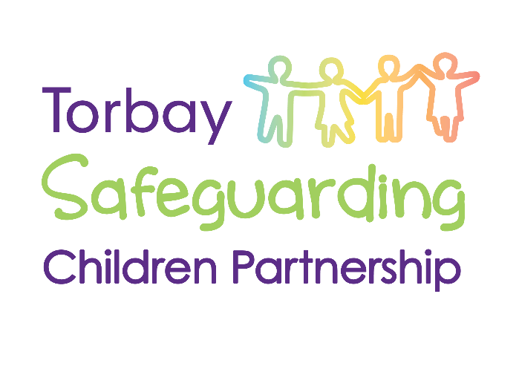
Torbay Safeguarding Partnership
Missing Children Strategy
March 2022

Introduction
Our Partnership is committed to reducing vulnerability and risk for children who go missing from home or care.
We understand that there are many reasons why a child may go missing from home or care, and that each individual child has different needs and circumstances.
We are committed to understanding and offering support to children and their families where missing episodes may be occurring.
As well as children who are reported missing to the police, we also acknowledge that many missing children may not be reported by their families/carers (these children are considered ‘hidden missing’. There are also many reasons for this.
We are therefore also committed to supporting parents/carers/families to understand the importance of reporting children as missing when needed.
**Note – at the time of writing this strategy, Torbay does not use the ‘absent’ category for children.

Working Together – what we are doing
All children who are reported missing to Devon and Cornwall Police will have missing log numbers assigned to them.
Devon and Cornwall Police have dedicated Missing Person’s Safeguarding Officers who monitor and oversee police responses to missing reports for all children.
Notifications for any child in Torbay who is reported missing (and subsequently found) to Devon and Cornwall police are shared with:
- Children’s Services (MASH and Exploitation Team)
- Health – Safeguarding Nurse Team
- Torbay Education Safeguarding Service
- Checkpoint
Our Child Exploitation Team within Children’s Services is responsible for monitoring and recording all missing episodes for:
- Children living in Torbay with their families
- Children Cared For by Torbay who are living in Torbay
- Children Cared For by Torbay who are living in other local authority areas
- Children Cared For by other local authorities living in Torbay
Our Safeguarding Leads in education and health services who are notified of missing episodes are responsible for ensuring that relevant practitioners in partner agencies are aware if a child is missing.
When a child is reported as missing, there is an agreed shared responsibility on all partner agencies to
- assist with sharing relevant information relating to the missing episode
- locating the child to end the missing episode and return them safely to their parents/carers
- considering if there is any additional support that needs to be offered
Torbay holds a weekly multi agency ‘triage’ meeting, attended by:
- Children’s Services – Exploitation Team
- Police
- Education
- Health
- Checkpoint
This meeting is aimed at ensuring that information about children who go missing is recorded accurately and analysed by safeguarding partners, that return home interviews are completed in line with statutory requirements, and to analyse local activity and service responses to missing episodes for children.
This meeting also reviews any new or reviewed exploitation toolkits that have been submitted.
Where there are concerns that a child may be ‘hidden missing’ (ie not reported to the police), our Exploitation Team can offer advice, consultation to professionals and parents, and may also be invited to attend multi agency meetings to support a conversation about the child’s vulnerabilities.

Return Home Interviews
As per national guidance, each Torbay child is offered a Return Home Interview (also known as a Return Home conversation) with a practitioner from the Children’s Society Checkpoint project.
Torbay has commissioned the Children’s Society to undertake these on behalf of Torbay Council under the 0-19 commissioning arrangements within 72 hours of the child being located. This service is commissioned for
- children living within Torbay
- Torbay Cared For Children living up to a 30 mile radius from Torbay in other local authority areas
Checkpoint will automatically be notified of any missing child in Torbay so that they can offer the Return Home Interview without delay when the child is located.

Children living in Torbay from other local authority areas
Torbay does not offer automatic Return Home Interviews for Cared For Children who are living in Torbay from other local authority areas.
There is an expectation that the child’s ‘home’ authority makes arrangements for these to take place at the same time as making arrangements for the child’s placement.
The Exploitation Team and/or Police Missing Persons Safeguarding Officers will however communicate as needed with the child’s Social Work team to gather or share information relating to vulnerability and care arrangements.
The child’s Social Work team from the ‘home’ authority can also request communication or discussions with Torbay’s Exploitation Team by contacting missingteam@torbay.gov.uk.
If a child from another local authority area does go missing in Torbay, and Torbay have not yet received the formal notification, this will be requested from the child’s ‘home authority’ along with other relevant information regarding vulnerability.

Torbay Cared For Children living in other local authority areas
There is an expectation that any Social Work team making arrangements for a child to live in another local authority area will adhere to the following (taken from Torbay’s Out Of County Placements Protocol July 2021):
- Has the Local Authority in which the child will be placed been notified appropriately?
- Has the Local Authority in which the child will be placed been sent the exploitation toolkit and any other relevant information about the child, for example information relating to missing episodes and risk management strategies or plans?
- Have the local exploitation profile and missing/exploitation protocols been received from the provider and has this been considered as part of the placement planning process? Do you as a social worker or Team Manager have access to these protocols? Are these referred to within the placement planning meeting or Cared For Reviews?
- What arrangements are there for independent return home interviews and advocacy through the offer from the provider? If there are no arrangements, how is Torbay going to ensure that these take place and are of a high quality?
- Have you made a referral to the local MACE or equivalent missing or CSE forum in the Local Authority in which the child will be placed? Have you provided key contact details for allocated workers, to ensure efficient and timely information-sharing with safeguarding partners in the local area? Have you ensured that you are invited to all key meetings?
- Are Torbay’s missing and exploitation protocols reflected within the child’s plan?

Missing episodes longer than 24 hours

If a Torbay child (living in Torbay or Cared For in another local authority area) is missing for 24 hours or more, clear management oversight is required on the child’s case record with the following:

- Analysis of information gathered about the missing episode
- Views expressed by the child and parents/carers
- Analysis of vulnerability and potential risk of harm to the child
- Clear action for next steps
- Notification to Service Manager, and where there is additional vulnerability identified, also to Head of Service

If a child is missing for 72 hours, a missing person’s strategy meeting will be convened.
This meeting will include partner agencies and other relevant involved professionals, the purpose being:

- Analysis of information gathered about the missing episode
- Views expressed by the child and parents/carers
- Analysis of vulnerability and potential risk of harm to the child
- Clear action for next steps, including consideration of media use
- Whether threshold is met to progress to a Child Protection Enquiry (Section 47 Children’s Act)
- Notification of significant event to Divisional Director and Director of Children’s Services

Whilst Torbay will not convene a strategy meeting if the child is Cared For by another Local Authority, there will be clear communication from Torbay to the ‘home’ authority to request an update on oversight and care planning for the child.

Repeat missing episodes

If a Torbay child (living in Torbay or Cared For in another local authority area) has 3 or more missing episodes in a 90 day period, a missing persons strategy meeting will be convened. The purpose of this meeting is:
- To review the expressed views of the child and their carers relating to each missing episode
- To analyse the missing episodes and consider responses to any vulnerability
- To identify patterns or trends that could be disrupted
- To identify support needs for the child and their parents/carers/families
- To identify any locations or individuals of concern where disruption could be required
- Whether threshold is met to progress to a Child Protection Enquiry (Section 47 Children’s Act)

Where there repeat missing episodes, whilst Torbay will not convene a strategy meeting if the child is Cared For by another Local Authority, there will be clear communication from Torbay to the ‘home’ authority to request an update on oversight and care planning for the child.

Other Useful Documents:
- Statutory Guidance on Children who run away or go missing from home or care January 2014 – Department for Education
- Torbay’s Out Of County Placements Protocol July 2021

