ONE MINUTE GUIDE - Chronologies

What is a chronology?
Chronologies are a vital tool for practitioners working with children and their families, supporting practice in a number of different ways. They are crucial to:
- Capture significant events in the child and family’s life
- Consider the child’s felt and lived experience
- Understand the source of actual and potential harm impacting on children and young people
- Identify protective factors and to decide next steps for intervention in a range of contexts.

Compiling and analysing chronologies serves as a foundation for relationship-based practice as they provide an overview of what has happened in families' lives, aid understanding of what their experience of services and professionals might be, what can be learnt from this, and how this can be worked with to effect change in the future.
Chronologies: a tool for multiple purposes:

- To support relationship-based practice
- To aid child-centred practice
- To analyse risk, harm and patterns over time
- To identify strengths, resilience and protection
- To explore and analyse capacity for change
- To support decision-making and next steps
- To support permanence, life story and identity for children in care
- To underpin reflective supervision and practice

How to compile a chronology. When a child/ family has been allocated to you for an assessment or a piece of Early Help work please check to see if there is already an open chronology on MOSAIC. If there isn't please open a chronology on mosaic on the eldest child in the family (under 18). You may decide to open additional chronologies if the children are living in different addresses (this will rely on your professional judgement). See separate MOSAIC guidance - Working with Chronologies and Created Chronologies

A chronology is a list of events that have occurred within a family in date order providing the date of the event, brief detail of what the event was and the source of the information where required, and the significant of this event. Overall, the chronology should provide a prompt, concise and visual outline of significant events based on the facts. It is down to practitioner judgement when a chronology starts. At a minimum it should start at the child's date of birth, however there may be family history or pre-birth involvement that may be relevant to summarise.

Chronology template on Mosaic
Title
Name (Person ID) born DOB
Date | Age | Source | Event | Analysis, impact and actions | Category
1.01.2020- 07.12.2022 |  | Previous chronology | Family History | Please see previous chronology dated 1.01.2020 which is uploaded on MOSAIC  Include a very brief summary of the history | Previous chronology
The date or time period for each significant event should be recorded here. |  | Referral source i.e., Health, Education, Police etc. | The date or time period for each significant event should be recorded here. | Analysis involves paying careful attention to what is going on in any situation in order to understand that situation and make recommendations for support.  Potential and actual impact on the child. To include observation, child’s expressed views and professional judgment.  Actions need to be:  S - Specific  M - Measureable  A - Agreed  R - Realistic  T - Timely | Contact / Referral, Child Protection, Early Help, Health, Police, Education, Family Event
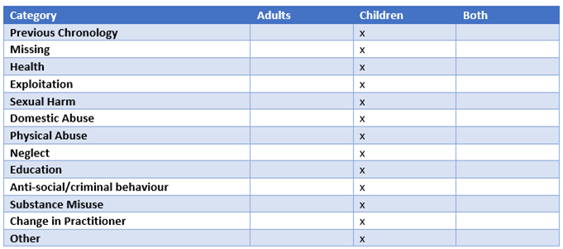
Under Categories', please select the applicable category from the above dropdown list
Significant events should focus on the circumstances that had a positive or negative impact on the child / family.
- Key dates of birth, deaths, marriages, co-habitations, relationships.
- Childhood history of parents.
- Social care intervention - Injuries, neglect of care, incidents of hospital admission, parental incidents including domestic abuse, substance use,
- Transitions and life changes, house moves, changes of carer, contact arrangements.
- violence, criminal history.
- Incidents of racism and oppression.
- Key professional interventions, what’s been tried, missed appointments, engagement, other professionals involved.
- The child’s voice – when seen, observed behaviour, views sought.
- When the child has been provided with explanations and what words were used.
- Family and organisational responses to intervention.
- Outcome of referrals and actions taken.
- Child’s health history, immunisations, injuries and hospital admissions.
- Education, training and employment including achievements, qualifications, changes of school, periods of exclusion, absence.
- Changes in the child’s legal status and placement history of children in care.
- Events of religious/cultural significance i.e. baptism, bar mitzvah.

The information recorded in chronologies should be succinct and to the point. Usually, two or three sentences detailing the incident or event and its significance will be sufficient and help practitioners identify relevant patterns when it comes to analysing the information at a later point.
Practitioners should remember that the chronology will be shared with the family and potentially the child when they are older, so it should be written in accessible language with jargon and acronyms avoided.

Conclusion
Chronologies are a critical tool to support social work practice with children and their families. They provide a foundation for relationship-based practice and identify patterns of risk, harm and protective factors and how they have occurred over time. They also help plan next steps for assessment and intervention.
Chronologies need to be opened, maintained and updated on a regular basis; analysed and reviewed in supervision and relevant meetings; and presented in a range of contexts including child protection conferences and care proceedings. Information contained in the chronology needs to be succinct, recording key events and impact on the child.
This one minute guide supports practitioners to understand how chronologies can be helpful and identifies the process of compiling, analysing and presenting chronologies within their work to support decision making at every stage of the child's / families journey.

Completing social work chronologies: Practice Tool (2022) | Research in Practice

As partners of Research in Practice we have access to a wealth of learning resources and training to support evidence-informed practice with [children, young people and families / adults, carers and families]. You can create an account here or if you have one login to view resources on a wide range of topics. Ask me for more information.

If you require any further support, please do not hesitate to contact The Stronger Futures Academy. Karley.middleton@portsmouthcc.gov.uk

