Working with Chronologies and Created Chronologies

Contents
Accessing the Chronology functionality 3
Case Chronology 3
Adding events to a Case chronology 4
Viewing the Case chronology 5
Created chronologies 6
Created chronologies list 6
Creating a Created chronology 6
Editing existing Created chronologies 7
Chronologies Quick Guide 9
Case chronology 9
Add events to a Case Chronology 9
Created chronologies 9
Creating a new Created chronology 9

Accessing the Chronology functionality
The Chronologies functionality can be accessed from a child's Person Summary, by clicking on Case chronology:
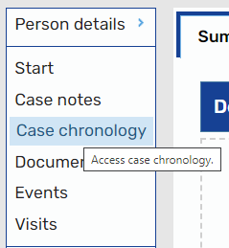

Case Chronology
When clicking on Case chronology, you will be presented with the Case chronology screen:
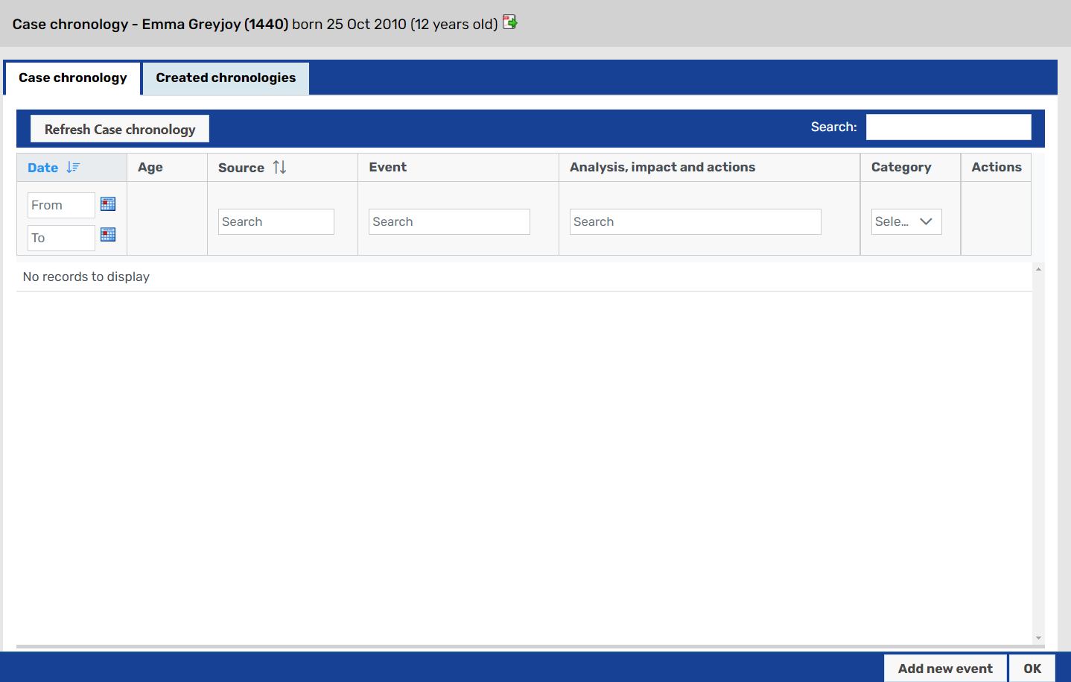

When opening the Case chronology screen for the first time, there are two main areas to be aware of:
These are the Case chronology and Created chronologies tabs. Some users will not have the Created chronologies tab More detail on the Created chronologies tab can be found in the Created chronologies section below.
These buttons allow you to Add new events to a chronology, or you can exit the Case chronology screen by clicking OK.

Adding events to a Case chronology
To add a new event, click Add new event. This will bring up the Add new event to Case chronology pop-up:
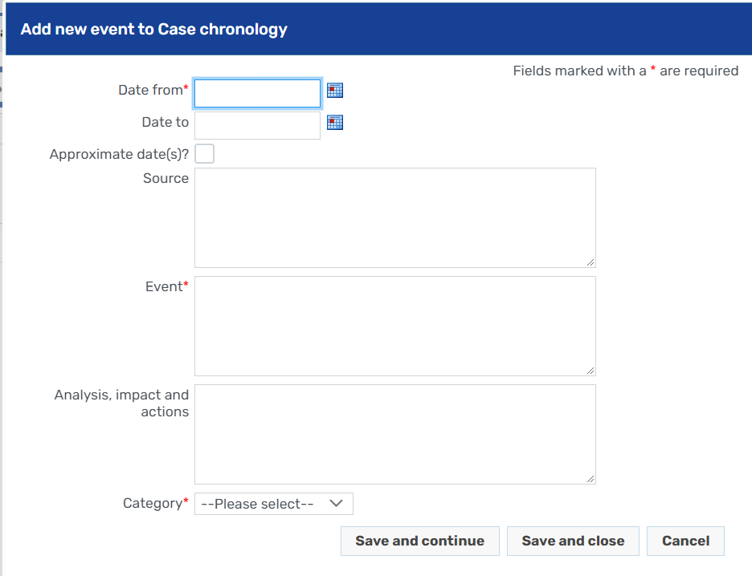

For every event added, Mosaic makes it mandatory to add:
Date from
Event
Category
If an event happened across a date range, then you can add a Date to as well as a Date from. It is not necessary to add a Date to if an event occurred on one day.
If dates added are approximate, you can check the Approximate date(s)? checkbox to indicate this.
Once all required fields are completed, you can select to:
- Save and continue - adds the item to the Case chronology, but does not close the pop-up so recording can be continued
- Save and close - adds the item to the Case chronology and closes the pop-up
- Cancel - abandons all changes to the item and closes the pop-up

When transitioning from previous Word-based recording to using Mosaic chronologies, the first item added in the chronology should be:
Date from: the date recording started in Mosaic
Event: Chronology recording started in Mosaic - please see uploaded chronology in Documents for recording before this date
Category: Previous Chronology
This emphasises that previous recording is held in the uploaded documents in Mosaic, and an up-to-date version of this chronology should be uploaded prior to starting the recording in Mosaic.
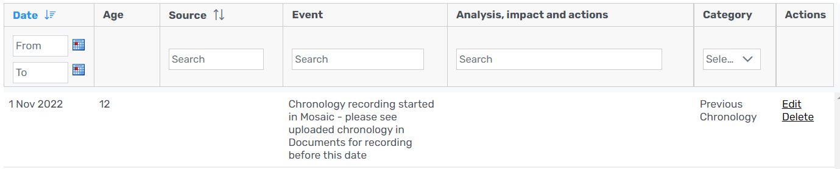

Viewing the Case chronology
Once events are added into the Case chronology, events will appear with the newest event at the top of the screen:
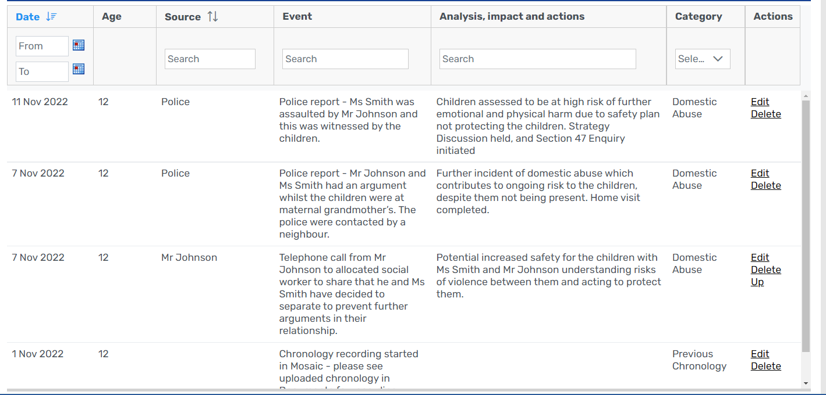
This can be changed by clicking on the Date title of the column to show the first event at the top of the screen if required.
Note the Age column is automatically generated based upon the child's date of birth and the Date from field.
The column headers and first row enable users to search, sort and filter events recorded in the chronology. It is possible to:
- Filter events by dates/date ranges in the Date column
- Filter events by Source by typing in the Search bar under Source
- Sort events by sources by clicking on the Source column title
- Filter events by key words by typing in the Search bar under Event
- Filter events by key words by typing in the Search bar under Analysis, impact and actions
- Filter events by category by selecting the applicable categories from the dropdown list under Category

If two events in the chronology have the same Date from, it is possible to adjust which appears first:
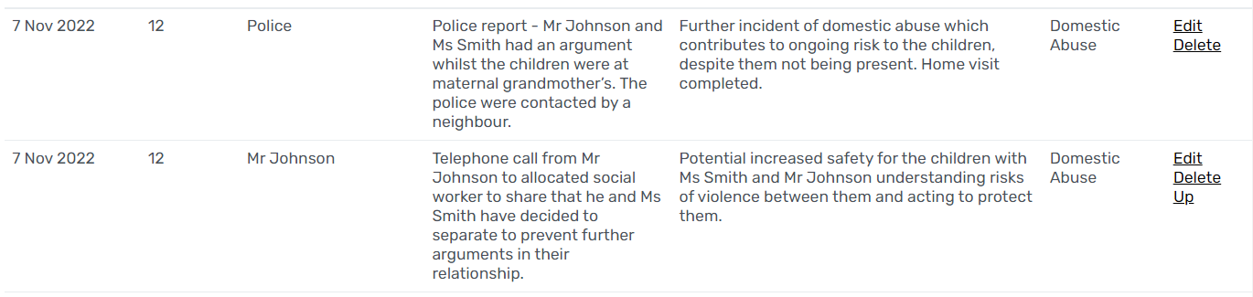
At present, as per the guidance above, the oldest event is at the bottom of the chronology. Looking at the chronology above, it appears that Mr Johnson phoned the social worker before the Police report was received. If this is inaccurate, then you can click on the Up selection in the right-hand column to move this item above the previous one on the same day.

Events added to Case chronologies can be edited by clicking the Edit link next to them. This brings up the event pop-up to allow for amendments.
Events added to Case chronologies can be deleted by clicking the Delete link next to them. Clicking this will bring up a warning:
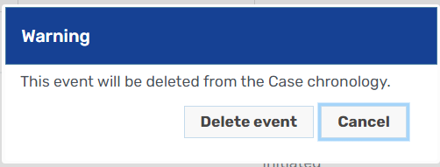
Once Delete event is clicked, items cannot be recovered. Click Cancel to prevent deletion.

To ensure you are always viewing the most up-to-date Case chronology, it is recommended that you click Refresh chronology prior to reading, as another user may be editing the chronology whilst you are viewing it.

Created chronologies
Some users will have access to the Created Chronologies screen. This allows users to create chronologies for specific purposes, using items from the main chronology and others, and once completed, these can be saved and exported to Microsoft Word.

Created chronologies list
Clicking on the Created chronologies tab will present you with the Created chronologies screen, which will show all previously created chronologies within Mosaic. Where none have been created, it will read No records to display.

Creating a Created chronology
To create a new Created chronology, click Create new.
This will bring up the Create new chronology screen:
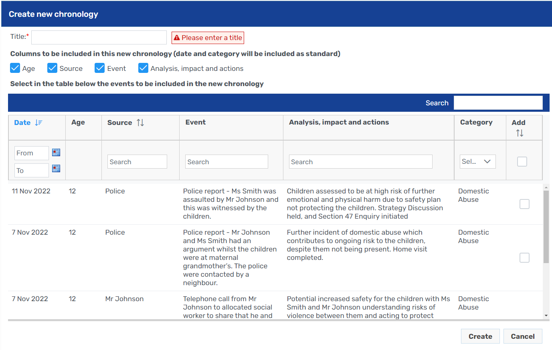

Every Created chronology must have a title
Users can select which of the Chronology columns they wish to include in their Created chronology (Date and Category are included as standard). Please note, once the chronology is created, it is not possible to add these columns later
Users can select events from the Case chronology to add to the Created chronology. Checking the checkbox next to an event will include it and checking the checkbox in the first row will add all the events. Note it is possible to sort and filter (as above) using the first row to identify items to add.

Once completed, click Create to create the Created chronology.

Editing existing Created chronologies
Once a Created chronology has been made, it will appear in the Created chronologies list in the Created chronologies tab:
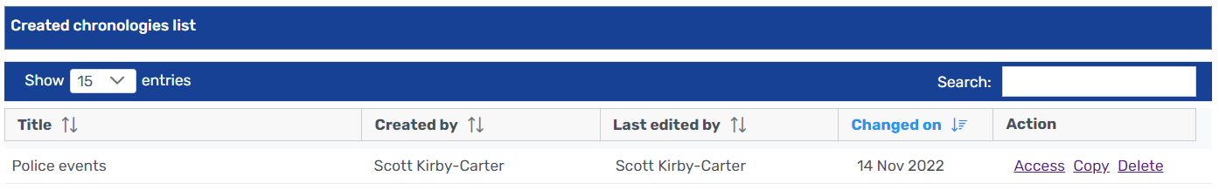
From here you have three options (depending on your permissions)
- Access this allows you to access that Created chronology and edit it
- Copy this will create a copy of this Created chronology, which you can then access to edit
- Delete some users will have the ability to delete Created chronologies. This should only be used when absolutely certain that the Created chronology is not required, as it cannot be restored once deleted.
Once you click Access on a Created chronology, you will be taken to the main screen for that Created chronology:
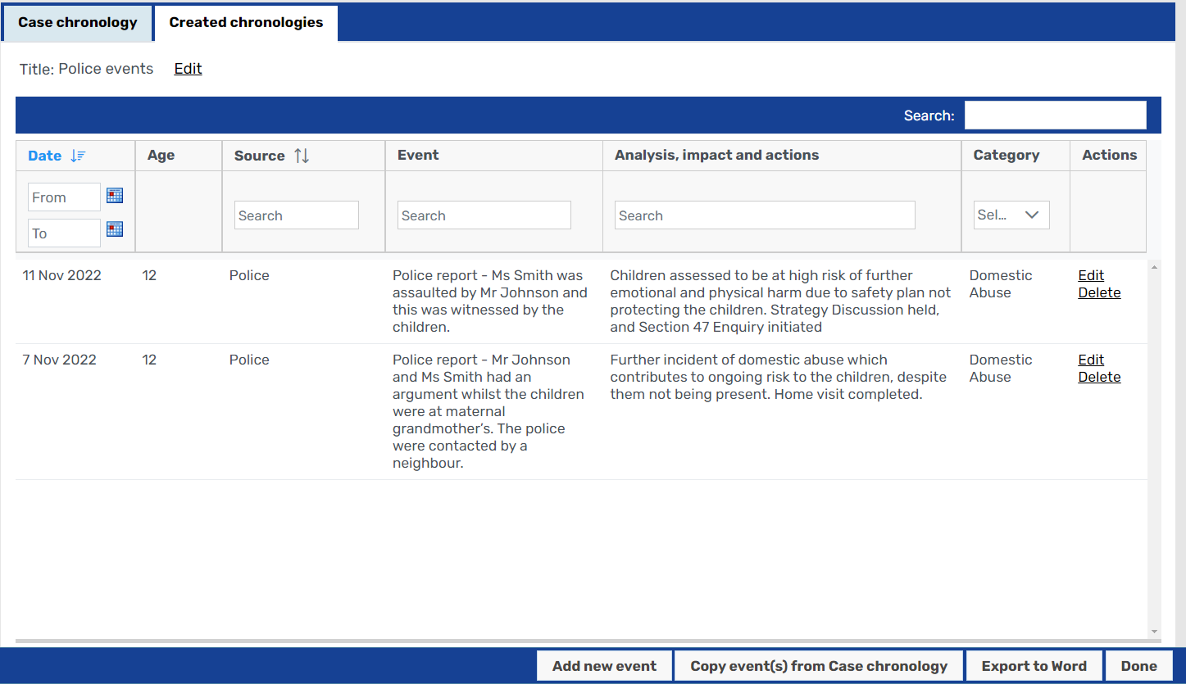

Here you can review the Created chronology and undertake the following actions:
You can edit or delete existing events in the Created chronology using the options in the right-hand column
You can add a new event to this Created chronology - please note that events added in this way do not copy back to the main case chronology
You can copy events from the Case chronology - clicking this button will bring up the Case chronology, with checkboxes for you to add events, and these can be added by clicking Add copied events. Please note that any events that are already added will not be labelled as such, so review your finished Created chronology to ensure that you've not copied the same event twice
You can export the Created chronology to Word - clicking this button will download a version of the Created chronology to your Downloads folder as a Word document
You can return to the list of Created chronologies by clicking Done

Chronologies Quick Guide

Case chronology
To access Case chronologies:
- Search for a person
- In their Person summary, click Case chronology

Add events to a Case Chronology
- Click Add new event
- Ensure Date from, Event and Category are completed as a minimum
- Click Save and close

Created chronologies
To access Created chronologies, click on the Created chronologies tab

Creating a new Created chronology
- Click Create new
- Give the Created chronology a title
- Select the columns you want to include
- Check the events you want to include
- Click Create

Version History
VERSION | REASON FOR AMENDMENT | AUTHOR | DATE
1.0 | Initial document | S Kirby-Carter | 14/11/2022

