Up2U Family Practice Guidance for using with Cases
This guidance is for supervisors to support and for trained Practitioners to use the Up2U: Family Practice sessions and resources.
UP2U: Family Practice sessions can be used for cases with: |  | Often the parents/carers, children and or young person may also have:
Parents/Carers:  - Struggling to recognise and manage emotions  - Neglect towards children  - Physical or emotional Abuse towards children  - Unhealthy Relationships with children, partners, family member, professionals or other adults  - Parental Conflict  - Domestic Abuse*  * for medium or high risk domestic abuse refer to specialist DA services or attend weekly drop-in for advice from the Up2U team |  | - Childhood experiences of abuse/domestic abuse  - Other childhood trauma  - Mental Health  - No experience of healthy relationships  - Poor impulse control/ Lack of emotional regulation  - Poor problem solving  - Links to alcohol and substance misuse  - Poor attachment  - Function of control to prevent insecurity  - Life stress  - Relationship breakdown  - Jealousy  - Separation  - Low self-esteem  - Difficulty planning life events  - School refusal/truancy  - criminality
Children/young people:
- Struggling to recognise and manage emotions
- Using unhealthy behaviours towards parents, siblings, friends, other children or other adults
- Child/adolescent to parent abuse*
*For child/adolescent to parent abuse contact CAPA@portsmouthcc.gov.uk for assessment and guidance

How to use Up2U: Family Practice: |  | Useful for cases:
- 25 sessions - 'Pick and Mix' choose sessions based on:  - Need  - time frame available (can deliver 1 session or up to 25 sessions)  - activities can be used without full session  - Sessions can be delivered to different members of the family |  | - Where families move between services and tiers  - Linking interventions/support to plans  - Evidence of intervention (pre-preceding before court and for court)  - No 'referral on' service to meet need  - As part of parenting capacity assessment  - Preparatory work for formal restorative meetings and reunification

Core Concepts of Up2U: Family Practice

Sweep to Keep
The use of 'Sweep to Keep' is used as a Cognitive Behavioural model:

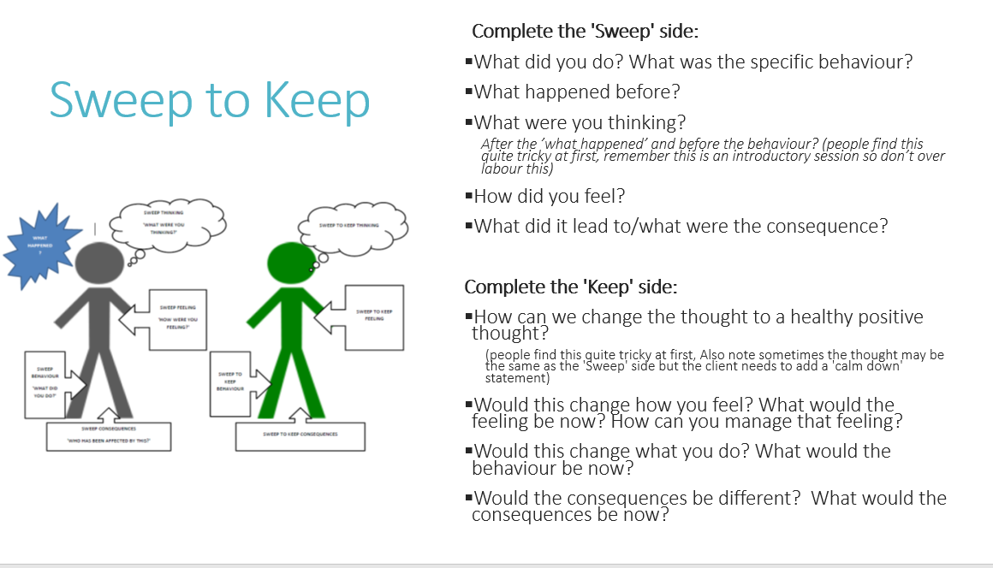

Colours - Transactional Analysis
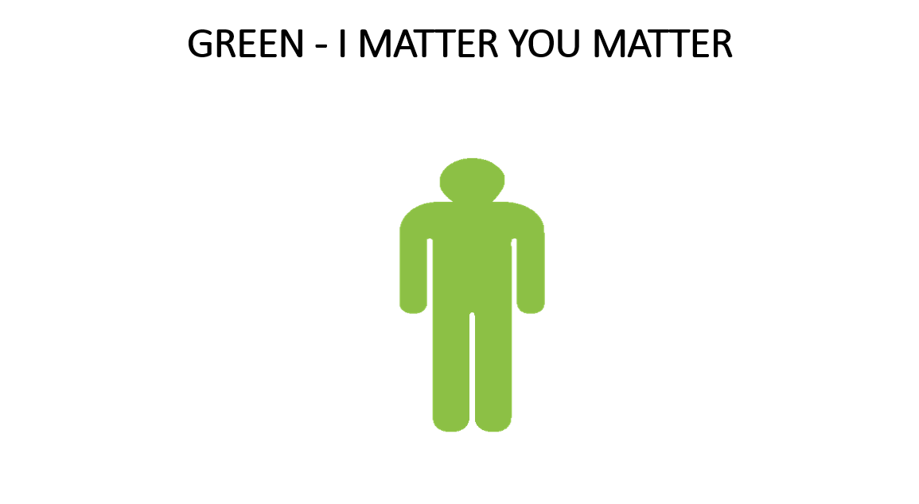 | 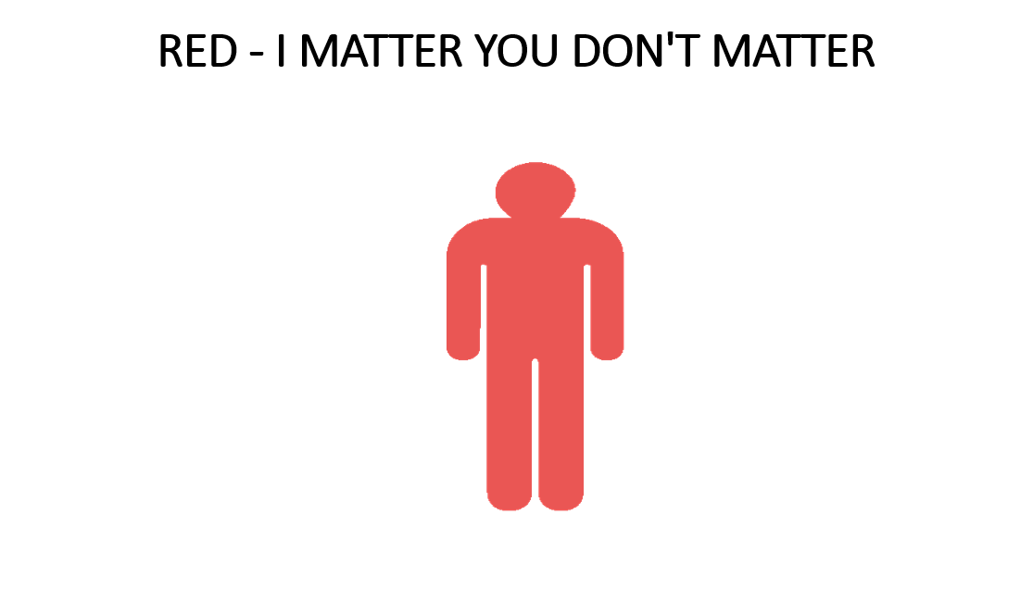
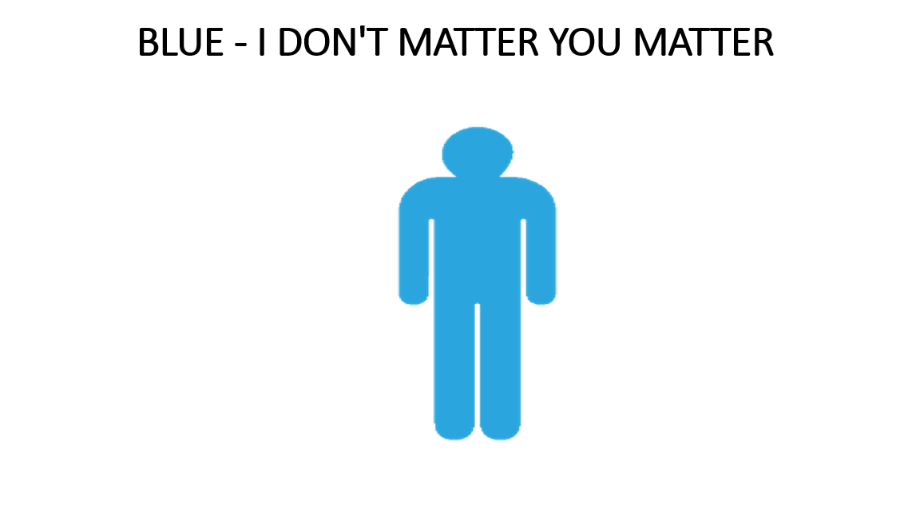 | 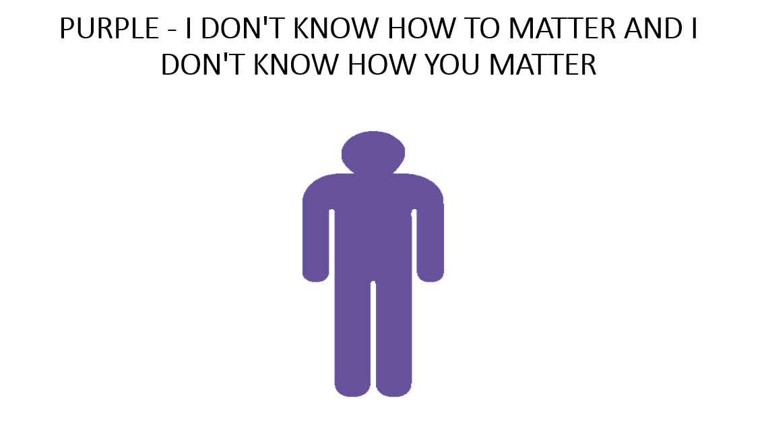

Sessions Overview

Module A3 Recognising and managing thoughts and feelings

 | What is this session about? | Who is it for:
A3.1 Managing overwhelming feelings and thoughts | A3.1 focus' on what happens to your body when you have overwhelming feelings such as anger, stress and anxiety. It helps clients to form links between their body cues and emotions. It gives the client skills of how to stop/ interrupt thoughts. Before the emotions run away with them. This session is useful to use with client's who are needing immediate techniques to lower adrenaline and fight + flight mode. | Parents/carers/young people who struggle to recognise and manage their emotions
A3.2 Introduction to Self-Talk | A3.2 introduces the key concept of Sweep to Keep using cognitive behavioural therapy. It looks at how we think, can influence how we feel, which influences how we behave. It explores what is/isn't in our control, and healthy and unhealthy thinking. (' I'm no good at this', 'they're never going to change') | Parents/carers/young people who use unhealthy self-talk and/or are not aware of their self-talk and how it leads to feelings and behaviours
A3.3 Recognising your emotions | A3.3 focus' on emotions in more detail. It explores what this feels like in the body and if it is a comfortable or uncomfortable feeling. It helps clients to learn how to replace unhealthy self-talk narrative for healthy with the use of sweep to keep. | Parents/carers/young people who struggle to recognise and manage their emotions - builds on A3.1
A3.4 Thinking Positively | A3.4 uses a scenario to help reiterate the concept of how spiralling unhealthy thoughts can lead to unhealthy behaviours. It really helps to cement the concept, additionally the client can then use their own examples to explore spiralling thoughts. | Parents/carers/young people who use unhealthy self-talk and/or are not aware of their self-talk and how it leads to feelings and behaviours - builds on A3.2
A3.5 Anger and Aggression | A3.5 explores the roles anger and aggression play in the relationship and the difference between the two. It looks at what anger feels like in the body and what anger looks like for the client, by exploring what behaviours are being used. This session also has RACE tool that helps clients plan for how they will manage and cope in high-risk situations for aggressions. | Parents/carers/young people who experience strong feelings of anger which lead to unhealthy behaviours
A3.6 Managing Stressful Situations | A3.6 focus' on how stress affects clients physically and mentally and explores what the causes may be. Helps them to process it and looks at its patterns. Then it explores healthy coping strategies. It also assists in identifying high risk situations and how to manage, avoid and cope. The session is useful for client's who are struggling to notice patterns in their unhealthy behaviours linked to their stress levels and how they manage stress. | Parents/carers/young people who struggle to cope in stressful situations
A3.7 Guilt | A3.7 explores how guilt can lead to unhealthy behaviours. The client learns new skills for taking responsibility for their behaviours that lead to guilt and also the behaviours that are consequences of feeling guilty. The session does this through the use of a scenario. The session is useful to use with clients who are struggling to take responsibility for their behaviours or turn to anger to disguise their guilt. If this is the case it is also useful to do the anger and aggression session. | Parents/carers/young people who struggle to accept and process feelings of guilt, which then leads then to further unhealthy behaviours
A3.8 Shame | A3.8 helps clients to process the difference between guilt and shame and learning how to identify thoughts and feelings linked to shame that can lead to unhealthy behaviours. When exploring shame, it looks at how client's feel about themselves and how this can be linked to behaviours. The client then learns skills how to manage and challenge the negative thoughts. | Parents/carers/young people who experience shame but do not recognise how this can lead to unmanaged emotions and cycles of unhealthy behaviour
A3.9 Recognising how other people feel | A3.9 helps clients to understand their own emotions and other people's emotions. It explores facial expressions and body language. It is useful for clients who are not expressing themselves safely or reading other people's emotions effectively. | Parents/carers/young people who find it difficult to read and understand how other people may feel
A3.10 Justifications | A3.10 helps clients to understand and identify types of thinking that can justify behaviours. It challenges unhealthy self-talk and unhealthy behaviours by exploring examples of justifications. (Deny responsibility, shifting the blame, 'I'm not so bad, look at them' 'they wind me up') This is done through the use of scenarios. This session is useful for client's who are not taking responsibility for their actions or often justify their behaviours | Parents/carers/young people who justify their own or other people's behaviour
A3.11 Paranoid Thinking | A3.11 uses scenarios to process examples of paranoid thinking. Paranoid thinking- unjustified suspicion and mistrust of other people. Client's are supported to unpick their own examples of paranoid thinking and convert to a healthy thoughts and behaviours. | Parents/carers/young people who have paranoid thinking (not from a mental health condition)
A3.12 Managing Frustration | A3.12 helps clients to recognise their own thoughts, feelings and behaviours in frustrating situations. By exploring what causes them frustration and previous patterns, they learn new techniques to manage their frustration behaviour in a healthy way. | Parents/carers/young people who struggle to manage their frustration. This can be used as well as session A3.5
A3.13 Low Mood | A3.13 looks at the difference between Low mood and depression. It focus' on how thoughts linked to low mood can spiral to unhealthy behaviours. It looks at how self talk plays a strong part in this and supports strategies for healthy alternatives. | Parents/carers/young people who experience low mood, but not for clinical depression
A3.14 Managing Anxiety | A3.14 looks at what anxiety is and how it feels for the client. It explores the fight and flight mode and what is causing anxiety. With the sweep to keep tool the client is able to pick apart the behaviours they have been using following this feeling and learning new coping strategies and behaviours that may be a healthier alternative. | Parents/carers/young people who struggle to manage their anxiety
A3.15 Maintaining the Change | A3.15 consolidates all the skills learnt from the previous sessions. Focusing on thoughts can influence our feelings, that influence our behaviours. It does this using a scenario with 'a day in a life'. The client is then encouraged to draw a parallel and explore from their own experiences. | Parents/carers/young people who have repeating cycles of unhealthy behaviour that build

A4 Making my Relationships Healthy
 | What is this session about? | Who is it for:
A4.1 Colours - do I matter? | A4.1 introduces the key concept of the colours. It helps clients to identify patterns of behaviours and attitudes that they use that are healthy and unhealthy using the colours as a tool. | Parents/carers/young people who have unhealthy relationships with other people
A4.2 Colours - do you matter? | A4.2 looks at using colours as an attachment style how they interact with one and other. It helps the client to identify their own predominant colour within a relationship. This session really helps with the realisation of the benefits of being 'green' healthy within a relationship. (Do session A4.1 before it) | Parents/carers/young people who need a more in-depth understanding of the colours and the interactions between people
A4.3 Health - v - Unhealthy Relationships | A4.3 encourages clients identify healthy and unhealthy behaviours within a relationship. It builds on existing healthy behaviours and supports the growth of new healthy patterns. | Parents/carers/young people who struggle to understand unhealthy and healthy relationship behaviours
A4.4 How my behaviours affect my children | A4.4 helps clients to understand how their healthy and unhealthy behaviours within their relationships can affect their children. It also explores what their children may think feel and act. This helps the client to understand how it can affect their relationship with their child. In the session they then use sweep to keep finding health alternatives for unhealthy behaviours. | Parents/carer who have unhealthy relationships with their partner, family, friends, or professionals that impacts on their children
A4.5 What Colour am I with my children? | A4.5 focus' on what colour parent the client is. By looking at healthy and unhealthy behaviours and ways to change the thinking, feeling and behaviour to support healthy parenting. It breaks down daily tasks with children for example bedtime routine and looks at different colour responses. This helps the client to understand what colour they may be. Sweep to keep is then used to sweep unhealthy behaviours and go green. | Parents/carers who use unhealthy parenting behaviours
A4.6 Being a Green parent | A4.6 focus' on how they respond to their children's behaviour and what colour response it is. This session is useful for clients who are quite reactive with their children. (Do complete session A4.1 around colours first) | Parents/carers who use unhealthy parenting behaviours
A4.7 Responding to how my child feels | A4.7 looks at how the client responds to their child's emotions and helps them to learn new ways of reacting that are healthy. This session is useful if the client is not seeing the child's emotions or reacting to their emotions. 'What are you crying for? Stop crying' | Parents/carers who struggle to recognise and respond in a healthy way to their child's emotions
A4.8 Relationships with my Family | A4.8 looks at how the client interacts with other family members and the colours/ behaviours they use and what is needed to go green. | Parents/carers/young people who have difficult relationships with other family members
A4.9 Relationships with my Friends | A4.9 looks at the impact of wider relationships that may encourage unhealthy behaviours. It helps clients to identify ways to improve relationships and gain confidence in challenging them. | Parents/carers/young people who either have difficult relationships with friends and/or are influenced by friends
A4.10 Relationships with Professionals | A4.10 focus' on identifying relationships with professionals and creating steps to improve unhealthy behaviours. It does this by explores their roles and what they are trying to do and looking how the client thinks, feels and responds to them. | Parents/carers/young people who have difficult relationships with professionals

For further support:
- Practitioners/supervisions can attend the weekly Up2U Drop-Ins - every Thursday 9.30 - 11.30:
Microsoft Teams meeting
Join on your computer or mobile app
Click here to join the meeting
- Contact Kim.Smith@portsmouthcc.gov.uk for details of monthly 'Masterclasses' - these focus on key concepts around Up2U: Family Practice
- Contact Amy.Ford2@portsmouthcc.gov.uk, John.Bolderson@portsmouthcc.gov.uk or Leigh.Tyler@portsmouthcc.gov.uk for advice around sessions and using Up2U: Family Practice with cases

