NORTH
SOMERSET
Safeguarding Children Partnership
Safeguarding Children
Newsletter

Summer Edition

72962

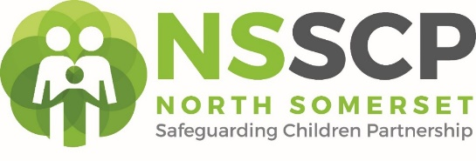

First Summer Edition
CH June 2023

MAR
2022
SAFEGUARDING UPDATE FOR ALL PARTNERS

Welcome to this first summer edition of our Safeguarding Children Newsletter. Please share widely within your organisation.
This newsletter will now be available on the North Somerset Safeguarding Children Website. Please see also see the link below:

Interim Business Manager

Dear Colleagues: Hello everyone! I would like to introduce myself:

SPOTLIGHT BULLETIN PLEASE NOTE!

1. NSSCP BUSINESS PLAN 2023 – 2026
2. CHILD EXPLOITATION STRATEGY 2023-2026
3. ISSUE RESOLUTION Policy (previously known as the Escalation Policy found on resources link)
4. SERIOUS CASE REVIEW KATRINA
5. EFFECTIVE SUPPORT GUIDANCE

All are AVAILABLE ON NSSCP WEBSITE LINKS ARE HERE:

https://nsscp.co.uk/resources-library

My name is Maggie Lilburn. I have recently been appointed as your Interim Safeguarding Children Business Manager for NSSCP Partnership. My background is working as a Designated Nurse Safeguarding Children for a large Safeguarding Partnership and Acute Hospital Trust in the NE of England. I look forward to sharing my experience and knowledge with you all and to assist you in helping to build a safer and stronger partnership in North Somerset. If you have current safeguarding children information to share in future Newsletters or require any further information, please don’t hesitate to contact me on the e-mail address below.
Maggie Lilburn – Interim safeguarding children business manager maggie.lilburn@n-somerset.gov.uk

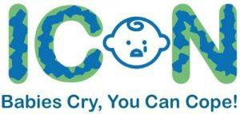

Click the picture to Watch Ellis’s Story

What do you know about ICON?
ICON is a vital tool for all professionals who work with families. When you work with a family with a newborn baby please talk to them about coping with infant crying. You don’t need to be specially qualified or a health professional to share the ICON information. Everyone can and should do this.
On 19th April an amazing conference was held for practitioners in South Glos, Bristol and North Somerset. It explored ICON and included a presentation from Ellis’s mum – you can watch Ellis’s story in the clip above – click on the picture to watch. It is an emotional
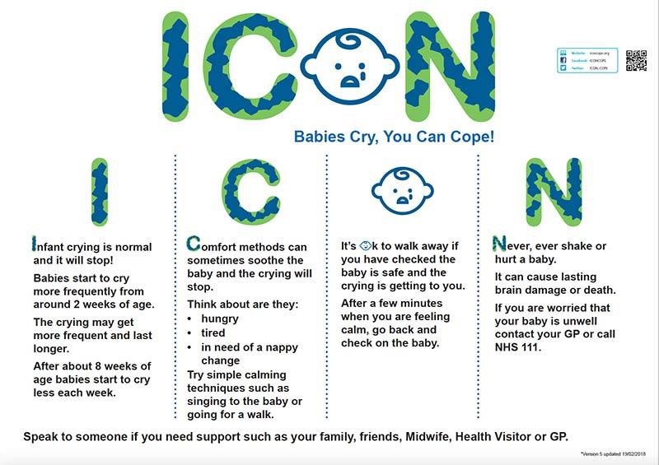
story and you may find it distressing but it is a powerful reminder of why we need to share this messaging.
Although over 200 people attended the conference, lots of North Somerset professionals will have missed this opportunity.

Abusive Head Trauma has featured in several local and
national Serious Case Reviews.
The themes from these reviews (SCR Toby, SCR Baby E&F) and The National Panel review (The Myth of Invisible Men) were
explored in the conference. The NSPCC have
also produced a briefing ‘Learning from Case
Reviews’ about Children under Two. Read it here

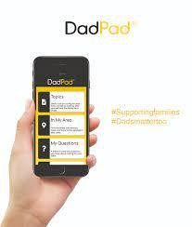
Have you heard of DadPad?
The conference also included a presentation from Julian Bose, the founder of DadPad have resources that are perfect to share with men when there is a new baby expected in a family. More information is available on the DadPad website here.
There is a DadPad App available to download onto phones that is free to use and when a postcode is added it populates with all the local information for the area.

NB For those who were unable to access the conferences now is your chance! Please click on the link below and
Search for ICON Training

Welcome to the Keeping Bristol Safe Partnership website. (bristolsafeguarding.org)

Last Minute Spaces…

Multi-Agency Workforce Development CPD

Please note there are places available on the following event(s):

• Domestic Abuse Advanced – 7 June 2023 – 09:30 – 16:30
• Advanced Inter Agency Child Protection (full 1 day course) – 9 June 2023 – 09:30 – 16:30
• Inter Agency Child Protection – Introduction – 21 June 2023 – 09:30 – 15:00
• Bereavement Workshop – 23 June 2023 – 09:30 – 12:30
• Domestic Abuse Basic Awareness – 28 June 2023 – 09:30 - 12:30
• Safer Recruitment for Schools and Early Years Colleagues Only – 29 June 2023 – 09:30 – 16:30
• Advanced Inter Agency Child Protection (full 1 day course) – 4 July 2023 – 09:30 – 16:30
• Advanced Inter Agency Child Protection UPDATE – 12 July 2023 – 09:30 – 13:00 –
• Advanced Inter Agency Child Protection (full 1 day course) – 18 July 2023 – 09:00 – 16:30
• Advanced Inter Agency Child Protection UPDATE – 12 September 2023 – 09:30 – 13:00
• WRAP Training a Workshop to raise awareness of Extremism and Radicalisation (Prevent Agenda) – 18 September 2023 – 09:30 – 11:00
• Young People and Substance Misuse Intermediate Level Training – 22 September 2023 – 09:30 – 12:30
• Child Sexual Exploitation (CSE) (Awareness Raising) – 27 September 2023 – 09:30 – 12:30
• Advanced Inter Agency Child Protection (full 1 day course) – 29 September 2023 – 09:30 – 16:30

Please book your place(s) on https://www.n-somersetcpd.org.uk

----------------------------------------------------------------------------------------------------------------------------------------------------------------
WHY LANGUAGE MATTERS – THE TOXIC TRIO
The term ‘toxic trio’ is used by professionals to refer to the co-occurrence of parental domestic abuse, parental substance misuse and parental mental illness in a child’s life. To some, the presence of this ‘trio’ signals that a child may be experiencing abuse or neglect.

Although the term was originally used to describe three factors commonly present in case reviews, the grouping
together of these specific factors means that ‘toxic trio’ consequently leads to being misunderstood as:

- if any of these factors are present, a child will experience abuse
- if none of them are present, a child is safe.

The article linked below explains that the term is unhelpful and inaccurate and includes: the definition and background to the term and its uses; what the issues are with ‘toxic trio’ as a term; the impact its use might have

on safeguarding children and families; and how professionals can reframe their thinking around using the term.

Key points to take away
- The concept of the ‘toxic trio’ of parental domestic abuse, substance misuse and mental illness meaning a child will experience abuse is not robustly evidenced by research.
- It is negative, stigmatising and fails to account for full range of adversities and barriers families can face.
- The factors within the ‘trio’ cover a broad spectrum of concerns that can impact families in different ways. Practitioners should be supported to evaluate the bigger picture and respond to the specific individual needs of families and children.
Click here Read the article

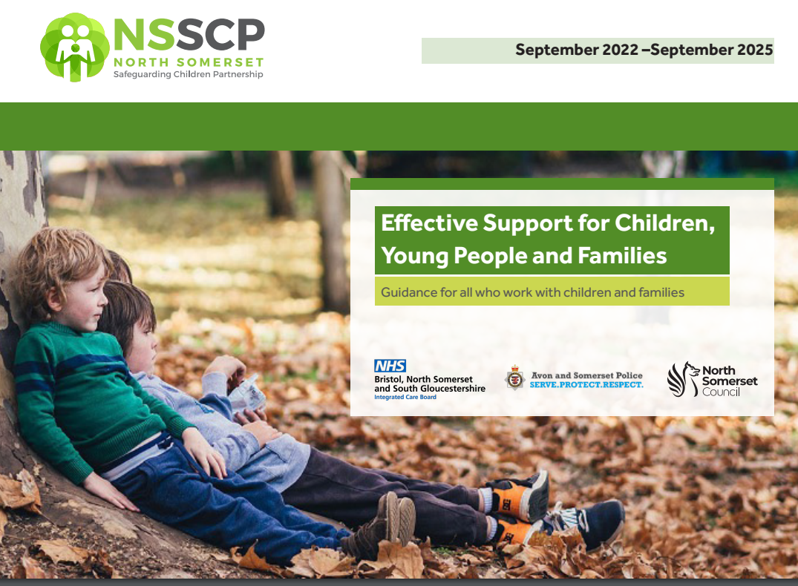

This guidance has been developed by the North Somerset Safeguarding Children’s Partnership in response to Working Together to Safeguard Children July 2018.

Children, young people, and their families will have different needs, which may change over time. This document introduces a continuum of need and gives examples of the factors that may indicate the need for additional support. This document now replaces the ‘Threshold Guidance’ and is designed to assist professional judgements in determining how to meet those needs.

North Somerset Safeguarding Children’s Partnership recognises that every approach to supporting children and young people should involve parents, carers, professionals, and the wishes of the child wherever possible.
A copy of the guidance can be obtained here https://nsscp.co.uk/resources-library

Effective Support – Training offer.
If you are a practitioner and would like to find out more about how to use the effective support document and learn more about the development of services to support families in North Somerset. You can book onto the following courses via North Somerset CP:

Effective Support Document Training (previously The Threshold Guidance) – Friday 30 June 2023 09:30 - 12:30
Effective Support Document Training (previously The Threshold Guidance) – Monday 3 July 2023 09:30 - 12:30

