Bracknell Forest Council

Youth Justice Team (YJT)

Resettlement Policy

Author (name) | Steve Bailey
Author (designation) | Head of Service, First Response
Approved by: | Children’s Services Leadership Team
Date Approved: | February 2023
Review Date | February 2026

Table of Contents

Page

- Introduction 3

- Purpose of the Document 3

- Legal Context and National Guidance 3

- Implementation, Responsibilities and Review 3

- The aims of resettlement for children 4

- Effective Planning 5

- Initial Planning Meeting 6

- Review Meetings 7

- Pre-release Meetings 7

- Maintaining Contact 8

- On Release 8

- Recording 9

- Overcoming Barriers 10

- Governance 11

Appendix 1 - 7 Pathways to Resettlement 12

1. Introduction

1.1 Resettlement of children from custody is a statutory responsibility of local authorities under the Crime and Disorder Act 1998 and is carried out in partnership with agencies including Police, National Probation Service, Health, Education and the Youth Custody Service.

2. Purpose of the Document

2.1 The purpose of this Policy is to provide direction and guidance to the effective resettlement of children and young people in Bracknell with reference to the underpinning principles of constructive and effective resettlement based on recent research and guidance.

2.2 The objective of this Policy is to:
- Set out the aims of resettlement for children
- Promote a constructive resettlement approach, following the ‘child first’ principles
- Ensure a consistent approach to implementing constructive resettlement across the team for all children leaving custody

3. Legal Context and National Guidance

3.1 This Policy should be read in conjunction with nationally required guidance, namely the Youth Justice Board Case Management Guidance, specifically “Custody and Resettlement: Section 7 Case Management Guidance” (updated June 2020) and the National Standards for Children in the Youth Justice System (2019), specifically Standard 4: In Secure Settings and Standard 5: On Transition and Resettlement.

Users of this policy will also find detailed research, information and examples of effective practice in the HMI Probation Effective Practice Guide ‘Resettlement Effective Practice Guide’ (2023)

This policy includes local practice guidance to assist in providing a high standard of resettlement practice for children and young people in Bracknell.

4. Implementation, Responsibilities and Review

4.1 This policy will be stored and be accessible to all Childrens Social Care staff on the Council’s Tri.X page

4.2 Managers should ensure that staff are aware of this policy and where it is available.

4.3 All staff are responsible for complying with this policy.

4.4 Managers are responsible for monitoring compliance with this policy.

4.5 The policy will be reviewed every three years by the relevant YJT management team, or sooner if required

5. The aims of resettlement for children

5.1 Resettlement is support which a child receives to return to the community following a custodial sentence. The purpose of resettlement is to help the child shape a more pro-social identity, and to build on their individual strengths, attributes, abilities, talents and resources to help them remain safe and life a crime-free life. This aims to reduce the likelihood of further offending.

5.2 Effective resettlement takes a strengths-based approach and acknowledges that a child may need a variety of support and interventions to help keep them and other people safe, and to enable them to successfully return to and integrate in their communities.

5.3. This policy relates to the resettlement of children from custody. This is a statutory responsibility of the Local Authority, in partnership with the Police, National Probation Service, Health and HMPPS Youth Custody Services.
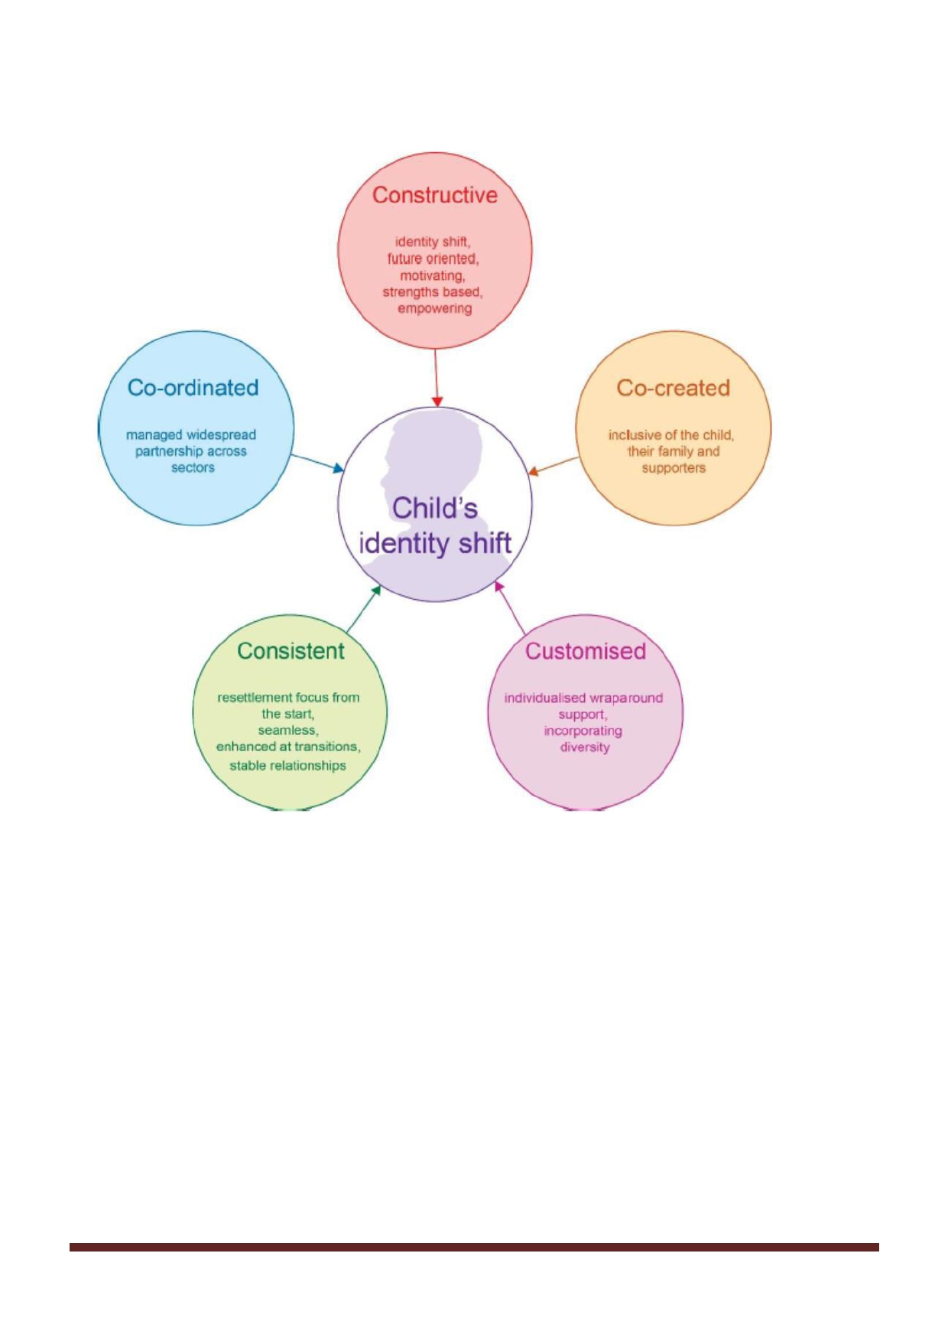
5.4 Resettlement should be seen as a journey for the child, rather than a single transition event and the resettlement approach should follow the five core principles below:

Constructive - focused on the future, positive and useful, with an emphasis on strengths within the family and of the child. In addition, the resettlement of children and young people in Bracknell will be mindful of the need to work in a trauma informed way, taking into account the Adverse Childhood Experiences that a child may have experienced and the impact of these ACE's upon behaviour and needs.

Co-created - assessment and effective planning produced in collaboration with child, family and social and professional network. The voice of the child and parents should be
evidenced throughout the whole journey with the child - in each stage of assessment,
planning, intervention delivery and reviewing.

Customised - individual plans and interventions that are tailored to meet the needs of
the individual child, designed to be delivered in the way that suits their needs and at a
level that best supports them to make a positive identify shift.

Consistent - planning for Resettlement will start at the first opportunity when a young
person enters custody and continues throughout the journey. The resettlement work
should be a fluid process which provides a seamless transition through custody, into the
community and throughout the life transitions that the child will experience. The structure of the team will allow for consistency of worker from assessment throughout
sentence.

Co-ordinated - working in partnership across agencies and with the child and their
family to dovetail with any additional agency plans and interventions for the child. The
YJT will work alongside partners to ensure that resettlement work complements and is
complemented by the work of other agencies. This will be particularly important when
looking at the 7 Pathways in planning for resettlement.

6. Effective Planning

6.1 If a child is at risk of entering custody, then:

- The YJT will complete the Assetplus PSR, Bail Recommendation, or Placement Notification Stage including Custody Module and send to the YJB. This should be done no later than the day before sentence.

- The YJT will refer to the YJT Health Practitioner to complete or update a health assessment for all young people at risk of a custodial sentence, where possible prior to sentencing. This information will be included in the placement notification paperwork.

6.2 Once a Young Person is sent to custody:

Actions to be taken by the YJT officer:

- Young person to be seen in Court cells and assessed for safeguarding/risk
concerns.

- Complete Post Court Section of Assetplus ensuring any concerns from Post Court interview are recorded clearly.

- Notify YJT Placement Team and send Assetplus - also verbally advise if there are concerns.
- Ensure Parents are aware of sentence and placement details.

- Notify other relevant agencies e.g. Social Care if young person is a Child Looked
After (CLA).

- Notify YJT Education worker who will begin their process.

6.3 Youth Justice Application Framework (YJAF):

- Once Young Person arrives in Secure Establishment (SE) the Assetplus should be reviewed and updated by SE and YJT Case holder should follow the YJAF guidance for the process throughout Young Person's time in SE.

- It is important to use YJAF to access information from the SE including case notes and any assessments completed and these should be recorded into Childview records.

- Where there are issues with SE not using YJAF these should be addressed initially by a discussion with SE caseworker and if this is not effective then should be discussed with manager who can escalate.

7. Initial Planning Meeting

7.1 An Initial Planning Meeting will be held within 10 working days at the SE - this should be face to face meeting and the YJT Caseworker will invite parents/carers to the meeting and facilitate their journey by taking them with them or funding transport in agreement with a manager.

7.2 Relevant external agencies and internal Bracknell YJT specialists will be invited to the meeting.

7.3 The purpose of this meeting is to agree a sentence plan to reduce the risks of reoffending, build on strengths, set realistic targets for desistence and start planning for resettlement. The meeting should therefore consider each of the seven pathways for successful resettlement (see appendix 1).

7.4 The meeting will be chaired by the Youth Justice Operational Manager, with the YJT case worker in attendance.

7.5 Facilitating the participation of the child, so that their voice is heard and reflected in the meeting and the plan, should take account of the child’s individual needs including, but not limited to, their gender, ethnicity, speech language & communication needs, disability, sexual orientation and health needs.

7.6 The YJT and the secure accommodation staff must consider any existing Education, Health and Care Plan (EHCP) when devising the sentence plan. The case manager and secure estate staff must consider the child’s legal right to an assessment of SEND needs throughout the sentence planning process and, if there are felt to be undiagnosed SEND needs, a formal assessment can be requested by the YJT from the Local Authority.

7.7 The criteria for Release on Temporary License (ROTL) should also be discussed at the initial planning meeting, as this can assist in resettlement planning – for example ETE interviews, accommodation visits etc.

7.8 Any potential barriers to resettlement should be identified at this initial meeting with proposed actions to overcome them. For example, any perceived difficulty in meeting accommodation needs must be discussed from the very start of the custodial phase, to tackle the issues at the earliest opportunity and to escalate concerns as necessary.

7.9 Sentence Planning dates (future meetings) should be agreed at this meeting and
recorded in Childview as forward meetings.

7.10 Details of the meeting should be recorded in Childview and an Assetplus review should take place as per YJAF guidance. The Bracknell Youth Justice Case Worker is responsible for ensuring that the Pathways and Planning document meets the requirements of this policy.

8. Review Meetings

8.1 Review meetings are to take place at a minimum of three-monthly intervals. These are to be face to face as above.

8.2 Where sentence is less than 6 months; review meetings to take place in line with
SE guidance.

8.3 The Assetplus Review is to be completed as per YJAF guidance. Bracknell YJT Case Manager is responsible for ensuring that the Resettlement Plan section meets the requirements of this Policy.

8.4 Where a young person is assessed as high risk of re-offending, causing serious harm to others or there are high safety and well-being concerns, planning must include consideration of other processes to manage these risks (e.g. MAPPA, Risk-Focus Meeting, Enhanced Case Management, Solutions Panel, escalation to the management of the SE and escalation via the Management Board etc).

9. Pre- Release Meetings:

9.1 The penultimate review meeting must be no later than one month prior to date of release. This should trigger the opening of the Assetplus Release from Custody stage which should be completed prior to Final Release Meeting. This meeting will finalise arrangements for the Community element of Resettlement (notice of supervision/licence) ensuring that Resettlement Plans are focused on the Resettlement Pathways, promote Desistance, and support the Young Person in a positive identity shift using a model of Child First, Offender Second.

9.2 The Final Release Meeting should take place no less than 10 working days
before release date. This meeting will agree transport arrangements for release,
YJT contact on release and a reminder of final licence conditions.

9.3 The Assetplus Review is to be completed as per YJAF guidance. The Bracknell YJT Case Manager is responsible for ensuring that the Resettlement Plan meets the requirements of this policy.

10. Maintaining Contact:

10.1 YJT Case Manager will visit Young Person at least monthly and in addition to the initial planning, review and pre-release meetings. This contact should usually be face-to-face but there may be some circumstances where this can be via tele-conferencing or other forms of technology. The YJ Case Manager and the Operational Manager should be able to assure themselves of the child’s welfare and safety whilst in custody, as well as the progress of their sentence plan, regardless of the means of communication taking place.

10.2 In addition, YJT specialists and other workers involved in a young person’s resettlement will be encouraged to visit the young person separately from the visit by their Case Manager. This is to increase level of contact by community professionals during time in the SE to support successful resettlement. These sessions will be structured sessions focusing on the Resettlement Planning and delivering interventions or undertaking activity to support the plan. The YJ specialist workers will be engaged on a case-by-case basis but could include speech and language, health, mental health, restorative justice and ETE.

10.3 Contact with parents / carers by the YJT Case Manager or Parenting Worker will take place monthly for the duration of the child’s time in the SE and must be in addition to the Planning, Review and Pre-Release Meetings. The focus of these visits will be to engage parents/carers in the Resettlement Pathways planning for Constructive Resettlement which may include an offer of parenting programme delivered by Support Worker in YJT. Contact with parents / carers should take a holistic ‘think family’ approach and consider referrals to other services such as Adult Services, Early Help and consider the needs of any siblings or other children in the home.

11. On release

11.1 The arrangements for transporting the young person from the SE must be agreed at the pre-release planning meeting. The YJ case Manager can transport the child back home / to their accommodation from the SE, however if the young person is subject to an Intensive Supervision and Surveillance (ISS) Licence they must attend Time Square in order to be given the timetable first.

11.2 If the young person is not being collected from SE by the YJT, then the young person must be seen at the YJT on the day of release and the appointment will be set at the Pre-Release Meeting.

11.3 Contact for all young people released from custody will be a minimum of twice per week regardless of length or risk levels. This is to provide support around the
Resettlement Plan.

11.4 The Case Manager and Parenting Worker will carry out a Home Visit within 5 working days of release, speak to Parents/Carer twice per week and have ongoing face to face contact at least once every two weeks.
11.5 If a Young Person has become 18 years old whilst in custody before the mid-point of their sentence, they will be subject to an extended period of supervision which will be in place for 12 months from the mid-point of sentence. This extended period is a rehabilitative support measure not punitive and any decision to breach should be balanced with overall progress and be in the best interest of Young Person and public.

11.6 A planning meeting should then take place within 5 working days of
release. This must include young person, parent or carer, YT workers and any
other relevant professional where possible.

11.7 A review of progress should take place within 1 month of release and no less than three months thereafter. The reviews should focus on progress against the Resettlement Pathways and Planning stages in AssetPlus which should be reviewed fully to be responsive to progress made, changes in circumstances and the needs of the young person and parents & carers
.
12. Recording

12.1 Ensure all meetings are recorded in Childview

12.2 Record meetings as planning meeting or review meeting not as a prison visit.
Prison visits should be recorded as such.

12.3 Record evidence of all contact with young people, parents/carers and other
relevant contacts in Childview.

12.4 Ensure all information from SE is recorded in Childview, and also upload assessments, reports, minutes from meetings or other documents into Sharepoint saved with title and date.

12.5 Copies of sentence plans and reviews should be attached in Childview

12.6 If there are issues accessing these plans, this should be discussed with a manager.

12.7 When recording meetings or contacts please ensure you record who was present
including, YP and parent/carer.

12.8 When recording contacts/meetings please include strengths and positives however small.

12.9 A review of Assetplus and the Planning document must take place at each
transition. This includes entering or leaving custody, move to another SE, change
from Remand to Sentence or Bail, Case Closure.

12.10 Remand cases – The Planning document should consider any
possible bail application and outline any community planning to manage risk and
safeguarding as a contingency until P&P reviewed within Assetplus review on
transition.

12.11 Bail cases - Planning needs to include plan for community and also custody, including planning for management of risk and safeguarding If this is Bail Recommendation Assetplus and outcome is remand, a strong plan at this stage will allow worker to use that plan for first month of custody. Assetplus review should then be done at 1-month stage to incorporate Initial Planning Meeting information
.
12.12 Ensure Plans reflects the Resettlement Pathways and are strengths based, supports identity shift, recognises diversity needs and manages risks to young person and community. Try to build some enjoyable experiences in the plan for young person where possible based on their views.

12.13 Ensure actions from Multi-Agency Risk Focus Meetings are evidenced in
case recording and planning

12.14 Transition planning should be done prior to any transition/move - for example pre- release for transition from custody to community to ensure plans are in place
before release.

12.15 Transition planning should show how the Resettlement Pathways will continue
through the journey from custody to community or vice versa.

13. Overcoming Barriers

13.1 The following list highlights the processes in place to support successful resettlement:

- Accommodation: Bracknell Forest Joint Homelessness Protocol / Young People in Need of Accommodation (for 16-18 year olds). BFC Housing & Children’s Social Care Joint Protocol, available on tri-x.

- Education, training and employment: Bracknell Youth Justice Education Focus Meeting

- Health: YJT Health Practitioners and Health & Justice Team

- Trauma, emotional wellbeing and SLCN: YJT Specialist Workers and Health & Justice Team

- Substance Misuse: Bracknell Forest Drug and Alcohol Team, “New Hope”

- Families: Youth Justice Parenting Worker & BFC Early Help Services

- Transitions: identify those who will transition to adult provision – follow the national case transfer protocol to Probation and utilise the BFC Approaching Adulthood policy available on Tri-x.

13.2 Where there are perceived barriers to successful resettlement not resolvable through using the above channels and resources then then the YJT will make a referral to the Children’s Social Care Solutions Forum, a weekly panel chaired by the Head of Services for Life Chance or the Assistant Director of CSC. At this meeting, the Head of Youth Justice will also decide whether to escalate a concern or challenge to the YJ Management Board and the Chair.

14 Governance

14.1 The Head of Youth Justice will provide reports to the YJT Management Board representatives including outcome measures for young people, subject to custodial sentences and resettlement. This will provide an opportunity for a multi-agency response to changing need which will ensure a collaborative approach across services to learn from any custodial sentence received by a child to develop future services to prevent children from entering Custody.

Appendix 1 : 7 Pathways to resettlement

