London Borough of Waltham Forest

People’s Directorate

National Data Opt-Out –
Internal Business Process

Distribution List:

Limited Stakeholders

Key Dates:

Current Version: 19th May 2023

Release Type/Version:
Release 0 Draft 1 – For Stakeholder Review
Release 1.0 – 5th May 2021
Release 2.0 – 19th May 2023 – Review of process.

Introduction

This paper considers the internal activities required to fulfil the London Borough of Waltham Forests’ obligation to meet the requirements of the National Data Opt-Out Programme.

The National Data Opt-Out enables individuals to choose whether or not they consent to their confidential information being shared for secondary care purposes. The information can be used for research and planning purposes by private, voluntary sector and independent organisations and adult social care.

National data opt-outs apply to a disclosure when an organisation, for example a research body, confirms they have approval from the Confidentiality Advisory Group (CAG) for the disclosure of confidential patient information held by another organisation responsible for the data (the data controller) such as a Local Authority.

The CAG approval is also known as a section 251 approval and refers to section 251 of the National Health Service Act 2006 and its current Regulations, the Health Service (Control of Patient Information) Regulations 2002. The NHS Act 2006 and the Regulations enable the common law duty of confidentiality to be temporarily limited so that confidential patient information can be disclosed without the data controller being in breach of the common law duty of confidentiality.

In practice, this means that the organisation responsible for the information (the data controller) can, if they wish, disclose the information to the data applicant, for example a research body, without being in breach of the common law duty of confidentiality.

LBWF members of staff who will be responsible for carrying out the request to check for data opt outs met with the delivery project in March 2021 and agreed the internal business processes required to comply with the programme.

High Level Process

The starting point of LBWF compliance with the National Data Opt-Out occurs when a request is made by an organisation outside LBWF for client data to fulfil a particular research or planning purpose.

There are a variety of ways in which organisations may initially request this data however all requests should be passed to the Caldicott Guardian to review suitability of request.

Following Caldicott Guardian approval the Business Inteligence team will review reporting requirements and extract a relevant cohort of NHS numbers from the Mosaic Case Management system.

These NHS numbers are then uploaded to the NHS Personal Demographics Service via a secure messaging service and a file received back to highlight those clients who have opted-out.

The Business Intelligence team will use the verified file, add any additional requested information and respond to the original requester cc’ing the Caldicott Guardian.

Business Process Flow Diagram

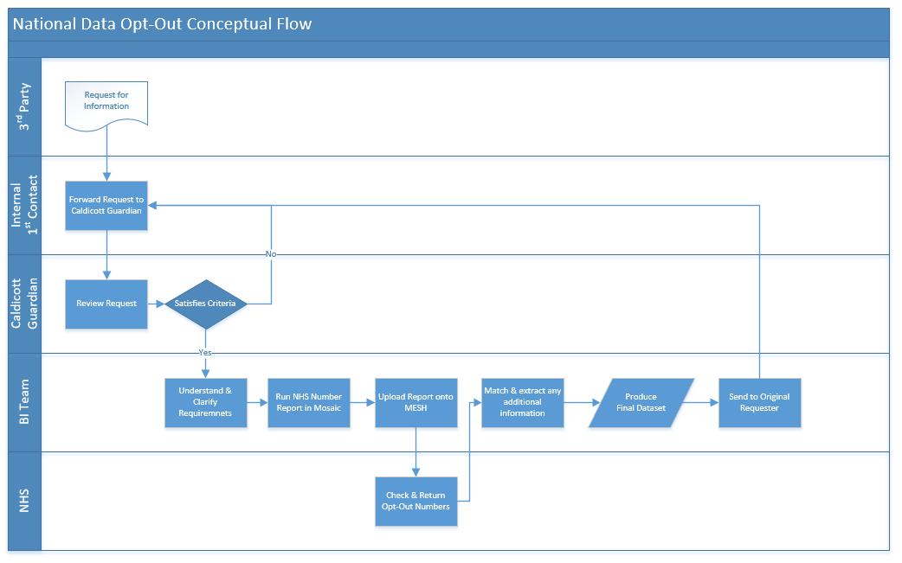

Key Stakeholders

Role | Description / Action | Named Individual | Contact
Adult Social Care Clients | Persons who have the right to opt-out.  The LBWF website will be updated to advise service users of their rights and point them to the NHS website if they wish to opt-out. | Various | N/A
Adult Social Care Staff (General) | Staff may be in receipt of research requests and/or queries from service users.  Internal communication will be sent advising staff of the new process and a) where to send research requests b) where to point service users. | Various | N/A
Caldicott Guardian | Has overall responsibility for approving requests for research.  Approval is required for any request and Caldicott Guardian should be cc’d into any correspondence between BI Team and original requester. | Darren McAughtrie | darren.mcaughtrie@walthamforest.gov.uk
BI Team Lead | Has responsibility for confirming research request, checking opt outs through MESH and providing information to original requester. | George Harrison | george.harrison@walthamforest.gov.uk
Internal Technical Contact | Responsible for any technical issues with the MESH Mailbox. | Stuart Torres-Catmur | Stuart.Torres-Catmur@walthamforest.gov.uk
General Enquiries | Has background overview of project for general queries. | Linden Giles | Linden.Giles@walthamforest.gov.uk

Understanding the national data opt-out - NHS Digital

