**Placement with Parents– Guide to the assessment**

**What is placement with Parent?**

This guidance applies to any placement of a child (for more than 24 hours) on a Care Order or an Interim Care Order, with a parent or person with Parental Responsibility or a person who held a Child Arrangement Order immediately before the Care Order was made.

Hull CYPFS model of practice is Signs of Safety, the assessment on Liquid Logic is a ‘risk assessment’ and we acknowledged that a different approach is required when assessing PWP, because the placement takes in to account more information than would be required of a Signs of Safety approach to assessing the needs of Children and Young People.

**The assessment:**

When recording the assessment please record this on the C&F assessment, taking in to consideration the guidance notes below, in terms of where to record the evidence and information and the assessment template guide (Link below). The assessment should be assessed through:

* Obtaining relevant information about the proposed main carer or carers and all members of the household; **(assessment section : Who needs to be seen, when, where and how often)**
* Inspecting the accommodation; (Complete and attach the health and Safety check list :link below) (**This would then be referenced in what we are worried about / what is working well)**
* Checking the proposed carer and all members of the household aged 16 and over with:
  + The Police (Public Protection Unit);
  + The parents and adult members of the household by them applying for a basic DBS check if they live in England and Wales, or currently provided via Disclosure Scotland if they live in Scotland
* The carer's GP and Children's Services records. (**Record who needs to be seen, when and how often- to list the people you have spoken with and completed checks. This can then be referenced in harm, strengths, existing safety/complicating factors dependent on applicable information)**

**The assessment needs to take account of:**

* The parents' capacity, and the capacity of other adult members of the household, to care for children. Where a child has suffered, or was likely to suffer, significant harm the assessment should address 'what has changed in parental capacity and circumstances that indicate this placement will be in the child's best interest and will promote safe care?' In particular in relation to the child:
  + To provide for the child 's physical needs and appropriate medical and dental care;
  + To protect the child adequately from harm or danger, including any person who presents a risk of harm to the child;
  + To ensure that the home environment is safe for the child including, where relevant, the need for a risk assessment of any pets and the environment in which they are kept;
  + To ensure that the child's emotional needs are met and he/she is provided with a positive sense of self, including any particular needs arising from religious persuasion, racial origin, and cultural and linguistic background, and any disability the child has;
  + To promote the child's learning and intellectual development through encouragement, cognitive stimulation and the promotion of educational success and social opportunities;
  + To enable the child to regulate his/her emotions and behaviour, including by modelling appropriate behaviour and interactions with others;
  + To provide a stable family environment to enable the child to develop and maintain secure attachments to the parents and other persons who provide care for the child.
* The parents' state of health (physical, emotional and mental), the parents' medical history, including current or past issues of domestic violence, substance misuse or mental health problems;
* The state of health (physical, emotional and mental) of other adult members of the household and their medical history, including current or past issues of domestic violence, substance misuse or mental health problems;
* The parents' family relationships and the composition of the parents' household, including:
  + The identity of all other members of the household, their age and the nature of their relationship with parents and one another, including any sexual relationship; their relationship with any parent of the child;
  + Other adults who are not members of the household but are likely to have regular contact with the child;
  + Current/previous domestic violence between household members including the parents.
* The parents' family history, including:
  + The particulars of the parents' childhood and upbringing, including the strengths and difficulties of their parents/carers;
  + The parents' relationship with their parents and siblings, and their relationships with each other;
  + The parents' educational achievement, including any specific learning difficulty/disability;
  + A chronology of significant life events;
  + Other relatives and their relationships with the child and parents.
* Criminal offences of which the parents or other members of the household have been convicted or cautioned;
* Parents' past and present employment/sources of income;
* The nature of the neighbourhood and resources available in the community to support the child and parents;
* Any available information about the parents' previous experiences of looking after children. Where a parent has other children subject to care/adoption orders, earlier case records should be explored to ascertain the circumstances which led to social work involvement and any indication that the capacity of the parent to bring up children has changed.

**(This would all be recorded under the section of what is working well and what we are worried about)**

**Why is a child or young person placed with parents- Our Principles?**

The principles that should inform the decision to place a child or young person on a care order with their parents are:

1. Children and young people are best placed with their families when it is safe to do so;
2. Placement with parents as the final disposal in care proceedings will be rarely used;
3. Family-led decision making, and strength based approach to practice will be central to our approach;
4. Placement with parents should be viewed as a short term, temporary arrangement;
5. The decision to place with parents, whether planned or unplanned will follow a satisfactory safety planning and assessment.
6. There will be high support to the parents or carers and child, along with rigorous planning and oversight once the order is granted.
7. There is continued assessment of risk and need, and evaluation of whether the child / young person is achieving good outcomes.

The purpose should be to work with the parents and support them, to achieve agreed improvements, with the overall aim of discharge of the Care Order.

The management of the timelines, trajectory and plans should be focussed on strengthening and enhancing the parent’s role, supporting family relationships and parent-led decision making.

The arrangement should be regularly reviewed to ensure that it continues to be in the child’s best interests; and that it is still appropriate and safe for the child to be placed with parents, via a continuous assessment and interventions.

**Visiting Requirements during and after the assessment?**

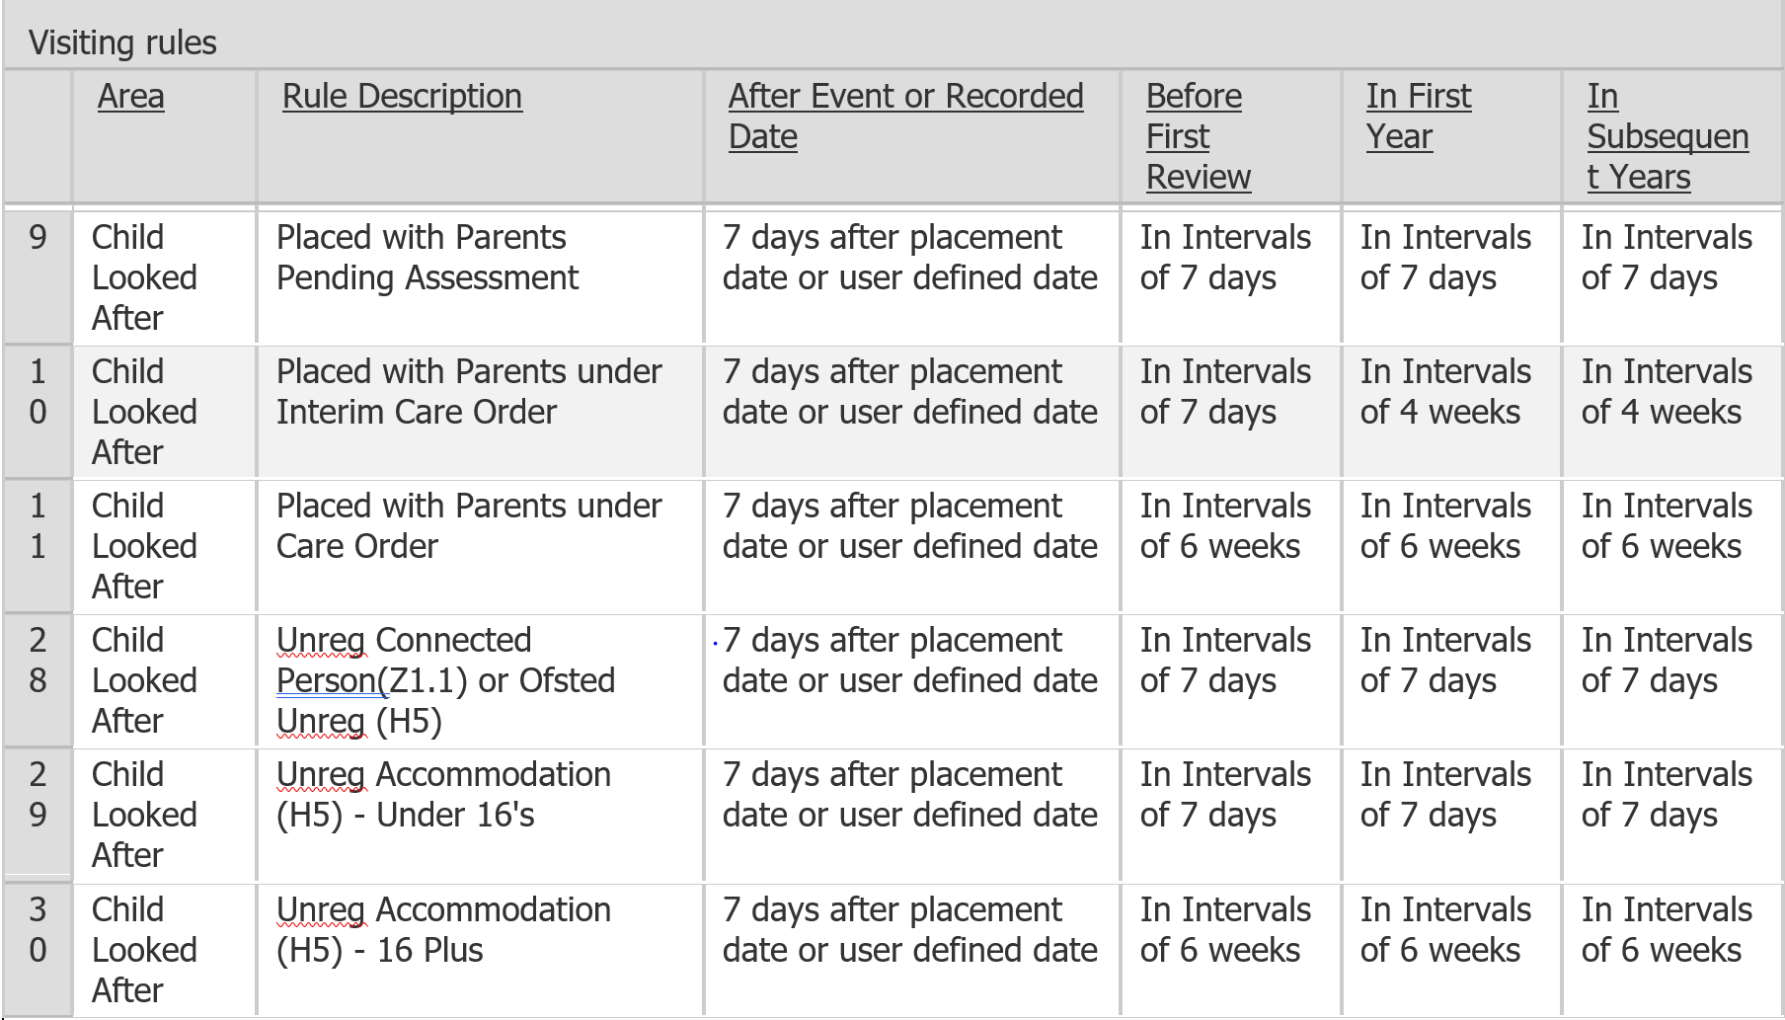

**Government legislation and guidance**

For more information, please click the link below:

**Once we load the new guidance to trix we can then add the links to policy, assessment guidance and the health and safety check list and forms , cannot add this until we have agreed on this , the same for the visiting template.**