Point of You Child and Young Person Feedback Service

Purpose
Point of You is a feedback service for use by Children and Young People. A platform for them to tell us how we did. It allows us to hear what children and young people think about the help and support we provide so we can improve and get better.
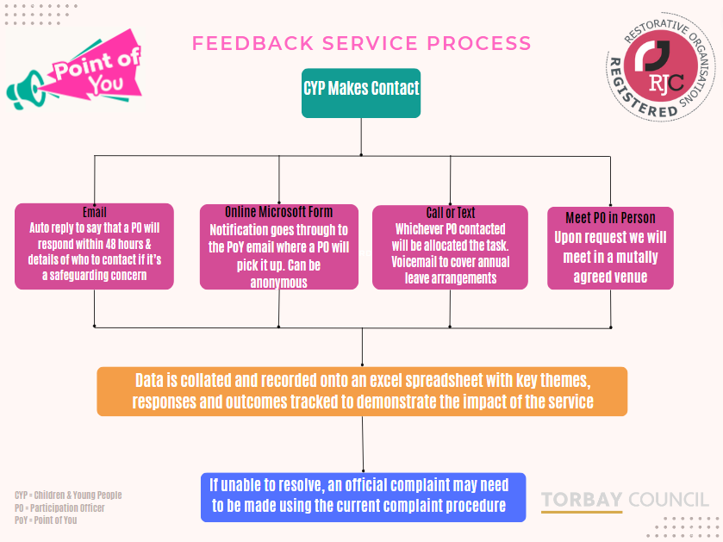
The intention of this service is for Children’s Services to offer meaningful ways we can interact with children and young people to improve and get better, exploring how we can implement their feedback into future service design and delivery. In line with our restorative practice approach, we want to demonstrate that we actively seek out opportunities to work ‘with’ and alongside our children and young people.

Outline of process

Methods of contact
Children and young people can get in touch via the following methods:

- Email pointofyou@torbay.gov.uk
- Call, text or meet a Participation Officer.
- Microsoft online form (a Special Educational Needs and Disability version is available)
- Scan a QR code

Email correspondence
The mailbox will be monitored and responded to by a Participation Officer on a weekly rota basis. The Relational Practice Lead will cover where there are gaps. On receipt of an email to the inbox the sender will receive an automated email acknowledging receipt of an email and enclosing a link to our privacy notice. The allocated Participation Officer will then aim to respond within 48 hours. Any immediate safeguarding concerns will be responded to as detailed in the safeguarding section.

Auto Reply:
‘Thank you for contacting the Point of You Feedback Service Email. This account is monitored between the hours of 9:00am and 5:00pm Monday - Friday. If your email was sent outside of these times this will remain unread until the next working day. We will aim to reply within 48 hours during working days.

You can find the feedback service privacy notice here: Children's Services - Torbay Council

If you have a safeguarding concern, please contact Torbay MASH torbay.safeguarding@torbay.gov.uk who are open to receive new referrals between the hours of 9.00am and 4.30pm Monday – Thursday and 9.00am and 4.00pm on a Friday. If the concerns you raise need a response outside of the MASH opening hours, then you should make contact with the Out of Hours Emergency Duty Team by telephone on 0300 456 4876 for immediate safeguarding concerns. You can also ring the police direct on 999 in any situation requiring a police emergency response.’

Telephone, Text and whats app
Both Participation Officers have access to a work mobile phone.
Katie Harris - 07785 934 552
Sophie de Sousa - 07500 608 141
Communication received via telephone, text or WhatsApp will be allocated to the Participation Officer who is directly contacted. During periods of annual leave, the Participation Officer will ensure their voicemail is enabled detailing they’re on annual leave and interim cover arrangements.

Face to face contact
Upon request a Participation Officer will meet with a young person in a mutually agreed place to gather feedback directly.

Microsoft Forms
Children and Young People can submit feedback via a short online form below:
Point of You Feedback Service (office.com)
Special Educational Needs & Disability Version - Point of You Feedback Service (office.com)

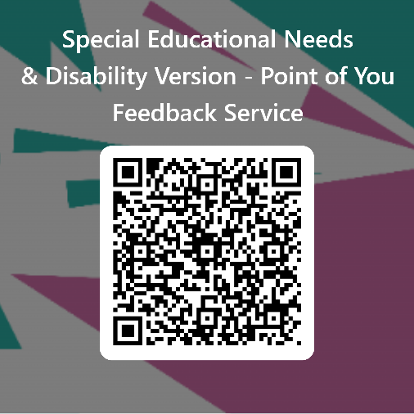
QR Codes
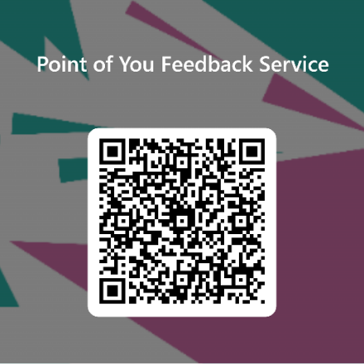

Recording of data and storage
Whilst we do not ask for any specific information such as name and age etc, children and young people can choose to submit feedback anonymously or they may choose to provide personal information when using certain feedback methods.
Email addresses, name, and feedback will be collected where this information is freely given. Additional information such as age, contact details, racial / ethnic origin, religious / psychological beliefs, sex life / sexual orientation and other personal information including special category data, may be disclosed to us by the young person.
Information received will be transferred to an excel spreadsheet. Access to information will be restricted to senior managers, the Learning Academy, and auditors for the purpose of improving practice and responding to feedback. Access to restricted and sensitive information (e.g. name, email address etc), would be only accessible by authorised personnel within the Learning Academy unless a safeguarding concern means information needs to be shared.
For the purposes of quality assurance and report writing key themes will be tracked on a spreadsheet to ensure that the correct follow up action has been taken and to support service design, delivery, and improvement. We will aim to keep all responses anonymous for this where possible. If this is not possible, we will seek to inform the young person and gain consent to share their details.
All data collected will be kept live until its conclusion. Upon conclusion it will be kept for a period of 6 months before permanent deletion. Although information on the spreadsheet will be kept but will remain confidential and password protected.

Consent
We have not set an age range for the use of this service so as not to act as a barrier for its use. Its intention is to encourage children and young people to freely contact us with their feedback. In consultation with our Head of Information Governance Joanne Beer, we have been advised that consent for use of this service is not required as children and young people are actively making a choice to give their feedback so we can therefore assume that consent is freely given. However, our duty must be to inform them about what we are doing with their data. A privacy notice has been created to meet this requirement Children's Services - Torbay Council.
If we can identify that a young person submitting feedback is under the age of 12, we will actively make efforts to signpost the young person to an advocate where appropriate.
If following initial contact, we ask children and young people if they want to be involved in further participation activities such as the Young Person Panel, Children in Care Council etc then we will capture consent to enable us to contact them further.

Feedback & Complaints
Participation Officers will model a restorative approach by working in a very open and transparent way through clear explanation and follow up of feedback to explain and explore options. They will be guided by children and young people in terms of gaining consent if feedback needs to be escalated i.e. to a formal complaint, clearly explaining the options, and actively involving them in the decision-making process. Advice will be sought from Governance support where negative feedback is received to discuss if this may need to be formally recorded as a complaint (subject to consent). Positive feedback received will also be shared with Governance support to include in their annual reporting on complaints and compliments.

Safeguarding
If an allegation / safeguarding risk is raised within the feedback collected from the child / young people, this will be passed onto the MASH team and / or LADO and then archived from the Point of You service until permanent deletion after 6 months once we have received confirmation of receipt from the MASH team. We will actively, where possible, inform young people and gain consent if we must make a referral to MASH/LADO.

Version control
Date | Revision No | Originator of change | Change description
06.09.23 | 1 | Bexs Rushton | Original draft document presented to Children Social Care Senior Leadership HOS Meeting
08.09.23 | 2 | Bexs Rushton | Signed off by CSCSLT with request for minor amendment to include that we will seek consent where we can if we are unable to keep data anonymous.

