End to End Procedures for Family Safeguarding
(including Step Up / Step Down between Children’s Social Care and Early Help)

Version 5.0
Jan 2024

Document name & file location | End to End Procedures for Family Safeguarding (Previously called Referral, Assessment, Planning and Decision Making for Children in Need)  Tri.X
Document Author | Steve Bailey
Document owner | Steve Bailey and Alan Guest
Review date | This document is to be reviewed a minimum of every 3years, the next review to occur no later than Jan 2027. Incremental reviews may take place as required.
Accessibility | This document can be made available in large print, Braille, audio or in electronic format.  Copies in alternative languages may also be obtained.
Destruction date | In line with Retention Schedule
How this document was created | Version 1.0-1.9 | Author, sign off and periodic reviews since document created in 2009 to 2020
 | Version 2 | Review by Children’s Social Care and Early Help, June 2021
 | Version 3 | Review by Children’s Social Care, March 2022
 | Version 4 | Review by Children’s Social Care, May 2022
 | Version 5 | Review by Children’s Social Care, Jan 2024
Circulation restrictions | No exceptions
Version | Detail of change |  | Name & Date
1.0 | Document created |  | October 2009
1.1 | Reviewed and updated |  | Mairead Panetta, June 2013
1.3 | Reviewed and updated |  | Sarah Roberts, January 2014
1.4 | Reviewed and updated |  | Mairead Panetta, July 2014
1.5 | Reviewed and updated |  | Mairead Panetta, June 2015
1.6 | Reviewed and updated |  | Mairead Panetta, February 2016
1.7 | Reviewed and updated |  | Mairead Panetta, December 2018
1.8 | Reviewed and updated |  | Andrew Ellery, May 2019
1.9 | Reviewed and updated |  | Andrew Ellery, September 2020
2.0 | Reviewed and updated |  | Andrew Ellery & Elaine Morgan, June 2021
3.0 | Reviewed and updated |  | Steve Bailey, March 2022
4.0 | Reviewed and updated |  | Steve Bailey & Peter Hodges, May 2022
5.0 | Reviewed and updated |  | Alan Guest, January 2024

Accessibility

This document can be made available in large print, Braille, audio or in electronic format.
Copies in alternative languages may also be obtained.
Please contact:

Children’s Social Care
Bracknell Forest Council
Time Square
Market Street
Bracknell
Berkshire RG12 1JD
Telephone: 01344 352020

Table of Contents
1 Introduction 1
2 Policy 1
3 Legal Framework 1
3.1 Children Act 1989 1
3.2 Children Act 2004 3
3.3 The Equality Act 2010 3
3.4 The United Nations Convention on the Rights of the Child 3
4 Procedures 3
4.1 Early Help Assessment 3
4.2 Management of Contacts to Children’s Social Care 4
4.3 Management of Referrals and Re-referrals 5
4.4 Management of Assessments 7
4.5 Step Up / Step Down between Children’s Social Care and Early Help 11
4.6 Case Responsibility and Transfer within Children’s Social Care 14
4.7 Planning and Decision Making 16
4.8 Child in Need Planning Meeting 16
4.9 Family Group Conference and Mediation 20
4.10 Reviewing Child in Need Plans 20
4.11 Mind of My Own 22
4.12 Child Protection Strategy Discussion 23
4.13 Initiating Section 47 Enquiries 24
4.14 Written Agreements and Unannounced Visits 24
4.15 Outcomes of Section 47 Enquiries 26
4.16 Solutions Forum 27
4.17 Children Looked After 27
4.18 Case Closure 29
5 Appendices 31
5.1 Appendix 1 - Bracknell Missing and Exploited Children’s Referral Pathway 31
5.2 Appendix 2 - Bracknell Forest Missing Children Return Home Interview Pathway 32
5.3 Appendix 5 Flowcharts 34

Introduction

These local procedures, to be read in conjunction with Working Together 2018 and the pan-Berkshire Child Protection procedures, set out:

- How Children’s Social Care assess whether children are ‘in need’
- How services are provided when this is seen as the most appropriate form of support
- How services are planned and reviewed
- How children and families step up and step down between early help and children’s social care

Policy

Bracknell Forest Children’s Social Care seeks to promote the well-being of ‘children-in-need’ within their families and communities, and to enhance their outcomes through the delivery of assessments, support and interventions so as to discharge it’s duties and powers under relevant legislation.

It does so by:

- undertaking assessments of the needs of individual children in collaboration with children, families and partner agencies
- determining, in partnership with families in so far as is possible, what action should be taken and what services should be provided to respond to that need
- planning, co-ordinating or delivering services to enable children to thrive, achieve and remain within their own families, as long as this is consistent to promoting and safeguarding their welfare

ensuring that the impact of services, support or other intervention is monitored and plans are reviewed

Children’s Social Care provides services to children and families where children are assessed as meeting the threshold of being ‘children in need’, however not all children assessed as being ‘in need’ will necessarily require or receive a service from Children’s Social Care. Other agencies (e.g. Education, Early Help, Health or the Voluntary Sector) may be better placed to provide services to meet specific family needs without requiring Children’s Social Care’s involvement.

Legal Framework

Children Act 1989
The Children Act 1989 sets out the responsibilities of Councils with Social Services. Responsibilities as the lead agency for establishing whether a child is in need and for ensuring services are provided to that child as appropriate.

The duties and powers of the local authority to assess the needs of a child and to provide services are outlined in Part III of the Children Act 1989, in particular Section 17, and Schedule 2 Part I. Part III is the main part of the Act (titled Local Authority Support for Children and Families) about the delivery of services by social services departments. Other Parts (I, II, IV and V) outline the way in which court orders may be obtained to authorise or enforce certain actions, in relation to family proceedings, care and supervision and the protection of children.

Children in Need

The Children Act 1989 states the general duty of every local authority.

It shall be the general duty of every local authority (in addition to the other duties imposed on them by this Part):
- to safeguard and promote the welfare of children within their area who are in need; and
- so far as is consistent with that duty, to promote the upbringing of such children by their families by providing a range and level of services appropriate to those children’s needs.
Children Act 1989 Section 17 (1)

This duty rests with the local authority as a whole. The provision of the range and level of services appropriate to children’s needs is done by local authorities, schools, health and voluntary agencies working together in partnership and in line with agreed multi-agency threshold guidance.

Definition of Children in Need

The Children Act 1989 provides a definition of a ‘child in need’
For the purposes of this Part a child shall be taken to be in need if:
- he is unlikely to achieve or maintain, or to have the opportunity of achieving or maintaining, a reasonable standard of health or development without the provision for him of services by a local authority under this Part;
- his health or development is likely to be significantly impaired, or further impaired, without the provision for him of such services; or
- he is disabled and “family”, in relation to such a child, includes any person who has parental responsibility for the child and any other person with whom he has been living.
Children Act 1989 Section 17 (10)
“development” means physical, intellectual, emotional, social or behavioural development; and “health” means physical or mental health.
Children Act 1989 Section 17 (11)

Children with Disabilities

Local Authorities are required to provide services for disabled children which are designed to minimise the effects of their disabilities and to give them the opportunity to lead lives that are as normal as possible (Children Act 1989 Schedule 2 paragraph 6)

Definition of Children with Disabilities

Under the Children Act 1989, disability is defined as follows:
A child is disabled if he is blind, deaf or dumb or suffers from mental disorder of any kind or is substantially and permanently handicapped by illness, injury or congenital deformity or such other disability as may be prescribed.
Children Act 1989 Section 17 (11)

The definition of disability under the Children Act 1989 is different from Health and Education definitions. A disabled child under the Children Act 1989 is one whose disability is ‘substantial’ and ‘permanent’ and where their needs which arise from their disability requires more support than is available through the capacity of their parents/carers and mainstream services.

Substantial will mean considerable or significant factors which are life changing or limiting, and might include issues to do with risk and dependency. Permanent means existing indefinitely, not expected to improve. However, there must be sufficient flexibility to take account of intermittent or episodic conditions.

Child Protection
The Children Act 1989 sets out the local authority’s duty to investigate child protection concerns.
Where a local authority:
- are informed that a child who lives, or is found, in their area – is the subject of an emergency protection order; or is in police protection; or
- have reasonable cause to suspect that a child who lives, or is found, in their area is suffering, or is likely to suffer, significant harm,
the authority shall make, or cause to be made, such enquiries as they consider necessary to enable them to decide whether they should take any action to safeguard or promote the child’s welfare.
Children Act 1989 Section 47 (1)

Children Act 2004

The Children Act of 2004, section 53, amends the Children Act 1989 and requires local authorities to give due regard to a child’s wishes when determining what services to provide under section 17 of the Children Act 1989, and before making decisions about action to be taken to protect individual children under section 47 of the Children Act 1989. These duties complement requirements relating to the wishes and feelings of children who are, or may be, looked after (section 22(4) Children Act 1989), including those who are provided with accommodation under section 20 of the Children Act 1989 and children taken into police protection (section 46(3)(d) of that Act).

Section 10 of the Children Act 2004 establishes a duty on local authorities to make arrangements to promote co-operation between agencies in order to improve children’s well-being defined by reference to the five outcomes and a duty on key partners to take part in those arrangements.

The Equality Act 2010
This Act puts a responsibility on public authorities to have due regard to the need to eliminate discrimination and promote equality of opportunity. This applies to the process of identification of need and risk faced by the individual child and the process of assessment. No child or group of children must be treated any less favourably than others in being able to access effective services which meet their needs.

The United Nations Convention on the Rights of the Child
This is an international agreement that protects the rights of children and provides a child-centred framework for the development of services to children. The UK Government ratified the UNCRC in 1991 and, by doing so, recognises children’s rights to expression and receiving information.

Procedures

Early Help Assessment

The Early Help Assessment is intended to promote more effective, earlier identification of children’s additional needs and improve multi-agency working to meet them. It provides a simple, non-bureaucratic process for a holistic assessment taking account of the child, their family and the community. In Bracknell Forest the Early Help Assessment will be undertaken by practitioners working with the children and young people at tier 1 and 2. As far as possible an Early Help Assessment will normally accompany any professional referral to Children’s Social Care or can be used as the referral documentation.

Management of Contacts to Children’s Social Care

A contact will normally be:

Notifications from other agencies (such as Police)

A request for general information, advice or assistance (e.g. childminding list; benefits query, or notification of intention to undertake a Statement of Educational Needs)

Offering a service (e.g. prospective foster carer)

Recording of significant information on an already open case where assessments and/or intervention are ongoing

Notifications from early help regarding families they wish to ‘step up’ or seek a consultation
- A report from the Emergency Duty Service (EDS), informing Children’s Social Care that a child or family who is not an open case has come to the notice of EDS out-of-hours

Contacts can be received via phone, email or through a dedicated online portal. Some families may present directly to Children’s Social Care by attending an office or other council site. Members of the administration team are usually the first team to receive a contact for Children’s Social Care and they enter it onto the Mosaic system and filter it to the relevant Social Work teams for action.

Open or Recently Closed Families

For children and families that are open to the long-term teams (i.e. Family Safeguarding Teams, The Children Looked After Pod, and the Children’s Specialist Support Team), any new contacts or referrals are entered onto Mosaic and passed directly to the relevant team.

For children and young people who were previously open to one of the long-term teams but closed within a 3-month period, any new contacts or referrals on these children are entered onto Mosaic and passed directly to the relevant long term team Duty Worker for the previous team to review and discuss with their manager.

New or Closed Families

All contacts about children who are not previously known or who are closed over 3-months to Children’s Social Care will be triaged and responded to by our integrated front door (the MASH). MASH Admin will record the contact on Mosaic and pass to the information to the MASH management team for initial triage and allocation to a triage officer.

Possible decisions by the MASH management triage:
- Allocation to a MASH triage worker to update a chronology, discuss a contact with a family member or other professionals, so-as-to support decision making
- Allocate to a MASH triage worker to provide information and advice/signposting to other services
- Allocation to a MASH triage worker or Early Help triage worker to seek consent to progress a contact to a referral to an Early Help Family Hub (once the Early Help Senior has agreed that a family meet the criteria to receive a targeted intervention, a referral will be sent to the Family Hubs)
- Allocation to a MASH triage worker or Early Help triage worker to identify a partner agency to undertake or update an Early Help Assessment with a family
- Ensuring that a record of any consultation / advice given to another professional is clearly documented – recorded on Mosaic if the name and personal details of the child are provided
- Coordinating specialist advice or support from partners to respond to consultations / advice seeking from other professionals (e.g. signposting to Named Professionals / Designated Leads)
- Triggering confidential MASH checks about children and families where there are repeated concerns, ‘borderline’ concerns or lack of clarity about needs and opportunities for support
- Progress to Referral to Children’s Social Care for an assessment under S17 of the Children Act or where a Strategy Discussion needs to be convened
- No Further Action

Contacts regarding unborn children
Information about unborn children is recorded on Mosaic at the earliest possible opportunity. On receiving a contact about an unborn baby, the unborn child is created on Mosaic with an expected date of delivery and the contact added on the system.

- Long Term Teams – if the case is to open straight to a long-term team (where a sibling is already receiving services or an assessment) the case is opened to the relevant Key Worker and Key Team in order to review
- MASH – for all other cases concerning unborn babies, the case is allocated to “Unborns to Review” on Mosaic and the contact passed to the MASH Senior for initial triage and decisions on next steps. This may include ‘No Further Action’ until a pregnancy has reached 12-16 weeks before an assessment is started. The MASH Manager will review the ‘Unborns To Review’ case list on Mosaic weekly and pass a referral to Children’s Social Care Duty and Assessment Team based on the below criteria for the timing of assessments, taken from the Multi-Agency Protocol on Pre-Birth Assessments.

The Pre-birth Assessment should be completed between 20-30 days and no later than 45 days and recorded on the social work assessment template. It will commence as early as possible when a viable pregnancy is identified, but no later than 16 weeks into the pregnancy and no later than 12 weeks if there are additional high risk vulnerabilities such as having had a previous child removed. At this point a decision is to be made whether an Initial Child Protection Conference is appropriate, or a Legal Planning Meeting needs to be convened to consider initiating Public Law Outline prior to birth and/or initiating proceedings at birth.

- Contacts for high risk unborn who will need an assessment are progressed at approximately 12 weeks.
- Contacts for an unborn who have not been identified as high risk but require an assessment are progressed to an assessment at approximately 16 weeks.
- Contacts for unborns which are received before the 12 or 16 week gestational periods (depending on current threshold) are allocated to “Unborns to Review” and diarised to a date when they reach the estimated respective gestational periods for review by the MASH Senior.

Management of Referrals and Re-referrals
A referral will normally follow from:
- Information received about a child, adult or family which points to the need for further (professional) enquiry or intervention (this will have been already recorded as a contact)
- A request for an assessment / or service where the thresholds for service may be met
- Any significant one-off pieces of work requiring professional knowledge /skills to resolve
- An Early Help Assessment having been undertaken with a recommendation for referral to Children’s Social Care

Feedback to Referrer
In all cases feedback should be provided to the individual making the contact / the referral with an explanation as to what decisions have been made and what are the next steps.

Lead Professional Role
The lead professional role falls to a social worker once the referral has been accepted by Children’s Social Care. A Family Worker may be allocated to support or become the allocated key worker. Children’s Social Care Family Workers do not carry out single assessments.

Decision Making
Working Together 2018 - The social worker should make a decision about the type of response that is required within one working day of contact with the department. This will include determining whether:

- the child requires immediate protection and urgent action is required;
- the child is in need, and should be assessed under section 17 of the Children Act 1989;
- there is reasonable cause to suspect that the child is suffering, or likely to suffer, significant harm, and whether enquiries must be made and the child assessed under section 47 of the Children Act 1989;
- further specialist assessments are required in order to help the local authority to decide what further action to take; and
- services are required by the child and family and what type of services

Possible Responses to Referrals and Re-referrals
- Assessment
If the response to a referral is that further assessment is required to ascertain whether the child is a child in need, they will be allocated to the named duty worker responsible for completion of the assessment. Where appropriate, practitioners from the Children’s Specialist Support Team and professionals from other agencies such as health and education will need to contribute to the assessment.

- Provision of a one off service or resource (e.g. one off financial; grant).
An assessment must be completed prior to a one-off service being provided and the case closed. The child and family and the referrer must be informed of the action to be taken.

- Strategy Meeting
Where information gathered results in the social worker suspecting that the child is suffering or likely to suffer significant harm, the local authority should hold a strategy discussion to enable it to decide, with other agencies, whether to initiate enquiries under section 47 of the Children Act 1989. Working Together (2018) and The Berkshire Local Safeguarding Children’s Board Child Protection Procedures must be followed.

- Private Fostering Notification
This will be passed to the Family Placement Team for an assessment of the private fostering arrangements. The Assessment Team is responsible for undertaking a Single Assessment in relation to the child who is being privately fostered for new cases.

For children and young people already allocated in the long-term teams who become privately fostered, the allocated worker will undertake the necessary assessments. *see Policy Procedures & Practice for Private Fostering.

- Fostering Referrals
Expressions of interest or enquiries received regarding people wishing to become foster carers will be passed to the Family Placement Team Duty Worker.

- In Family Adoption Enquiries
Enquiries received regarding in-Family adoptions will be passed to the Family Placement Team Duty worker.

- Adoption Enquiries
Enquiries received regarding Adoption will be passed to the Family Placement Duty worker.

- Special Guardianship
Expressions of interest or notifications received regarding people wishing to become special guardians will be passed to the Family Placement Duty Worker.

- Occupational Therapy Referrals Guidance
Screening is carried out at the first point a request is made for Occupational Therapy services – this is often made to our integrated front door. The purpose is to gather enough information to enable the Occupational Therapy Service to prioritise their work and to identify any other needs that may require additional services. Where no social work needs are identified, the child or family will not need to be seen by a Duty Social Worker as the Occupational Therapist will subsequently be visiting to assess the child.

- Re-referrals
Cases referred, which have been closed for less than 3 months by a long-term team, will be passed directly back to the long-term team. If the case is to be allocated, an Assessment will be undertaken by the allocated worker. This may be a brief piece of work, updating the information and analysis already available to the team, or may require more in-depth assessment if the referral is about a new issue/need.

Management of Assessments

Purpose of assessment
The purpose of an assessment is to determine whether the child is in need, the nature of any services required and whether any specialist assessments should be undertaken to assist the local authority in its decision making.

Timeliness of assessment
The child should be seen as soon as possible. How soon is dependent on the child’s needs and nature of the referral, however all children should be seen within 5 working days of the referral. For children who are need of immediate protection, action must be taken by the social worker or Police at the earliest opportunity. This should be completed within 24 hours, unless there are exceptional circumstances.

The timeframe for the assessment must be agreed with the supervisor. The maximum timeframe for the assessment to conclude, such that it is possible reach a decision on next steps, should be no longer than 45 working days from the point of referral. (Working Together 2018)

Local practice is that most assessments should be completed within 20 working days of the referral and should not exceed 35 working days. If the needs of the child and family are such that the assessment cannot be completed in that timescale this must be discussed with the supervisor.

The Head of Service for First Response will oversee any single assessments which extend beyond 30 days within the front door, and those over 45 days in a long-term team through setting up a panel to ensure that oversight is in place, any blocks or barriers are problem solved and solutions supported.

At any stage of the assessment social workers may organise or co-ordinate of services to support the child and their family/carers and should not wait until the assessment reaches a conclusion.

If during the assessment the child’s safety becomes a concern it must be secured before proceeding further with the assessment.

Communication with the family and consent
It is the responsibility of the social worker to make clear to children and families how the assessment will be carried out and when they can expect a decision on next steps. Families should be given the explanatory leaflet “A Guide to Assessment for Children and Families.”

The parent or carer’s consent to the Assessment and to information being sought from and shared with other agencies should be obtained. This consent should be recorded on the appropriate forms. If the child/young person is of sufficient age and understanding, their consent should also be obtained.

Personal information about children and families held by professionals and agencies is subject to a legal duty of confidence and should not normally be disclosed without the consent of the subject. However should a parent or carer or a child withhold consent, the law permits the disclosure of confidential information if it is necessary to safeguard a child or children in the public interest; that is, the public interest in child protection may override the public interest in maintaining confidentiality. Disclosure should be justifiable in each case, according to the particular facts of the case, and legal advice should be sought in cases of doubt.

Characteristics of a high quality assessment
High Quality Assessments:

Are child centred. Where there is a conflict of interest, decisions should be made in the child’s best interests
- Are thorough and proportionate
- Are rooted in child development and informed by evidence

Are focused on action and outcomes for children

Are holistic in approach, addressing the child’s needs within their family and wider community

Involve children and families

Include threats to the welfare of children from within their families, and vulnerability to abuse or exploitation from outside their families i.e. contextual safeguarding

Build on strengths as well as identifying difficulties

Are ones in which evidence is built and revised and assumptions are tested and revisited throughout the process

Lead to action, including the provision and review of services

Are transparent and open to challenge

Bracknell Forest assessment practice standards
All cases requiring an Assessment will be allocated to a named worker and this will be recorded on Mosaic.

The Assessment should include:
- Seeing the child face to face, and alone where appropriate
- Direct work should take place with children which is in keeping with their age, stage, ability, understanding and communication needs (with reference to their EHCP if they have one)
- Interviews with /observations of the child to gather their views and ascertain their wishes and feelings about needs, strengths, and services to be delivered
- Interviews with the child’s carers and family members as appropriate
- Respectful consideration of family structures, culture, religion, ethnic origins and other unique characteristics
- Involvement of at least one other agency in gathering information
- Analysis of the presenting issues as well as past information
- A chronology
- A genogram
- Identification of the child’s needs

Summary of strengths/resilience/risks/concerns

Recommendations for future action and service required, and how these might be provided

Assessments will be quality assured by the social worker line manager and then signed by both practitioners as a completed document

The family will be sent a copy of the Assessment Record and given an opportunity to discuss and comment on it, and to sign it

Assessments should use appropriate tools where they support analysis – a range of tools are available on the staff intranet. Assessment should be informed by and refer to current research evidence where applicable

Undertaking a systematic assessment
Enquiry
Research has shown that taking a systematic approach to enquiries using a conceptual model is the best way to deliver a comprehensive assessment for all children. A good assessment is one which investigates the following three domains

- The child’s developmental needs, including whether they are suffering or likely to suffer significant harm
- Parents’ or carers’ capacity to respond to those needs; and
- The impact and influence of wider family, community and environmental circumstances

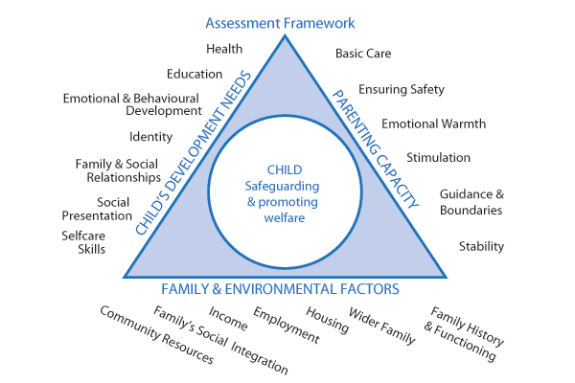

The interaction of these domains requires careful investigation during the assessment. The aim is to reach a judgement about the nature and level of needs and/or risks that the child may be facing within their family. It is important that:

- Information is gathered and recorded systematically
- Information is checked and discussed with the child and their parents/carers where appropriate
- Differences in views about information are recorded; and
- The impact of what is happening to the child is clearly identified

Obtaining an accurate base line on the child’s development during the assessment process is essential so that progress can be monitored during the time of social care intervention to ensure that the outcomes are improving.

Analysis and Critical Thinking
The social worker should analyse all the information gathered from the enquiry stage of the assessment to decide the nature and level of the child’s needs and the level of risk, if any, they may be facing.

Critical reflection through supervision – and other support mechanisms in place – should strengthen the analysis in each assessment and the social work manager should challenge the social worker’s assumptions as part of this process.

An informed decision should be taken on the nature of any action required and which services should be provided. Social workers, their managers and other professionals should be mindful of the requirement to understand the level of need and risk in a family from the child’s perspective and ensure action or commission services which will have maximum impact on the child’s life.

Decision points and review points involving the child and family and relevant professionals should be used to keep the assessment on track. This will ensure that help is given in a timely and appropriate way and that the impact of this help is analysed and evaluated in terms of the improved outcomes and welfare of the child

Chronologies
Different types of chronologies are created for different reasons through the journey of a child or young person, for example, multi-agency or court chronologies. However, this policy focuses on master chronologies on Mosaic.

In Children’s Social Care a chronology should be started as part of the process of completing a single assessment and it should be updated during the period of Children’s Social Care involvement, no later than at 3-month intervals.

A chronology should not be a duplication of the case recording on the child’s file. The following information is required
- the date of the significant event
- a summary of the event
- the source of the information

Professional Consultants and Specialist assessments
Assessments should always be based on information sharing between the agencies involved with a family and a collaborative multi agency approach to analysis. They should also be informed by existing assessments such as the assessment for children with special educational needs (Education, Health and Care Plan) and young carers and disabled children assessments. In addition practitioners and their managers may benefit from the expertise and experience of professionals in other disciplines in order to arrive at well-balanced judgements about the needs of children. These professionals can act as consultants or advisers to assist and contribute to the assessment processes, which includes analysis of information gathered.

Areas where social workers may seek additional information, consultation or special services include those families where there is parental mental health, parental substance misuse, domestic violence, and parental learning disability. The effects of these on children are likely to be complex and require a careful and thorough assessment. In these circumstances Children’s Social Care Social Workers should collaborate with Adult Services or adult workers within the department as part of the Family Safeguarding Model.

In some circumstances it may be necessary to commission specialist assessments to provide specific understanding about an aspect of the child’s development, parental strengths and difficulties or the family’s functioning. These specialist assessments may include:

Parenting assessments

Occupational Health assessments

Paediatric assessments

Psychological or psychiatric assessments of the child or of the parents

Where appropriate Children’s Social Care should co-ordinate all specialist assessments and consider a single planning process focused on outcomes.

Social workers are specialist workers who often see children in multiple contexts (home, school, community) and spend time with their families and liaise with other professionals in the child’s life. They are often well placed to identify children who would benefit from assessments in their own right that are led by other agencies across Bracknell’s multi-agency partnership – this might include:

- Speech and Language
- Special Educational Needs
- Mental Health and Emotional Wellbeing

As part of the Social Worker’s Single Assessment work they will coordinate activities to ensure that appropriate referrals are made, and use relevant and proportionate parts of their Single Assessment to help inform the assessment of other professionals.

Completion of an assessment

On writing the assessment report on Mosaic, the social worker will make a recommendation to their supervisor who will make the final decision on what action is to be taken following the completion of the Assessment and record this decision, with reasons.

On completion of assessment one or more of the following may be recommended.

- It is assessed that the child is not in need and no further action need be taken and the case is closed
- There is no continuing role for Children’s Social Care, but additional supports from within the family network would enable the family to manage and prevent further referral to Children’s Social Care
  - In these cases the Assessment Team should make a referral for a Family Group Conference. When the referral is made and passed to the Family Group Conference Development Worker there will be no further input from the Assessment Team worker. An independent Family Group Conference Co-ordinator will be commissioned to work with the family network and any identified professionals to facilitate the Family Group Conference. Once the Family Group Conference has been held, any plans and decisions made will be reviewed by the family network and any professionals directly
- Referral to appropriate agency to meet assessed need
- Provision of service from within Children’s Social Care to meet assessed need
  - In these cases a plan of action with anticipated outcomes clearly identified is developed, either Child in Need or Child Protection plan
- Emergency provision of specific services where needs are significant and urgent
- The family will benefit from stepping down to a targeted early help service

For certain types of assessment report, the Scheme of Delegation highlights specific levels of sign off:

Reports to Court Under S7 of the Children Act | Sign off by Team Manager, can delegate to an Assistant Team Manager
Reports to Court Under S37 of the Children Act | Sign off by Head of Service
Decision not to convene an Initial Child Protection Conference after a S47 (across all teams) | Validation of Social Worker recommendation by supervisor, then sign off by Duty Team Manager and in consultation with Conference and Review Team Manager where it is felt this would be beneficial. If any disagreement, refer to a Head of Service

Step Up / Step Down between Children’s Social Care and Early Help

The purpose of a step up / step down process is to ensure that children continue to receive the right service, at the right time and that services continue to provide a needs-based response, led by an appropriate part of children’s services.

It is acknowledged that the needs of families can change over time, and this may occur after improvements are made by specialist services or where needs continue to escalate when in receipt of a targeted service. Once the role of specialist services is coming to a successful end, it is important that the support provided to a family remains seamless and focused on the family needs. In any situation, where stepping down or up is being considered, it is important that the family are kept at the centre of decision making and that their consent to share information is obtained, except in circumstances that may place a child at greater risk of harm.

Working Together 2018 provides the below examples of where an early help response could be beneficial for children and families:
- Is disabled and has specific additional needs
- Has special educational needs regardless of whether they have a statutory EHCP
- Is a young carer
- Is showing signs of being drawn into anti-social or criminal behaviour, including gang involvement and association with organised crime groups
- Is frequently missing/goes missing
- Is in a family circumstance presenting challenges for the child, such as drug and alcohol misuse, adult mental health issues and domestic abuse
- Is misusing drugs or alcohol themselves
- Has returned home to their family from care
- Is a privately fostered child
- Has a parent/carer in custody

This element of the policy focuses on those children and families who have been in receipt of statutory services or are in need following a period of early intervention. It is important for practitioners to be mindful that the provision of any service at targeted or specialist level should form part of a continuum of support that responds to the different levels of need that children and families may have.

Step up to Children’s Social Care
The process for accessing a service from Children’s Social Care is the same for all internal and external partners. A referral needs to be made to our MASH. It is at this stage that further enquiry may be undertaken to determine the appropriate next steps.

Whilst a single assessment is undertaken by Children’s Social Care following stepping up from Early Help, the family will remain open to the Family Hubs to ensure continuity of support.

Targeted level services
For the purposes of this guidance, the targeted services are the Early Help Family Hubs, Targeted Youth Services and Youth Justice Prevention Service.

Stepping down to Early Help or Targeted Youth Services following assessment by the Duty and Assessment Team
Some step downs take place following the recommendations at the conclusion of a single assessment.

If it is clear that the needs can be met in line with the multi-agency threshold guidance, by our Early Help Services, the Duty and Assessment Team should send a copy of their assessment to earlyhelp.referrals@bracknell-forest.gov.uk.

The duty system run by Early Help will then review and allocate accordingly and ensure that any clarifications are sought from the social worker.

If it is unclear to the social worker/family worker and/or manager that right service provision is available, they should consult with the Early Help Locality Manager prior to closing their involvement.

Where necessary, good practice would include a handover visit between the social worker/family worker and the Early Help professional.

Referrals exclusively for Targeted Youth Services, for children aged 13-19, should be made by email to youth.service@bracknell-forest.gov.uk.

In any case, consent from the family is required.

Stepping down to Early Help following a plan held by a long-term social work team

The decision to close a case following a period of intervention whereby the child/ren have been subject of a plan, then the step-down should occur at the Review Child in Need Planning Meeting with the relevant service in attendance (Family Hubs, Youth Justice Prevention and/or Targeted Youth Service). The decision must be authorised by the Team Manager or Assistant Team Manager. All other agencies involved with the family should be informed of the intention of a case being closed and the reasons for this.

An agreed plan of support with S.M.A.R.T actions for the receiving Early Help Service should be developed and in the case of the Early Help Family Hubs, this will then be reviewed at a minimum of 6 weekly intervals. This should be completed in partnership and with the consent of the family.

Multi-disciplinary support for complex situations managed by Early Help
For families presenting with complex needs or where Early Help practitioners are wanting support and guidance to progress their intervention, an Early Help Case Discussion Panel is in place and occurs every 3 weeks. This is in addition to supervision arrangements and management oversight that already exists for Early Help practitioners.

Children’s Social Care are present partners at the case discussion panel. This enables expertise to be shared and a joined-up approach to problem solving. In addition to Children’s Social Care, the below professional disciplines are also present:
- Early Help Parenting Lead
- Getting Help Manager
- Children’s Social Care (MASH Manager)
- MASH Early Help Senior
- Educational Psychologist

If a decision is reached that a family should step-up, the panel will agree that a referral to the MASH should be made.

Step down to Youth Justice Prevention
Any service is able to make a referral directly into the Youth Justice Prevention Service. The criteria for the service is for children/young people where professionals are concerned that the young person may be at risk of offending and becoming involved in the justice system.

All services are able to refer into the service using an existing assessment or the referral form that can be obtained from the service. The below are some of the behaviours that may indicate a need for a preventative Youth Justice Service:
- School exclusions because of defiance, disruptive behaviour, frequent truancy
- Violence or aggression towards others or a young person who is destructive towards property; reacts disproportionately to situations
- Inappropriate sexual behaviour, including frequent use of inappropriate sexualised language: persistently sending or coercing peers into sending indecent images
- Theft
- Fire setting
- Drug and alcohol related behaviour e.g. early use of substances: suspicions of dealing or drug running on behalf of others
- Young people who negatively target others because of their race, religious beliefs, sexuality, age, gender or a disability
- Anti-Social Behaviour (not committing crimes but causing a nuisance in the community that are likely to lead to an arrest by the police)
Completed referral forms should be sent to the below:

Jo Graves, Operational Manager, Bracknell Youth Offending Team
76 Binfield Road, Bracknell, Berkshire, RG42 2AR
Email jo.graves@bracknell-forest.gov.uk

Cindy Henn, YOT Prevention Case Manager, Bracknell Youth Offending Team
76 Binfield Road, Bracknell, Berkshire, RG42 2AR
Email cindy.henn@bracknell-forest.gov.uk

Step down to Universal Services
Specialist and Targeted Services need to consider stepping down to Universal Services where the needs are appropriate. If it is felt that some monitoring support is needed (e.g. someone being available as and when the family need it) or a single service low level response, then a discussion with professionals involved with the family would suffice.

Case Responsibility and Transfer within Children’s Social Care
Following completion of an Assessment, all cases that require services from Children’s Social Care will transfer from the Assessment Team to the relevant longer-term team (i.e. the Family Safeguarding, or the Children Specialist support Service).

Cases remaining with Duty
Exceptionally, where it appears that case can be closed within 4 weeks of the completion of the assessment following a time limited piece of work, the Assessment Team may keep the case in short term services order to achieve this and avoid unnecessary case transfer. There will be no Child in Need or Child Protection plan completed, instead written recommendations from the assessment. The short term work may include support from family workers, a Family Group Conference or Mediation or step down to Early Help Services.

Children in Need cases - will not remain in the Assessment Team for longer than 8 weeks from the point of referral except in exceptional circumstances. This timescale allows for the completion of a complex Single Assessment and 2 weeks for the transfer process to be completed.

The team holding the case will be responsible for arranging a Child in Need Planning Meeting.

Child protection cases - if the Assessment Team has begun Section 47 enquiries, the case will transfer to the relevant long-term team at either the Initial Child Protection Conference or, if there is no Child Protection Conference, at the completion of a Single Assessment. The Assessment Team Manager must inform the receiving Team Manager of the date and time of the Child Protection Conference as soon as this is known, to facilitate their attendance and prior identification of the future key worker.

Looked after children cases - if a child has become accommodated (Children Act 1989 Section 20) the case will be transferred at the initial planning meeting, which will be held prior to admission if it is a planned admission, otherwise within a maximum of 5 working days of the child becoming looked after.

Cases subject to emergency court action followed by no further legal action, will transfer in accordance with their subsequent status. For example, if the case is taken to an Initial Child Protection Conference, then transfer will take place at this point.

For cases that are the subject of proceedings, the allocated Assessment Team worker will complete the initial statement for court. The long-term team will assume case responsibility in line with the above process i.e. the case will transfer at ICPC. If the Assessment Team have issued proceedings, they will complete the relevant court work until the first hearing where this will be handed over.

Case Transfers
Transfers between teams must consider the needs of the individual child and minimise changes in social workers.
The children are allocated to the team most relevant to the children’s greatest needs and in line with the level of input required. For most cases that require long term intervention, the cases will be transferred to the Family Safeguarding Service.
This should take place at an appropriate time in the child’s life e.g. at a LAC review, ICPC, CIN Review Meeting or first court hearing.

Transfer procedure from the Assessment team
- The Duty worker identifies the need for transfer following completion of assessment and informs admin at the weekly team brief or before, and a transfer email is sent to the long-term teams.
- Every Tuesday morning a Transfer Agreement Meeting is held between the Long Term Teams’ managers, where any questions or clarifications can be sought if necessary. If a transfer is accepted, the meeting is unlikely to be required.
- Long Term managers provide a worker name and team. These details are passed to the Duty worker who will who set up the CIN meeting, within a fortnight of the transfer being agreed.
- There is an expectation that the case record will be up to date and a chronology completed by the time of the child in need/LAC planning meeting or ICPC.
- Genograms can be created on Mosaic but if the families are large and complicated, the genogram should be drawn with dates of birth and scanned into Smart Office. If the case is going to Initial Child Protection Conference, or care proceedings are to be issued, the genogram will need to be captured in Word programme.
- The Assessment Team is responsible for identifying the needs of the children and the need for onward Child in Need or Child Protection plan services. The relevant planning meeting is used by the Long-Term Team to decide how resources can be allocated to best meet those needs. Decisions made at this meeting may deviate from the Duty Team recommendations regarding what sort of services a family should be allocated within the plan.
- The case is to transfer within two weeks of the agreed transfer. Cases still waiting for a planning meeting after this timescale will automatically transfer to the Long-Term Team and the Duty Team will communicate this in writing to the family and involved professionals
- A transfer checklist will be completed by the Duty Team to ensure accurate case file data and compliance with standards before the relevant CIN Meeting / ICPC takes place and a copy scanned or added to the file.

Process for transferring between long term teams
- The team manager of the long-term team (Children Specialist Support Service/Family Safeguarding and Children Looked After Pod) emails the manager of the receiving team outlining case details and the reason the child/ren need to transfer to that team.
- It is the responsibility of the team managers to discuss the transfer and agree a date.
- A transfer checklist will be completed by case holding Social Worker to ensure accurate case file data and compliance with standards before the relevant transfer takes place to the new social work team. A copy will be scanned or added to the file.

Bracknell Forest practice standards: case transfer
- Accountability for cases will always be clear. The allocated worker or team will be recorded on Mosaic
- Parents, children and carers, and referrers where relevant, will be kept informed of case transfer arrangements
- Cases will transfer at a multi-agency child in need planning meeting. In exceptional circumstances a joint home visit by the case holding social worker and the social worker who the case will be transferred to, will best meet the needs of the family and these cases will transfer following the home visit without a full multi-agency meeting being held.
- Case records transferred from the Assessment Team will be up to date and will be authorised by a manager. Information on MOSAIC will be up to date.
- The single assessment or letter informing the family of the outcome of S47 enquiries will be sent to the family prior to the transfer planning meeting or initial child protection conference with a fair processing (or privacy) notification.

Transfer to other Local Authorities
Where a child in need has moved permanently to another local authority area, the original authority should ensure that all relevant information (including the child in need plan) is shared with the receiving local authority as soon as possible. The receiving local authority should consider whether support services are still required and discuss with the child and family what might be needed, based on a timely re-assessment of the child’s needs, as set out in this chapter. Support should continue to be provided by the original local authority in the intervening period. The receiving authority should work with the original authority to ensure that any changes to the services and support provided are managed carefully.

Planning and Decision Making
The impact of any interventions and the achievement of better outcomes for children, and young people and their families is dependent on effective planning. Development of a child’s Child in Need or Child Protection plan is informed by the Single Assessment process.

Bracknell Forest practice standards: planning
The Child’s Plan will:
- be developed from an up to date assessment
- involve children and young people, and their families in its development
- involve service providers from all relevant agencies/organisations in its development
- describe the identified needs of the child, and what therapeutic services are required
- be responsive to changes in a child and young person’s needs or circumstances
- include specific, achievable, child-focused objectives and identify measurable outcomes;
- identify timescales for these outcomes to be achieved
- be specific about actions to be taken (in each of the three assessment domains) and identify who is responsible for each action
- clearly identify roles and responsibilities of professionals and family members, including the nature and frequency of contact by professionals with children and family members;
- be specific about services and resources required to achieve the desired outcomes, establish costs and how these will be met
- lay down points at which progress will be reviewed, and the means by which progress will be judged
- include means of evaluating the impact of actions taken and services provided
- identify consequences and contingencies should desired outcomes not be achieved or circumstances change

Bracknell Forest practice standards: decision making

Decisions will be:
- participative and collaborative, reflecting a desire to work in partnership with families and other agencies
- made on the basis of agreement and negotiation where possible, as opposed to imposition
- involve family members at all stages and respect family views
- be based on strengths within the family as well as addressing deficits and concerns
- be made be subject to review, and
- the process for making the decision will be recorded as well as the decision

Child in Need Planning Meeting
For children who are not looked after or subject to a protection plan, in every case where a decision has been made by Children’s Social Care to provide services following a Single Assessment, a Child in Need Planning Meeting will be convened to make the necessary arrangements.

The purpose of the Child in Need planning meeting
The purpose is to provide a forum where professionals and families will:
- make decisions regarding the provision of services to children and their families. (As such it should focus on decision-making as opposed to concentrating on information sharing.)
- develop the working plan to safeguard and promote the welfare of the child
- identify the people who will implement the plan
- review effectiveness of the plan
- make arrangements for the single assessment to be updated as required

Issues to be addressed in the Child in Need planning meeting
- issues arising out of the assessment
- previous departmental and other agency involvement with the family and family background
- child’s developmental needs (each child of the family/household should be considered individually)
- parents’/carers’ capacity to respond appropriately to the child/young person’s needs
- family and environmental factors
- child’s views
- parent’s views
- analysing needs and actions requested to safeguard and promote the child’s welfare
- whether any additional protective action should be taken, including consideration of whether the situation fulfils the criteria for holding a Child Protection Conference
- whether a Family Group Conference is required to continue to develop the plans being developed for the child/young person
- developing a Child’s Plan
- any specialist assessments required and arrangements for commissioning these (i.e. who is to do what and when is this to happen)
- date of the Planning Group, if needed, and the next Child in Need Planning Meeting

Practical arrangements for a Child in Need planning meeting
These should be made by the team holding the case.

Attendees:
- Parents/carers and young people of sufficient age and understanding should be encouraged to attend
- Representatives from Early Help, Health and Education who have contact with the child will be invited to the meetings, together with any other agency working directly with the family, have had recent involvement or who may be able to offer a service to the family
- If a meeting does take place without the family being present, this should be considered a professionals meeting with managers present and chaired by a senior Children’s Social Care manager for a child whose behaviour places him or her at risk of significant harm. This meeting should follow the same format as a Child in Need Planning Meeting, the family must be kept informed of the process and outcome and a child in need planning and reviewing process
- Child/young person’s involvement in the process
- The child or young person’s involvement and participation in the Child in Need process are essential whether they attend the meeting or not
- Decisions regarding attendance should involve the young person and be based on his/her maturity and what is in his/her best interests
- Independent Advocacy should be explained and offered
- Informal advocacy should be explained and offered
- In all circumstances the views and wishes of all children old enough to express their views and wishes should be ascertained using whatever medium is most appropriate

How to prepare the family:
The agency convening the meeting are responsible for engaging the family in the child in need process. They should:
- Discuss the issues on the agenda with them in advance of the meeting
- Provide written information
- Prepare the family for the meeting by explaining its structure and format and how they can participate
- Offer parents and young people the chance to put their views in writing
- Explain to parents that they may need independent support, information and advice to be able to participate fully from an informed position, particularly where there is a divergence of views
- Explain that they may be accompanied to the meeting by a supporter if they wish
- Explain that they may have an interpreter if necessary

Time and Venue
- The Child in Need Planning Meeting should be held at a time and place that maximises the ability of the family to participate in a meaningful way
- Ideally the venue should be familiar to the family and able to provide comfortable, family friendly surroundings (possibly the family home
- Consideration should be given to the accessibility of the venue for people with a disability or who are dependent on public transport
- Child In Need meetings must be held in person, unless there are reasonable adjustments required to enable the attendance of children and parents.

Identifying Chairperson and their role
- The Chair of Child in Need Planning Meetings will be Children’s Social Care representative who has an understanding of child in need issues and knowledge of the child protection procedures

The Chair must:
- Fully explain the role of the Social Worker at the initial Child in Need Planning Meeting
- Facilitate the exchange of information and the inclusion of all those attending the meeting
- Facilitate the participation of parents, carers, children and young people
- Ensure the meeting follows the agenda and that the meeting keeps to time
- Help members to interpret the information and focus on the relevant issues
- Manage any conflict and facilitate discussion of opposing views
- Encourage clear, jargon free communication and challenge the evidential base of any judgements given
- Summarise regularly to ensure all involved are aware of what is happening

Recording – decisions, actions, disagreements
- A summary of the issues discussed, decisions made, actions agreed and any disagreements must be recorded, together with the agreed Child’s Plan
- Recording must make tasks and responsibilities (for both the family and agencies) clear
- If no agreement can be reached the record of the meeting should record disagreements and any action proposed

The Child in Need Plan should include the following components:
- the objective of the plan, for example to provide and evaluate the efficacy of therapeutic interventions
- what services will be provided by which professional group or designated agency
- the timing and nature of contact between professional workers and the family
- the purpose of services and professional contact
- specific commitments to be met by the family
- specific commitments to be met by the professional workers
- which components of the plan are negotiable in the light of experience and which are not
- what needs to change and the goals to be achieved (for example the child’s weight to increase by a specific amount in a particular period, regular and appropriate stimulation for the child in
- keeping with her or his development and age)
- what is unacceptable care of the child

Communication and keeping participants informed
The CIN plan must be sent to everyone who was invited to the meeting within ten working days.

It is the responsibility of the key worker to make sure that parents and child(ren) are clear about the objectives of the plan, the causes of concern, what needs to change and about what is expected of them as part of the plan. They need to accept the plan and be willing to work to it and to understand the consequences if things do not change.

All parties should be clear about their respective roles and responsibilities in implementing the plan.

If the family do not speak English, the plan should be constructed with the family in their first language and they should receive a written copy in their first language.

If family members’ preferences are not accepted about how best to safeguard the child, the reasons for this should be explained. Families should be told about their right to complain and make representations, and how to do so.

In some cases it will be useful or useful or necessary for those professionals most directly involved with the case and family members to meet together between Child in Need Planning Meetings to either further develop the plans made or to review changes in the child’s/family’s circumstances.

Roles and responsibilities of participants in a Child in Need planning meeting

The social worker is responsible for:
- completing the Single Assessment of the child and family (where necessary), securing contributions from other professionals and family members as necessary
- acting as lead worker for the inter-agency work with the child and family
- co-ordinating the contribution of family members and other agencies to the actions that need to be taken
- putting the plan into effect, including home visits, either announced or unannounced
- monitoring progress against the objectives set out in the plan
- alerting appropriate managers where the plans cannot be progressed and it is necessary to consider alternative action

Where no social worker is allocated, it is the responsibility of the Team Manager or Assistant Team Manager to oversee the management of the Child in Need Planning Plan and to notify family members and other agencies of this fact.

The responsibilities of other participants are:
- to contribute to the Single Assessment and to continuing assessments (where necessary)
- to carry out agreed tasks in accordance with their own agency functions: if this is not possible the lead worker should be consulted before any plans regarding the child or family are altered
- to provide specialist advice which will inform the plan
- to provide the lead worker with written reports as requested
- to communicate regularly with the lead worker about the progress of their own part of the agreed plan
- to inform the lead worker of any change in circumstances relevant to the plan
- to alert the lead worker to the need to convene a Review Child in Need Planning Meeting early
- to help identify unmet need

Frequency of Child in Need Visits
It is recommended that Child in Need Plan visits take place at a minimum ofevery 15 working days. There are some families who require long term support (e.g disability support packages) where this is not appropriate and longer timescales, at least every six weeks can be agreed by the Team Manager. Occupational Therapy only children in need is every 12 weeks. Within these parameters professional judgement should be used, based on assessment of need as agreed at the Child in Need planning meeting. It is important to consider that the child’s needs and response to risk should dictate the frequency of visiting, which can be more frequent than the minimum if required.

Allocation to Family Workers
Family Workers can case hold Children in Need that are deemed appropriate to the child’s needs and the worker’s skills level, training and experience. Should Child Protection concerns emerge on a Child in Need case, these will be assessed by a Social Worker, maintaining the relationship between the child and the Family Worker. Should a Child in Need become a Child Protection or Looked After Case, it will be re- allocated to a Social Worker.
A Family Worker should not hold a case that has had a recent Child Protection s.47 investigation unless there are particular reasons for this, and the risk management indicates that it is safe to do so with management authorisation. For example, where there is an absolute confidence that a s.47 has resulted from a malicious referral albeit these situations are rare.
Family Workers will not hold children in Private Fostering arrangements or children subject to a Supervision Order.
More information can be found here : Children’s Social Care Family Worker Policy.

Family Group Conference and Mediation
If the criteria for a Child in Need Planning Meeting are met, then consideration should also be given to offering the family the option of a Family Group Conference or mediation. Family Group Conferences can be used at any stage as short term interventions or in long term teams. For example:
- Planning – Family Group Conferences should be considered where there are complex packages of support and mediation where there is family conflict
- Child Protection – A Family Group Conference should be considered at Child Protection Conferences as part of the protection plan and as part of a pre-proceedings meeting
- Looked After Children – Family Group Conferences should be considered before placement or as soon as possible afterward. A Family Group Conference should also be considered at first and subsequent LAC Reviews, as appropriate
- Leaving Care – A Family Group Conference should be considered when drawing up and reviewing the Pathway Plan
- Court Proceedings – A child/young person being considered for care proceedings or a court order should not prevent a Family Group Conference taking place.

Reviewing Child in Need Plans

The first Review Child in Need Planning Meeting should take place within three months of the initial meeting and thereafter at least every three months with review dates determined at the first meeting. For longer term disability support CIN this can be every six months. The frequency of Child in Need Review meetings should be increased if there is a need to do so, such as in response to specific concerns or changes in need.

The purpose of the review meeting is to revise and update both the assessment and plan, to check it is being implemented and to monitor progress against the objectives and outcomes stated in the plan

The Review Child in Need Meeting should consider:

changes in circumstances since the last meeting

the overall aim of the intervention and whether this remains relevant in light of any progress or development

the objectives and actions agreed in the Assessment and the extent to which these have been met, including, consideration of any alternative actions or provisions that have been used and any services planned but not yet provided and any work still to be completed

any revised priority needs or risks to the child

whether the current level and type of service provision is appropriate

whether there is sufficient change to the situation to avert cumulative impairment of health or development or of harm becoming serious for the child

whether the parent(s)/carer(s) are able to use the services offered and are able to provide adequate parenting

the cumulative effect of any repeated minor incidents and persistent deficits in parental care upon the child’s health and development.

A Child in Need Meeting is the only place in which the decision to cease a Child in Need Plan can be made. This must be made in consultation within supervision by the Child’s Social Worker’s manager, who will record the rationale for step down in the supervision record. The rationale must also be clearly set out in the closing CIN review minutes.

The criteria for ceasing a CIN plan is:

- the child is no longer unlikely to achieve or maintain a reasonable standard of health or development
- the child’s health or development is no longer likely to be significantly impaired
- the procedures are followed (e.g. the child becomes looked after or subject to Child Protection Procedures)

A review Child in Need meeting could be chaired by a Senior Social Worker (but not the case holder) but the plan must be sent to an Assistant Team Manager or Team Manager to authorise.

A record of the meeting together with the new plan will be made and circulated to everyone invited to attend the meeting within 10 working days.

Mind of My Own

Mind of My Own is our digital direct work platform, this is applicable to children of all ages and abilities. There are key accessibility options within it to enable use with children where English is not their first language. The application can be used jointly with children or by children independently at any time on their own device. All staff can access Mind of My Own via their council issued devices. It does not require installation and can be accessed at: https://space.mindofmyown.org.uk/

The mind of my own app will support the quality and frequency of direct work with children by capturing their authentic voice at various points throughout working with them. It allows children to tell us “in the moment” their wishes and feelings so that we can respond and support them, whilst celebrating positive achievements and gather feedback.

This application will also help children prepare for visits, meetings, and conferences by being supported to have their views placed at the centre of those interactions. This will assist professionals and partner agencies in meetings to hear the child’s voice and respond to their needs holistically.

The following practice standards are applicable for all children within children’s social care.

STANDARD | DESCRIPTION | TIMELINE
Introduction | All frontline workers will introduce all children & young people to either Mind Of My Own One or Express (as age appropriate) as a way for them to participate and have their voice heard | When first working with a child or young person during the initial visit.
One Accounts | All frontline workers will help young people open on/going on a plan with CSC setup their own One account to use independently if it is age appropriate. This must include gaining consent from parents/carers. | During first visit to a child.
Worker Accounts | All staff working with children & young people will have their own worker account and must use this during visits with children & young people where appropriate. | As part of induction for new starters.
IROs & Conference Chairs | Our IROs and conference chairs will speak with children / young people before all reviews and conferences, reminding and encouraging them to use Mind Of My Own as a means of participation. | A minimum of 2 weeks before all CLA reviews / CP conferences
Closed Cases | Children should be encouraged to speak to a trusted adult in their network when our work with them ends rather than continue to use our services  Children who submit a statement within 3 months of closing, this will be sent to their previous Social Worker for review and will be treated as a contact.  Children who submit a statement more than 3 months after closing this will be sent to MASH as a contact. | Contact to be reviewed within 24 hours.
All Social Workers / Family Workers | All social workers must encourage young people to use Mind Of My Own to prepare for all meetings, reviews, visits, or conferences.  All social workers must encourage young people to use Mind of My Own to inform single assessments and Family Programmes.  Complete a ‘My Wellbeing’, ‘My Life’, or ‘This is me’ statement with each child on your case load | At least two weeks before all meetings / reviews / Core Groups / Conferences.  At least once during each assessment.

Child Protection Strategy Discussion

Whenever there is reasonable cause to suspect that a child is suffering, or is likely to suffer, significant harm Children’s Social Care should convene a strategy discussion to determine the child’s welfare and plan rapid future action. A strategy discussion can take place following a referral or at any other time, including during the assessment or planning process. It might take the form of a multi-agency meeting, teleconference or in some instances, series of phone calls and more than one discussion may be necessary. A Strategy Discussion may be triggered at any point where there the threshold is met – not just at the Front Door / at the point of a new referral.

Purpose of Child Protection strategy discussion

The discussion should be used to:

Share available information

Agree the conduct and timing of any criminal investigation

Decide whether enquiries under section 47 of the Children Act 1989 should be undertaken

Where there are grounds to initiate a section 47 of the Children Act 1989 enquiry, decisions should be made as to:

What further information is needed if an assessment is already underway and how it will be obtained and recorded

What immediate and short-term action is required to support the child, and who will do what by when

Whether legal action is required

Timescale for CP strategy discussion

A strategy discussion/meeting should take place within 24 hours of concerns first coming to our attention, however should take place as soon as possible in more urgent situations. For more complex matters, the Head of Service may agree an extension in line with the Pan-Berkshire Safeguarding Children Partnership procedures.

Professionals involved in Child Protection strategy discussion

It will involve the social worker and a member of staff more senior, a police representative, and health professionals as a minimum. Other relevant professionals will depend on the nature of the individual case but may include the professional or agency which made the referral, the child’s school or nursery and representatives from any health services the child or family members are receiving. All attendees should be sufficiently senior to make decisions on behalf of their agencies.

Roles and responsibilities
Guidance around roles and responsibilities can be found in Working Together to Safeguard Children 2018.

Initiating Section 47 Enquiries

A section 47 enquiry is initiated to decide whether and what type of action is required to safeguard and promote the welfare of a child who is suspected of, or likely to be, suffering significant harm. A section 47 enquiry is carried out by undertaking or continuing with an assessment in accordance with the Bracknell Forest Practice standards for a good assessment.

Local authority social workers have a statutory duty to lead assessments under section 47 of the Children Act 1989. the police, health professionals, teachers and other relevant professionals should help the local authority in undertaking its enquiries.

Written Agreements and Unannounced Visits
4.13.1 Written Agreements (sometimes called Safety Plans) are one of the tools used by Children’s Social Care to help manage risk and need. They help to make clear what Social Workers are worried about, what support will be offered to families and what families are expected to do to show that they are keeping their child or children safe.

The main purpose of these agreements/plans are:

To safeguard

To support

To test

To set expectations

To record (evidence)

Written Agreements often work best when they are co-produced with families about how they will keep children safe and what they need to do so. They are not legally binding documents, but they are good evidence that families are working with CSC and detail the things which families are doing to protect and care for their child or children. If the agreement is breeched, then it can form part of social work evidence for example in Child Protection conferences, PLO or Court that parents are not safeguarding their children. Any Written Agreement should make this clear to families.

When to Use Written Agreements/ safety plans

Written agreements / safety plans should only be used exceptionally and not as a routine approach to risk management or with over reliance on their worth.

The need for an agreement should always be discussed in advance with a team manager or ATM, who should also sign it as well as parents and the social worker.

Written agreements should not be used to list a whole set of requirements, expectations, or services. These should be contained within a child’s plan. Written Agreements do not replace a robust and SMART plan; they should focus on a specific issue

Written agreements are not legal documents but can provide supporting evidence if applications are later made to the Court;

They are not a substitute for the PLO process / letter before proceedings (which is a legal document);

Written agreements/safety plans are a statement of the Local Authority’s concerns and advice to a parent / carer; they are not a contract and therefore there is no requirement for parents to sign their agreement.

The grounds for concern should be outlined at the start, specifically identifying the risk of harm that has been identified;

There should be clarity about what is being asked for under the “what the Local Authority expects” section. Expected actions should be brief, clear, measurable and specific;

The Consequences of not keeping to the agreement should follow the wording in the template;

A clear review date should be set and this should, where possible be incorporated into an existing forum such as CIN meeting, core group meeting or within a specified timeframe (i.e. a month);

Timescales should be reasonably short as work should be on-going to alleviate the position or escalate intervention where required;

A written agreement should not be used at the close of a case as it needs to be reviewed and ended;

The agreement should be signed by a team manager to give it the correct weight and authority;

A copy should be retained on the child’s file (scanned into Smartopen).

When entering into a Written Agreement with any family, social workers should be clear about what is safe, realistic and achievable. For example, asking a victim of domestic violence to supervise or manage contact between their abuser and a child is unlikely to be an effective safeguard if they remain scared, traumatised or at risk of further abuse themselves. In such an instance, a more effective strategy may be to engage with the perpetrator and wider family to undertake a risk assessment and develop a Written Agreement with them instead.

A template for a Written Agreement can be found here.

4.13.2 Unannounced visits are a tool workers use to monitor the safety and wellbeing of children, young people and their families and whilst mostly used for children subject to written agreements & CP Plans, they can form part of the plan for any child open to Children’s Social Care, including Children in Need and Children Looked After.

Unannounced visits give workers the opportunity to see children, and understand the care which they are receiving, in ways which pre-planned visits may not, and gives workers opportunity to formulate a more balanced assessment of children’s lived experiences, as part of a series of visits or contacts with children. They can evidence where parents are making positive changes in their own lives and the impact that this is having on children as well as where those improvements are becoming normal or a routine part of day-to-day life. Simply put – unannounced visits help us understand what life is like for children ‘when we aren’t there.’

For some children and their families unannounced visits can be anxiety-provoking and confusing – for example children who have been removed from home before, parents who work from home or children whom need high levels of structure, predictability and routine, therefore some children may benefit from increased frequency of pre-planned visits for example in the evening time or early morning, with use of unannounced visits at a more reduced frequency. Visiting schedules should be agreed in supervision to ensure that they have purpose, achieve their aims and are done in child-centred ways. This includes working openly with families if you intend to increase frequency of unannounced visits and may include using a Written Agreement with families about frequency, how they will be undertaken, what additional support families need, how unannounced visits can support the family’s own goals and what contingency plans are agreed if an unannounced visit results in the social worker identifying immediate concerns about children’s care or safety.

Unannounced visits should be recorded on the child’s Mosaic file using the relevant drop-down option:
- CIN Visit – Unannounced – Child Seen
- CIN Visit – Unannounced – Child Not Seen
- CLA Visit – Unannounced – Child Seen
- CLA Visit – Unannounced – Child Not Seen
- CP Visit – Unannounced – Child Seen
- CP Visit – Unannounced – Child Not Seen

Unannounced visits may be used at the point of receiving a referral to a family, but are not be a routine way of making a first contact with families.

Outcomes of Section 47 Enquiries
Local authority social workers are responsible for deciding what action to take and how to proceed following section 47 enquiries.

If Children’s Social Care decides not to proceed with a Child Protection Conference then other professionals involved with the child and family have the right to request that a conference be convened, if they have serious concerns that a child’s welfare may not be adequately safeguarded.

As a last resort, the Safeguarding Children’s Partnership have a dispute resolution process to resolve differences of opinion.

Where concerns of significant harm are not substantiated
Social workers should:
- discuss the case with the child, parents and other practitioners
- determine whether support from any services may be helpful and help secure it
- consider whether the child’s health and development should be re-assessed regularly against specific objectives and decide who has responsibility for doing this

All involved professionals should;
- participate in further discussions as necessary
- contribute to the development of any plan as appropriate
- provide services as specified in the plan for the child
- review the impact of services delivered as agreed in the plan
- seek advice and guidance as required and in line with local practice guidance

Where concerns of significant harm are substantiated and the child is judged to be suffering, or likely to suffer, significant harm
Social workers:
- convene an initial child protection conference (see next section for details). The timing of this conference should depend on the urgency of the case and respond to the needs of the child and the nature and severity of the harm they may be facing. The initial child protection conference should take place within 15 working days of a strategy discussion, or the strategy discussion at which section 47 enquiries were initiated if more than one has been held
- consider whether any practitioners with specialist knowledge should be invited to participate
- ensure that the child and their parents understand the purpose of the conference and who will attend
- help prepare the child if they are attending or making representations through a third party to the conference. Give information about advocacy agencies and explain that the family may bring an advocate, friend or supporter

Children who are returning to Initial CP conference for a second or subsequent time:
- if a child is returning to an Initial CP Conference for a second or subsequent episode of CP planning in their life then the team manager should consider legal advice and potential commencement of the PLO process. Decisions to do so, or not do so, should be recorded on the case file. The Team Manager should also review that the actions in the proposed CP Plan are carefully considered, targeted, build on what has been successful before and not simply be a repeat of previous actions.

All involved professionals should:
- convene an initial child protection conference (see next section for details). The timing of this conference should depend on the urgency of the case and respond to the needs of the child and the nature and severity of the harm they may be facing. The initial child protection conference should take place within 15 working days of a strategy discussion, or the strategy discussion at which section 47 enquiries were initiated if more than one has been held
- consider whether any practitioners with specialist knowledge should be invited to participate
- ensure that the child and their parents understand the purpose of the conference and who will attend
- help prepare the child if they are attending or making representations through a third party to the conference. Give information about advocacy agencies and explain that the family may bring an advocate, friend or supporter

Solutions Forum
To promote a collaborative approach to care planning for complex and risky cases, the Care Planning Forum is a meeting to ensure that all options to help parents achieve change are being explored and that where change is not taking place in the child’s timescales, plans are reviewed, interventions escalated and thorough consideration is given to enabling the child to live within their extended family if there is a risk that they cannot remain in their parents’ care.
Solutions Forum is chaired by the Assistant Director or the Head of Life Chances (vice-chair) and takes place every week. This can be a step taken before seeking Legal Advice to ensure that a wide range of appropriate interventions and assessments are considered in establishing family change, writing a letter before action, or initiating care proceedings.
(See Terms of reference)

Children Looked After
Entry to Care Panel (E2C)
Weekly panel where decisions are made prior to any child entering care, moving placements or leaving care. Slots booked through CLA.admin@bracknell-forest.gov.uk

If emergency entry into care them emergency E2C to take place prior to the child becoming CLA to support with planning.

Discharge of children who are accommodated under Section 20 Children Act 1989
Under Section 20 of the children act 1989 those with parental responsibility or the children if over the age of 16 can discharge the period of accommodation. In such circumstances the Head of Service (Life Chances) should be notified via Entry to Care Panel. There must be consultation with everyone who holds parental responsibility (where possible), the child and the IRO.

If the child is aged 16 or 17 and has been in care for at least 20 days then there is additional mosaic form required for completion and approval by the Assistant Director (CSC)

Funding Decisions for children’s placements
All children where there is a request for them to become looked after, change placements of cease to be looked after should come to Entry to Care Panel for approval. The following funding decisions sit with the Assistant director for Children’s Social Care upon completion of the external placement form on mosaic
- Agreement to fund a placement for a children with IFA Carers
- Agree to fund out of borough placement of a child in a residential placement
- Agreement to a child placed at a distance of more that 20 miles from Bracknell Forest (delegated from

Withholding an address of a child looked after from parents
Decisions to without the address of a child looked after from those who hold parental responsibility must be made by the relevant Head of Service and in all circumstances legal advice should be sought.

Head of Service authority for Children Looked After
Below is a list of key decision for Children Looked After which required Head of Service for Life Chances approval. This can be delegated to another Head of Service for CSC.
- To consent to medical treatment or give other consent for looked after children who are unaccompanied asylum seekers or without an adult with PR, who are looked after under Section 20
- To sign passport applications for a child looked after
- To agree a holiday abroad for a child looked after
- To approve the applications of children in care who wish to join HM Forces
- To agree the change of a child’s name internally and on Mosaic for children in care (via entry to care panel)
- To legal agree a legal change of name for children in care (via entry to care panel)
- To agree to place siblings separately (Via Permanency Planning Meeting or Entry to Care panel)
- To vary allowances to foster carers / contributions by young people in placement in exceptional circumstances

Adoption
The primary functions for recruiting, supporting and training prospective adopters and family finding for adoption for children are undertaken by our regional adoption agency Adopt Thames Valley.
Adopt Thames Valley should be included as early as possible where one of the viable permanency options may be adoption.

Reports for Adoption Order
Schedule 2 reports are required to be completed under The Adoption and Children Act 2002. Only social workers who meet the following requirements can complete reports for Adoption.

The Restriction on the Preparation of Adoption Reports Regulations 2005
that the person—

(a)has at least three years' post-qualifying experience in child care social work, including direct experience of adoption work;
(b)is supervised by a social worker who—
(i)is employed by the local authority or registered adoption society in question; and
(ii)has at least three years' post-qualifying experience in child care social work, including direct experience of adoption work.

These reports must be signed of by the relevant Team Manager.

Family Time
Bracknell Forest Council will promote, encourage and facilitate family time between children that are looked after, their families of origin and others who have played an important part in their lives. Consideration of the impact of family time on the child, both positive and negative, will be included in any assessment process and when decisions are made about family time arrangements. Family time will not go ahead as planned when there is clear evidence that it prevents the authority from safeguarding the child's welfare. If this happens, those affected will be notified.

Good, regular, and consistent family time arrangements are important in facilitating reunification. For most children, the aim from the outset will be to reunite them with their family, provided it is safe. Developing and maintaining close links between the child and their family are essential to this objective.

Where children have to live apart from their family, regular, sustainable and positive family time arrangements will contribute to helping the child develop a proper understanding of their identity and origins, supporting their permanency needs and promoting their stability.

Managing family time can place considerable strain on all the parties involved therefore, a clear understanding about the arrangements should be agreed from the beginning to help prevent future difficulties.

The following set of principles underpin our approach to facilitating family time for all children who come under the scope of this policy:
- We actively promote children who are looked after to spend time with their parents, sisters and brothers, wider family, friend/s or other person/s connected with the child, including previous care givers when reasonably practicable and consistent with the child’s welfare.
- Family time is always for the benefit of the child. It should be seen as supportive and that it is the child’s right to spend time with their family.
- We will supervise family time only when necessary to ensure children are safeguarded and their welfare promoted; where possible, this will be someone familiar to the child – family member, friend, key worker/care giver when safe.
- We consider the child’s network, including the role of the care giver in family time when planning the stages of arrangements.
- We will use best endeavours to ensure family time is facilitated in an appropriate child-centred venue, taking account of the child and/or young person’s age and whom they are meeting to promote a positive experience.
- We encourage sessions to be engaging and fun. We will support families to identify activities that will best facilitate the child’s enjoyment while offering appropriate bonding, with financial assistance where considered necessary.
- We actively consider diversity factors as part of all assessments for family time, taking account of ethnicity, culture and language needs (including those where English is not their first language) of children, young people and their families.
- We support children and young people having a choice about who they wish to see and spend time with.
- We actively support brother and sister relationships to ensure enduring links are maintained and promoted through family time.
- Workers will support family time and offer parenting advice and support where necessary.

More information can be found in the Family Time Policy

Case Closure

Case closure decision making
No case can be closed if a child says they feel unsafe and no case involving a vulnerable child will be closed before the child and the child’s carer have been advised of a closure, and a plan for step down to non-statutory services to support the family and welfare of the child, has been agreed. Consideration may be given to “Step Down” to the Family Hub to provide some ongoing additional support at a lower threshold of need.

Where families do not engage with an assessment under S17 and there are concerns about unmet needs which may escalate in the future then either a Strategy Discussion will take place or a Non-Engagement Risk Assessment template will be completed by a social worker to collate what is known about a child’s circumstances and to analyse any residual risks to a child and make a recommendation about next steps. This risk assessment will include what is known about the child’s situation, an analysis of any past information held on file, details of strengths / signs of safety and the role of any professional who will continue to support and / or be in contact with the child and family. This will be signed off by a manager to be able to authorise case closure, or based on the assessment, to convene a Strategy Meeting or a Review CIN Meeting.

The decision to close a case and the step-down plan will normally be made at a Review Child in Need Planning Meeting. The decision must be authorised by the Team Manager or Assistant Team Manager. All other agencies involved with the family should be informed of the case being closed and the reasons for this.

Case Closure Pack and Learning from Feedback
A closing pack containing a complaints form, a service user feedback form should be used with the family by the social worker when closing cases. In Long Term Teams this feedback form may be completed by a social worker directly with the child or family if deemed appropriate.

The decision to close a case and the step-down plan will normally be made at a Review Child in Need Planning Meeting. The decision must be authorised by the Team Manager or Assistant Team Manager. All other agencies involved with the family should be informed of the case being closed and the reasons for this.

Case Closure Record
A Closure Record should be completed to close all cases that have progressed to Single Assessment. Those closing at the conclusion of a single assessment will not need the full closure record completing as the assessment will contain the details.

A Closure Record completed by a long-term team will include:

a summary of the reason by Children’s Social Care involvement since date of most recent referral

overall summary of program achieved and impact of CSC involvement

what services have their child and family received?

what has happened/changed in the family?

how have the child/family responded to the intervention?

what impact has the intervention had on the child/family?

the views of the child, their family (and when appropriate, service providers from relevant agencies), about the decision to close the case

demonstratable evidence that the child is safe

name of lead professional or detail of the referral to the Early Intervention Hub

Closing a case on Mosaic

The necessary screens on Mosaic at case closure, including ending the key worker involvement and team involvement must be completed by the Team Manager or Assistant Team Manager.

Case closure due child moving to another authority

If the case is being closed because a child is moving to another local authority area, and the child has continuing needs, a referral must be made to the local authority to which the child is moving, and the date of this referral, and the date of acknowledgement of this referral included in the Closure Record.

Appendices

Appendix 1 - Bracknell Missing and Exploited Children’s Referral Pathway

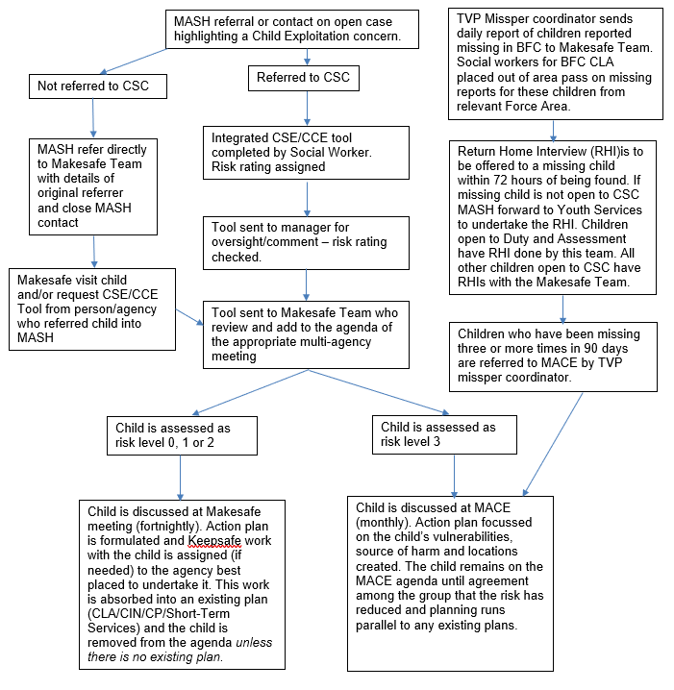

Appendix 2 - Bracknell Forest Missing Children Return Home Interview Pathway
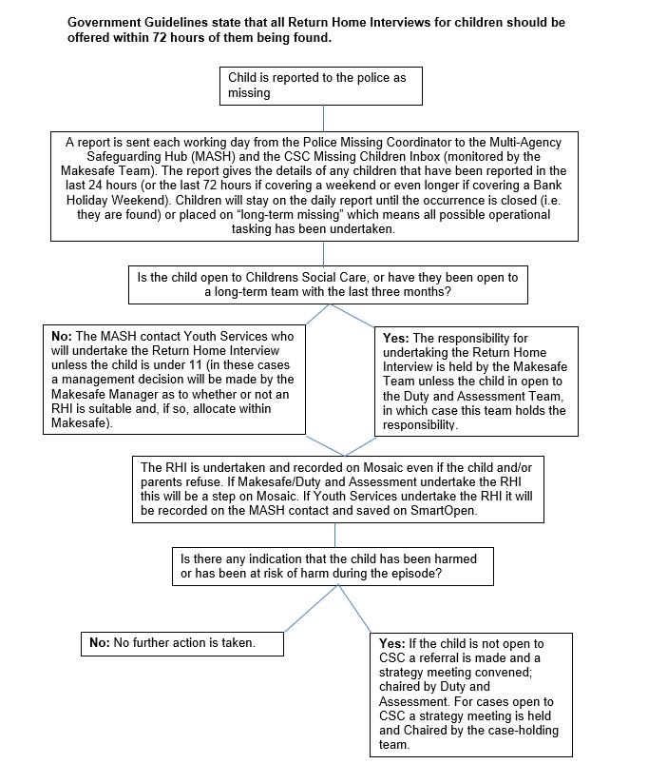
Guide to Return Interview
This form is a guide for the return interview.
It has several purposes, but it is important to remember that the welfare of the child is paramount and the prime purpose of the interview is to safeguard the child.
Other purposes are:
- To ensure the child is safe in his/her placement (home, care etc):
- To investigate how the child’s welfare can be safeguarded and promoted in the future:
- To prevent further episodes of the child going missing;
- To promote safe behaviour if the child does go missing again;
- To obtain intelligence to facilitate finding the child if he/she goes missing again.
- To assess whether child protection procedures should be initiated;
- To decide whether a criminal investigation should be initiated in respect of the child going missing, actions done to the child while missing

The list is not exhaustive.

The interview should take place as soon as possible after the return home.

The interviewer should conduct the interview in a sensitive manner, and as far as is possible not with carers. The interviewer should be mindful that the child may be running away from an abusive situation and conduct the interview accordingly.

The form should not be rigorously adhered to. It is a guide to help the young person share information and therefore the interviewer should use his/her discretion to deviate from this guide.

It is expected that the police will inform families of the potential for return interviews when they do the safe and well check.

Appendix 5 Flowcharts
Flow Chart 1 : Action taken when a child is referred to local authority children’s social care
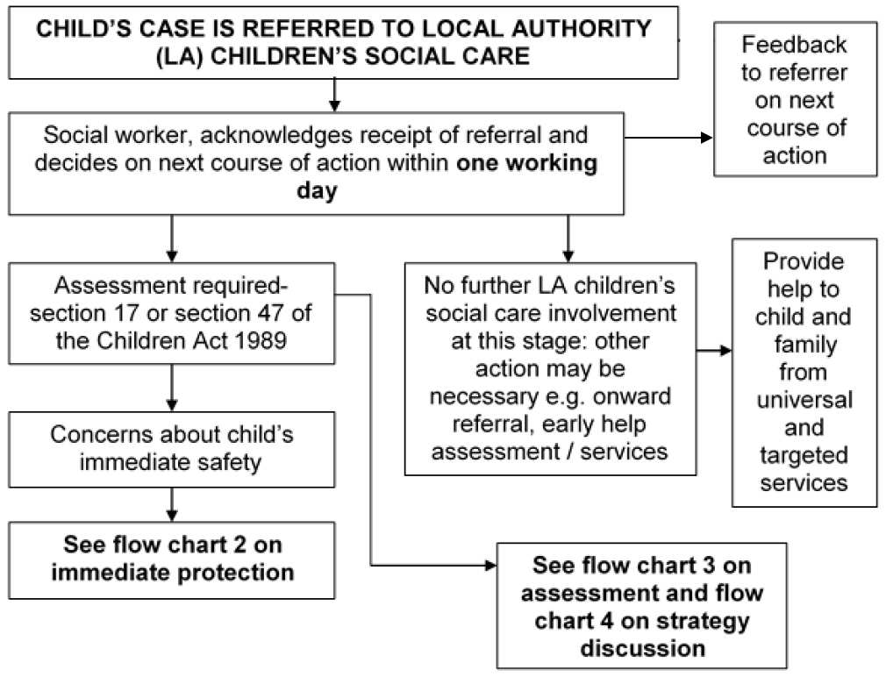

Flow Chart 2 : Immediate protection
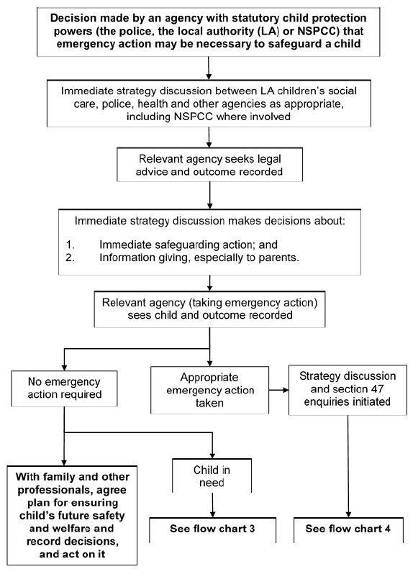

Flow Chart 3 : Action taken for an assessment of a child under the Children Act 1989
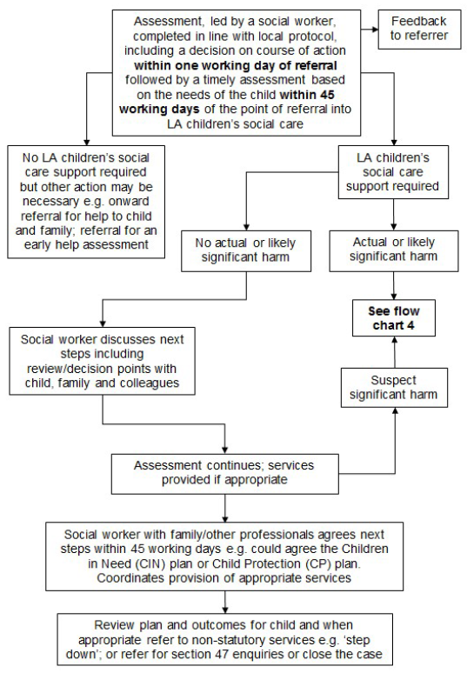

Flow Chart 4 : Action following a strategy discussion
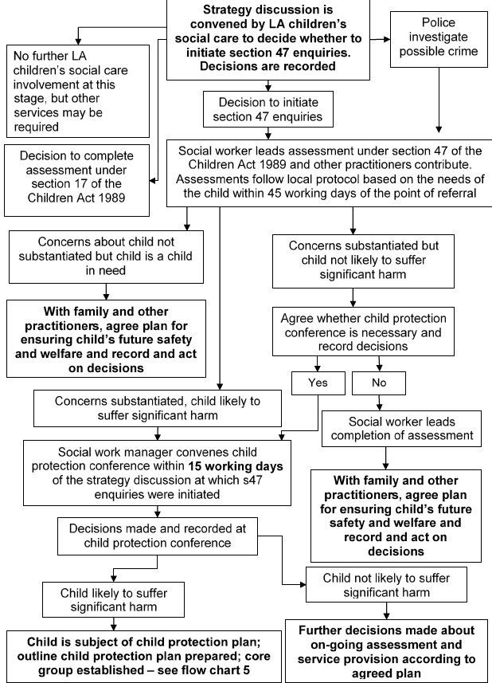

Flow Chart 5 : What happens after the child protection conference, including the review?
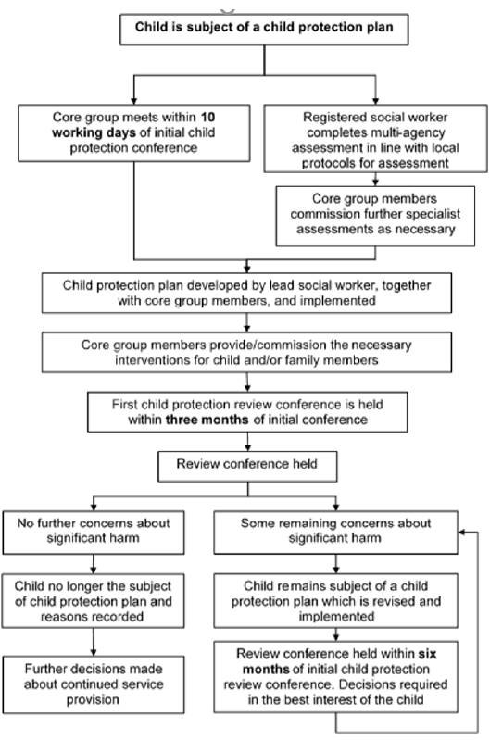

The DfE definition is “someone who has a physical or mental impairment which has a substantial and long term adverse effect on his or her ability to carry out normal day to day activities”.

