April 2024

**Young Carers**

Practice Guidance



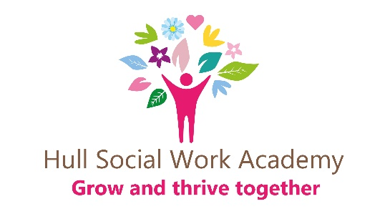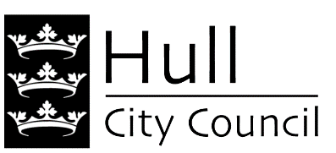

**Introduction**

This guidance will help practitioners who are assessing or supporting a young carer.

**Who is a young carer**

A young carer is a young person aged under 18 who cares for a family member who may have a disability, serious illness, a mental health issue or an alcohol, drug or substance problem. Caring for someone can take its toll emotionally and physically. A young carer has less time for hobbies, interests, friends, part-time work or school work. A young carer may take on extra household chores, sort out medications, help someone to wash, or be a comfort to someone who requires mental or emotional support. They might be helping their little sisters or brothers get dressed or even take them to School. The tasks undertaken can vary according to the circumstances, the level and frequency of need for care, and the structure of the family as a whole.

Different factors can make the situation more complicated, too, such as the cost of living crisis, family living far away or limited family networks who support. A young carer often has to take on these adult responsibilities and worries while they’re still a child.

**What is the impact of being a young carer**

Caring responsibilities can have a negative effect on young people.

[Our research](https://www.childrenssociety.org.uk/information/young-people/young-carers) shows that young carers can feel stressed or anxious, miss school, have limited time to spend with their friends, and feel they have to limit their plans for their own futures. At the same time, many young carers say it can be positive, too. They might value the closeness they have with the person they care for, and feel resilient through meeting the challenges they have experienced (Children’s Society 2024)

**Supporting Young Carers**

There is national support for young carers and each local authority in the country has available support for young carers. The Children’s Society have an abundance of resources to support young carers and their families [Supporting Young Carers | The Children's Society (childrenssociety.org.uk)](https://www.childrenssociety.org.uk/what-we-do/our-work/supporting-young-carers)

Under the Children and Families Act 2014 [(part 5 Section 96)](https://www.legislation.gov.uk/ukpga/2014/6/part/5/crossheading/young-carers-and-parent-carers/enacted) and in line with the [Young Carers (Needs Assessments) Regulations 2015](https://www.legislation.gov.uk/uksi/2015/527/pdfs/uksi_20150527_en.pdf) young carers are entitled to an assessment, whatever the level of care they provide.

Under the [Care Act 2014](https://www.legislation.gov.uk/ukpga/2014/23/contents/enacted), local authorities also have a duty to consider the needs of children living in households where there is an adult who has a disability or impairment that requires help or care as part of a “whole family assessment”. If you are assessing an adult’s needs, you have to consider whether a child is in the household and consider whether any of the children may undertake any care roles in the home. The Care Act 2014 [(section 63-65)](https://www.legislation.gov.uk/ukpga/2014/23/section/63/enacted) also gives rights for young carers aged 16 to 18 who are transitioning to adulthood to have their specific needs assessed in light of how their role might change. This is called a Transition Assessment.

In addition, [Working Together to Safeguard Children 2023](https://assets.publishing.service.gov.uk/media/65cb4349a7ded0000c79e4e1/Working_together_to_safeguard_children_2023_-_statutory_guidance.pdf) reinforces the need for agencies to work in partnership to support families with young carers using a whole family approach. It is important to note, particularly when communicating with young carers and their families, that any assessment offered will be focused on the needs of the young person themselves, and will not be an assessment of how well they are carrying out their caring responsibilities.

**Assessment of a Young Carer**

Assessments of young carers focus on the child or young person’s needs. They are not an assessment of how well care responsibilities are carried out.

Local authorities must offer an assessment where it appears that a child is involved in providing care. This legislation is aligned with similar provision in the Care Act 2014 requiring local authorities to consider the needs of young carers if, during the assessment of an adult with care needs, or of an adult carer, it appears that a child is providing, or intends to provide, care. In these circumstances the authority must consider whether the care being provided by the child is excessive or inappropriate; and how the child’s caring responsibilities affects their wellbeing, education and development.

**What Support is available for Young Carers in Hull**

Hull Young Carers Project is an assessment and support service for people aged between 5 and 18 years who are impacted by caring responsibilities. They work in close partnership with a range of universal and targeted services, and in particular community based youth services.

It is delivered by the Youth Development Service and aims to offer tailored support when needed with a variety of wider opportunities for young carers. Hull have a great offer. To gain further information about The Young Carers Project or internet local offer page.

Email - [TheYoungCarersProject@hullcc.gov.uk](mailto:TheYoungCarersProject@hullcc.gov.uk)

[Make a referral to request early help support (opens in new window)](https://earlyhelpportallive.hullcc.gov.uk/web/portal/pages/publicehassess#ssa)

**Young Carers Wellbeing Grants**

The Grant widens opportunities for young carers to explore their own interests and hobbies and improve their overall wellbeing.

An application can be supported through the Hull City Council’s Young Carer Project or any professional that is aware of the young person’s caring responsibilities.

A young carer can apply for a grant of £300 to support an existing interest (link here)

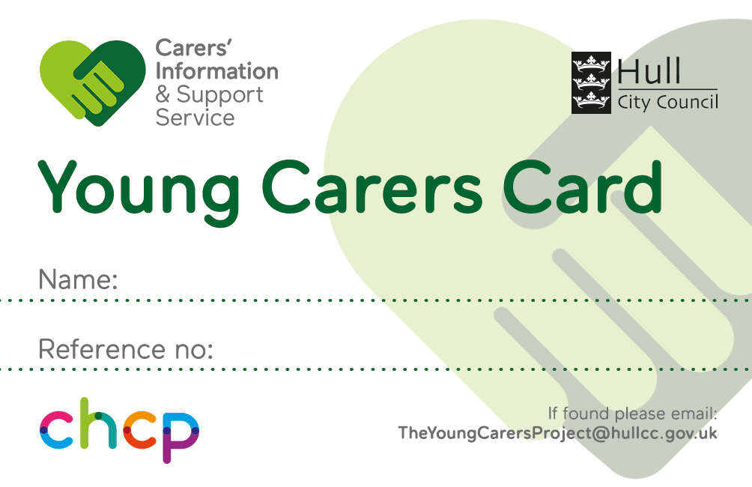

Hull City Council and the Carers Information and Support Service (CISS) in partnership with the NHS offer a Young Carers Card for young people in the City.

The Young Carers Card supports young people by officially identifying them as a young carer. The Young Carers Card offers discounted access to local health and wellbeing service and selected local shops and businesses.

For more information about this[TheYoungCarersProject@hullcc.gov.uk](mailto:TheYoungCarersProject@hullcc.gov.uk)

**How to refer and access support**

Professionals and Families can make an Early Help young carers referral for support by accessing the Hull City Council Website

<https://childrensportallive.hullcc.gov.uk/>

Young Carers aged 10 and over can contact their local youth centres to access the young carers support sessions.

**Youth Development Service Youth Centres;**

West Locality (Kingston Youth Centre and Ainthopre Youth Centre): 01482 331 238

East Locality (Andrew Marvell Youth Centre): 01482 791 226

North Locality (Route One Youth Centre): 01482 491 960 and Astra Youth Centre: 01482 310925

For further information on Young Carers Project please contact the team at; [TheYoungCarersProject@hullcc.gov.uk](mailto:TheYoungCarersProject@hullcc.gov.uk)

**How can practitioners working with adult recognise and support young carers needs?**

If you work with adults with a physical illness or disability, mental health condition, or drug or alcohol problem then you need to consider whether they have children undertaking a caring role.

Hull is committed to the family help and early intervention approach, which means that families should be enabled to have the right conversations about their needs or concerns with the right people and at the right time. By working collaboratively, we can ensure that the right level of support is provided by the most appropriate agency for that young carer and their family.

If you’re a practitioner supporting a young carer there are the following pce of guidance and tools to assist with the assessment and support.

The [Care Act and Whole‑Family Approaches](http://www.local.gov.uk/sites/default/files/documents/care-act-and-whole-family-6e1.pdf) — lays out how a practitioner should assess the needs of a family.

* [Young Carers’ Needs Assessment](http://www.local.gov.uk/sites/default/files/documents/Young%20Carers%20needs%20assessment.pdf) — provides support information for understanding how to work with young carers.
* [The Whole Family Pathway](https://www.childrenssociety.org.uk/sites/default/files/2022-12/2022419_Whole-Family-Pathway_AW.pdf) — a resource to support practitioners in implement changes in legislation for young carers and their families.

**Here is key research to help you understand the needs of young carers:**

* [Hidden from View](https://www.childrenssociety.org.uk/sites/default/files/2020-10/hidden_from_view_final.pdf) — Provides a valuable insight into the daily lives and outcomes for young carers.
* [There’s nobody is there](https://www.childrenssociety.org.uk/sites/default/files/2020-10/theres-nobody-is-there.pdf) – no one who can actually help? — looks at the challenges with estimating the number of young carers and knowing how to meet their needs.

**More Information?**

There are a range of resources both locally and nationally which offer advice and guidance on supporting young carers and their families:

* The youngcarersproject@hull
* [Young carers | Hull](https://www.hull.gov.uk/young-people/young-carers)
* The Carers Trust offer support and advice to carers, including young carers and young adult carers
* NHS guide to young carers’ rights
* Young Minds offers support and advice on young people’s mental health and wellbeing
* Childline offers a private and confidential service for children up to the age of 19, to talk to a trained counsellor over the phone by calling 0800 1111 or via online chat or email