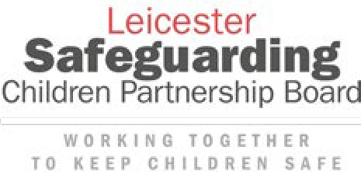

Leicester, Leicestershire and Rutland

**Practice Guidance: supporting Children and Young People who Self-Harm and/or have Suicidal Thoughts**

**Contents**

1. Introduction 3
2. Principles of our approach 4
3. Self-harm 4
4. Being Curious – asking questions and recognising the young person may need help 9
5. Understanding risk of self-harm and suicide – providing responses 11
6. Sharing Information – understanding consent 14
7. Providing on-going support 16
8. Getting further help 17
9. Training for Practitioners 18
10. Resources 19

Appendix 1 22

Do’s and Dont’s 25

Appendix 2 27



# Introduction

**Who is the document for?**

This guidance is primarily for frontline staff working with children and young people who:

* Present with self-harm and/or suicidal thoughts
* Require support as a result of self-harm, suicidal ideation and or previous suicide attempts

The guidance contributes to delivering the priority outcomes of the Leicester Safeguarding Children Partnership Board ([www.lcitylscb.org/](http://www.lcitylscb.org/)) and the Leicestershire and Rutland Safeguarding Children Partnership ([lrsb.org.uk](https://lrsb.org.uk/)).

In addition, it includes information that can be shared with children, young people and their families ([www.psych.ox.ac.uk/files/research/coping-with-self-harm-brochure _ final _ copyright.pdf)](http://www.psych.ox.ac.uk/files/research/coping-with-self-harm-brochure_final_copyright.pdf))

Overview for staff:

*Establishing a connection with young people/children is fundamental to helping them to talk to you and share their thoughts, feelings and things that they might be doing.  Things that may help to develop this relationship include, showing the young person/child that you are available whenever and however they chose to talk making clear that access to them is within the professional boundaries that you work to and offering them different ways to do this, e.g. talking or writing this down , listening and not asking too many questions about why they’ve self-harmed, letting them know it’s ok to be honest about what they’re going through. You can also encourage them to talk to another trusted adult if they’re finding it hard to talk to you.  It is important to ask them open questions about what is happening for them, however as stated in the guide we also need to ask direct questions about any plans, intent or things that may have happened in relation to self-harm or suicidal thoughts.*

*Talking about this may feel difficult or scary. You might be worried about saying the wrong thing or making the situation worse. This is understandable. But if you’re worried, it’s really important to find out how a young person or child is feeling.  Being able to share their thoughts, and knowing you’re someone they can turn to, will help them feel less alone. Asking them about their self-harm and suicidal thoughts will also help you to understand what’s going on. This means you can make a more informed decision about what to do next.*

**Why have Guidance?**

The purpose of the guidance is to:-

* Improve understanding of self-harm and suicidal ideation
* Encourage information sharing, support, advice and responses to children and young people who self-harm and/or experience suicidal ideation.

If this is achieved children and young people and their families will have:-

* Timely responses to all levels of need as soon as worries emerge.
* Good quality information and support proportionate to their needs.
* A positive experience of well-coordinated multi-agency support.
* Support for the child/young person’s self-harming behaviour and improve their emotional wellbeing.

The intention, severity and impact of the self- harming behaviour on the safety and emotional wellbeing of the child/young person should inform decisions about the support or intervention that is provided in response.

This document provides a guide for practitioners but does not replace professional judgement and expertise. It intends to support the use of existing information and resources that are available to underpin service delivery and decision-making including Leicester, and Leicestershire and Rutland Safeguarding Children Partnerships (LLR SCPs) procedures and locally defined practice standards.

The guidance includes some useful tools and links to local resources that are available to children and young people and their families. It also includes information for practitioners to ensure they can access advice and support when concerns about the severity and/or impact associated with self- harming increases.

# Principles of our approach

* Building strong relationships with children and young people and their families
* Practitioners understand their role and are curious to find out how they can help children and young people
* Practitioners have confident conversations with children and young people and really listen to what they are telling them
* Working with children, young people, parents and carers builds strong support networks, improves resilience and informs safety plans to reduce risk
* Timely information sharing to get better support for the child/ young person – and understanding consent
* Promoting multi-agency working across agencies to make best use of expertise and skills even when this may be supporting more specialist mental health treatment
* Understanding the impact on staff wellbeing and providing support and training

# Self-harm

**Understanding self-harm?**

Self-harm is a broad term which includes a variety of things that people do to hurt themselves. Self-harm is when somebody intentionally damages or injures their body.

Some of the reasons that people may self-harm include:

* expressing or coping with emotional distress
* trying to feel in control
* a way of punishing themselves
* relieving unbearable tension
* a cry for help
* a response to intrusive thoughts

Self-harm may be linked to experiences that are happening now, or in the past. But sometimes the reason is unknown.

The reasons can also change over time and will not be the same for everybody. NHS (2020)

[www.nhs.uk/conditions/self-harm/getting-help/](https://www.nhs.uk/conditions/self-harm/getting-help/)

**Who does Self Harm Affect?**

Self-harm is a common behaviour in children and young people, affecting around one in 12 people with 10% of 15-16 year olds self-harming at any time (Young Minds, 2018).

Published prevalence data of adolescents in England found that 15% had self-harmed at some point (Morey et al, 2017) average age of starting self-harm was 13yrs (Gillies et al,2018)

Rates of self-harm in children and young people reported by parents were much lower than the rates of self-harm reported by the children and young people themselves.

Rates of self-harm in looked-after children and young people are significantly higher. Approximately 39% of children and young people in residential care have self-harmed.

Research indicates that the most common method in children and young people is cutting and head-banging

(Prevalence and Characteristics of Self-Harm in Adolescents: Meta-Analyses of Community- Based Studies 1990–2015) [www.jaacap.org/article/S0890-8567(18)31267-X/fulltext](https://www.jaacap.org/article/S0890-8567(18)31267-X/fulltext)

While it is true that self-harm can affect anyone, some people are more likely to self-harm because of things that have happened in their lives – where they live, things that are happening with friends, family, or at school, or a combination of these.

Some factors might make someone more at risk of self-harm. This could include experiencing mental health problems such as depression or anxiety or struggling with other challenges such as eating disorders or trying to connect to their identity and societal

pressures around that. They may have experienced adverse childhood experiences including being abused or being exposed to difficult parental problems such as domestic abuse, substance misuse and poor mental health. They may be in the care of the Local Authority or be a young person leaving care. They may have been bereaved by suicide.

Statistics show that self-harm is more common in females, whereas completed suicide is more common in males.

**Why do people self-harm?**

Self-harm can be a way of obtaining temporary relief from a difficult and otherwise overwhelming situation or emotional state. During acts of self-harm, it is common for people to feel separate or disconnected from their emotions and pain. A sense of temporary relief is usually experienced following self-harming. Self-harm may be an attempt to communicate with, influence or secure help from others, or it may remain a secretive behaviour. People often self-harm to regain control of their situations, emotions or thoughts. It is often assumed that people who self-harm are suicidal, but for many people it is actually a way of coping or surviving. For many children and young people self-harm is something they may experiment with (in the same way that children and young people experiment with alcohol, sex, smoking etc.) and it will not become a long-term coping strategy. For others, it is indicative of underlying distress, especially if the self-harm is over a long period of time and/or is serious or life threatening.

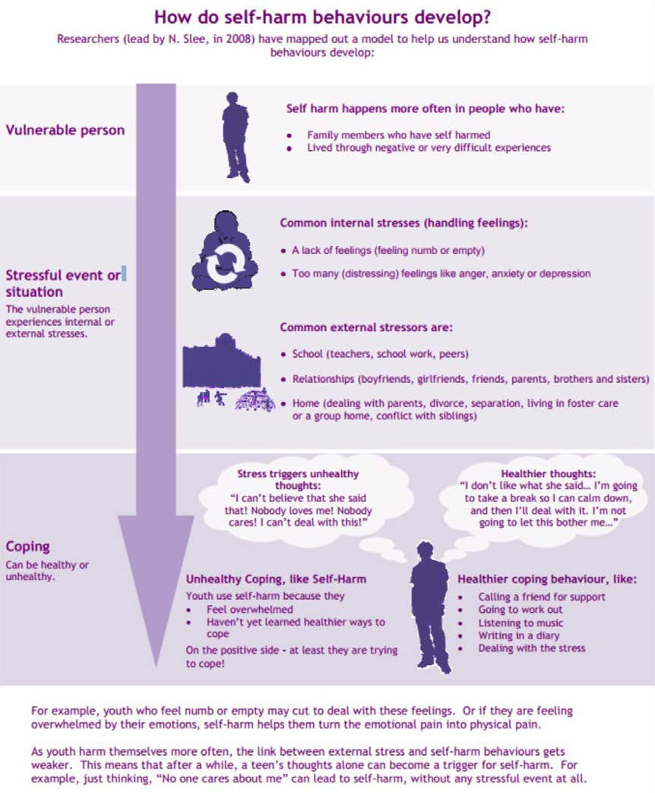

**The role of social media**

Children and young people can view content online that may normalise self-harm and potentially discourage them from seeking help or even encourage these behaviours. Despite this, social media is more commonly used for constructive reasons such as seeking support and coping strategies.

Children and young people may find it easier to talk to strangers than to close family and friends as the anonymity of online forums provides a safe place where they can access emotional help and support. It is important to encourage children and young people to make the most of these valuable aspects of social media while helping them to develop the tools to avoid aspects of online life which are problematic. Children and young people may be particularly vulnerable to wider online exploitation such as grooming and practitioners should take into account resources available more generally to support safe use of social media and online resources by children and young people. Resources are available here.

**Suicide**

Suicidal ideation, also known as suicidal thoughts, is thinking about or having an unusual preoccupation with suicide. The range of suicidal ideation varies greatly from fleeting thoughts, to extensive thoughts, to detailed planning, role playing, and incomplete attempts.

Paradoxically, self-harm can be a coping mechanism to dull mental distress with the aim to preserve life, which can be a difficult concept to understand. Despite this clear distinction, children and young people who self-harm are known to be in a high-risk group for future suicide; however suicidal feelings are likely to originate from the issues behind the self-harm rather than the self- harm itself. In some cases death occurs as a result of self-harm but is not intended. Suicide is

still a rare event in children and young people; attempted suicides are uncommon in childhood and early adolescence but increase markedly in the late teens and continue to rise until the early 20s. However, all people working with children/young people must be aware of the potential for someone to complete suicide and work together to ensure that no child/young person feels suicide is their only option.

The national confidential Inquiry into suicide and homicide NCISH (2017) identified the following themes in suicide by children and young people

* Family factors such as mental illness
* Abuse and neglect
* Bereavement and experience of suicide
* Bullying
* Suicide related internet use
* Academic pressures, especially related to exams
* Social isolation or withdrawal
* Physical health conditions that may have social impact
* Alcohol and illicit drugs
* Mental ill health, self-harm and suicidal ideas
* Adverse Childhood Experiences (ACEs)

These experiences may combine over time to increase risk, until suicide occurs in a crisis triggered by, for example, the breakdown of a relationship or exam pressures (NCISH, 2017).

Most children and young people self-harm without suicidal intent; but over half of young people who die by suicide have a history of self-harm (NCISH, 2017). It is important to take self-harm seriously, not only because it is often an expression of distress, and can cause bodily harm, but also because it is associated with an increased risk of suicide.

Local research in LLR by Child Death Overview Panel identified some common themes in suicide by children and young people

In addition to the themes identified by the NCISH, risk factors from the 2009-17 Audit also included:

* Family history of suicidal behaviour;
* Gender [particularly being male];
* Poor social and family support;
* Negative changes in the environment;
* Lack of a joined up/family approach [where necessary] in service provision.

However the most common themes emerging from the full local 2017- 2020 review were:-

* Diagnosed or suspected neuro-developmental issues (ADHD/ADD/ASD)– those leading to rigid or impulsive thinking patterns and impulsive behaviour
* The impact of parental separation on children and young people;
* The impact of combined Adverse Childhood Experiences;
* Perceived pressure at schools, with private schools featuring quite prominently;
* Many of the young people had at some point expressed to intention to kill themselves.

The NCMD Report into Self Harm and Suicide also identified a number of risk factors found in child death reviews. Practitioners should consider these risk factors and the ones mentioned below:

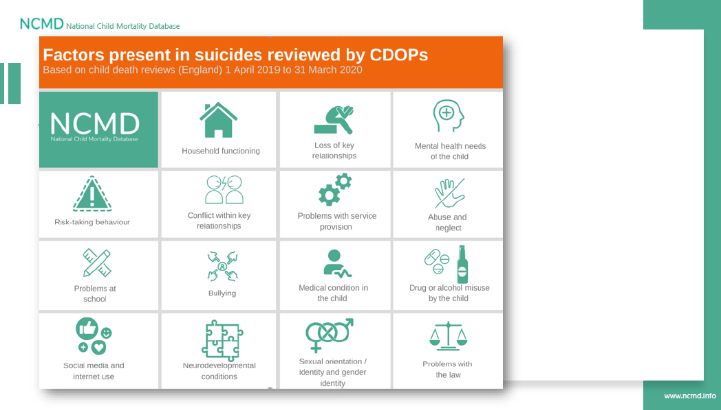

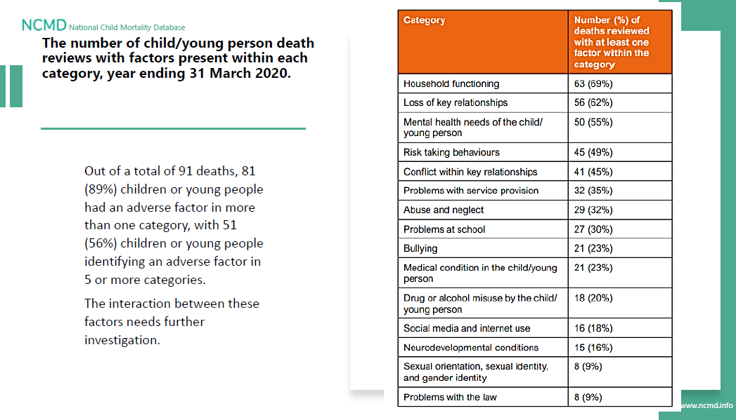

**The following risk factors below should also be considered:**

* Level of planning and intent
* Frequency of thoughts and actions
* Evidence of or disclosure of substance and/or alcohol misuse
* Delusional thoughts and behaviours
* Signs or symptoms of a mental health disorder such as depression or anxiety
* Feeling overwhelmed and without any control of their situation
* Self harming behaviours (Note - some types of self-harm are especially dangerous: self-poisoning can be fatal and repeated self-poisoning can cause accumulated organ damage which could be irreversible, ligaturing and the potential for strangulation).
* Low self esteem
* Social isolation and loneliness
* Feelings of hopelessness
* Factors identified as risks by the NCMD as outlined in the infographics above
* A physical health condition and/or poor physical health that may or may not have a social impact
* Previous history of self-harm or suicide in parents, carers, siblings, the wider family, or peer group and consideration given to the impact of this and what support can be provided.
* Bereavement whether by suicide or not of a parent, carer, sibling, peer or significant other
* Consideration given to the impact on the child/young person of parents/carers or family members who have physical health condition or diagnosis, poor physical health or mental health diagnosis/problems
* Consideration given to the impact on the child/young person of parents/carers where there is substance and/or alcohol misuse
* Isolated community support
* Fears of crimes
* Homelessness or poor housing
* Difficult times of year or anniversaries
* Peer issues including friendships, relationship breakdowns
* Bullying
* Inadequate provision of basic needs and no access to leisure or social facilities
* Trauma
* Academic pressure (especially related to performance and pressure at examination times)
* Poor parental support, relationships, parental separation including divorce and conflict within the family environment.
* Significant pressure placed on the child and setting of unrealistic goals (overachieving or underachieving).

**Warning signs:**

Children or young people who are self-harming or who are contemplating suicide may display changes in behavior, for example:

* suicide-related internet use (searching for information about suicide or posting messages with suicidal content)
* physical marks or scarring on the body
* expressions of suicidal ideation (especially to peers)
* reluctance to undress or expose specific parts of the body where injuries may be located
* changes in mood
* lowering of school grades
* becoming withdrawn
* changes in eating or sleeping habits
* expressing feelings of hopelessness or failure
* abuse of drugs or alcohol
* isolation from friends and family

Studies have also shown, however, that a proportion of young people have died as a result of suicide where this has appeared to have been ‘out of the blue’ with no known previous expression of suicidal intention, no reports of previous self-harm and where risk factors were not obviously present. This indicates that it is not always possible to identify young people at high risk of suicide.

Any assessment of risks should be talked through with the child or young person and regularly updated as some risks may remain static whilst others may be more dynamic such as sudden changes in circumstances within the family or school setting.



# Being Curious – asking questions and recognizing the young person may need help

It is important to talk to a child or young person about self-harm, even if that feels uncomfortable. Children and young people say that the first time they speak to a professional about self-harm they want to be treated with care and respect.

**Talking about Self harm and suicide some general points**

* Take concerns seriously and respond in a non-judgemental way
* Explain confidentiality requirements from the start (see below)
* Ask the child/young person to share what’s happening from their perspective
* Use active listening, for example: “Can I just check that I have understood what you mean?”
* Acknowledge the distress and show concern, for example: “That sounds very frightening. Let’s see what we can work out together to help”
* Be aware of the language they use – the child/young person may not be aware of the terms ‘self-harm’ or ‘self-injury’
* Avoid making promises and be realistic about what you can and can’t do
* Explore with the child/young person if they have any thoughts of suicide and if so the extent and nature of these thoughts
* Value your own ability to respond in an appropriate way

**Talking about Self-harm**

Try to understand if there are underlying reasons behind self-harming, rather than solely focusing on the behaviour. However, avoid asking them directly why they self-harm as many young people won’t be able to explain it and may find this distressing.

Listen and if they cannot explain, offer to help them discover the reason together. It is easy to focus on the aim of stopping the young person from self-harming; however, this may not be their goal.

Talk to them to understand the purpose self-harm is serving and come to a shared understanding of what you are hoping to achieve. Talk to the child/young person about anything that triggers them to self-harm and strategies that help in these situations:

**Talking about suicide**

<https://youngminds.org.uk/youngminds-professionals/our-projects/no-harm-done/>

It is understandable to feel anxious about talking to a child/young person about suicide. However, there is no evidence to suggest that bringing it up in conversation will encourage them to act on their thoughts. It is important to allow the child/young person to express their feelings first and for them to be heard:

##### Being curious and asking questions together with an assessment of the appearance and behaviour of the child or young person will lead to:

* An increased awareness of the child’s or young person’s needs but no further action, or
* An increased awareness of the child’s or young person’s needs so that ongoing support and potential review process can be put in place locally,

or

* Establish a recognised need for the child or young person to be referred on for a more in-depth assessment and support from specialist services (refer to flow chart below)

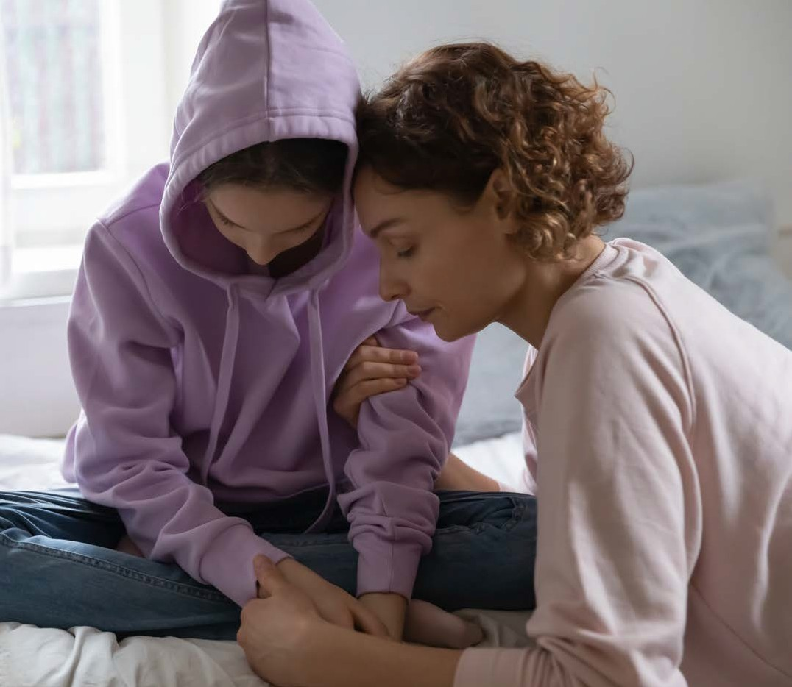

# Understanding risk of self-harm and suicide – providing responses

**Self-harming behaviour**

For many children and young people, self-harm is controlled and they do not hurt themselves in a serious way that requires medical attention; however, this may change over time as the factors that influence risk can change over time. Although it may not be part of your role to formally assess risk, it is still important to use your professional judgement to make a decision about the level of need and if there is a cause for concern.

Some methods of self-harm are particularly dangerous and the child/young person may not realise the risks involved. Self-poisoning and ligaturing (tying a rope or cord around the neck) can result in accidental death. Self-poisoning can also cause long-term organ damage so the impact may not be visible straight away.

**Suicidal thoughts**

Suicidal thoughts and feelings in a child/young person should always be met with concern. However, the risk of suicide for a child/young person may be higher in certain circumstances.

When risk is not immediate you can also use a ‘safety plan’ (**Appendix 2**) to explore their thoughts in more detail and formulate a plan for staying safe. The child/young person keeps the plan and is encouraged to follow it step by step when they feel suicidal. With the consent of the child/young person, the plan can be shared with appropriate adults in their life such as family or school/college staff. They can support them to implement the plan.



Worried about self-harm?

The urge to self-harm is like a wave

It feels the most powerful when you start wanting to do it

Learn to ride the wave with the free Calm Harm app using these activities: Comfort, Distract, Express Yourself, Release, Random and Breathe

When you ride the wave, the urge will fade

The stem4 Calm Harm app is avaliable as a free download from App Store and Google Play

[www.stem4.org.uk](http://www.stem4.org.uk/) @stem4org #calmharm #ridethewave Registered Charity No. 1144506

We encourage you to talk to a GP, teacher, family member or

friend

**Leicester, Leicestershire and Rutland Self Harm Pathway for Children and Young People**

**CHILD/YOUNG PERSON PRESENTS WITH ‘ACTUAL’ SELF HARM OR WITH IDEAS OF SELF HARM, SUICIDAL THOUGHTS OR BEHAVIOURS**

**Level of risk to be established by using Baseline Risk Assessment: Questions and Guidance (appendix A).**

**If you are concerned that there is an immediate risk to the child/young person’s physical health or that they may harm themselves or others, call 999. If there are ANY safeguarding concerns follow the LLR SCPs Safeguarding procedures procedures.**

**LOW RISK MODERATE RISK HIGH RISK**

* **Superficial harm, e.g. wounds that do not require medical attention**
* **There is no specific plan or intent**
* **Protective factors in place e.g. positive, ongoing support**
* **All suicidal thoughts are infrequent and easily dismissed**
* **The self-harm behaviour is not routine**
* **There is no accompanying risk taking behaviour or concerns about the safety to child/young personor others.**
* **The impact on daily life is minimal**
* **No specific plan or intent**
* **Suicidal thoughts are frequent but easily dismissed**
* **Recent or previous suicide attempt/s**
* **Self-harming behaviours linked to other risk factors e.g. alcohol or substance misuse**
* **The self-harm is routine and has been happening over a period of time irrespective of the severity of the self- harming**
* **The self-harm is being used frequently as a coping mechanism**
* **The impact on daily life is moderate**
* **Frequent suicidal thoughts which are not easily dismissed**
* **Specific plans and intent to act on these thoughts. Also consider if there is access to lethal means**
* **Self-harm increasing in frequency, intent and severity**
* **The self-harm is part of a complex mix of issues which increase the risk to the child/ young person and/or others**
* **There are number of risk factors present e.g. diagnosed mental health problem, high number of Adverse Childhood Experiences**
* **There is evidence that without specialist and/or clinical intervention the severity of self- harm will escalate**
* **The impact on daily life is high**

**Discuss concerns with child and parent/carer and gain consent to refer to other agencies. If they give consent consider:**

* **Early Help**
* **Healthy together 0-19 years’ service (school nursing)**
* **Children’s Centres**
* **Digital Resources online e.g. Kooth, Calm Harm app, ect (further resources in procedures)**

**If consent is not given, discuss this with safeguarding lead.**

**Give family sources of advice and information to allow them to access support and clearly record assessment.**

**Discuss concerns with child and parent/carer and gain consent to refer to other agencies. If they give consent consider:**

* **PAS (Professional Advisory Service) 0116 2955048 (Open 8.30am – 3pm weekdays) Consent is not needed to discuss a case anonymously**
* **Input from Early Help or Children’s social care**
* **Request review by GP to consider further assessment**
* **Make referral if able e.g. Healthy together 0-19 years’ service (school nursing), CAMHS, paediatrician**
* **Turning point**

**If consent is not given, discuss this with your agency’s safeguarding lead. Cases can also be discussed with the PAS if no patient identifiable details are shared. Give family sources of advice and information to allow them to access support and clearly record assessment.**

**Children, young people and parents/carers can call the Central Access Point (CAP) 24 hour phone line on 0116 295 3060 for urgent mental health support.**

* **If injured or serious and imminent risk – call 999**
* **Phone 111 or arrange GP assessment**
* **Refer to Children’s Social Care**

**Children, young people and parents/carers can call the Central Access Point (CAP) 24 hour phone line on 0116 295 3060 for urgent mental health support.**

**Through all stages communicate/liaise with all other agencies involved to provide co-ordinated multi-agency care.**

**Discuss with your agency’s Safeguarding Leads where advice and guidance is needed.**

**CONSENT**

**If there are safeguarding concerns consent need not to be obtained Consider capacity and consent**

[**www.cqc.org.uk/guidance-providers/gps/nigels-surgery-8-gillick-competency-fraser-guidelines**](http://www.cqc.org.uk/guidance-providers/gps/nigels-surgery-8-gillick-competency-fraser-guidelines)

# Sharing Information – understanding consent

**Sharing Information**

##### Good information sharing enhances effective joint working

When considering if information can be shared it is always important to :

* Explain at the outset, openly and honestly, what and how information will be shared
* Always consider the safety and welfare of a child/young person when making decisions on whether to share information about them
* Seek consent to share confidential information. You may still share information if, in your judgment, there is sufficient need to override the lack of consent
* Seek advice when you are in doubt from your manager or safeguarding lead
* Ensure the information is accurate and up to date, necessary, shared only with those people who need to see it, and shared securely
* Always record the reasons for your decision in line with GDPR principles and let the child/young person know that this will happen and who will have access to this information Involving parents, carers or another trusted adult

Understanding when to share information with parents/carers can seem complicated as it includes assessing the child’s or young person’s competency to make decisions about their care, as well as the level of risk. Make sure you are aware of your organisational safeguarding/child protection policy, as different settings take different approaches to this. If you are unsure how to proceed in an individual case, talk to a manager or safeguarding lead for advice.

**Children under 13 years old**

If a child under 13 discloses self-harming behaviour it is always important to involve a trusted adult (usually a parent/carer but explore this with the child) as the child does not have capacity to make decisions about their care. Talk to the child about how they feel and be open and supportive with them throughout the process in order to maintain a trusting relationship.

**Young people aged 13 and over**

Young people aged 13 and over can make informed choices in respect to whom they wish to share personal information with and seek support from, unless they are deemed as not competent, i.e. there are concerns about their cognitive ability to make informed choices.

Therefore, if a young person chooses not to involve their parent/carers, this must be respected under the United Nations Convention on the Rights of a Child. Confidentiality should not be breached without explicit consent from the young person concerned.

##### The exception to this is if it is deemed by the professional concerned that the information shared by the young person is causing, or may cause, significant harm to them. In such cases it is always important to share information with the relevant people, regardless of consent from the young person.

This decision-making process must be clearly recorded and must demonstrate that the welfare of the young person is the paramount principle. If it is necessary to override a young person’s right to confidentiality, you should inform the young person that you are doing so, unless in your professional judgment this compromises the young person’s safety and/or increases risk.

Developing a safety plan with the child/young person can support them to stay safe and with their consent sharing this with other practitioners and family members is a useful way to provide support and reduce risk of serious harm.



# Providing on-going support

The decision of whether to carry on supporting the child/young person within your organisation, or whether to refer on for additional support, will depend on the identified needs of the child/young person, including the level of risk, and if your service is best placed to support them. If it is appropriate to continue working with the child/young person you may want to consider the following:

* + Have you got the necessary skills?
  + Does it fit within your role?
  + Do you know who to consult for advice while you see the child/young person?
  + What does the child/young person want?

A safety plan could be used to capture the offer of help; possible triggers and strategies to be used to reduce risk and regularly review this.

Be aware that self-harm behaviours can become a usual response to daily stresses and can therefore escalate in severity.

Do not become complacent if someone presents with self-harm on a regular basis as circumstances can change and additional support may be required. If you are unsure if it is necessary to refer on, talk to your line manager or designated safeguarding lead for advice. Ensure that you record any discussions or actions related in line with your organisational policies.

If you are aware that a child or young person is awaiting services from CAMHS make sure you contact CAMHS to both provide and receive updates on support that may be in place as part of the overall risk assessment and planning. Sharing information about new concerns or wider agency involvement will assist the overarching care plan for children, young people and their families and will help in clarifying the roles of each agency involved, this will also assist in informing the timescales for intervention based upon prioritisation.

For some children where risk is high formal coordinated support and a safety plan to reduce risk may form part of the wider formal planning processes including, such as; **child in need**, **child protection or children in care.**

# Getting further help

##### Practitioners can access support for children and young people from a number of places depending on the level of concern.

##### When the risk of suicide or serious injury is high safeguarding procedures should be considered to coordinate joint approaches including making a referral for social care intervention.

##### Pathway to services locally:-

<https://lrsb.org.uk/uploads/llr-professionals-service-directory.pdf>

##### LEICESTER, LEICESTERSHIRE & RUTLAND CHILDREN & YOUNG PEOPLE MENTAL HEALTH SERVICE INFORMATION FOR PROFESSIONALS

If as part of your work with the child or young person you think they may be a victim of neglect, abuse or cruelty, contact your local Children’s Social Care office - please see the links below.

If it is an emergency, you should call the Police on 999.

You do not need to know everything about the child or what is happening. But they may have talked to you about issues that make you believe they are suffering harm which is contributing to their behaviour.

[Leicestershire County contact details](https://www.leicestershire.gov.uk/leisure-and-community/community-safety/report-abuse-or-neglect-of-a-child) [Rutland County contact details](https://www.rutland.gov.uk/my-services/health-and-family/childrens-social-care/report-a-concern-children-and-young-people/) [Leicester contact details](http://www.lcitylscb.org/what-to-do-if-you-are-concerned-about-a-child/)

For more details on making a referral (including the Multi-Agency Referral Form MARF), please see the [Referrals Procedure](https://llrscb.proceduresonline.com/p_referrals.html).

There is also Multi-Agency Referral Form (MARF) Guidance for your area [Leicestershire County Multi-Agency Referral Form (MARF) Guidance](https://llrscb.proceduresonline.com/files/marf_guidance_leicestershire.pdf) [Rutland County Multi-Agency Referral Form (MARF) Guidance](https://llrscb.proceduresonline.com/files/marf_guidance_rutland.pdf)

[Leicester Multi-Agency Referral Form (MARF) Guidance](https://llrscb.proceduresonline.com/files/marf_guidance_leicester.pdf)

# Training for Practitioners

**Mental Health First Aid Training (MHFA)** is a training program that teaches members of the public how to help a person developing a mental health problem, experiencing a worsening of an existing mental health problem or in a mental health crisis. Like traditional first aid, Mental Health First Aid (MHFA) does not teach people to treat or diagnose mental health or substance use conditions. Instead, the training teaches people how to offer initial support until appropriate professional help is received or until the crisis resolves.

[https://mhfaengland.org](https://mhfaengland.org/)

MHFA courses are delivered as part of the multiagency safeguarding training programme and are accessible here: [www.lcitylscb.org/lscpb-learning-development/](http://www.lcitylscb.org/lscpb-learning-development/)

Or here: <https://lrsb.org.uk/upcoming-events>

**Zero Suicide Alliance** 25 minute e-training (FREE) [www.talksuicide.co.uk](https://www.talksuicide.co.uk/) to take the training.

**Rural Community Council** who run a Suicide Awareness and Prevention course; [www.ruralcc.org.uk/awareness/](http://www.ruralcc.org.uk/awareness/)

**Health Education England** 1.5 hour on-line suicide prevention training (FREE) [www.hee.nhs.uk/news-blogs-events/news/new-health-education-england-learning-tool-help-health-](https://www.hee.nhs.uk/news-blogs-events/news/new-health-education-england-learning-tool-help-health-professionals-spot-early-warning-signs) [professionals-spot-early-warning-signs](https://www.hee.nhs.uk/news-blogs-events/news/new-health-education-england-learning-tool-help-health-professionals-spot-early-warning-signs)

**Applied Suicide Intervention Skills Training (ASIST)** is a two-day interactive workshop in suicide first aid. ASIST teaches participants to recognise when someone may have thoughts of suicide and work with them to create a plan that will support their immediate safety. Although ASIST is widely used by healthcare providers, participants don’t need any formal training to attend the workshop - anyone 16 or older can learn and use the ASIST model. [www.livingworks.net/programs/safetalk](https://www.livingworks.net/programs/safetalk)

##### Free online course helps parents discuss self-harm with their children:

[www.virtual-college.co.uk/news/virtual-college/2017/02/self-harm-course-launch](http://www.virtual-college.co.uk/news/virtual-college/2017/02/self-harm-course-launch)

**Local LLR website:** [www.startaconversation.co.uk/about-us](https://www.startaconversation.co.uk/about-us)

**CAMHS Young People’s Team also offer a programme of training (only for people who are working with a child/Young Person who fits the team criteria) – which can be found here:** [www.lcitylscb.org/lscpb-learning-](http://www.lcitylscb.org/lscpb-learning-development/) [development/](http://www.lcitylscb.org/lscpb-learning-development/)**Or here:** <https://lrsb.org.uk/upcoming-events>

**Harmless:** The Harmless website training page is <https://harmless.org.uk/training/>

##### The Eventbrite page to book training is

[www.eventbrite.co.uk/o/harmless-lets-talk-training-14795237737](https://www.eventbrite.co.uk/o/harmless-lets-talk-training-14795237737)

**Final notes - Key Messages**

* Do not be afraid to talk about self-harm and suicide
* Respond in a non-judgemental way
* Do not just focus on the self-harm or suicidal intent; consider the underlying issues
* Be clear about your own organisational policies
* Refer on for support or speak to a specialist if you are unsure about the level of risk
* Work with other practitioners to ensure relevant information is shared when appropriate
* Remember you can play a part in keeping children and young people safe

# Resources

|  |  |  |
| --- | --- | --- |
| Mental health information and service user leaflets | Royal college of Psychiatrists | [www.rcpsych.ac.uk/healthadvice/parentsandyouthinfo.aspx](http://www.rcpsych.ac.uk/healthadvice/parentsandyouthinfo.aspx) |
| Information page and self help | Royal college of Psychiatrists | <https://www.rcpsych.ac.uk/mental-health/problems-disorders/self-harm> |
| Self-help information | CWM Taf Wales | <http://cwmtaf.wales/services/mental-health/stabilisation-pack/> |
| Toolkits, videos and resource packs for young people and parents/carers | Young Minds: No harm done | <https://youngminds.org.uk/what-we-do/our-projects/no-harm-done/> |
| Information for parents/carers on supporting a YP who self- harms | NSPCC | <https://www.nspcc.org.uk/preventing-abuse/keeping-children-safe/self-harm/> |
| Self-Harm helpline and crisis support | Hopeline UK/ Papyrus | 0800 068 41 41 or [www.papyrus-uk.org](http://www.papyrus-uk.org/) |
| Self-harm | Papyrus | [www.papyrus-uk.org](http://www.papyrus-uk.org/) |
| Self-harm information leaflets and forum | National Self Harm network | [www.nshn.co.uk/downloads.html](http://www.nshn.co.uk/downloads.html) |
| Service user led resource including on-line information and support to service users and carers/family | Harmless | [www.harmless.org.uk/](http://www.harmless.org.uk/) |
| Mobile App for service users | Calm harm App | <https://calmharm.co.uk/> |
| Service user leaflets and  self-help guides on a range of mental health difficulties | Northumberland Tyne and Wear NHS Trust | <https://web.ntw.nhs.uk/selfhelp/> |
| Mental health and wellbeing information, crisis support and self-help apps | NHS.UK | [www.nhs.uk](http://www.nhs.uk/)>oneyou>everymindmatters  [https://apps.beta.nhs.uk](https://apps.beta.nhs.uk/) |
| Information for parents/carers on common mental health difficulties in children and how to help | [www.nhs.uk](http://www.nhs.uk/) moodzone | <https://www.nhs.uk/conditions/stress-anxiety-depression/anxiety-in-children/> |
| On My Mind aims to empower young people to make informed choices about their mental health & wellbeing | On My Mind | <https://www.annafreud.org/on-my-mind/> |
| Telephone counselling/crisis support | Samaritans | 08457 909090 |
| Emotional health advice and counselling | Childline | 0800 1111 or  [www.childline.co.uk](http://www.childline.co.uk/) |
| On-line counselling | Kooth | [www.Kooth.com](http://www.Kooth.com/) |
| Emotional health and mental Health information and information leaflets | Mind | [www.mind.org.uk](http://www.mind.org.uk/) |
| Mental health information and information leaflets for service users and parents/carers | Young Minds | www.youngminds,org.uk |
| Emotional Health advice for under 25’s | The Mix | Freephone 0808 808 4994 |
| Emotional and mental health resources for children, families and schools including leaflets and podcasts | The Anna Freud national centre for Children and families | [www.annafreud.org/services-schools/schoolsinmind](http://www.annafreud.org/services-schools/schoolsinmind) |

|  |  |  |
| --- | --- | --- |
| Bereavement | The Laura Centre | www.thelauracentre,org,uk |
| Bereavement support for children following death of sibling or parent | Winstons Wish | [www.winstonswish.org.uk](http://www.winstonswish.org.uk/) |
| Bereavement | Cruse RD4U | Telephone: 0808 808 1677 (9.30am-5pm)  www.rd4u.org,uk |
| Bullying  Resources on bullying including cyber-bullying, transition to secondary school and sexual abuse | Kidscape | [www.kidscape.org.uk](http://www.kidscape.org.uk/) |
| Bullying | Beat Bullying | [www.beatbullying.org](http://www.beatbullying.org/) |
| Domestic Violence helpline | National Domestic Violence helpline | 0808 2000 247  [www.thehideout.org.uk](http://www.thehideout.org.uk/) |
| Family Issues | Relate | 0116 254 3011 or 0777 357 9005 |
| Text messaging service for health advice for young people and their parents/carers | Chat health | Chat health: 07520 615 386 (city); 07520 615 387 (county)  Parent Chat health: 07520 615 381 (city); 07520 615 382 (county) |
| Health promotion website with local links and resources | Health for teens | [www.healthforteens.co.uk](http://www.healthforteens.co.uk/) |
| Health promotion website with local links and resources aimed at younger children (approx. primary school age) | Health for Kids | [www.healthforkids.co.uk](http://www.healthforkids.co.uk/) |

**Professional Resources**

|  |  |
| --- | --- |
| Nice Guidance: self-harm in over 8’s short-term management and prevention of reoccurrence | [https://www.nice.org.uk/guidance/cg16/resources/selfharm-in-](https://www.nice.org.uk/guidance/cg16/resources/selfharm-in-over-8s-shortterm-management-and-prevention-of-recurrence-pdf-975268985029) [over-8s-shortterm-management-and-prevention-of-recurrence-](https://www.nice.org.uk/guidance/cg16/resources/selfharm-in-over-8s-shortterm-management-and-prevention-of-recurrence-pdf-975268985029) [pdf-975268985029](https://www.nice.org.uk/guidance/cg16/resources/selfharm-in-over-8s-shortterm-management-and-prevention-of-recurrence-pdf-975268985029) |
| Nice: Interactive flow chart- self-harm | <https://pathways.nice.org.uk/pathways/self-harm> |
| Nice Guidance: self-harm in over 8’s –longer term management | [https://www.nice.org.uk/guidance/cg133/resources/selfharm-in-over-](https://www.nice.org.uk/guidance/cg133/resources/selfharm-in-over-8s-longterm-management-pdf-35109508689349) [8s-longterm-management-pdf-35109508689349](https://www.nice.org.uk/guidance/cg133/resources/selfharm-in-over-8s-longterm-management-pdf-35109508689349) |
| NICE Guidance: risk assessment tools | [www.nice.org.uk/donotdo/do-not-use-riskassessment-tools-and-](http://www.nice.org.uk/donotdo/do-not-use-riskassessment-tools-and-) scales-to-predict-future-suicide-orrepetition-of-selfharm |
| Self-harm and suicide prevention competency framework | [https://www.ucl.ac.uk/pals/sites/pals/files/self-harm _ and _ suicide _](https://www.ucl.ac.uk/pals/sites/pals/files/self-harm_and_suicide_prevention_competence_framework_-_children_and_young_8th_oct_18.pdf) [prevention _ competence _ framework _ - _ children _ and _](https://www.ucl.ac.uk/pals/sites/pals/files/self-harm_and_suicide_prevention_competence_framework_-_children_and_young_8th_oct_18.pdf)  [young _ 8th _ oct _ 18.pdf](https://www.ucl.ac.uk/pals/sites/pals/files/self-harm_and_suicide_prevention_competence_framework_-_children_and_young_8th_oct_18.pdf) |
| Mental health of Children and Young People in England, 2017 | [https://digital.nhs.uk/data-and-information/publications/statistical/](https://digital.nhs.uk/data-and-information/publications/statistical/mental-health-of-children-and-young-people-in-england/2017/2017) [mental-health-of-children-and-young-people-in-england/2017/2017](https://digital.nhs.uk/data-and-information/publications/statistical/mental-health-of-children-and-young-people-in-england/2017/2017) |
| CAMHS Safety plan | Link: here |
| Stabalisation pack: A range of self-help resources produced by service users and the psychology team in Cwm Taf Wales | <http://cwmtaf.wales/services/mental-health/stabilisation-pack/> |
| Royal college of Psychiatrists | [www.rcpsych.ac.uk](http://www.rcpsych.ac.uk/) |
| Mental Health Foundation | [www.mentalhealth.org.uk](http://www.mentalhealth.org.uk/) |
| The Association for Child and Adolescent Mental Health | <https://www.acamh.org/topic/anxiety-disorders/> |
| Assist: Grass root suicide prevention- downloadable resources | [https://www.prevent-suicide.org.uk/find _ help.html](https://www.prevent-suicide.org.uk/find_help.html) |

|  |  |
| --- | --- |
| Get self help- downloads and worksheets | [www.getselfhelp.co.uk](http://www.getselfhelp.co.uk/) <https://www.getselfhelp.co.uk/docs/CopingSuicidalThoughts.pdf> <https://www.getselfhelp.co.uk/docs/SafetyPlan.pdf>  <https://www.getselfhelp.co.uk/docs/CrisisManagementPlan.pdf> |
| Evidence-based tools and resources for therapy | [www.psychologytools.com](http://www.psychologytools.com/) |
| e-learning for practitioners | [www.minded.org.uk](http://www.minded.org.uk/) |
| DOH- Future In Mind: promoting, protecting and improving our children and young people’s mental health and well-being | [https://assets.publishing.service.gov.uk/government/uploads/system/](https://assets.publishing.service.gov.uk/government/uploads/system/uploads/attachment_data/file/414024/Childrens_Mental_Health.pdf) [uploads/attachment _ data/file/414024/Childrens _ Mental _ Health.](https://assets.publishing.service.gov.uk/government/uploads/system/uploads/attachment_data/file/414024/Childrens_Mental_Health.pdf) [pdf](https://assets.publishing.service.gov.uk/government/uploads/system/uploads/attachment_data/file/414024/Childrens_Mental_Health.pdf) |
| Understanding and responding to children and young people at risk  of self-harm and suicide: A guide for practitioners | [http://www.cpft.nhs.uk/PDF/Miscellaneous/U%20R%20CYP%20](http://www.cpft.nhs.uk/PDF/Miscellaneous/U%20R%20CYP%20at%20risk%20of%20selfharm%20and%20suicide%202014%20v1%20electronic.pdf) [at%20risk%20of%20selfharm%20and%20suicide%202014%20](http://www.cpft.nhs.uk/PDF/Miscellaneous/U%20R%20CYP%20at%20risk%20of%20selfharm%20and%20suicide%202014%20v1%20electronic.pdf) [v1%20electronic.pdf](http://www.cpft.nhs.uk/PDF/Miscellaneous/U%20R%20CYP%20at%20risk%20of%20selfharm%20and%20suicide%202014%20v1%20electronic.pdf) |
| Truth about self-harm - extra for young people, friends and family | Link: here |
| A guide for schools - extra information for schools | Link: here |
| Coping with self-harm A guide for Parents and Carers | [www.psych.ox.ac.uk/files/news/copy _ of _ coping-with-self-harm-](http://www.psych.ox.ac.uk/files/news/copy_of_coping-with-self-harm-) brochure _ final _ copyright.pdf |
| ‘No Harm Done – a Parents Journey’ | [www.youtube.com/watch?v=b4cPCcJ6o88](http://www.youtube.com/watch?v=b4cPCcJ6o88) |
| EVERYMIND | [https://everymind.org.au/suicide-prevention/understanding-suicide/](https://everymind.org.au/suicide-prevention/understanding-suicide/messaging) [messagin](https://everymind.org.au/suicide-prevention/understanding-suicide/messaging)g |
| YoungMinds Offer a helpline especially for parents | <https://youngminds.org.uk/find-help/for-parents/parents-helpline/> |
| We can Talk - Which has good practical tips for caring for the young person with mental health problems | [www.wecantalk.online/fundamentals](http://www.wecantalk.online/fundamentals) |

Children and young people can experience a range of difficulties at any time in their life. Early help services are for children and young people of any age and can be supported from all kinds of services and organisations who work together to support the family. The Early Help offer across LLR brings together a range of services to support children, young people and their families who need some additional help.

**How to access Early Help:**

**Leicester City:** call 0116 454 1004 or via email to [early-help@leicester.gov.uk](mailto:early-help@leicester.gov.uk)

Leicester City Early Help and Prevention Offer [www.leicester.gov.uk/media/186710/early-help-and-prevention-offer.pdf](https://www.leicester.gov.uk/media/186710/early-help-and-prevention-offer.pdf)

##### Leicestershire County Council:

Referrals to [Early Help](https://resources.leicestershire.gov.uk/education-and-children/child-protection-and-safeguarding/early-help) are taken via the Children’s Duty Team on **0116 305 0005**

##### Rutland County Council:

Contact the [Early Help](https://www.rutland.gov.uk/my-services/health-and-family/early-help/) team on **01572 722 577** or email via secure email [EarlyHelp@rutland.gov.uk](mailto:EarlyHelp@rutland.gov.uk)

# Appendix 1

**Examples of questions to ask when considering the next step**

##### First Contact – Baseline Risk Assessment Stage

A child, peer or parent/carer may directly contact a member of staff. Equally a worker may notice a change in the child’s behaviour or appearance that leads to a cause for concern. Either way, an early baseline assessment should take place to ensure that the child or young person gets timely and appropriate support. Be mindful of capacity and consent [www.cqc.org.uk/guidance-providers/gps/nigels-surgery-8-gillick-competency-fraser-](https://www.cqc.org.uk/guidance-providers/gps/nigels-surgery-8-gillick-competency-fraser-guidelines) [guidelines](https://www.cqc.org.uk/guidance-providers/gps/nigels-surgery-8-gillick-competency-fraser-guidelines)

All key contacts need to feel confident to make an early baseline assessment via a number of basic but important questions – See below

##### Baseline Risk Assessment: Questions and Guidance

* 1. Initial questions
* Talk me through what has been happening?
* Where are you currently? Are you with anyone – if so who?
* Have you got any injuries or taken anything that needs attention? If so attempt to ascertain details of the nature and extent of potential harm. Depending on response consider emergency action.
* Who knows about this?
* Have you thought about hurting or harming yourself? Do you have thoughts of wanting to die? Are you planning to do any of these things – consider likely or imminent harm (intent)
* Have you got what you need to do it (means)?
* Have you thought about when you would do it (timescales)?
* Are you at risk of harm from others?
* Is something troubling you? – family, school, social, consider use of safeguarding procedures.
  1. Responses
* If an urgent medical response is needed call an ambulance
* Say who you will have to share this with (e.g. parent/carer designated teacher) and when this will happen
* Say who and when someone will speak with them again to help and support them
* Check what they can do to help keep themselves safe until they are seen again e.g. stay with friends at break time, go to support staff.
* Be clear that its ok to talk about self-harm and suicidal thoughts and behaviour
  1. Setting up the contract with the child or young person
* Discuss confidentiality and the limitations of this (e.g. that some information cannot be kept confidential and will need to be shared with the appropriate agency).
* Discuss safeguarding if necessary
* Discuss who knows about this and discuss contacting parents/carers
* Discuss who you will contact
  1. Further Questions
* What if any self-harming thoughts and behaviours have you considered or carried out? (Either intentional or unintentional – consider likely/imminent harm)
* If so, have you thought about when you would do it?
* How long have you felt like this?
* Are you at risk of harm from others?
* Are you worried about something?
* Ask about the young person’s health (use of drugs/alcohol)?
* What other behaviour or activities have you been doing that could place you at risk?
* What have you been doing that helps?
* What are you doing that stops the self-harming behaviour from getting worse?
* What can be done in school to help you with this?
* How are you feeling generally at the moment?
* What needs to happen for you to feel better?

##### Outcome

Responses to the questions, together with an assessment of the appearance and behaviour of the child or young person will lead to some or all of the following:

* Referral to children’s social care for initiation of child protection procedures
* An increased awareness of the child’s or young person’s needs and an on-going support and potential re-assessment system being put in place locally, or
* A recognised need for the child or young person to be referred on for more in-depth assessment and support.

##### Other considerations:

* What might be the function of self-harm (other than a clear suicide attempt) – what did the young person hope the act would achieve: a sense of relief or release; punishment; purification; a desire to feel physical rather than emotional pain; a form of communication of distress or other significant matter; something else?
* Method of self-harm – be aware of unintended consequences, such as liver damage from repeated ‘Paracetamol’ overdoses, stomach ulceration from aspirin overdose, brain damage from oxygen starvation in attempted hanging, drowning or exhaust poisoning, or bone damage resulting from jumping (this is not suggesting that

these be discussed with the young person at this point in time but may indicate the need for referral on to other services for a physical health assessment).

* Time of year may be significant, especially when school-related factors are involved, such as bullying or exams. Hence the start of terms or exam periods may see an increase in self-harming behaviour.
* Young people may be highly ambivalent in their views of themselves and any act of self-harm.
* Looked After Children - if a child/young person is Looked after then The Looked After Health Team should also be notified if a child has self- harmed (though this should not replace contact with Mental Health services and should be in addition to notification of child’s social worker)

## Do’s and Don’ts

**Do’s**



* Make first line assessment of risk
* Take suicide gestures seriously
* Be yourself, listen, be non-judgemental, patient, think about what you say
* Check associated problems, such as bullying, bereavement, relationship difficulties, abuse and sexuality questions
* Check how and when parents/carers will be contacted
* Encourage social connection to friends, family, trusted adults
* Implement initial care pathway
* Implement support/contact with young person
* Make appropriate referrals
* Set-up a meeting to plan the care pathway interventions based upon understanding of the risk and difficulties
* Provide opportunities for support, strengthen existing support systems

**Don’ts**



* Jump to quick solutions
* Dismiss what children or young people are saying
* Believe that a young person who has threatened to harm themselves in the past will not carry it out in the future
* Disempower the child or young person
* Ignore or dismiss people who self-harm
* See it as attention-seeking
* Assume it is used to manipulate the system or individuals
* Trust appearances
* Tell the child their actions are wrong/naughty
* Tell the child they need to stop
* Tell the child to make promises they can’t keep (around their self-harm

##### At this stage it is strongly recommended that the professional should ask the young person who else is aware of the young person’s circumstances or has been involved to avoid risk assessment duplication.

Responses to the risk assessment questions together with an assessment of the appearance and behaviour of the child or young person will lead to:

* An increased awareness of the child’s or young person’s needs but no further action, or
* An increased awareness of the child’s or young person’s needs and an ongoing support and potential re-assessment system being put in place locally, or
* A recognised need for the child or young person to be referred on for a more in-depth assessment and support (refer to flow chart).

**My Safety Plan**

**Appendix 2**

#### If you sometimes struggle with thoughts around self-harm or feel like you might do something that makes you feel unsafe, it can be helpful to create a plann to keep your self safe when thoughts feel overwhelming.

#### When you are feeling unsafe, follow the plan one step at a time until you are safe. Remeber, these feelings will pass.

1. **What warning signs or triggers are there that make me feel more out of control?**

***For example, this could be particular places, people, feelings or memories.***

1. **What ways of coping have I used in the past that helped?**
2. **What would I tell a close friend to do who was feeling this way?**
3. **What could others do that would help?**

LLR Self-harm and Suicide Guidance 27

1. **If I feel like harming myself or doing something that puts myself at risk, I will do one of the following: (try to list 6-8 items)**
   1. **.............................................................................................................**
   2. **.............................................................................................................**
   3. **.............................................................................................................**
   4. **.............................................................................................................**
   5. **.............................................................................................................**
   6. **.............................................................................................................**
   7. **.............................................................................................................**
   8. **.............................................................................................................**
2. **If the plan does not work and I stil feel like harmong myself, or putting my self at risk then I will do at least one of these things.**

**Contact my CAMHS worker/duty clinician on (Mon-Fri 9-5pm)**

**Phone the Samaritans on 0116 123 007 Free 24hr confidential helpline Call Childline on 0800 1111 Free helpline for children & young people in danger**

**Text Chat Health on 07520615387 ..11-19 text service with school nurses (Mon-Fri)**

**Contact YoungMinds on 0808 802 5544 or youngminds.org.uk (Mon-Fri 9.30am-4pm)**

**Get in touch with Kooth at https://kooth.com/ Online counselling**

**In case of an out-of-hours emergency, contact and out-of-hours GP or visit a local Accident and Emergency Dept**

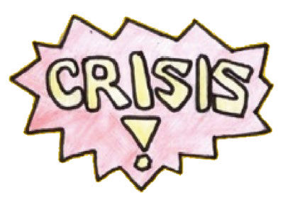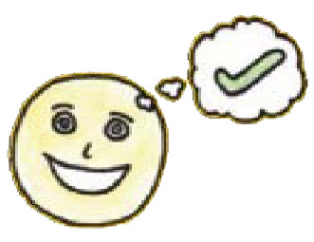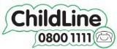

Leicester

U0918

### Safeguarding

Children Partnership Board

WORKING TOGETHER

TO KEEP CHILOREN SAFE

**Safeguarding** .

**Children Partnership**



LEICESTERSHIRE & RUTLAND