**Quality Assurance Framework**

**What is a Quality Assurance Framework and why do we need one?**

Quality Assurance is an umbrella term, which embraces all activity that contributes to service improvement. Quality Assurance activities evidence strengths and good practice; identify gaps and areas for development; drive learning and positive practice and monitor compliance with policies and procedures. Critically, this helps us to see what difference we made for the child/ young person and how can we improve and strengthen outcomes.

A Quality Assurance Framework helps those with leadership, senior management, case management or scrutiny responsibility to understand how effectively Merton Children’s Social Care & Youth Inclusion is delivering services to keep children / young people safe, promote positive outcomes and identify where improvements should be focused. Our Quality Assurance framework feeds into improving and upskilling our workforce and can help us to identify key areas for improvement.

At service and individual practitioner level the essential judgement is whether we are making a difference and improving outcomes for the children and families we come into contact with and how do we know this.

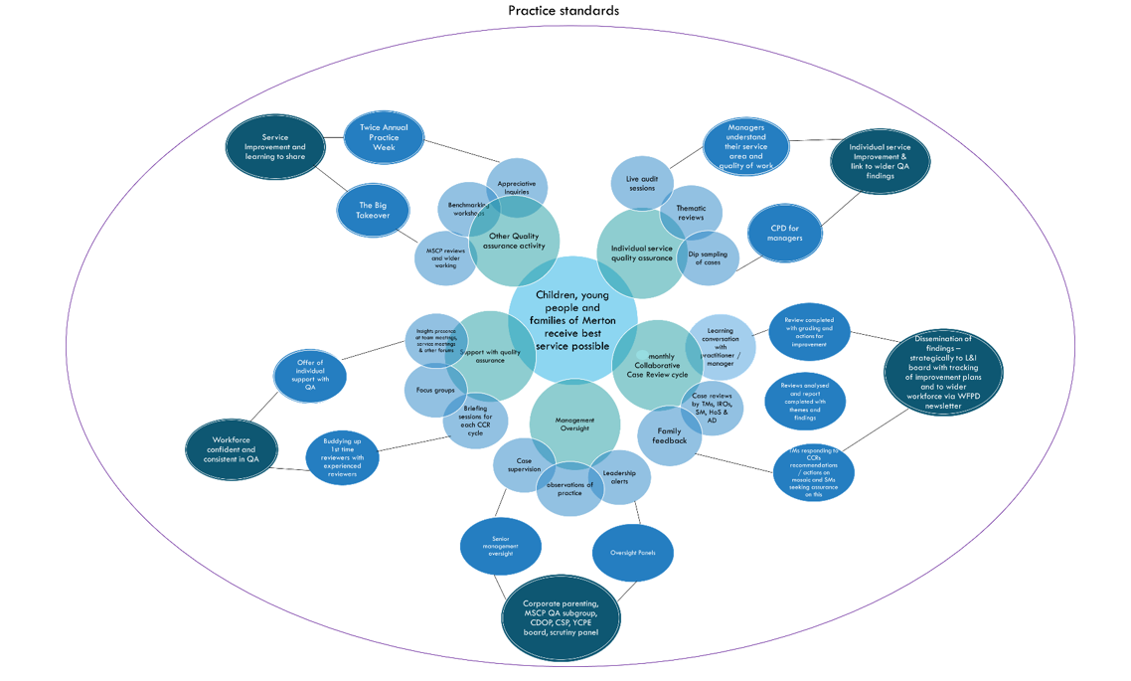

**We need to ensure:**

* We are providing services that are of a good standard.
* The service we are providing is having a positive impact for the child / young person and their family.
* The child / young person’s voice and views are central to what we do.
* Our intervention leads to improved outcomes.

**Merton Practice Framework**

Our practice model provides an evidence-based framework which develops consistent knowledge and skills across the workforce and supports our ambitions for the children and families in Merton. Using this common language and relationship-based approach supports integrated working across the organisation with our partners, while maintaining the focus on supporting children and families to improve outcomes.

**Practice Values:**

* Children are supported to remain in their families and communities.
* We will see children, hear children, keep them safe and promote their welfare.
* We will work in a respectful, open, and transparent way with our families, partners, and colleagues.
* We will be culturally competent and understand the meaning this has for our families.
* We recognise that every contact is an opportunity to create positive change through the relationships we build.

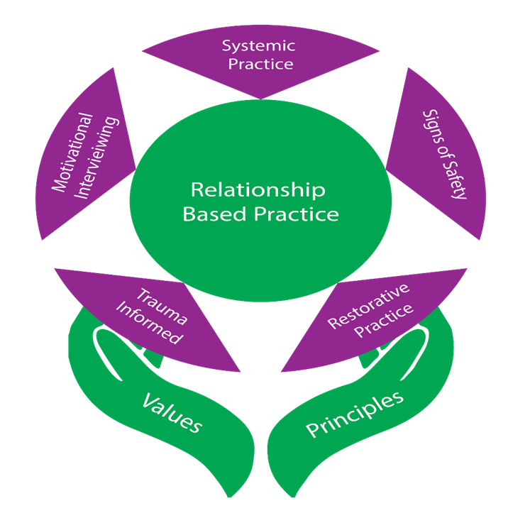

**Core Values for Quality Assurance**

* Curiosity through enquiry.
* Empowerment through discussion.
* Family focus in all activity.
* Strengths based and restorative.
* Collaboration at all stages.
* Meaningful and purposeful practice recommendations.

**Scaling**

In Merton Signs of Safety is a core element of our Practice Model and our scaling aligns with the Ofsted outcomes. Full descriptors are attached within the appendix.

|  |  |
| --- | --- |
| **Inadequate (0-2)** | The intervention is failing to protect the child/ young person from experiencing harm and/or continuing to be at risk of harm. The intervention is not meeting the needs of the child/ young person or improving their outcomes. |
| **Requires Improvement (3-5)** | The child/young person is not being harmed or left at risk of being harmed. However, the impact of intervention is not yet consistently delivering support which is of a good standard and is improving the child/young person’s outcomes. |
| **Good**  **(6-8)** | There is good support for the child/young person and family. This is protecting the child/young person from harm and resulting in measurable improved outcomes for them. |
| **Outstanding (9-10)** | There is consistently good or better support for the child/young person and family. This is protecting the child/young person from harm and resulting in significant and measurable improved outcomes for them. |

**How we Quality Assure in Merton**

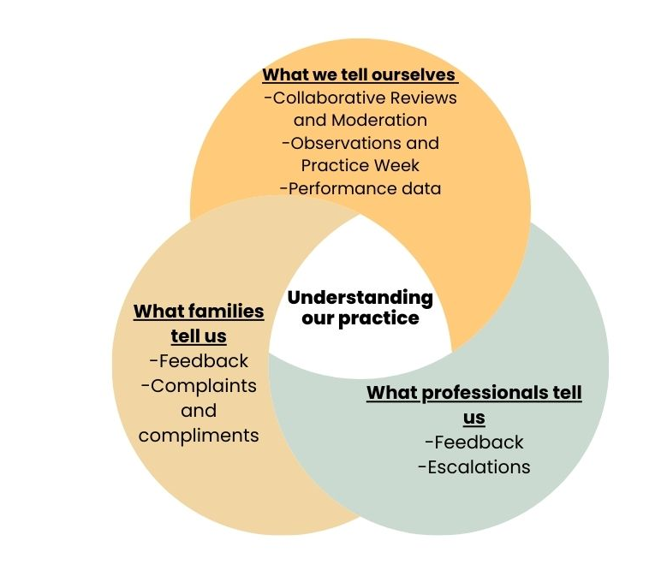

**Quantitative data**

Quantitative data is trying to quantify a problem; it is data that can either be counted or compared on a numeric scale. This could be performance and statistical data and is a method of quantifying what we do.

**Qualitative data**

Qualitative data is information that cannot be counted, measured, or easily expressed using numbers. This could be reading and reflecting on case files, having conversations, undertaking observations, and seeking feedback. This all provides rich data for analysis.

**Collaborative Review (CR) cycle**

Within Merton Children’s Social Care and Youth Inclusion (CSC&YI) we have a monthly Collaborative Review (CR) cycle. Within each cycle our cohort of Practice Reviewers will undertake a collaborative review of a child / young person’s record. Our reviewing cohort consists of our Team Managers (TMs), Independent Reviewing Officers (IROs), Service Managers (SMs), Head of Services (HoS), Director and equivalents.

**Collaborative Review Process**

**Moderation**

Our moderation process is to ensure that all CRs are completed to a high standard before they are returned to the case holding team and uploaded to Mosaic. A monthly moderation panel is held to review any Outstanding and Inadequate CRs. This is a space to benchmark the quality of reviews, seek consistency, as well as identifying key themes from CRs. Practice Reviewers and Team Managers are invited to the moderation panel to discuss the CR. The moderated grade will be final accepted grade however both grades will be reflected within the CR.

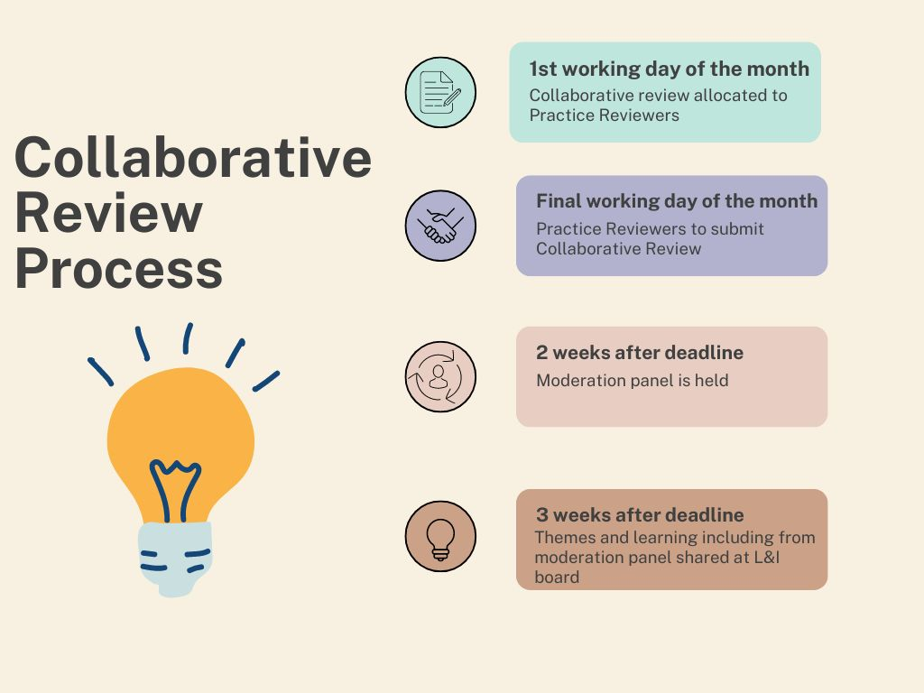

**What do we do with these findings?**

* All CRs are compiled and analysed as a cohort to understand the quality of practice within this area of focus. Scaled questions, overall grading and feedback from families is triangulated as part of the analysis.
* A CR report is produced by the Insights Team. This outlines the key findings, identifies good practice and develops an improvement plan based on the area of focus.
* The findings are shared with senior leaders and inform service plans and strategic planning.
* Our improvement plan is shared with our Workforce Practice Development (WPD) team to consider how to improve practice.
* The findings are disseminated through the WPD newsletter to our workforce including good practice examples and interventions around areas to improve practice.
* Actions for improvement are tracked by the Insights team and shared at Learning and Improvement (L&I) board.
* The Insights Team will review all Requires Improvement / Inadequate cases and track practice recommendations and assurance to close the loop. This is to ensure that we have high assurance that the CCR has sustained or delivered the required improvement for a child / young person.

**Escalations**

If a case is considered ‘Inadequate’ by a reviewer or moderator the findings must immediately be shared with Insights Team Manager, Insights Service Manager, Insights Head of Service, Child’s Team Manager, Child’s Service Manager & Child’s Head of Service. The Child’s Service Manager must review the child’s record in 24 hours and record mosaic assurance on the safety of those it relates to and quality of the work. Any urgent actions must be undertaken to ensure any children / young people are safe. If there is any dispute regarding the level of concern, the Insights Head of Service will provide the final decision.

The Dispute Resolution Process, known as DRP, is an escalation process adopted by the IRO’s & FIRO to action where concerns have been identified. In the first instance, the IRO/FIRO will seek to resolve the issue informally with the social worker or the social worker’s manager. If this is not resolved in a timescale appropriate to child’s needs, the IRO will consider taking formal action and completing Stage 1 of the DRP. The formal DRP has a timescale of no more than 20 working days to resolution.

**Supervision**

*“Effective supervision is an integral part of our practice and an important component of the Children's Social Care and Youth Inclusion (CSC&YI) performance management framework. It is a fundamental belief that our staff are the most important asset in fulfilling our responsibility to provide a quality service to children, young people, and families and foster carers. The supervision and development of all staff are significant processes in the success of the organisation.”*

[Merton Supervision Policy and Procedure](https://mertoncs.proceduresonline.com/p_sup_pol.html?zoom_highlight=supervision)

**Minimum case supervision requirements:**

|  |  |
| --- | --- |
| **Assessment and Intervention** | There will be regular management oversight during the assessment process. The first management oversight and supervision takes place at 10 days and then at a minimum of four weekly. Manager and worker should agree which cases they will discuss in detail in supervision. |
| **Child in Need** | Four weekly, with priority for detailed reflective supervision and/or mapping where cases are complex or 'stuck'. |
| **Child with Disability i.e. No parental concerns, focus is primarily on disability)** | Every 12 weeks. See above for children with a disability or are considered 'in need'. |
| **Child Protection/Court** | 4 weekly. |
| **Children Looked After** | Every 8 weeks. With Head of Service agreement this can be extended to 12 weeks. Head of Service agreement must be recorded on the child's record with the rationale. |
| **Care Experienced** | Every 12 weeks. |

**Supervision following case review:**

* Insights will add the collaborative review to Mosaic with case note alert to Child’s SW, TM & SM 5 days after review is returned to the allocated team. This will allow the allocated team time to read the review and discuss findings with the reviewer.
* Team Managers will add a record of case supervision to Mosaic following the collaborative case review.
* Team Managers will reflect with SW on the scaling and actions to improve quality where necessary and add any updates and rationale regarding decisions.
* Service Managers to seek assurance on any ‘Inadequate’ cases following escalation.
* Collaborative Reviews scaled as ‘Requires Improvement’ and ‘Inadequate’ will be tracked by the Insights team for assurance including identifying if supervision was added to address the collaborative case review and if actions have been completed.
* Findings will be shared at boards and panels including DMT, CSMT, Corporate Parenting, MSCP and Learning & Improvement board.

**Management Oversight definition**

*“Where a supervisor or manager reviews a child’s record via discussion or by reviewing the child’s record and actions are noted on Mosaic using a Management Decision case note.”*

[Management Oversight – Supervision Policy and Procedure](https://mertoncs.proceduresonline.com/p_sup_pol.html?zoom_highlight=management+oversight#2.-what-is-supervision-definition,-context-and-theoretical-framework)

Management oversight extends to senior leadership oversight through boards, panels, and leadership alerts. Our aim is to continue to develop and cultivate a learning culture in which the whole workforce has a role within QA. Some of our key staffing are:

* Principal Social Worker & Workforce & Practice Development (WPD) Team.
* Fostering Independent Reviewing Officer (FIRO) & annual report.
* Local Authority Designated Officer (LADO) & annual report.
* Independent Reviewing Officers (IROs) & Dispute Resolution Process (DRP) and reporting.

**Other QA activity**

Bespoke quality assurance guidance and support can be requested from the Insights team – [Insights@merton.gov.uk](mailto:Insights@merton.gov.uk).

Other activity

* Dip sampling / thematic reviews.
* Benchmarking workshops for managers / other CPD activities for the workforce.
* Live audit sessions including multi-agency partners.
* Appreciative Inquiries.
* Practice observations.
* Young Scrutineers and Young Inspectors reviewing case work.
* Practice Week – twice annual week-long event across CLLF to celebrate and share good practice.
* Takeover day – annual event in which young people will ‘takeover’ roles within the council.
* IRO annual report.
* Corporate Parenting Children in Care (CiC) Annual report.
* Youth Justice Annual report and plan.

**Additional resources**

* Self-Evaluation Form (SEF)
* Reviews and reports can be accessed via Insights – email [Insights@merton.gov.uk](mailto:Insights@merton.gov.uk)
* WPD Good Practice Examples - [Children Social Care & Youth Inclusion - Good Practice Examples Library](https://lbmerton.sharepoint.com/sites/csc_yi/GPEL/Forms/AllItems.aspx)
* Practice Week recordings - [Practice Week Archive](https://lbmerton.sharepoint.com/:f:/r/sites/qapd/Quality%20Assurance/Audit/Practice%20Week?csf=1&web=1&e=n58CqP)
* Newsletter archive
* Training schedule
* Merton Children's Services Procedures Manual - [Contents (proceduresonline.com)](https://mertoncs.proceduresonline.com/contents.html)
* [Effective Support for Families in Merton - Merton Safeguarding Children Partnership (mertonscp.org.uk)](https://www.mertonscp.org.uk/working-with-children/effective-support-for-families-in-merton/)
* Threshold continuum of need – LSCP - [Threshold Document: Continuum of Help and Support (londonsafeguardingchildrenprocedures.co.uk)](https://www.londonsafeguardingchildrenprocedures.co.uk/thresholds.html)
* Merton Safeguarding Children Partnership - [Home - Merton Safeguarding Children Partnership (mertonscp.org.uk)](https://www.mertonscp.org.uk/)
* Supervision policy - [Supervision Policy and Procedure for Registered Social Workers Employed by London Borough of Merton (proceduresonline.com)](https://mertoncs.proceduresonline.com/p_sup_pol.html?zoom_highlight=supervision)
* Practice Observation form - [Practice Observation Form.docx](https://lbmerton.sharepoint.com/:w:/s/qapd/EQsi81hmkB9MhSW88A1eAiYBPegLiNfTXJ9tvc0SeB32XA?e=Jdr0je)
* Thematic Case Review Tool - [Thematic Case Review Tool.docx](https://lbmerton.sharepoint.com/:w:/s/qapd/Ebp4fdx_rrlIt2Lm5FvQ8VsBXzZRgU6GL9bxRz2H1ppf4w?e=XIW6CP)
* Thematic Case Report Template - [Thematic Report Template.docx](https://lbmerton.sharepoint.com/:w:/s/qapd/EU9cYaVzR8BOsnVCIxv5hb8B167uRmUwb5pmr3PuLDeIEQ?e=aHkPxe)
* Grade Descriptors - [Grade Descriptors Grid](https://lbmerton.sharepoint.com/:w:/s/qapd/EcjYIpi1qEFHhMWsHT3EdCsBs0ZpQJMtP86DrSmI6EptJQ?e=RThms6)