

**Managing Demand: Priority and Risk Practice Guidance**

**Adult Services**

**Swindon Borough Council**

|  |  |
| --- | --- |
| **Version** | V4 12.09.24 |
| **Author** | Danielle Smith Principal Social Worker  Natasha Benger Head of Service Community Led Support  Leila Alizadeh-Mattingley Head of Service Integrated Pathways |
| **Approved by** | Adult Services Senior Leadership Team |
| **Review date** | 3 months |

**Contents**

|  |  |
| --- | --- |
| Introduction and purpose | p.2 |
| Who is this guidance for? | p.2 |
| Key principles | p.2 |
| Using the risk prioritisation tool | p. 2 |
| Support for people who are waiting – signposting | p.3 |
| Case example | p.4 |
| Management oversight and risk reprioritisation | p.5 |
| Escalation | p.5 |
| Appendix 1 - Risk and Priority Matrix Tool | p.6 |
| Appendix 2 - ADASS South West Deprivation of Liberty Prioritisation Tool | p.7 |
| Appendix 3 - Recording risk priority and decision making in Liquidlogic (LAS) | p.9 |

**Introduction and purpose**

There continues to be significant pressures on Adult Social Care Services, which has led to the use of waiting lists in many areas. This document is a working guideline to support a consistent approach to the dynamic risk management of people waiting allocation for an assessment in Swindon.

Although there are no specific national performance measures or legal timeframes relating to waiting lists and waiting times, we should strive for a timely response and ensure no unnecessary delay to achieve the best outcomes for people.

**Who is this guidance for?**

All Adult Social Care practitioners and managers.

The MCA/DoLS Team will continue to use the ADASS guidance and tool to prioritise the allocation of requests to authorise a deprivation of liberty, but should be aware of this guidance for information purposes.

**Key principles**

These principles underpin all practice and approaches in managing demand:

* We are person centred and take a strengths-based approach
* We take a curious approach to understanding individual needs, circumstances, and risks, including risks to carers and/or others
* We are clear about the legal framework we are working to and our duties within it, including the Care Act, Mental Health Act, Mental Capacity Act, Human Rights Act, and Deprivation of Liberty Safeguards (DOLs)
* We consider the significant impact on the person’s wellbeing where there are delays in assessing, supporting, and/or providing care and support and support them to seek interim solutions.

**Using the risk prioritisation tool**

As each person presents with a unique set of circumstances, it is neither possible or necessary to commence all assessments at the point of referral and it is important to have a process to prioritise those with the greatest risk. This guidance provides a Risk and Priority Matrix Tool which should be utilised to support decision making in relation to managing risk, demand and allocation of work.

Practitioners, duty workers and managers should refer to the tool when receiving referrals, requests for assessments, or upon establishing new information about a person waiting for an assessment. The tool is intended to be used as a guide and calls upon the skills, knowledge and judgement of those applying the priority to each person. Decisions must be person centred for individual people and not made as blanket decisions. The unique circumstances of the person will determine the priority level applied. Practitioners and duty workers should speak to their duty manager to discuss where they have concerns.

**Priority ratings, response and allocation:**

The priority ratings have been aligned to the in-built priority rating systems within Liquidlogic to determine how urgent a referral is:

**High/Red** – critical risk where serious harm has occurred or is likely to / loss of life may occur (same day urgent response required and continued daily review by duty until allocated unless risk mitigated to normal/amber or low/green)

**Normal/Amber**– substantial risk where harm may occur now or in the near future (allocation within 6 weeks)

**Low/Green** – low to moderate risks identified where harm may occur if action is not taken in the longer term and where a person quality of life may be affected if needs are not met (allocation within 3 months)

Managers can use the priority rating and the time someone has been waiting to determine when people should be allocated to a practitioner.

The Care Act 2014 provides local authorities with the powers to meet high/red needs requiring immediate response where they have not completed an assessment. Following the initial response, the person should be informed that a more detailed needs assessment will follow. Once the high/red needs are met, matters such as ordinary residence and finances can then be considered. Practitioners and duty workers should liaise with their manager or duty manager in these circumstances.

**Support for people who are waiting – signposting**

All efforts must be made at point of receiving a referral or on duty to reduce the risk priority level in accordance with our legal duties under section 2 of the Care Act to prevent and delay needs. This means taking a proactive and strengths-based approach to support people who are waiting allocation through signposting to other agencies and providing information and advice. All steps taken must be clearly recorded on Liquidlogic.

Organisations to signpost/refer to (this is not an exhaustive list):

* Community and voluntary organisations ([Local Offer](https://localoffer.swindon.gov.uk/home))
* Community health services e.g. rehab, district nurses, GP, falls service via rehab team/GP
* Trusted assessors for equipment (occupational therapy service)
* Live Well Hub
* Carers Centre
* Initiating carers emergency card and contingency plans
* Swindon Mind
* Housing
* AWP mental health services
* Swindon Domestic Abuse Support
* Support available from family / friends / neighbours

It is also of crucial importance that people are informed that they should contact us (01793 445500 in hours, 01793 436699 out of hours EDS) if their needs or circumstances change whilst they are waiting allocation and that we are confident they or their representative know how to contact the local authority in these circumstances. Again, this must be clearly recorded on Liquidlogic.

**Recording risk priority and decision making in LAS**

Please see Appendix 3 for step by step guide.

**Case example**

Referral received by a concerned neighbour informing that an older resident in their street who lives a few doors away has no electricity or heating in the property. Overnight temperatures at time of referral were -4’C. The person has been seen in the street sometimes half-dressed over the last few days and appears confused. It is believed the person has no informal support network. The referrer does not have a contact number for the person and the person is not known to adult services.

Duty worker refers to the Risk and Priority Matrix Tool and uses their judgement to determine this situation is high/red risk and arranges for a same day visit. The factors taken into consideration were:

* Immediate and/or unmanaged risk to the safety/survival of the person or others
* Nature or risk of harm/abuse is unknown and urgent risk assessment required
* Rapidly declining physical health, mental health, wellbeing and urgent need for care and support, which if not met, present an immediate risk to the person or others

During the visit the duty worker was able to carry out a risk assessment and took mitigating action to reduce risks including:

* Discussion with GP who was able to provide history and baseline information relating to cognition. A GP home visit was arranged and determined he had an infection on top of existing memory issues causing the confusion. Antibiotics started, with GP follow up at the end of the week.
* Arranging for a top up of his pre-payment electricity meter which in turn enabled him to be able to use the heating and have a warm home.
* Referral to Live Well Hub to support with a food parcel, some basic toiletries and to support with building up a rapport.
* Referral for short term home care for 2 visits a day to support with personal care and nutrition pending a full needs assessment.

The duty worker considered that the mitigating actions had now lowered the risk for this person to Normal/Amber and asked that the carers, GP and Live Well colleagues should make contact if there are any changes to the circumstances whilst arrangements are made to allocate and undertake a full needs assessment. Evidence of decision making was all recorded within Liquidlogic.

**Management oversight and risk reprioritisation**

Team Managers & ATM’s should maintain oversight and accountability of their waiting lists, working with their duty teams to review the wait list regularly.

Reviewing risk and priority must be action-focused wherever possible to protect your time. Where possible we should be actioning the work rather than continuously reviewing.

When a person has not been able to be allocated within the timeframe anticipated, a conversation needs to take place with the person and or their representative, which may also extend to other agencies to understand the current situation, presenting risks and reprioritise setting a new timeframe for response / allocation accordingly.

Team managers should assure themselves that the risk priority ratings on their waiting lists are representative to the presenting needs/risks and dip sample 3 people on the waiting list per month.

Team Managers & ATM’s should also ensure effective supervision is taking place in their teams to ensure there is oversight of practitioners’ caseloads, to support clear direction of work and ensure safe and effective practice whilst maintaining progression of work to support with managing demand.

**Escalation**

Teams should continue to work together, innovatively and flexibly to support people in their area or service and subsequently other teams and services.

If teams are not able to provide a same day response in high/red situations, this must be escalated to the team manager. If the team manager is unable to find a resolution they should escalate to the Head of Service without delay to determine the most appropriate response. If the team manager is not available please escalate straight to your head of service.

The adult services senior leadership team will maintain oversight of demand across the directorate to manage risk and support a whole service approach.

|  |  |  |
| --- | --- | --- |
| **High / Red** | **Normal / Amber** | **Low / Green** |
| * Immediate and/or unmanaged risk to the safety/survival of the person or others * Missing person with concerns for mental health or mental capacity * Care and support arrangements have broken down (paid or unpaid care) * Provider failure – closure of a service with immediate effect * Nature or risk of harm/abuse is unknown and urgent risk assessment required * Risk to self or others where significant harm has / or is likely to occur * S42 enquiry with unmanaged risks to one or more people * Rapidly declining physical health, mental health, wellbeing and urgent need for care and support, which if not met, present an immediate risk to the person or others * Hospital discharge to support exceptional health system pressure * Mental Health Act assessment * Person is homeless * OT manual handling risk to person/carer * Urgent need to review/replace equipment without which there is an immediate risk to the person/carer | * Extensive care and support needs where harm may occur now or in the future * Temporarily mitigated risk of relationship or care breakdown * Person’s presentation or degree of vulnerability recently increased * Concern around mental capacity in relation to current/known risk or current decision * Care Act s11 request (refusal of assessment where there are mental capacity and/or safeguarding concerns) * Request for carers assessment or review with risk of carer breakdown * Self-neglect concerns impacting persons wellbeing * Person living in unsafe environment (physical or lack of support) * Risk to tenancy, risk of homelessness * Request for MCA 21a challenge / COP3 / MCA for deputyship / Community DoLS where person is not safe * The person has a medical issue impacting on their wellbeing * The person has regular contact with emergency services including police, fire, or ambulance * Person has drug/alcohol dependency/misuse or mental health need and no services in place * Socially isolated and no support networks in place * Communication needs impacting on ability to communicate with others or to seek support * Time critical work: CHC DST, court report, capital depletion (funds running out), hospital discharge * Significant funding implications for the council (unpaid contributions, debt, direct payment management) * S42 enquiry with risk management in place * Cost-of-living pressure impact (relying on foodbank, refusing care due to cost etc) * Extensive care and support needs which require therapy assessment support * Therapy assessment, equipment, adaptations need with risk to person/carers needs | * There are some care and support needs but the person can maintain their independence/living arrangements * Needs could be met by preventative/community services * The person currently has care and support arrangements in place * The person has family friends, and/or advocacy support and can make their needs known if things change * The person requires a mental capacity assessment where there is low risk * There are other agencies or professionals involved in supporting the person * The person has physical or mental health needs and is engaged with relevant professionals * Person has drug/alcohol dependency/ misuse or mental health need and is engaged with services * Risk of falls and/or injury * Person self-discharged from hospital placing self at risk * Transitional care act assessment with 6 months or more until 18th birthday * Capital depletion care act assessment with notice * Nature or risk of harm/abuse is low and either historical or removed * Carer is under strain but is able to manage most aspects of their role with low risk to the person/carer * Therapy assessment where there is minor impact to physical/mental wellbeing. |

**Appendix 2**

**ADASS South West Deprivation of Liberty Prioritisation Tool**

Date: 5 January 2024

This tool is a template for local authorities to adopt and adapt as they see appropriate to support the prioritisation of resource allocation for deprivation of liberty referrals for both the Deprivation of Liberty Safeguards and deprivation of liberty in community settings. It has been developed with the support of DoLS and community deprivation of liberty stakeholders through working groups and draft iterations. Alongside the descriptors in the prioritisation tool, local authorities may also want to consider other factors such as length of time waiting and unique local factors. When prioritising cases that fall into the higher bandings, practitioners should consider thresholds and requirements for s.16 welfare applications, s.21A challenges for DoLS and the limits of the Re X streamlined procedure for deprivation of liberty in community settings.

Please note that this is a tool to aid local authority resource allocation and cannot be relied upon as a legal basis for a delay in authorising a deprivation of liberty referral.

|  |  |  |
| --- | --- | --- |
| Priority | Descriptors | Present in referral |
| **RED**  Immediate | |  | | --- | | * Considering all the circumstances, that the person wishes or would wish to exercise a right of appeal. * Evidence of high levels of distress linked to care arrangements in the place of residence. * Family, friends and/or Relevant Person's Representative/Rule 1.2 Representative are expressing objections to the care and living arrangements. * Dispute or disagreement in best interests requiring Court of Protection involvement. * Significant concerns regarding the appropriateness of or reasoning behind P’s placement that might indicate P should not have been placed there e.g., misrepresentation of placement or less restrictive options not adequately explored in decision making. * Presence of one or more high priority factors but P presents with elevated distress, and/or physical restraint involving multiple people, and/or objection from family, and/or deliberate efforts to leave. * Court of Protection order requiring renewal. | |  |
| **ORANGE**  High | |  | | --- | | * The person is objecting to the arrangements, but considering all the circumstances, it is unlikely that this would lead to a 21a appeal (DoLS) or require a s.16 welfare order (community dol). For example, objection is linked to acute confusion or disorientation rather than an objection to arrangements as such. * High levels of restrictions and/or restraint including physical restraint. * High level of environmental restrictions e.g., locked doors, constant CCTV and/or GPS monitoring. * Confinement to parts of the building for parts of the day/week. * 24/7 1:1 or higher supervision and support. * Covert medication. * Sedating medication. * Placed in a mental health ward or mental health hospital (and not subject to the Mental Health Act). * Restrictions on family contact (or other article 8 issues). * Evidence of disagreement from family, friends and/or Relevant Person’s Representative/Rule 1.2 Representative to specific parts of care plan only. * Un-befriended. | |  |
| **YELLOW**  Medium | * Objection to some specific aspects of care provision e.g., personal care. * Inconsistent expressions of wanting to leave the place of residence or disagreement with the care plan. * 1:1 for large parts of the day/evidence of high-level observation e.g., video/listening device for parts of the day, high shared support ratios throughout the day (e.g. 3:4). * Covert/sedating medication/restraint used infrequently. * Other factors of concern e.g., period since last Care Act review. * Longer term placement or care plan but with concerns over ongoing suitability. * Not un-befriended but family involvement is minimal e.g., visit twice a year only. |  |
| **GREEN**  Low | * New placement and not complex. * Stable and long-term placement (min 12 months). Settled with no objections and disagreements – permanent or temporary placement. * Non-complex renewal. * End of life and an authorisation will not make material improvement to the current situation. * All other care plans and situations that meet the acid test. |  |

**Appendix 3**

**Recording risk priority and decision making in Liquidlogic (LAS)**

There is an updated way of recording risk profiling/prioritising allocation for cases on the waiting list.

1. Please add a case note detailing the rationale/professional judgement for this risk decision. Please use the case note type **Risk Prioritisation. This is mandatory – this is a record of your risk decision making and so this step cannot be missed.**

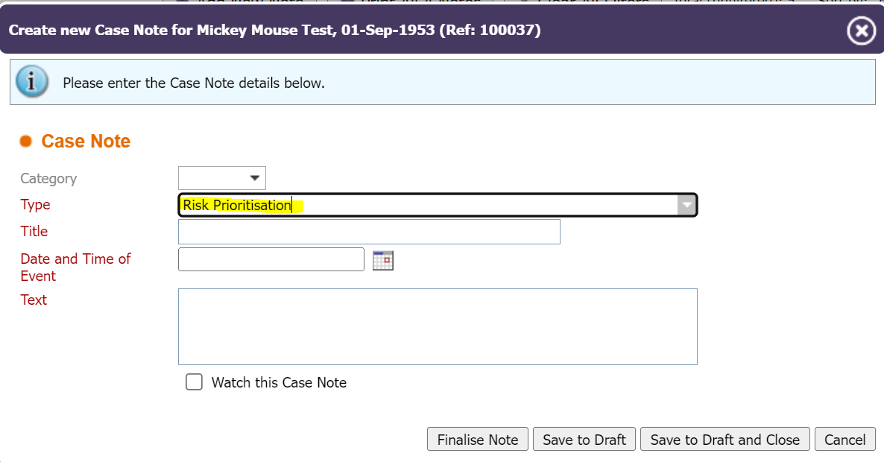

1. Please find the **Case** task for the person. (Please do not complete this on any other Task type as this will not show in reporting).
2. Click on the spanner to open the Task box for the Case.



1. Select the priority as High, Normal or Low, in line with the practice guidance. See screenshot below.
2. Please add a comment to say ‘see case note dated XXX’

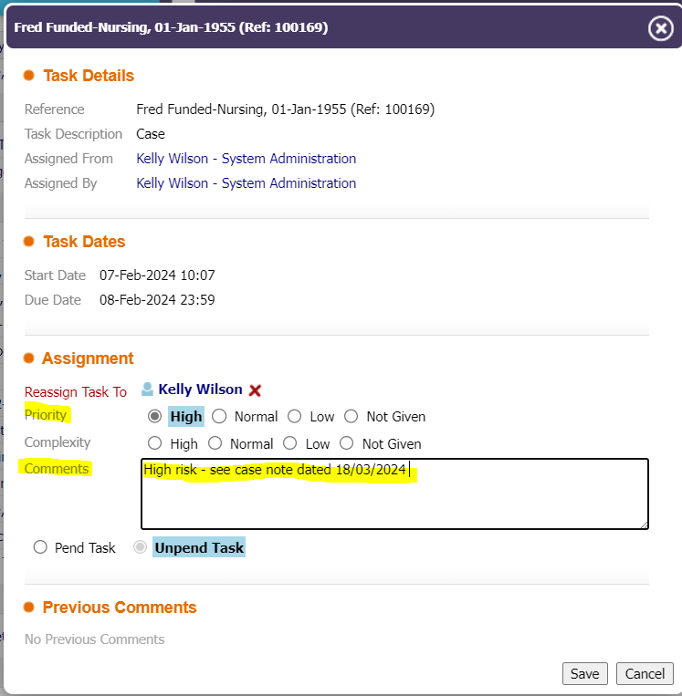

In order to set a date for when allocation is due, please click ‘Pend Task’ and then manually enter a future date based on the priority that has been set (High = same day urgent response or daily review, Normal = the date in 6 weeks’ time, Low = the date in 3 months’ time).

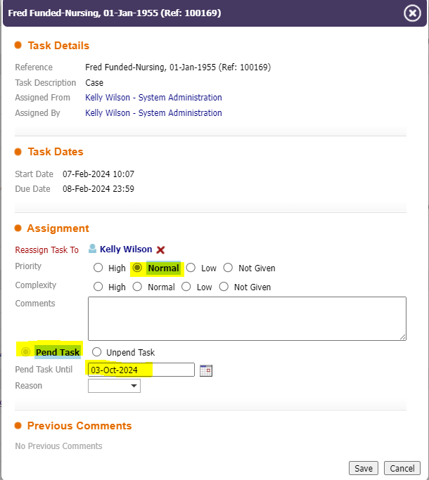

This allocation ‘due’ date will then show next to the Case task in the work tray: -

