Portsmouth City Council
Children and Families Services - Induction Handbook

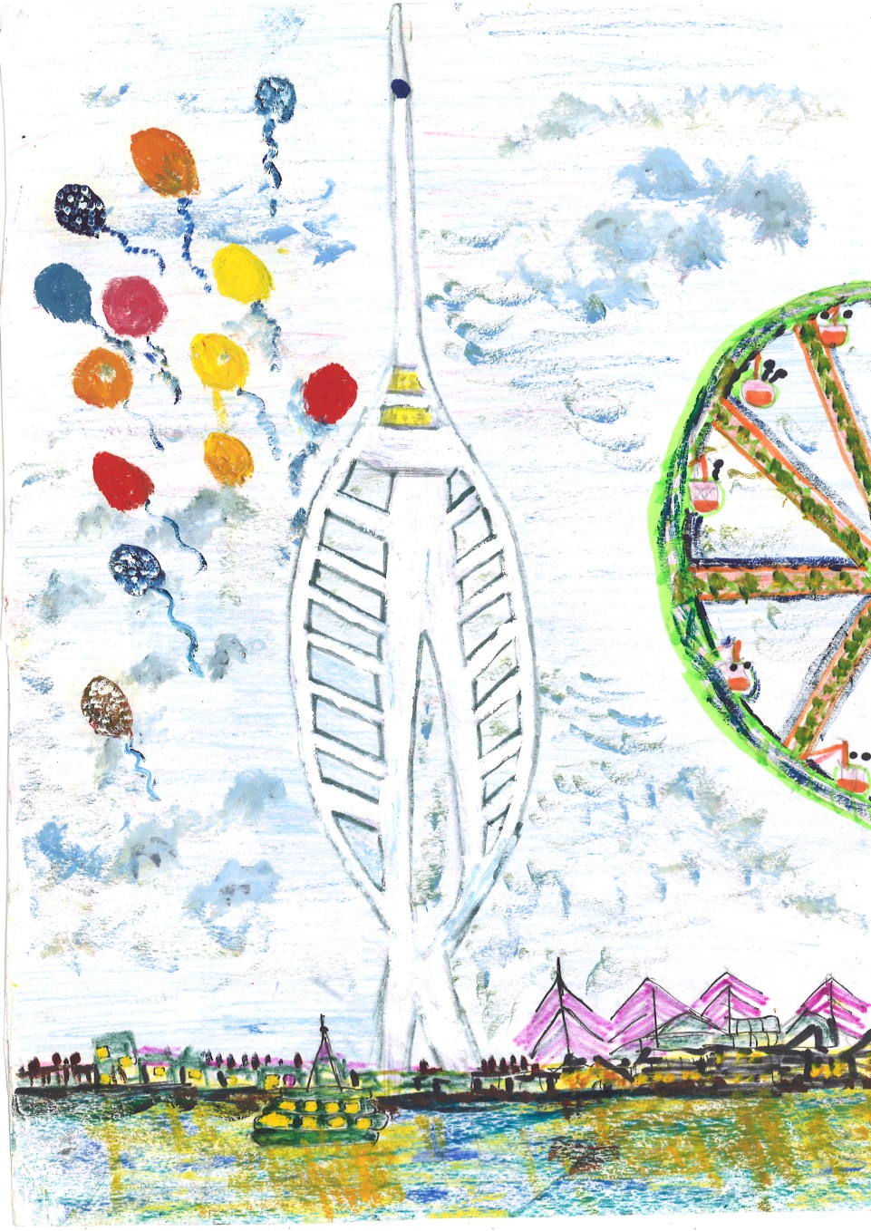

Welcome

Dear Colleague,

Congratulations on your appointment and welcome to Children and Families Services, part of the Children, Families and Education directorate at Portsmouth City Council.
In Portsmouth we recognise that children and families matter and are committed to supporting our staff to deliver high-quality social work intervention with vulnerable children and families in the city.
Across children and families' services in the city, we aim to work with children, young people and families to help them sustain safe and healthy lives and create the foundations for future success - their stronger futures.
I hope that this staff 'Induction Handbook' will support you over your first few months in Portsmouth and remain a handy reference guide throughout your employment with us. The Induction handbook provides you with information about the council and how Children and Families Services fits in. It also gives you reference to key documents and websites and provides a brief overview of the services we are responsible for.
Your first few weeks are likely to be very busy and you will have lots to take in, read and learn. Please do take the time to read through this Handbook and ask your line manager if anything is unclear.

I look forward to working with you.

Sarah Daly

Director Children and Families
Portsmouth City Council

About Portsmouth
Portsmouth is a large port city in the ceremonial County of Hampshire on the south coast of England. Located mainly on Portsea Island, it is the UK's only island city and with a population of 208,400 and it is the only city with a greater population density than London.
The naval base at HMNB Portsmouth is the largest dockyard for the Royal Navy and is home to two-thirds of the entire surface fleet. As a significant naval port for centuries, Portsmouth has the oldest dry dock and is home to some famous ships, including HMS Warrior, The Mary Rose, and Lord Nelson's flagship HMS Victory.
The city of Portsmouth and Portsmouth Football Club are both affectionately nicknamed "Pompey". The Spinnaker Tower is now a main feature of the waterfront area and Gunwharf Quays hosts a popular retail outlet centre alongside restaurants and bars.
Approximately 52,665 children and young people under the age of 19 years live in Portsmouth. At this time there are 48 primary schools, 10 secondary schools and nine special schools. In Portsmouth, nearly a quarter of children live in families with income that is below 60% of the median income, with estimates that include housing costs suggesting nearly 1 in 3 children were living in poverty in Portsmouth in 2021/22.
Children and young people from minority ethnic groups account for 26.1% of all children living in the area. After English, Romanian, Bengali, Polish and Portuguese are the most common languages spoken in Portsmouth schools.

Portsmouth City Council
Portsmouth City Council is based at Civic Offices, Guildhall Square, Portsmouth
PO1 2AL. The council has a total of 44 Councillors, 19 Liberal Democrats, 9 Labour, 7 Portsmouth Independents party, 4 Conservative, 2 Reform, 1 Independent.
The chief executive of the Council is Natalie Brahma-Pearl, and she supports directorates that manage the council's business:
- Adult Social care.
- Children, Families and Education Services.
- Corporate Resources.
- Cultural, Leisure & Regulatory Services.
- Executive.
- Finance.
- Housing, Neighbourhoods & Building Services.
- Portsmouth International Port.
- Public Health.
- Regeneration.
- Schools.

Children Families and Education Services
The Director of Children, Families and Education Services (DCS) is a statutory role that has responsibility for education improvement and special educational needs, and Children and Families Services. In Portsmouth there is a Deputy Director for Education, a Deputy Director for Children and Families Services and Assistant Director for Commissioning and Performance within the Children, Families and Education Directorate. There is also a Lead Member for Children, Families and Education.
Lead Member for Children, Families and Education
Cllr Nick Dorrington
Director Children Families and Education
Sarah Daly

Deputy Director Children and Families Services
Sam Bushby
Assistant Director Commissioning and Performance Hayden Ginns

Deputy Director Education
Nathan Caine

What are the strategic plans in Portsmouth?
The Children's Trust Plan 2023-2026
The 2023-2026 Children's Trust Plan has six priorities.
Each of these priorities has an accompanying strategy, and these are:
- Improve educational outcomes - Education Strategy.
- Safeguarding children from harm - Safeguarding Strategy.
- Physical health outcomes - Children's Public Health Strategy.
- Social, Emotional and Mental Health - the SEMH Strategy.
- Outcomes for children in our care and care experienced young people- Corporate Parenting Strategy.
- Special Educational Needs and Disabilities - SEND Strategy.

SAFEGUARDING STRATEGY

- We will ensure that children's and families' needs are identified at the earliest point and that they will receive effective early support and help.
- We will make sure that families will receive effective and timely support when children are at risk of experiencing neglect.
- We will work to ensure that families receive effective and timely support when children are at risk of experiencing sexual abuse.
- We will seek to ensure that young people will be kept as safe as possible from all forms of extra-familial harm, and there will be effective transitional safeguarding arrangements in place to support vulnerable young adults.
- We will make sure that children and young people have access to appropriate support that recognises the impact of trauma resulting from adverse childhood experiences (ACEs).
- We will ensure that there is an effective response to safeguarding children with additional needs and those from diverse communities.
- We will ensure there is sufficient professional and organisational development to provide an effective response to safeguarding children within Portsmouth.
- We will make sure there is a good understanding of safeguarding risks for children within education settings and an effective response to these.

Children and Families Services
In Portsmouth we have made significant investment in our social work service. When Ofsted visited us in May 2023, they noted, "Social workers talk positively about working in Portsmouth and inspectors consistently heard about their loyalty and commitment to the service. Agency staff feel valued and supported, and they have accessible training. Newly qualified workers are choosing to stay and work in Portsmouth and all workers feel supported by frontline practice managers. Portsmouth is a centre for learning and practitioners benefit from a comprehensive workforce development offer, including the Portsmouth Stronger Futures Academy, for the assessed and supported year in employment (ASYE), and a newly developed second year in practice programme for post-ASYE social workers to support the implementation of the Portsmouth model of family practice".
For our latest inspection reports please follow the link.

Portsmouth Model of Family Practice

Our vision for Portsmouth children and families' services is the concept of family practice. This means:
- Working whole family. Strong families are the bedrock of good outcomes for children. Being child-centred means understanding the whole family dynamics, in terms of risk and protective factors. We are there for all members of the family and need to address adult's issues to help them care for children.
- Restorative: Working with the family - and with each other - to co-produce solutions for that family. We recognise that people can change and when they do, can do things they previously had not been able to.
- Relational: Developing and sustaining strong intra-familial relationships through strong relational practice with families, supporting families to stay together as a bonded unit. Always striving to listen, understand and take into account families wishes and feelings.
- Trauma-informed: Understanding the impact of past and current trauma on the capacity of families to make and sustain relationships, make changes and on child and adult behaviours.
- Strengths-based and compassionate: We seek to understanding the need behind the behaviour, as this is often fear based. All people have value and inherent worth, and they are deserving of our time, attention and care.
- Holistic: Understanding all aspects of family lives using the Assessment Framework and recognising societal impacts such as poverty and racism.
- Hopeful: We expect and enable change to keep children safely living at home wherever possible and remain ever confident of the capacity of the family to make changes, while continually testing all possible narratives against the evidence to ensure we are sufficiently protecting children.
- Informed by difference: We recognise the significance of difference and the role difference and language plays in structuring the meaning and experience of the world.
In 2016, Portsmouth chose Restorative Practice as 'the way we work with families'. The city continues to be committed to embedding the language, practice, and principles of restorative practice: Working with, fair process, high support, high challenge. Restorative practice also reflects and informs the way we work together as professionals within and across agencies.
In our Children and Families Service this approach is supported by a Family Safeguarding-based approach, which provides a solid evidenced based foundation on which to develop our workforce by giving them the opportunity to work as part of a multi-disciplinary service, aimed at supporting parents to change so children can remain living safely within their families. For more detail re our approach and how we are supporting staff to deliver this please have a look at our workforce development strategy.

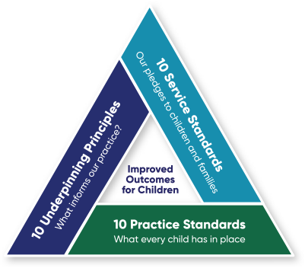

Underpinning Principles of the Portsmouth Model of Family Practice (10x10x10)

- Our relational approach to working with families and each other will be about listening, nurture, compassion and practical help as well as boundaries, accountability and challenge.
- We will prioritise the building, maintaining, and repairing of relationships.
- We will be intentional about our priority to keep families together safely by understanding and addressing past experience and/or trauma of all family members.
- Working with co-production of effective support plans.
- We will recognise the impact of unconscious bias and privilege on the way we work with families and each other.
- We are strengths focused while keeping the child’s wellbeing at the forefront, at all times.
- We work restoratively with families and within the multi-agency partnership.
- We take time to reflect and learn.
- We encourage professional curiosity and tenacity (including appropriate escalation).
- We will seek to coordinate professional intervention through a lead professional model, supported by the team around the worker.

Our local Service and Practice Standards (10x10x10), which outline our expectation for all frontline work with children and families. All staff are expected to:

- Explain to children and families why we are working with them and what we can and cannot do.
- Listen to children and families and consider their wishes and feelings in everything we do.
- Take care to ensure children and families understand what we are saying, by using clear and straightforward language, or a translator if necessary.
- Do everything we say and when we say we will do it.
- Be on time for meetings and appointments.
- Keep children and families updated on their progress.
- Keep children and families' personal information safe and explain how we are going to use it.
- Try to answer any questions from children and families or find someone who can.
- Work collaboratively with other services and professionals working with children and families.
- Treat people with respect and dignity

Practice Standards (10x10x10)
- All families understand the reason for involvement from Children and Families Services and have given appropriate consent.
- Children are spoken to alone and worked with by professionals who have the skills and resources to directly engage with them.
- Impact chronologies, genograms and sociograms will support our understanding of the child’s family and networks.
- Assessments will consider the lived experience of the child and their parents/carer.
- Assessments will consider the past experience and trauma of the parent/ carer and the impact of this on the current situation.
- We will take into account cultural heritage and equality factors and reflect on the impact of unconscious bias and privilege.
- All children have a plan co-produced with the family which explains what needs to happen; by when, by whom, what outcomes we are seeking together, how risk is managed, and what the contingency plan is.
- All case records are analytical, well written and timely, so that everyone can understand significant events that have happened; what the plan is, the purpose of our activity and intervention, and what difference has been made.
- Every case contains evidence of bi-monthly supervision that is reflective in nature.

- Every case will be supported by good quality management oversight. This will include reflective supervision; quality assurance of work being undertaken and a consideration of the impact of intervention.

Service Teams within Children and Families Services
You will receive an updated structure chart of Children and Families Services every month by email.

Early Help and Prevention
The Head of our Integrated Early Help and Prevention Service is Amanda Hales-Owen. Within this service are the three locality-based early help and prevention teams and community and public health services, including health visiting, school nursing and the family nurse partnership. Amanda is working hard to embed the key principles of whole -family working, team around the worker and outcome-focused intervention as business as usual. Integrating Portsmouth City Council's early help services (children's centres, youth work, etc) with community public health services has allowed us to develop a seamless offer for families with children aged 0-19.

North, Central & South Early Help and Prevention Locality Teams
Public services (schools, police, and health) have been organised into three cluster areas in Portsmouth: the north of the city, the centre of the city and the south of the city.

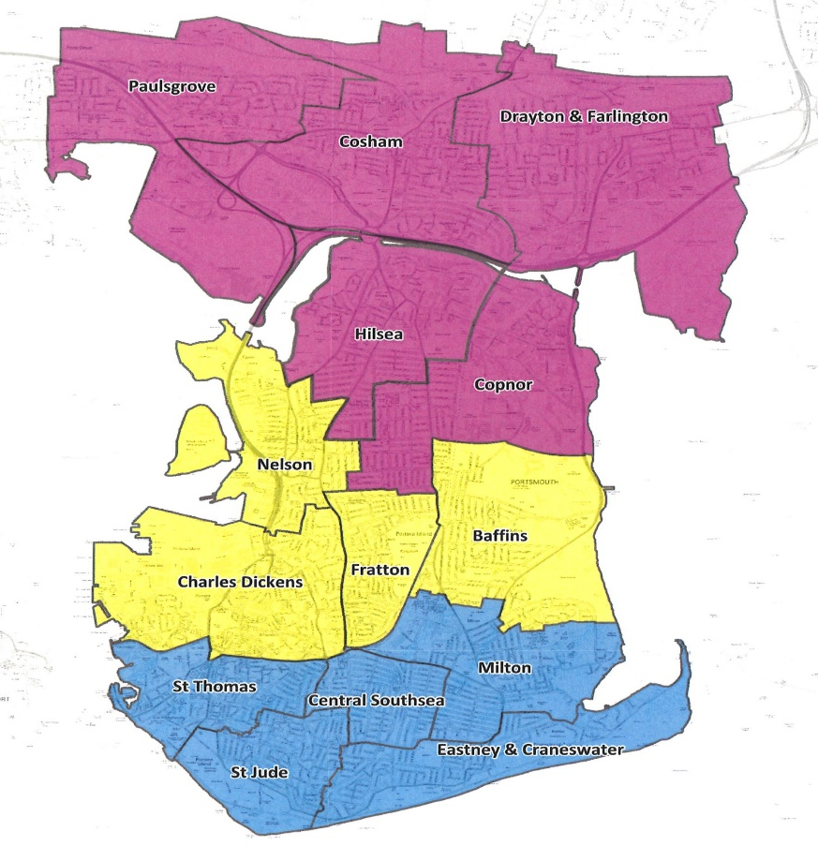
The Early Help and Prevention teams provide the healthy child offer for 0-5s, parenting support and bespoke packages of support facilitated by a lead professional building on the idea of 'team around the worker', so that relationships are built with a key professional who can be supported by other professionals to provide direct work, rather than a referral on actions.

The North Early Help and Prevention Locality Manager is Katy Willcox, Katy also has responsibility for the LGBTQ+ Service. The South and Central Early Help and Prevention Locality Manager and also manages Young Carers Service is Gill Noble. Access to a Tier 3 service is through the MASH and direct single-agency support can be accessed through the family hubs.
In the North of the city there are two family hubs, Paulsgrove and Northern Parade. There are two family hubs in the central area of the city, Buckland and Somerstown. The family hub in the South locality is Milton Park.
Paulsgrove and Milton have two main rooms. These are occupied every day with midwifery, health visiting and parenting activities.
Buckland and Northern Parade have three rooms. Two rooms are occupied every day with midwifery, health visiting and parenting activities.
Somerstown has four rooms. Two rooms are occupied every day with midwifery, health visiting and parenting activities.
Click here for more information about Portsmouth Family Hubs.
Family Safeguarding
The Head of Family Safeguarding is Adam Shepherd. Within this service is our four Family Safeguarding and Support Teams (North, Central 1 and 2 and South) and the MASH Team.

Multi-Agency Safeguarding Hub (MASH)
The MASH provides a multi-agency intelligence sharing service to support children and families in Portsmouth having access to the right help at the right time. The MASH manages all safeguarding contacts to the front door of children's services where the level of concern indicates there ought to be a co-ordinated multi-agency response.
Professionals from key agencies; children and families services, police, health, and education work together to ensure that safeguarding concerns are understood in the context of all known relevant information. This service supports robust decision-making and working-together arrangements across the children's workforce. To understand the threshold of need in Portsmouth please follow the link
The MASH Service Leader is Linda Mortimer

Family Safeguarding and Support Locality Teams
These teams are responsible for children in need (including those in need of protection) and the public law outline, including care proceedings up until the permanence plan is agreed in court. Staff in these teams will complete initial assessments for families referred by the MASH to determine whether they need ongoing social work support, usually as children in need. They will complete child protection enquiries where there are concerns a child is suffering, or at risk of suffering or significant harm and will take the lead role with children subject to protection plans. If concerns escalate, the social workers in these teams will manage the public law outline process and initiate care proceedings as necessary.
The North Service Leader is Julia Newton, the North team is based at Medina House in Cosham.
The Central team is split into two, the Service Leader for Central 1 is Jenny Cullen and the Service Leader for Central 2 is Karolyn Lake.
The South Service Leader is Vicky Williams.

Family Safeguarding Team (adults)
The Family Safeguarding Team Service Leader is Amanda Haylock. Family Safeguarding is based on the principle of safeguarding being a shared responsibility between adults and children's services. This whole family approach focusses on improving outcomes and reducing harm to children and the adults who care for them.
The Family Safeguarding Team consists of specialist adult workers who are co-located within the Family Safeguarding and support children's social work teams operating across the North, Central and South of the city. More recently we have also had adult workers joining our children we care for service (Building Your Futures). The team work collaboratively and in partnership with the children's workforce and families to tackle the parental need, including parental substance misuse, mental health issues, and conflict within family relationships. This enables more children to live safely at home with their families or return to their families if safe to do so. If you would like to understand more about the family safeguarding approach please click here.
The Family Safeguarding Team provides:
- Specialist advice, including Team around the Worker guidance.
- Specialist assessments and planning with families.
- Direct work on a 1:1 or group work basis with adults who care for children and work with parents who want children to return to their care.
- Access to specialist referral pathways when required.

Up2U
Up2U is a client focused assessment led intervention programme responding to individual need, risk, and responsivity by offering tailored packages. Due to this design, Up2U can work with all people who admit to using abusive/violent behaviours and want to change regardless of gender and sexuality and that can work with both partners in co-abusive relationships.
- Up2U: Family Intervention works to being delivered in the North of Portsmouth working with families where domestic abuse is identified as a feature and the parents are using unhealthy relationship behaviours.
- The Up2U: Creating Healthy Relationships therapeutic programme is offered to both parents to challenge unhealthy behaviours and help them to use healthier relationship behaviours. Children's Social Workers have been trained in the Up2U programme to support delivery and offer additional support to children.
Family Connections Service
The team facilitate family time arrangements for families in court proceedings. This team is made up of several experienced family practitioners who can contribute to the final care plans for children. In addition to supporting family time arrangements, they are also able to provide specialist intensive family support to enable safe rehabilitation plans to be progressed within court proceedings.

Children We Care For
The Head of our Children we Care for Services is Mark Jowett. Within this service are our Fostering and Adoption Teams, Through Care Teams, Staying Close project, and our Children's Homes.

Fostering Support and Home Finding
Jackie Clarke is the Service Leader for Fostering Support and Home Finding. We have a very strong fostering service in Portsmouth and this team are responsible for the retention of foster carers and the brokering of new foster placements both in-house or through independent sources
To support our existing carers the team run several events that encourage carers to get together with each other and with social care staff - both in the fostering team and across the operational social work teams. A more recent innovation in fostering has been the use of the Mockingbird programme. For more information, please go to the link.
Fostering Recruitment, Kinship Care and Adoption
Dave Crewe is the Service Leader for Fostering Recruitment, Kinship Care and Adoption. The team complete assessments of prospective carers, including family and friends and special guardians and provide supervision and support to each of them. All our foster carers are approved by the Fostering Panel, which is independently chaired and has an annual review.
To attract carers locally, the team have a marketing campaign Foster-Portsmouth and they run several recruitment events throughout the year.

Building Your Future and Child Safety and Asylum Team.
The Service Leader is Vicky Laybourne. The Building Your Future Team provides social work support to our children in long-term care placements and support reunifications (going home) back to their family or extended family.
The Child Safety and Asylum Team is a team which focuses on caring for children whom have fled their home countries in order to seek safety and asylum in the UK. The children whom we care for, are generally between the ages of 14 and 17 when they arrive. They have all experienced significant trauma, both in their countries of origin as well as on their journey to the UK, which they have often made alone. The team supports our children by ensuring that they are supported with their asylum claims as well as meeting their educational, health needs etc.

The Adoption Team is also part of the Regional Adoption Agency Adopt South with Hampshire, Southampton, Isle of Wight. The RAA is responsible for assessing, matching/linking, and supporting adoptive parents.

Children's Homes
Currently in Portsmouth we have three Children's Homes managed by the City Council.
Tangier Road is a five bedded home for both male and female young people aged 14 - 18 on a planned admission basis.
The White House is a three-bedroom home for young people aged 8 - 14. The White house accommodates both male and female residents on a planned admission basis.
Beechside Short Break Service provides flexible, individual care packages, including overnight, short-break care and activities for disabled children and young people in the local area. The age range is from 5 - 18.

Adolescents and Young Adults
The head of our Adolescents and Young Adults service is Keely Mitchell. Please see below the services offered by this service.

Supporting Your Future
Through Care Team 2 is led by Sarah Read. The team are responsible for care experienced young people and for unaccompanied children who come into the care of the Local Authority. Staff in these teams are responsible for ensuring that our statutory responsibilities for children we care for, and care experienced are properly met.

Staying Close Project
The Team Leader for the Staying Close Project is Shakira Gearty. Young people leaving residential care have historically been the most disadvantaged, as they have not had the opportunity to stay beyond their 18th birthdays in the same way as young people leaving foster care have been able to. Portsmouth are piloting a two-year Staying Close project - Aspiration, which has been funded through a government innovation grant. For more information in respect of this please see the following link.
Youth Justice Service
The Service Leader for the YJS is Lisa Morgan. The Youth Justice Service primary role is to reduce offending and re-offending in children aged 10 - 17. This includes delivery of restorative justice to support victims, which has become the preferred model of working across all children's services.
Adolescent Service
The Service Leader for the adolescent service is Nirvana Curley. Adolescent service is a multi-disciplinary team consisting of restorative practitioners, mental health practitioners, DASS (drug and alcohol support service), counsellors and a MET coordinator. The service offers two services, supporting families and supporting safety. Supporting families is a 12-week intervention offer supporting children and young people at risk of entering local authority care to remain within their families, through a restorative approach and utilising DDP and PACE approaches. Supporting safety offers direct work to children and families focused on children and young people at risk of exploitation.

Safeguarding and Quality Assurance Service.
Kate Soutter is the Head of the Safeguarding and Quality Assurance Service and as such, has responsibility for those services aimed at quality assurance and improvement.

Independent Reviewing Officers (IROs)
Jenny Brennan is the Service Leader for the Independent Reviewing Officers. It is their role to ensure that care plans for children we care for are relevant to meeting the child's needs and are being progressed in a timely way. If an IRO has concerns that services are not adequate to meet a child's needs or that there is a delay in providing a specific service, there is an escalation process that includes the option for legal advice and representation to the Child and Family Court Advocacy and Support Service (CAFCASS).

Child Protection Advisors
Jenny Brennan is also the Service Leader for the Child Protection Advisors who are responsible for the independent chairing of initial and review child-protection conferences. Their role is to determine whether a child is suffering or at risk of suffering significant harm and that a protection plan is the best way of addressing the concerns and minimising the identified risk. Through the review process they will monitor progress and ensure that protection plans are removed when the level of risk has reduced.

Local Authority Designated Officer (LADO)
Lydia Bowles is the LADO and manages all allegations against staff in Portsmouth who are working with children. A formal process exists to ensure that allegations against staff and foster carers are managed fairly and proportionately. The procedures relating to this position can be found in the 4LSCB procedures and the Portsmouth Safeguarding Partnership receives an annual report from the LADO detailing the allegation activity and the outcomes of any investigations.
Terri Johnson is the Service Leader for Quality Assurance. She supports practice discussions and oversees the quality of work undertaken in children and families.
Principal Social Worker, SF Academy, Participation and Advocacy.
Clare Poyner is PSW and manages the Stronger Futures Academy, Participation and Advocacy Team. As Principal Social Worker, Clare has lead responsibility for driving forward continual improvement and innovation, supporting the ongoing evaluation of the effectiveness of Portsmouth's arrangements to safeguard children. The PSW also manages and contributes to practice learning arrangements across the Children and Families Service.

Stronger Futures Academy
Stronger Futures Academy was launched in 2016 as the primary vehicle to drive recruitment and retention. The Academy is currently leading our workforce development strategy and supports the ASYE programme. The Service Leader for the Academy, participation and Advocacy teams is Karley Middleton.

Participation
Co-production and participation are a very strong feature of the work in Portsmouth at an operational and strategic level. The participation team are responsible for the Children in Care Council, annual surveys to capture the views of service users and progressing the way we involve service users in the design and delivery of services that affect them. Adam Murphy is the Participation Officer.
About ME Advocacy

About ME Advocacy service is for children and young people aged 4-25 who have a right to have their voice heard. With consent, our advocate support and enables a young person to share their feelings, views and wishes and to say what actions they would like to be taken on their behalf. We offer support for child protection conferences, children we care for reviews, Issue based referrals (short term support work, including complaints), family group conferences, and finally support and guidance for 16/17-year-olds who are homeless or at risk of homelessness. Liessa Mallinson is the Child's Advocate. To support our participation arrangements, we also commission a Family Group Conference service through Daybreak.

Planning and Partnerships
Hayley Webb is the Head of Service for Planning and Partnerships and is responsible for the following services.

Domestic Abuse

There are a number of resources available to victims of domestic abuse in Portsmouth, for more detail please click on the link

Counter-Extremism
In October 2015 the Government published its Counter-Extremism Strategy. This sets out Government’s commitment to challenge those who draw upon and promote ideologies that seek to normalise behaviours that run contrary to our shared values, which include democracy, the rule of law, individual liberty and the mutual respect and tolerance of different faiths and beliefs. The Strategy highlights four pillars:
- Countering extremist ideology.
- Building a partnership with all those opposed to extremism.
- Disrupting extremists.
- Building cohesive communities.

Crime Prevention
Portsmouth is one of 40 Councils in England and Wales that receives grant funding by the Home Office to employ a Community Coordinator to support national work to prevent crime and serious harm through partnerships with local communities and groups. David Knowles is the Community Coordinator in Portsmouth whose objectives include:
- Reducing neighbourhood crime including hate crime.
- Preventing crime against women and young people.
- Improving trust and confidence in the criminal justice system.
More information on the strategy can be found on www.gov.uk/government/publications/counter-extremism-strategy

Prevent
The Prevent service is managed by Charlie Pericleous and is about safeguarding people and communities from the threat of terrorism. It is part of Contest, the government's counter terrorism strategy and aims to stop people becoming terrorists or supporting terrorism. When there is concern about an individual who may be becoming a terrorist or supporting terrorism then they should be referred to the MASH who will consider whether they need to be considered at Channel. Channel is a programme, which focuses on providing support at an early stage to people who are identified as being vulnerable to being drawn into terrorism. The programme uses a multi-agency approach to protect vulnerable people by:
- Identifying individuals at risk.
- Assessing the nature and extent of that risk.
- Developing the most appropriate support plan for the individuals concerned.
More information on the strategy can be found on:www.saferportsmouth.org.uk/prevent-duty/what-is-prevent/
MOSAIC support team and data reporting team

Business Support

The Business Support manager for many of our business support functions across Children and Families Service is Karen Stewart. These teams ensures that front-line practitioners working with children and families safeguarding teams can spend as much time as possible on relationship-based intervention. Business Support provide valuable administrative support and their roles are varied and specific to the service area they support. Karen is supported by five Team Leaders: Caroline Eayrs who support MASH/Access to Records; Tammy Roux who supports Building Your Futures, Supporting Your Futures Teams and Child Safety and Asylum Team; Nicci Davis who supports Family Support and Safeguarding North, Central and South Locality Teams; Suzy Zammit who supports Fostering Teams and Adam Lambert who supports SQT.

Lisa Morgan YJS Service Leader is supported by Nicky Morgan's Business Support Team Leader who supports the Business Support for YJS.

Gill Noble and Katy Wilcox, Early Help and Prevention Service Leaders are supported by Cheryl Ward Business Support Supervisor for Early Help and Prevention Business Support who support the Family Hubs across the city.

Portsmouth Safeguarding Children Partnership
Under the Working Together guidance Local Authorities are required to have local multi-agency arrangements to oversee safeguarding activities. Most local authorities have set up Local Safeguarding Children partnerships to manage these arrangements. The Portsmouth Safeguarding Children Partnership has an independent chair, Scott MacKechnie, and a business manager, Lucy Rylatt who co-ordinates the work of the Partnership and its various sub-groups, overseen by Hayden Ginns. To find out more about the Portsmouth Safeguarding Children Board it is worth visiting their website as you will also find a number of useful one-minute guides there.
Top tips for a successful induction into PCC
As a new employee with Children and Families Services in Portsmouth City Council you will be given an induction programme by your line manager. The induction programme is designed to give you a brief introduction to the service and assist you undertaking your new role. You should expect to receive an induction checklist outlining the introductory activities.

The induction programme is expected to take two weeks, during which time we will try to avoid giving new employees case-holding responsibilities.
All newly qualified social workers should be linked into the ASYE programme and to the Stronger Futures Academy. In Portsmouth we are committed to creating a positive learning environment for all staff at all levels and our Academy is central to the delivery of our workforce development strategy.
Managers are committed to ensuring all managers are aware of new members of staff to promote a positive and supportive learning environment across the workforce. Furthermore, managers are expected to check with new employees how the induction programme is progressing and to make any amendments as appropriate to individual needs.

Corporate Induction
Portsmouth City Council offers a corporate induction day for all new staff to the council. There are several mandatory e-learning courses that you will need to take. For more information please click
The Portsmouth City Council intranet can be found by clicking the internet explorer icon on your desktop, which will take you directly to the intranet homepage. If you are looking for a specific document or form you can put a search in the top right-hand corner, which will list all results found in connection with your search.
Each directorate has its own section, which is updated with relevant information.

Online accounts
There are a number of IT-based systems that you will require access to as a Portsmouth City Council employee. Firstly, you will need your Portsmouth City Council account, which will give you an email address and access to the City Council intranet.

Emails sent between @portsmouthcc.gov.uk email accounts are considered secure, so if your role means emailing other colleagues within the council with personally identifiable information, you do not need a separate secure email account. You should however, double check the recipient list before you send it and not pass it outside the list of the intended recipients should you receive it.
You will also need a Fusion account. Fusion is the council's E-business
Suite and is used for many applications including human resources, payroll, internet procurement, accounts payable, accounts receivable, purchase orders and general ledger. For more information regarding Fusion please follow the link

In addition to these accounts, you will either need access to the Children's Mosaic Case Management system which will have been set up for you automatically along with your user and email accounts. To process your access to this system you will need to book onto an introductory course.
Learning and Development
Learning and development is considered very important when you work in Portsmouth. To understand our aspirations for your development please have a look at the prospectus.
Portsmouth City Council offers a range of courses to help you develop professionally and improve on your existing skills. The Learning Portal is the corporate database of training and allows you to search and book a course at a time to suit you. The learning gateway keeps a log of the courses you have attended and keeps track of the courses which you need to update periodically and also allows you to record your Continuous Professional Development. The portal can be accessed via the intranet and will prompt you to set up an account when you access it for the first time.
All newly qualified social workers will be linked to the ASYE programme, which is delivered through our Stronger Futures Academy. The Academy is well connected with Portsmouth, Winchester, Solent, and Chichester University and through this link there are opportunities to attend at various seminars facilitated by the University throughout the year. In addition to this there are specialist training courses that can be found on the Learning Portal. The Academy will also support you (where needed) beyond your ASYE year as well.
Research in Practice
In PCC you have the opportunity to join Research in Practice for free. Through this you will have access to a wealth of learning resources and training to support evidence-informed practice with children, young people and families / adults, carers and families. To join RIP please click on the link.
Other online resources
Policy Hub: The central storage area for all PCC Policies and templates, you can access Policy Hub via the icon on your desktop. It is not recommended to save policies or templates locally, as they are subject to change without notice.
Intranet: The PCC website, an icon of which is on your desktop. It is recommended not to save templates out of the intranet and file separately, as templates are updated without notice.
Online procedures: This is the central storage area for all Children and Families Services policies and procedures relating to practice.
4LSCB Procedures: A central storage area for all policies and procedures relating to practice that has been developed by the 4LSCB group, made up of Portsmouth, Southampton, Isle of Wight and Hampshire.
Who Cares Trust: National organisation that champions the voice of children and young people living in care.
PSCP: Here you will find a number of one-minute guides on a wide range of topics plus multi-agency learning from practice and a number of other resources.

GDPR Training
General Data Protection Regulation (GDPR) training is a requirement for all staff and can be completed through the Portsmouth Learning Gateway.

Supervision
In Portsmouth we recognise that working with the most vulnerable children and families in Portsmouth is meaningful and demanding work. In order for the practitioner to have a helpful and restorative relationship with the family they need to have effective, helpful, restorative relationships with their manager and with others within PCC. Good quality reflective supervision provides the foundations of these relationships. The expectation is that whether you are the Deputy Director or a Personal Advisor you will be in receipt of containing, purposeful and reflective supervision where-upon you will be worked 'with' and will receive high support and high challenge. Fundamental to this support is effective individual and group supervision. Within Portsmouth, supervision is fully integrated into case management, and it occurs both formally within one to one and group supervision, and informally through unplanned case discussion and in other group settings.
Within your first supervision you and your line manager will formulate a supervision agreement and will draft a well-being action plan. For more detail please refer to the Supervision Policy

Probation Periods & Annual Performance Conversations
Every new member of staff is expected to complete a six-month probation period. The purpose of a probationary period is to allow for the employee and employer to assess suitability of the role after having first-hand experience. Whilst this gives the employer opportunity to assess objectively whether the new employees are suitable for the job taking into account their capability, skills, performance, attendance and general conduct; it also gives new employees the opportunity to see whether they like their new job and surroundings. There is substantial evidence to suggest probationary periods increase the probability that new employees will succeed in their new roles.
It is expected that managers consider capability throughout the probationary period so that support can be offered proactively. In Children and Families Services, we recognise that social workers matter, therefore we are keen to nurture and support our staff to reach their full potential.
On an annual basis every member of staff should complete a performance conversation. This is an annual review which provides all staff with the valuable opportunity to reflect on their performance, potential and development needs. It is also an opportunity to celebrate the successes of the year and unpick the challenges. Within this conversation it is expected that the practitioner is able to demonstrate their competencies against the 10 x 10 x 10 standards and principles, the Professional Capabilities Framework and the Knowledge and Skills Statement. We would also expect practitioners to have evidenced their learning and development depending on where they are in their career pathway.

Within the process, the practitioner and the manager will agree a plan for the forthcoming year. The plan will briefly describe each goal and accountability for the next year, when it should be met or accomplished and how success will be measured. The goals should be reviewed as a regular part of professional development part of supervision, but no less than quarterly.

The reviews are a balance between reviewing progress against the tasks, reflecting on the values and behaviour expectations and also exploring any issues that may affect future success.
Communication
The Director sends a monthly Children, Families and Education Services Newsletter and a weekly message to all staff to keep everyone informed about relevant events and issues across the service. Service leaders should ensure the information included in the newsletter is communicated to staff face-to-face, during a team meeting, briefing, or similar forum.

The Principal Social Worker sends a monthly newsletter to all staff outlining practice developments, issues around well-being and learning and development opportunities. Again, this newsletter should be discussed within a team meeting.

All Staff Forums
Every year there is an event for all staff to get together. These events are intended to provide staff with an opportunity to learn about changes across the service and to network with each other and celebrate success.

Team Meetings
Each team in Children and Families Services meets on a regular basis to share information about team performance, wider service issues and directorate news and local and national policies. As part of our efforts to create a learning environment in which staff are encouraged to contribute to these meetings and, where appropriate, to feed ideas through the system to shape improvements in our service delivery.
Team meetings should provide a supportive arena to discuss opportunities and challenges. It is the task of managers to create a positive working environment that supports front-line staff in delivering social work that improves outcomes for our vulnerable children and families in Portsmouth.
Stronger Futures website and social media channels
Stronger Futures is the brand that we use in more Portsmouth to promote social work practice to external parties. On the website we showcase the work undertaken and post any job vacancies. For this to be success we encourage employees to like/share/tweet on our social media channels and to cite the brand in our employee signature, your line manager will show you how to do this.
Health and Safety and Lone Working
We would encourage you to look at both of these sections on the intranet. Each team has their own lone working arrangements and so please speak to your line manager about this and what measures are put in place to keep you safe when you are lone-working.
Wellbeing
Portsmouth City Council have a strong commitment to the health and wellbeing of employees. We would recommend that you read the full wellbeing policy available on PolicyHub by searching 'wellbeing'.

There are a number of services and resources available to support employees in managing their health. These include:
- Occupational Health - Specialist support for staff with health conditions and work-related health issues is available via our occupational health service on referral from a manager or HR.
- Employee Assistance Programme (EAP) - The EAP is a free and confidential service that provides wide-ranging health and wellbeing support. This includes up to six free sessions of guided self-help for anxiety or depression, and counselling to help with bereavement, relationship break-ups or stress.
- Manager Essentials - These intranet pages host a number of tools and resources to aid managers in supporting the health and wellbeing of their employees. They include:
- Wellbeing action plan.
- Supporting staff with their mental health.
- Day 1 intervention for stress.
- Return to work form.

- Wellbeing pages - We care about the wellbeing of all our staff and want to give you opportunities to improve your health and quality of life. We offer a range of help and advice services, as well as events and courses to get you on the right track to a healthy lifestyle – both in and outside of work. The pages cover topics such as:
- Back care
- Stress awareness
- Menopause
- Cancer screening
- Caring for someone
- Domestic Abuse

The council's also hosts a variety of e-learning modules via Learning Portal Skillsbooster and Bookboon to help support the health and wellbeing of our employees. Topics include:
- Skills Booster: Mental Health in the Workplace (overview)
- Skills Booster: Mental Health in the Workplace (Doing the Right Thing)
- Skills Booster: Mental Health in the Workplace (Managing Stress)
- Skills Booster: Dealing With Sensitive Issues in the Workplace
- Skills Booster: Facing Anger and Emotion at Work
- Skills Booster: Managing Remote Workers
- Skills Booster: Building resilience.
- Bookboon: Positive Psychology
- Bookboon: Personal Confidence & Motivation

Equality and Diversity
We expect everyone who works at Portsmouth City Council to be treated and to treat everyone else with dignity and respect.
To support equality and diversity, we have a range of networks that have been set up to foster our ambitions. These include:
- Lesbian, Gay, Bisexual, Transgender and Questioning plus Network
- GEM (global ethnic majority)
- Disabled Network

Within the Civic Offices, you will find accessible and inclusive spaces, including but not limited to:
- Multifaith Room – Core 5, Floor 1
- Breastfeeding Room – Core 3, Floor 3
- Gender neutral toilet facilities – Core 3 of Floors 1-5

Please note, our gender neutral toilet facilities are not labelled on the map, but can be found by looking for the symbol next to the labelled Breastfeeding Room on Core 3, Floor 3

We really hope that you enjoy your time at Portsmouth City Council.

