Advocacy

My name is ____
Photo of YP

I am ___ years old

I am learning about advocates.

Advocates listen to children
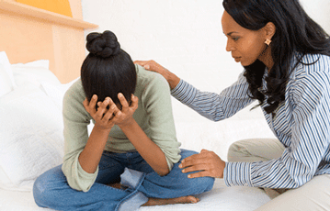

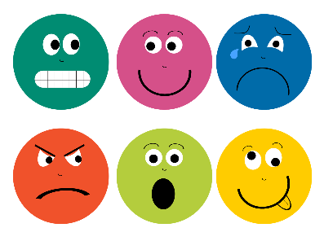
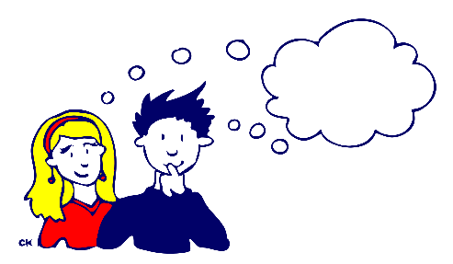
To find out their

Thoughts + Feelings
Advocates help children by making sure that the adults that look after them listen

to their:
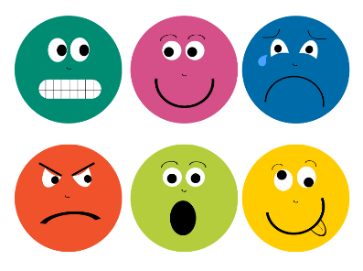
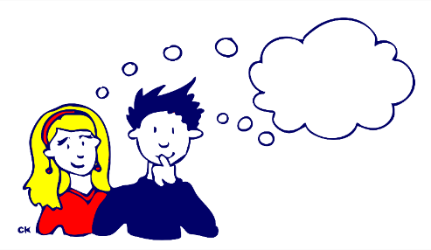

Thoughts + Feelings
My advocate is called
Photo of advocate
________

_______ is going to visit me
at ____
Photo of advocate
Photo / symbol for home / school etc.

She is going to try to help me
With (brief description of reason for referral)
________________________

________ may not be able to solve all my difficulties
Photo of advocate

She will make sure that the adults know:

Photo of YP

What I think
She will make sure that the adults know:
Photo of YP

How I feel

When they make a choices about me
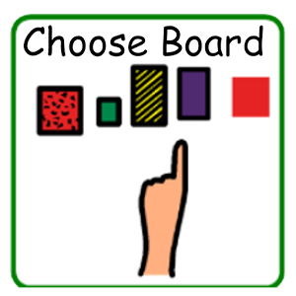
Photo of YP

