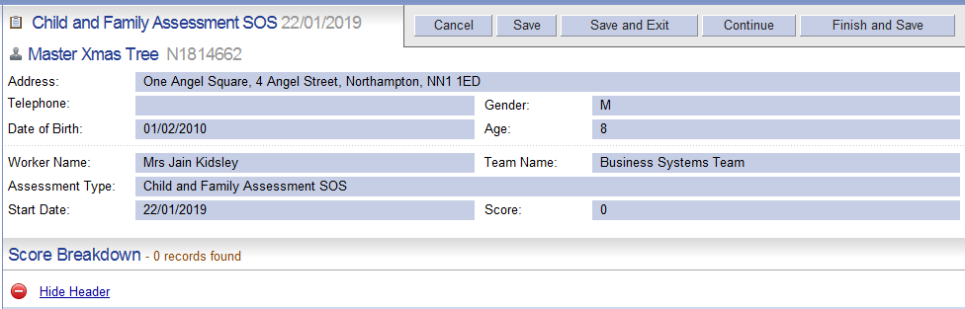

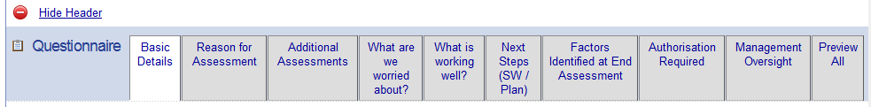

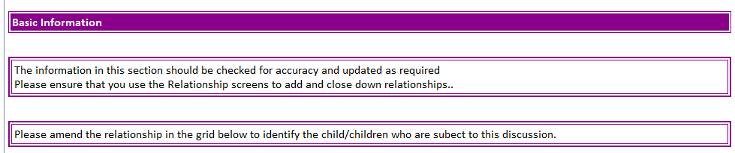

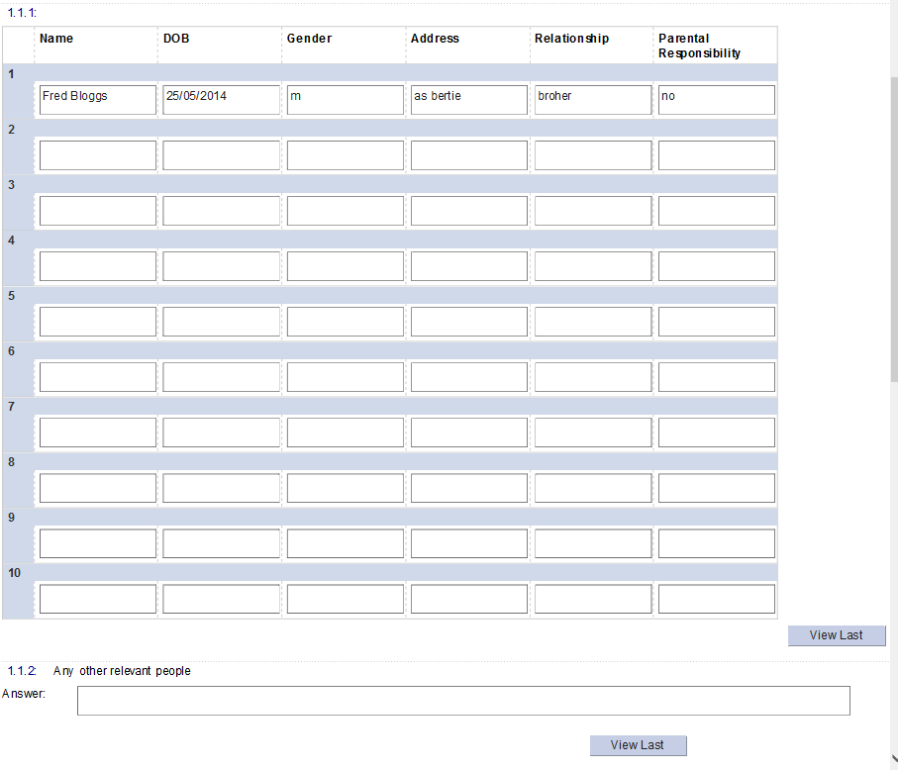

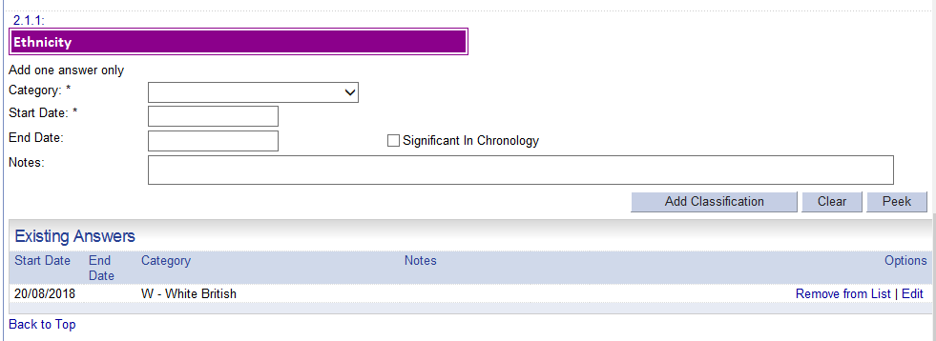

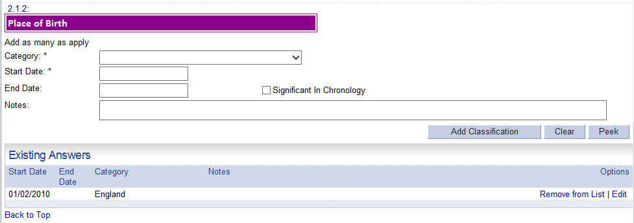

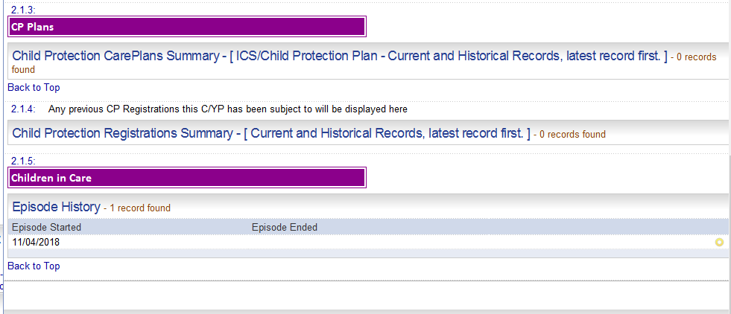

## END OF BASIC DETAILS TAB

## REASON FOR ASSESSMENT TAB

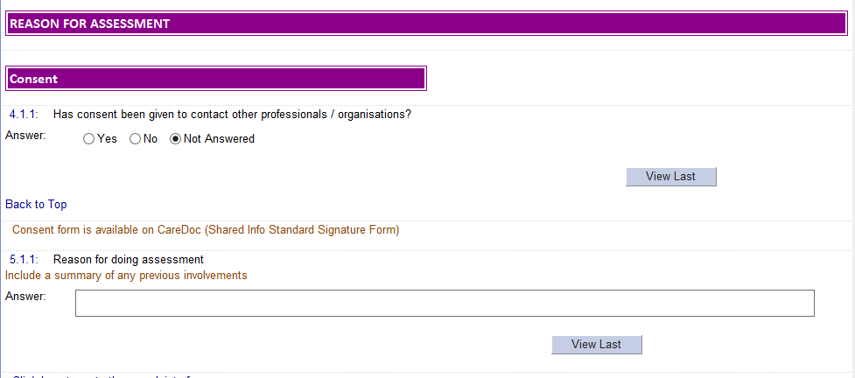



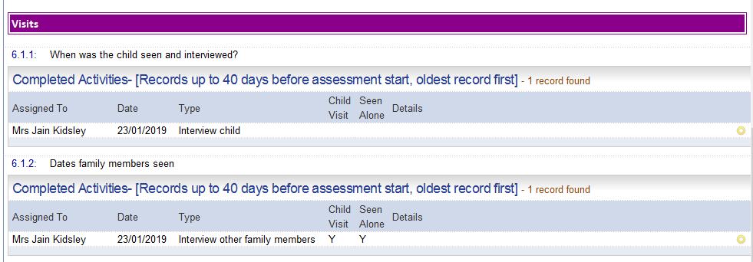

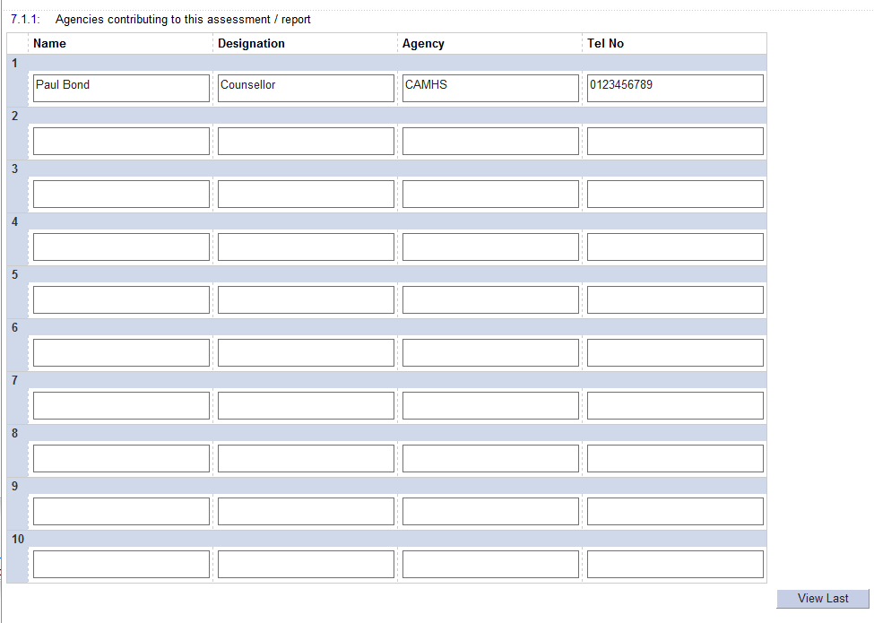

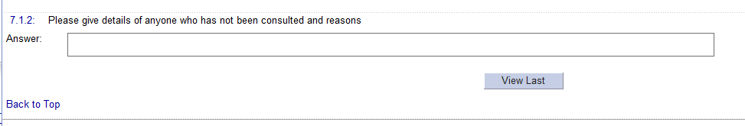

**END OF REASON FOR ASSESSMENT TAB**

**Additional assessment TAB**

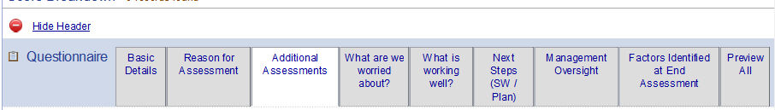

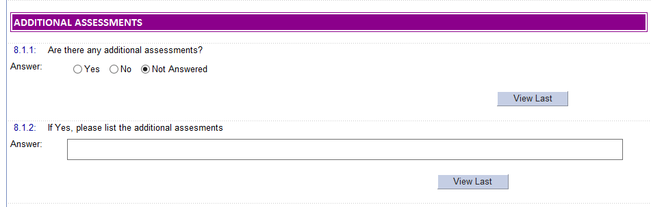

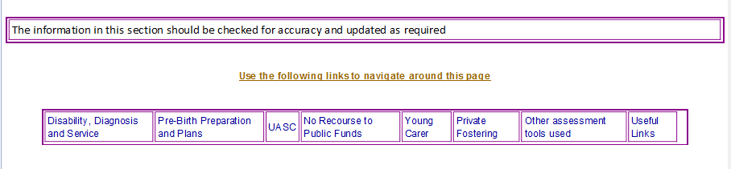



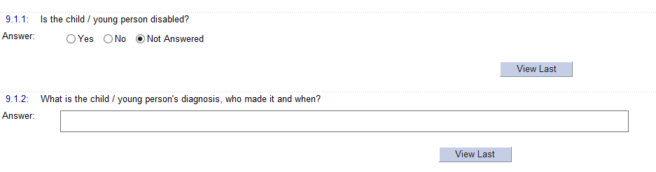

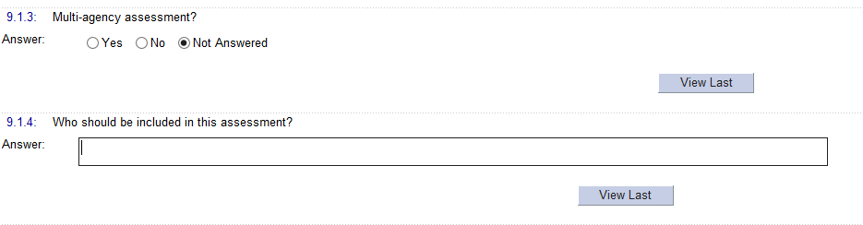

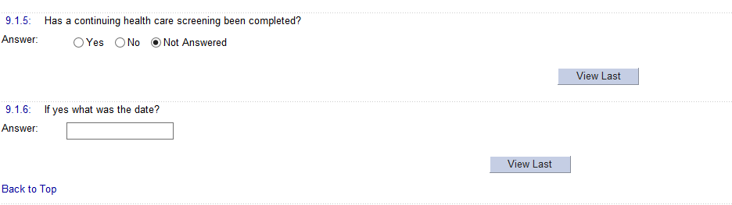

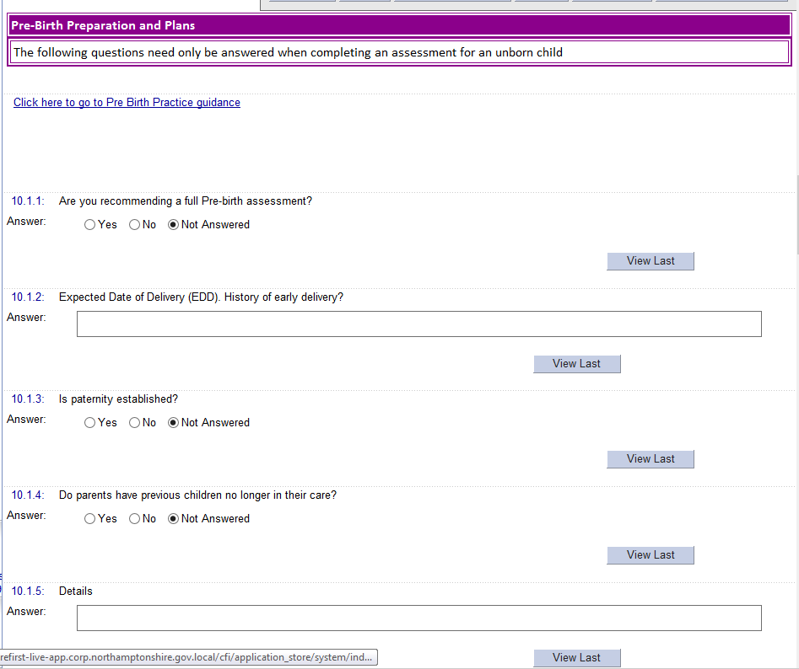

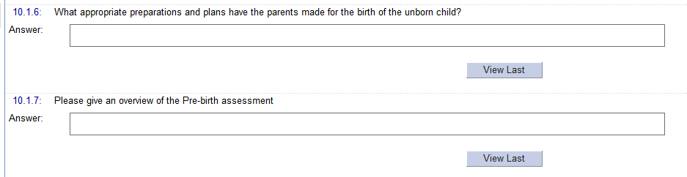

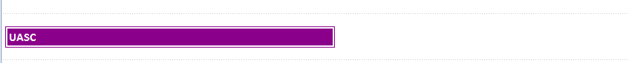

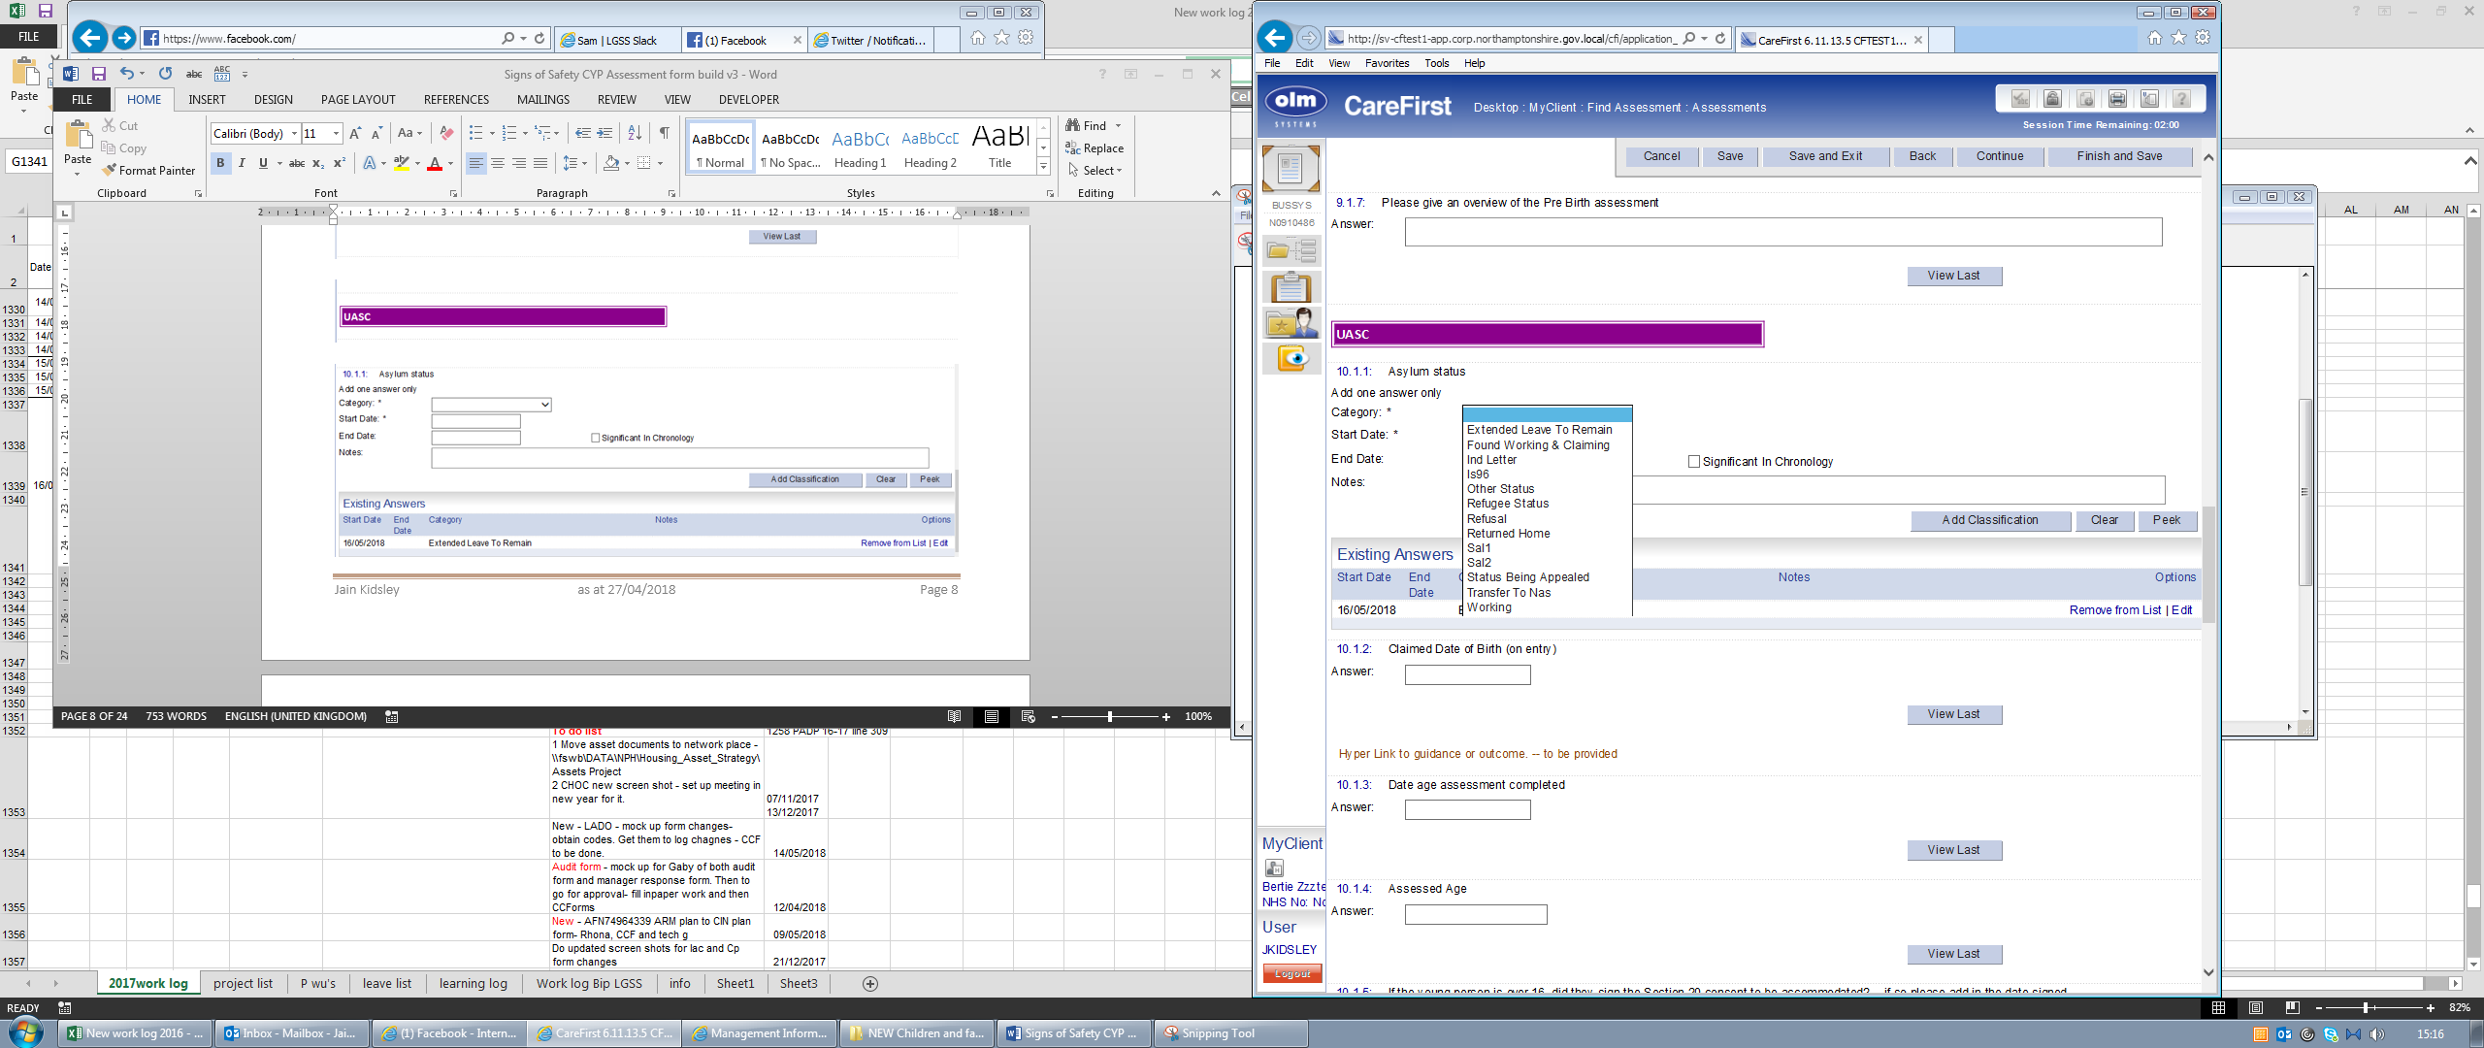

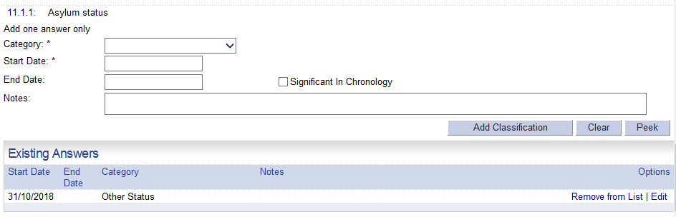

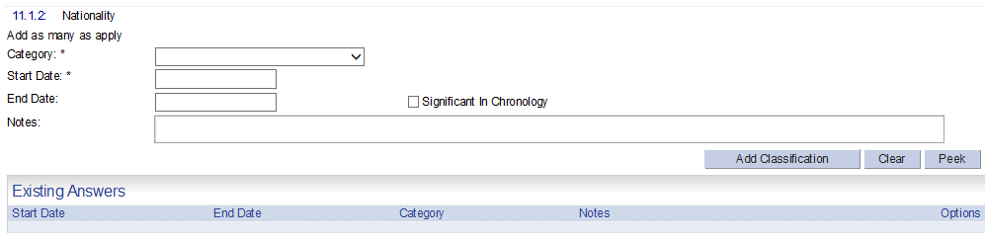

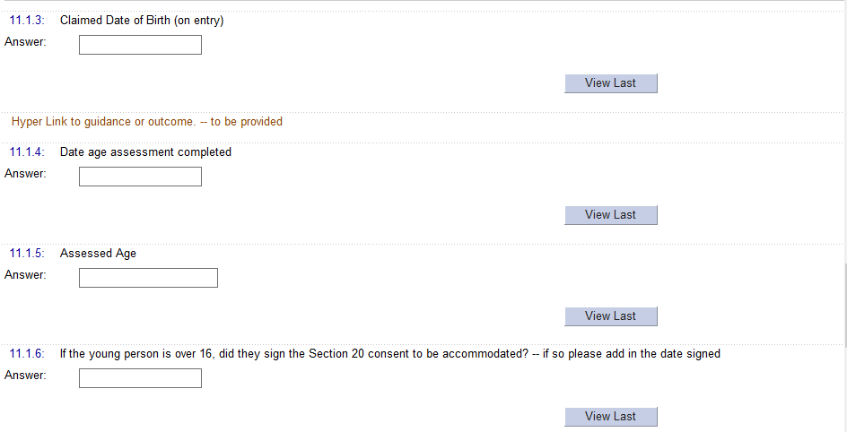

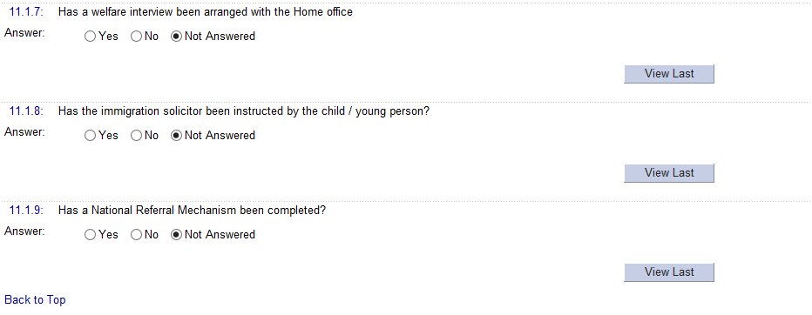

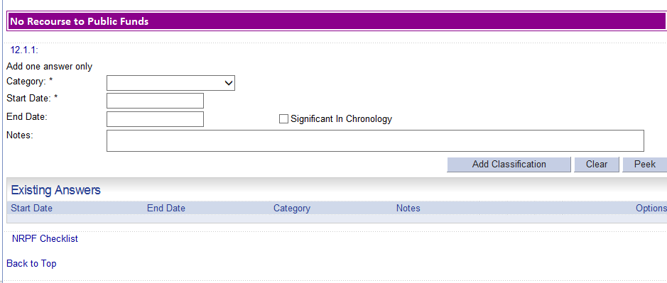

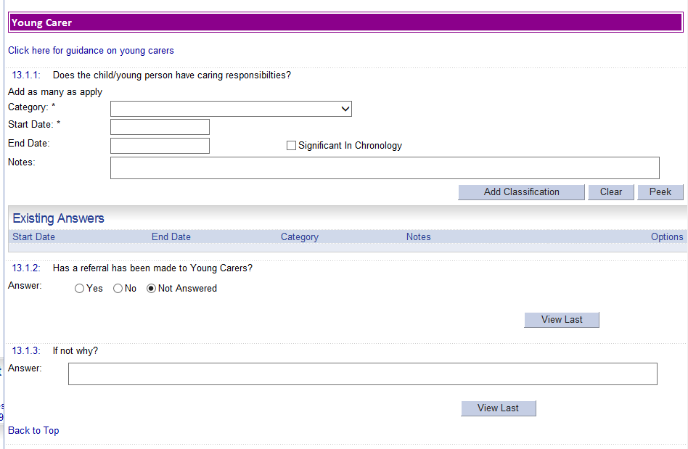

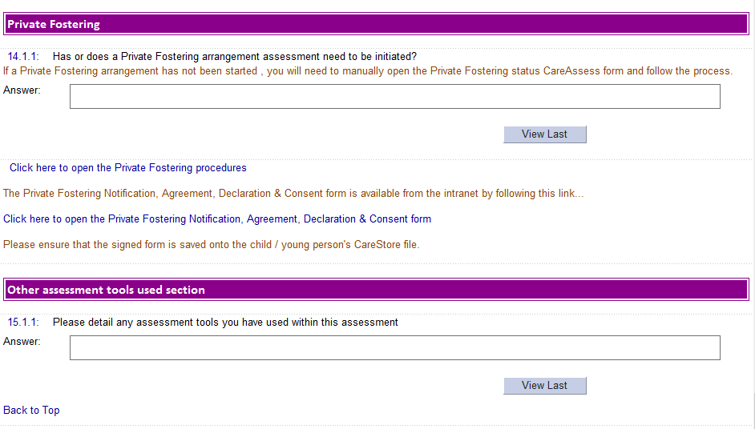

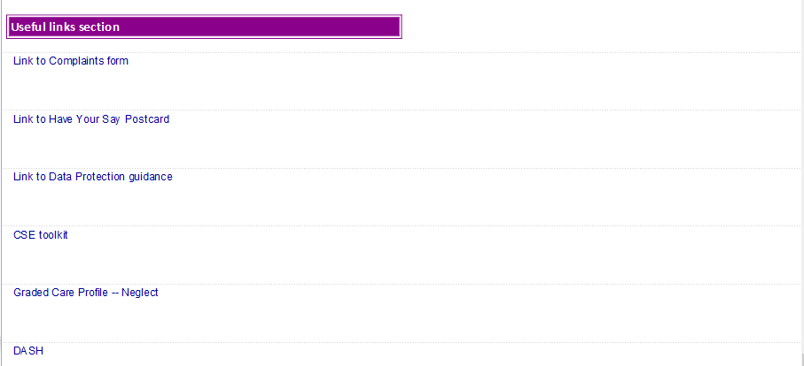

## END OF ADDITIONAL ASSESSMENTS TAB

## What are we worried about TAB.



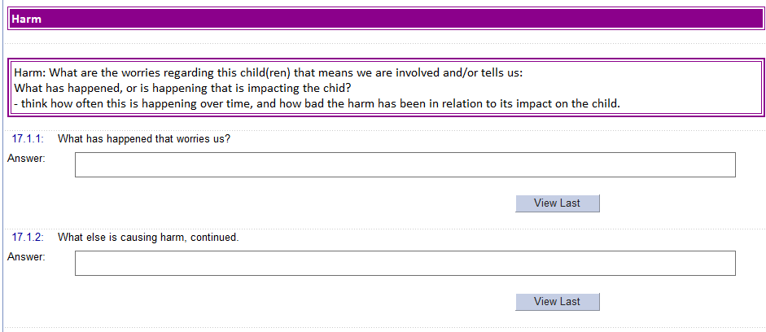

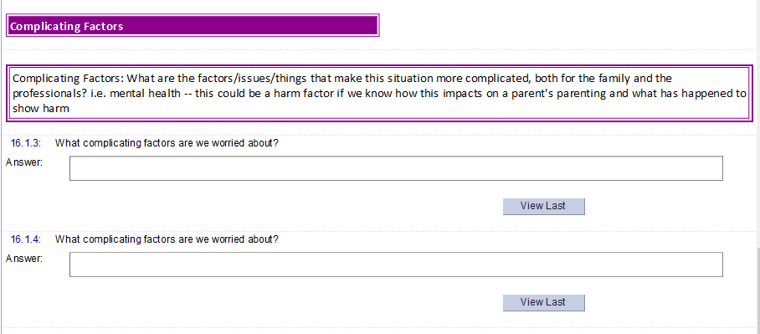

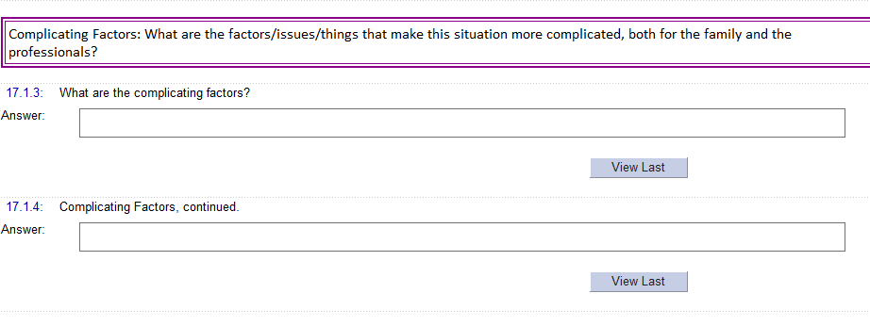

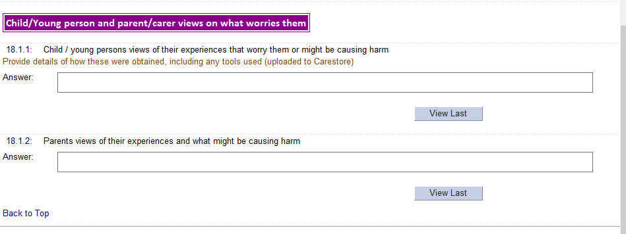

## End of What we are worried about TAB

## Start of What is working well TAB.



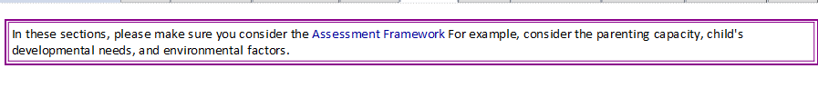

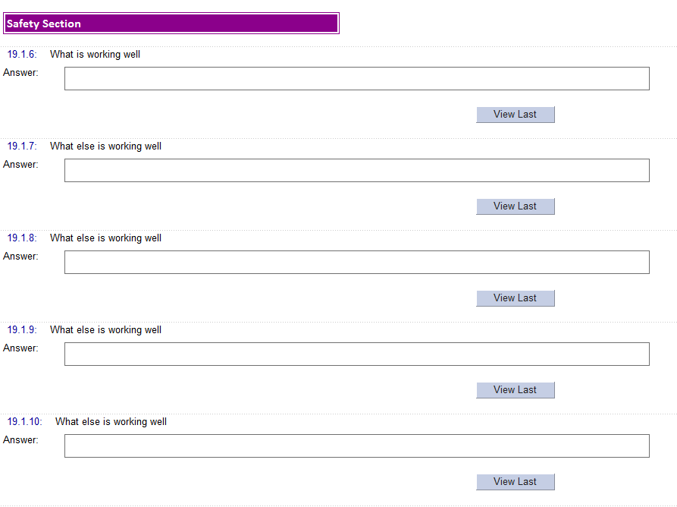

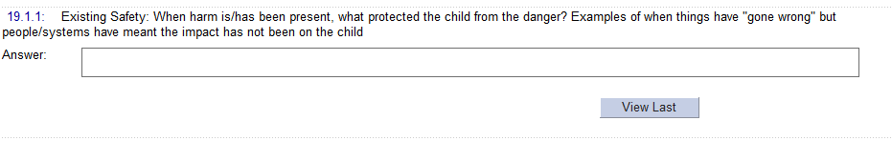

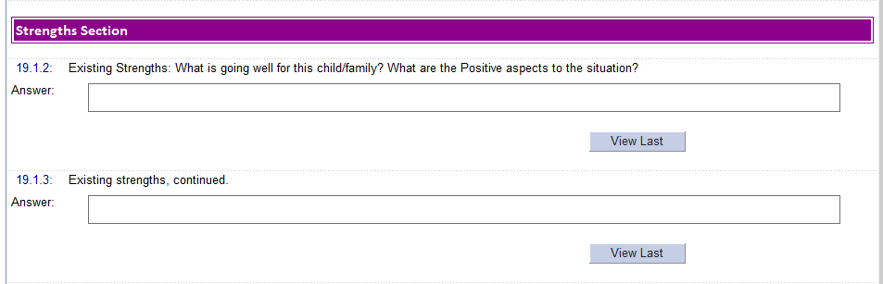

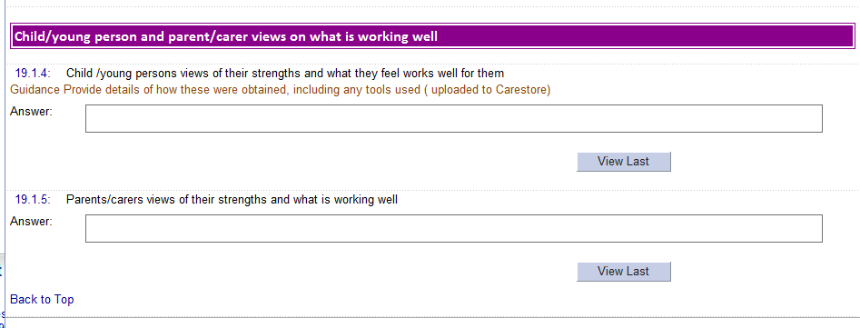

## END OF Working Well TAB

## Next steps TAB

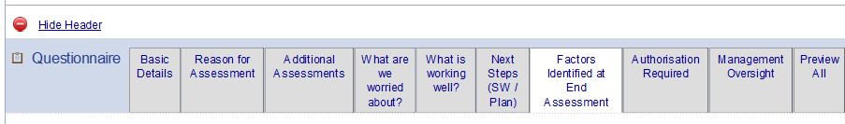

**Missing from live**

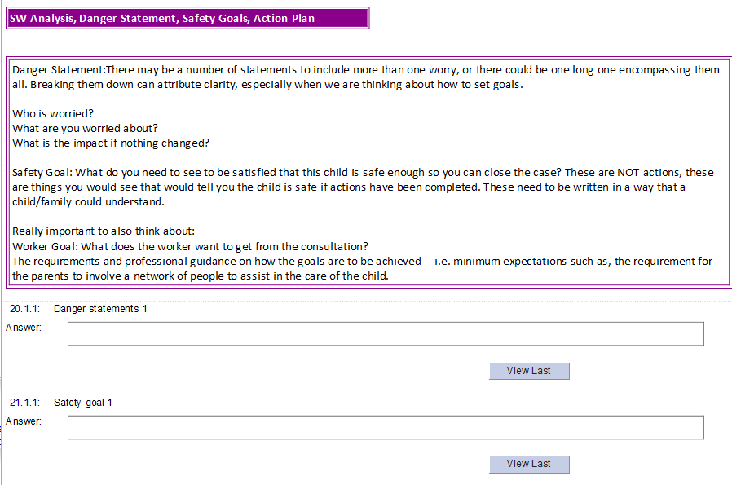

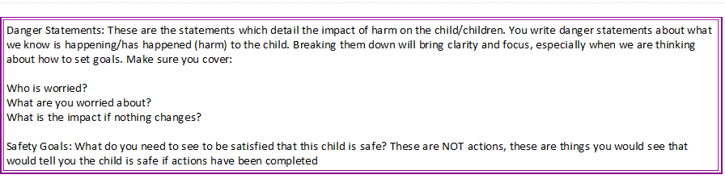

**In live -**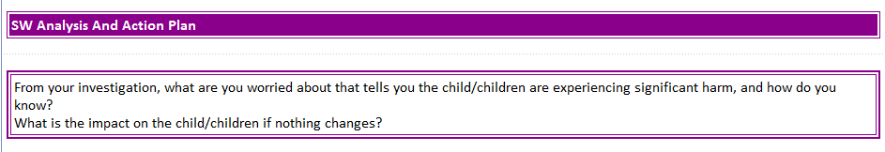

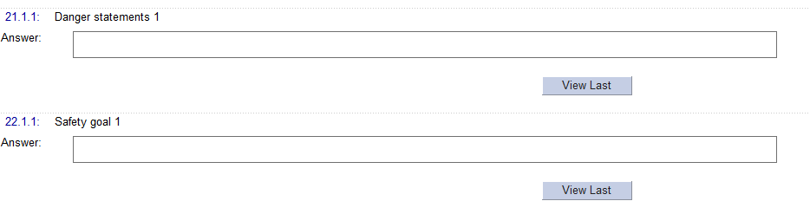

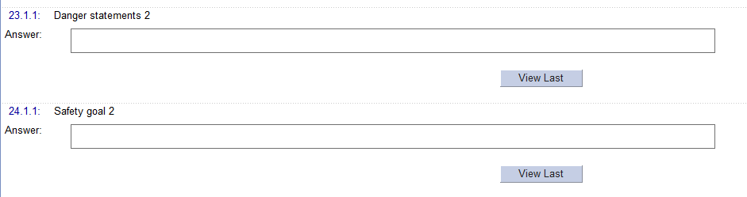

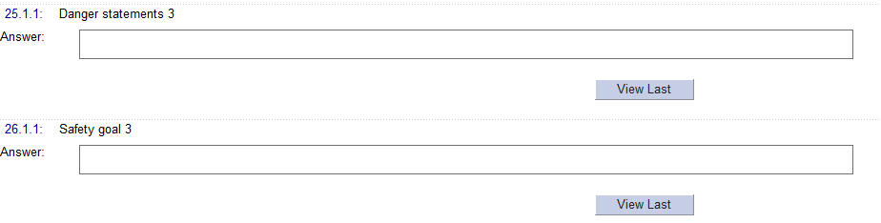

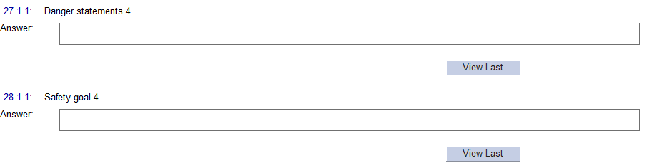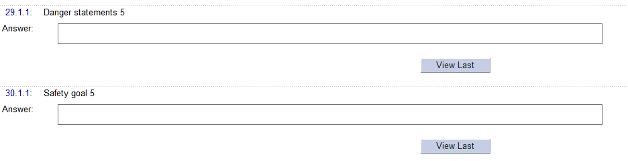

AMEND wording - On a scale of 0 to 10 where 10 is there are no real worries about the child and 0 is there are serious concerns, where would you scale this today?

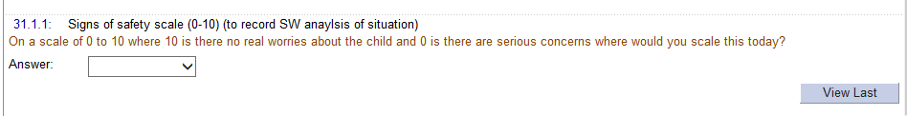

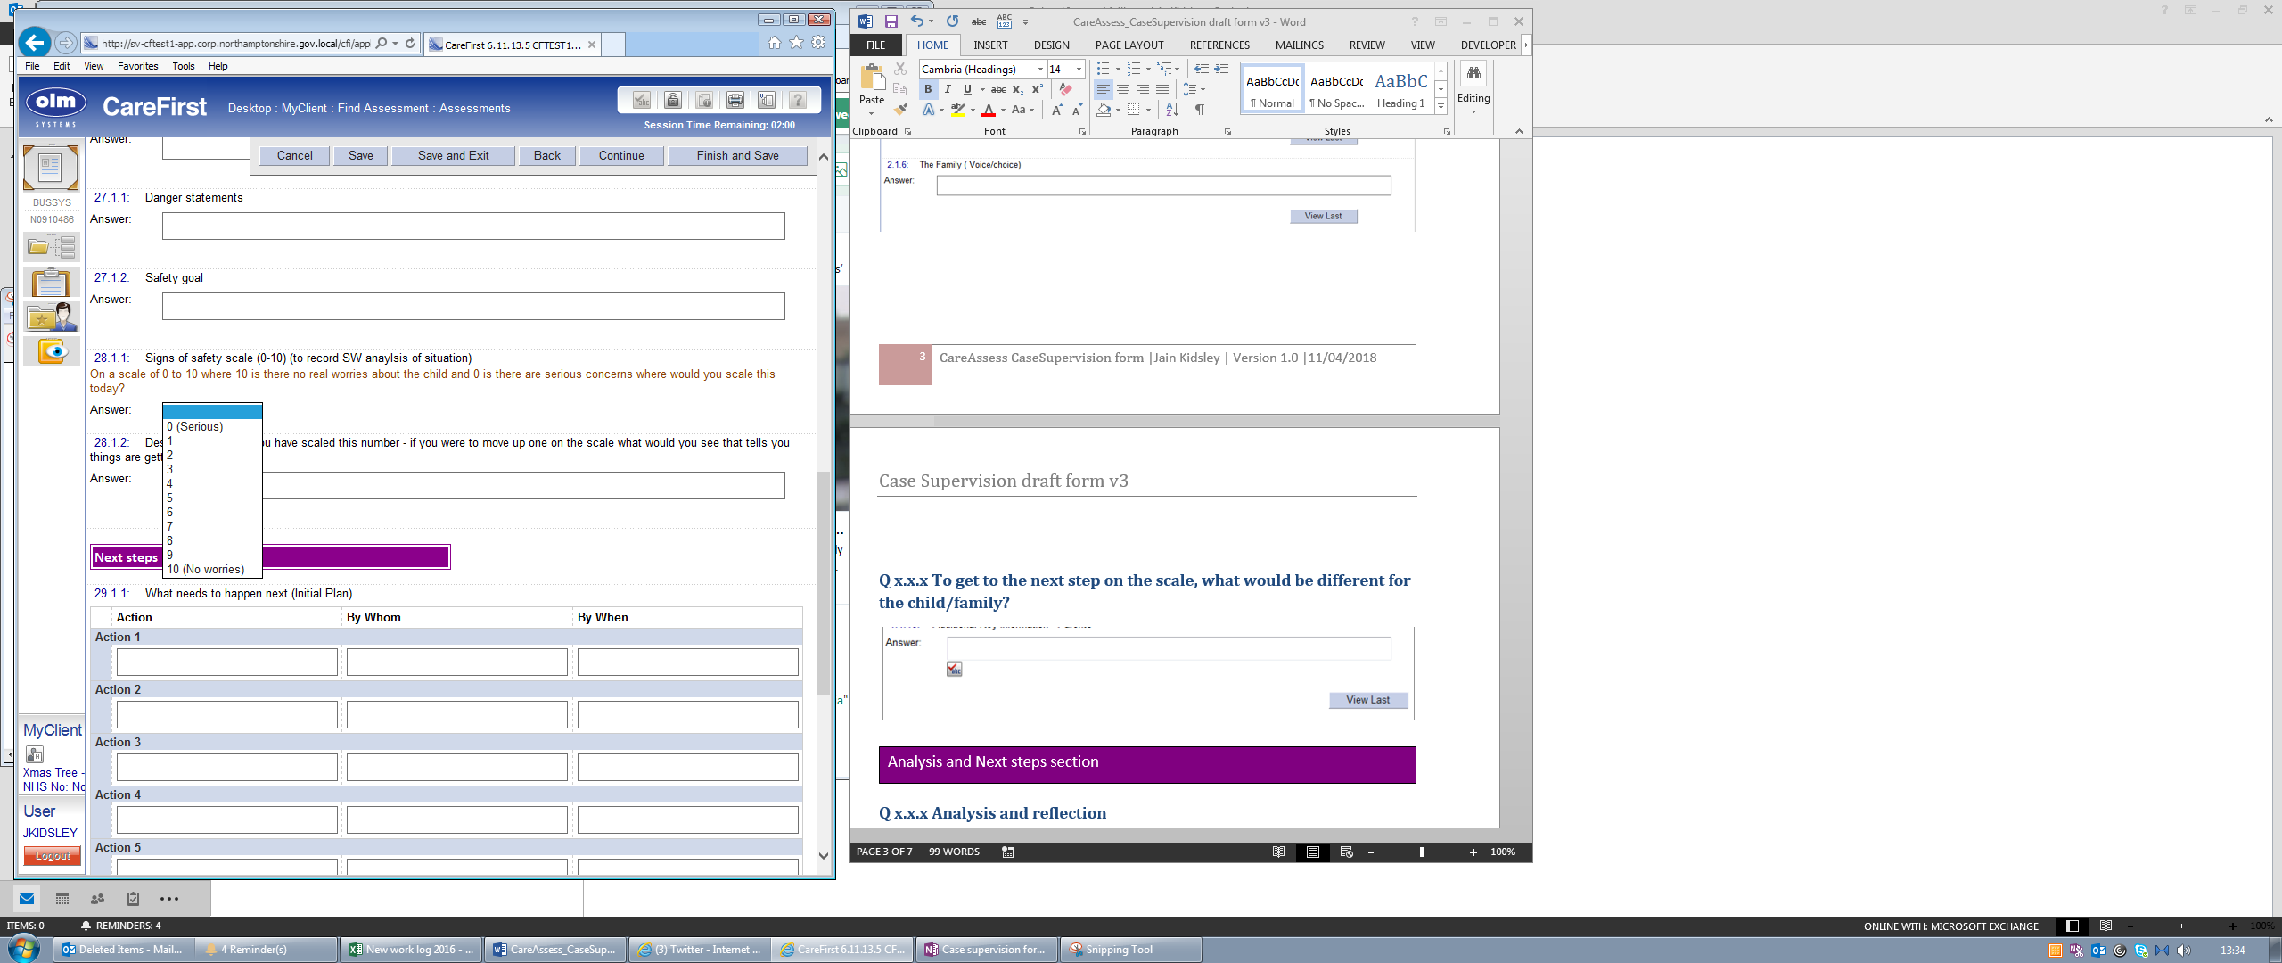

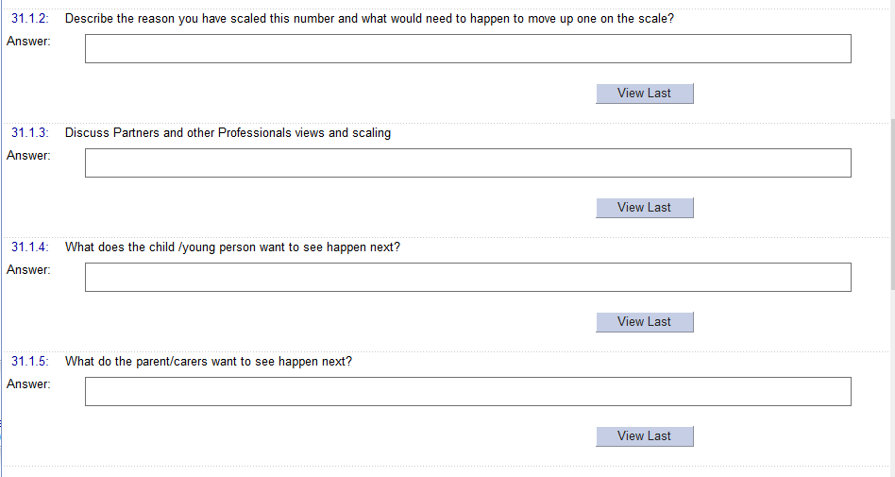

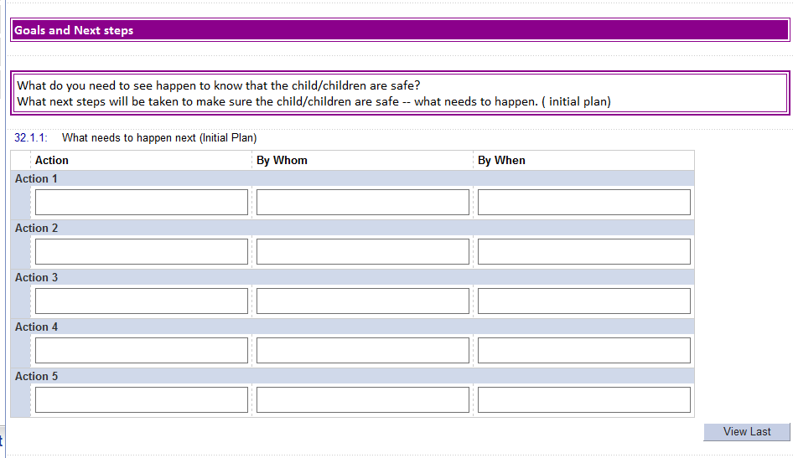

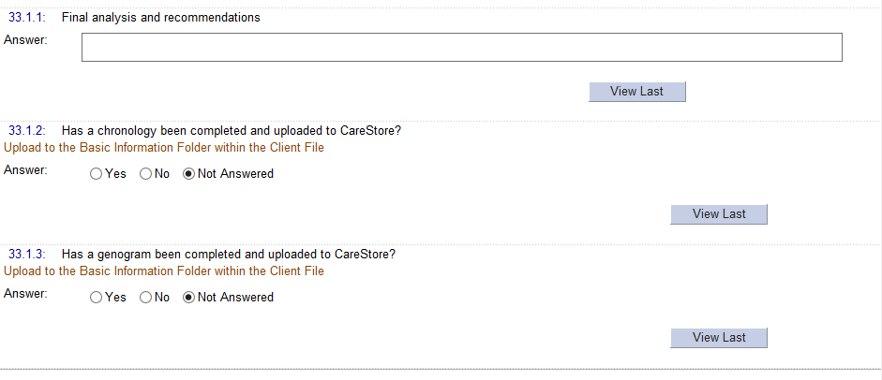

**END OF NEXT STEPS TAB**

**Factors identified tab**



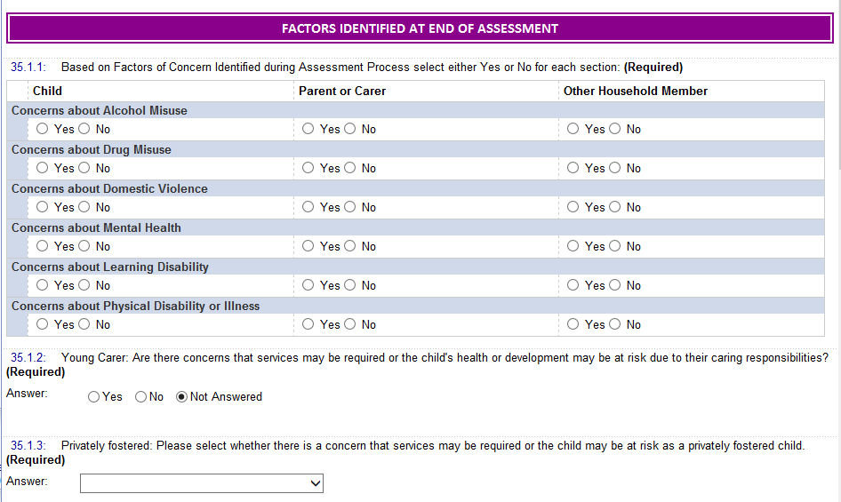

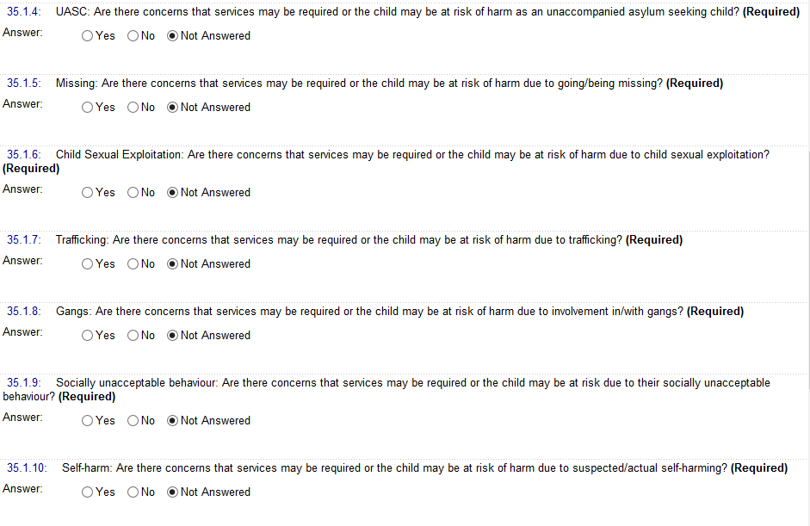

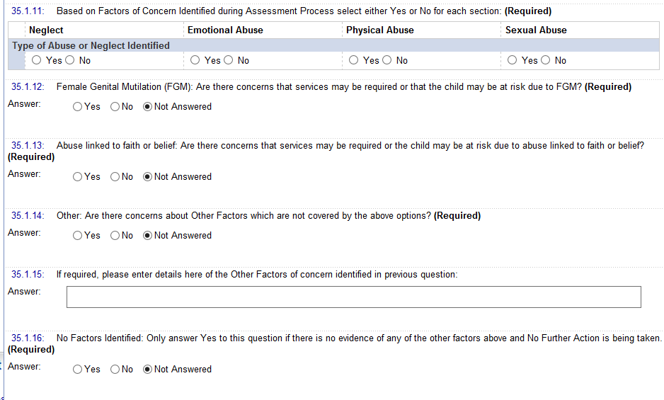

## End of Factors Identified tab

## Start of Authorisation required TAB

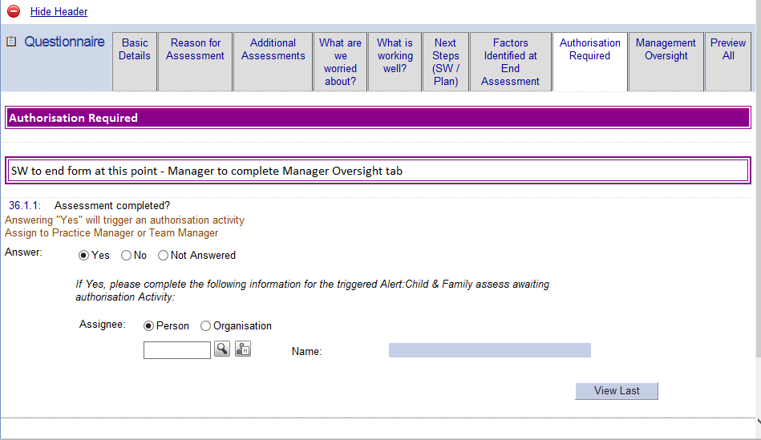

## End of Authorisation required Tab

## Start of Manager Oversight tab.

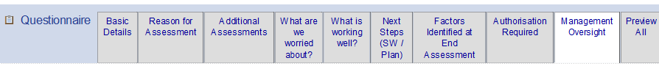



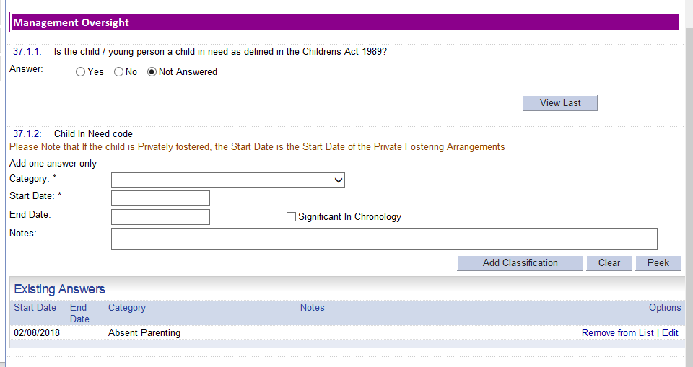

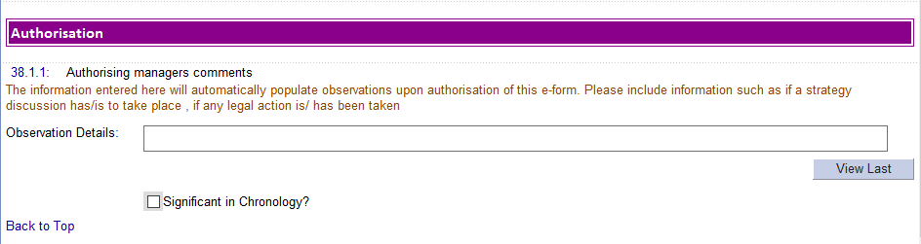

## END of MANAGER oversight tab.

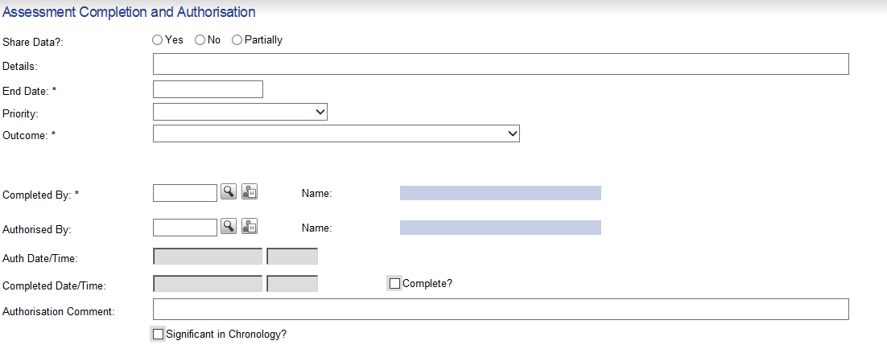

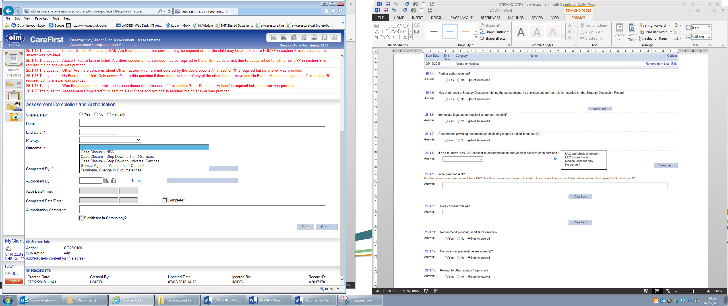

**END OF FORM**

Other Information

Manager Authorisation Required

Triggers

|  |  |  |  |  |  |  |
| --- | --- | --- | --- | --- | --- | --- |
| **Q No:** | 26.1.20 | **Q Text:** | Assessment Completed? | | **Mand?** | Y |
| **Answer Selected** | | **Item triggered** | | **Details** | **Assign To** | |
| Yes | | Activity | | **C-Worker Alerts and Reminders \ Alert: Single Assessment Awaiting Authorisation** created upon assessment completion. High priority.  Activity Requested and Status Date: Assessment Outcome Date | Determine in assessment | |