Genogram Guidance

Genograms not only provide a quick visual picture of the complexity of a family, but are also a tool to have conversations with families to help us to understand relationships, and develop networks. They are important in ensuring that all family members are identified and that it is clear who is biologically important to the child.

Symbols:

Female Male Gender unknown (unborn)

Deceased – this can be a sensitive imagery, so make sure you ask how to record the death of family members.

Separated

Divorced

Using lines to explain relationships:
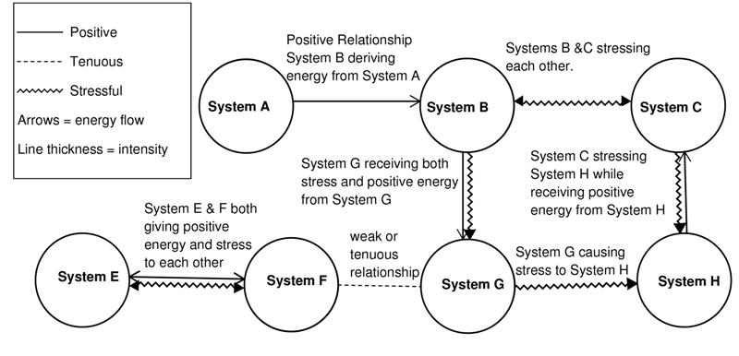

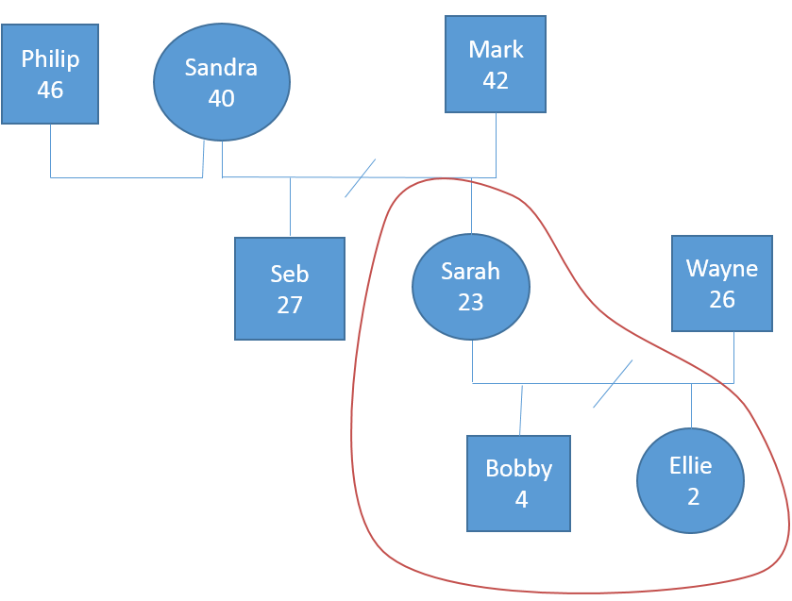
Basic Example:

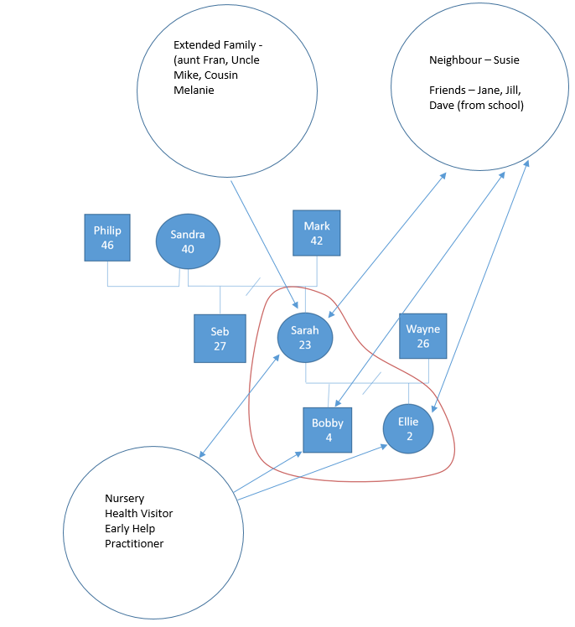
Detailed Example

