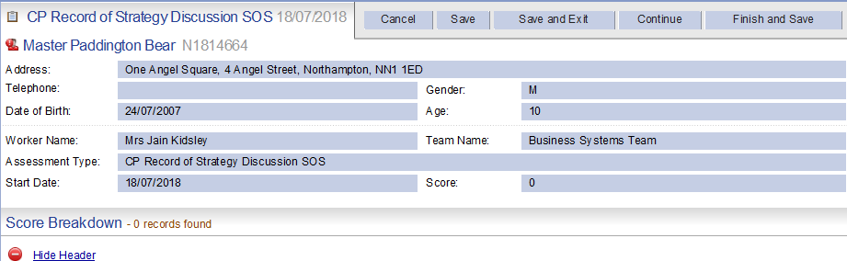
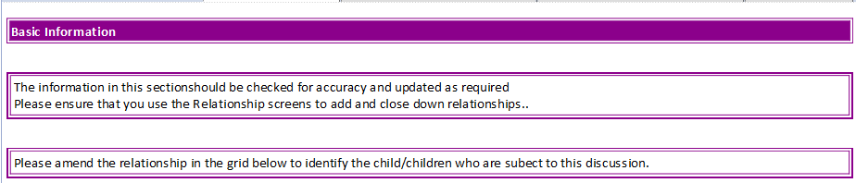
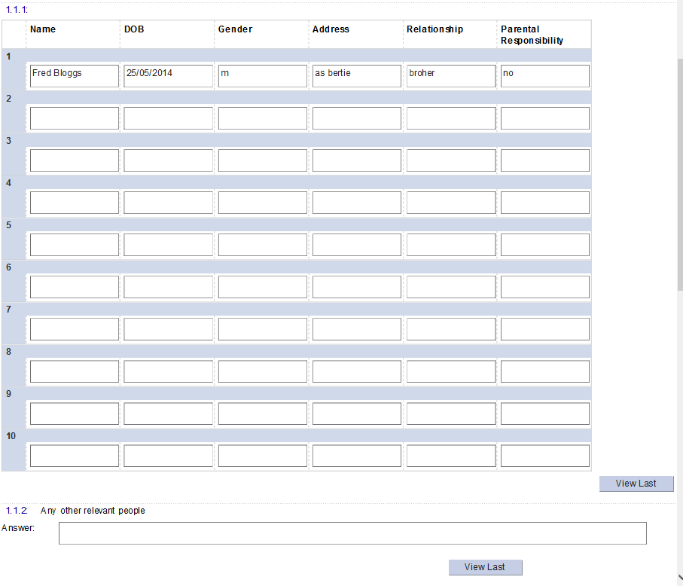

End of family details TAB

START OF RECORD OF DISCUSSION TAB
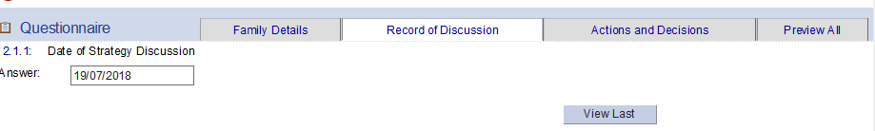
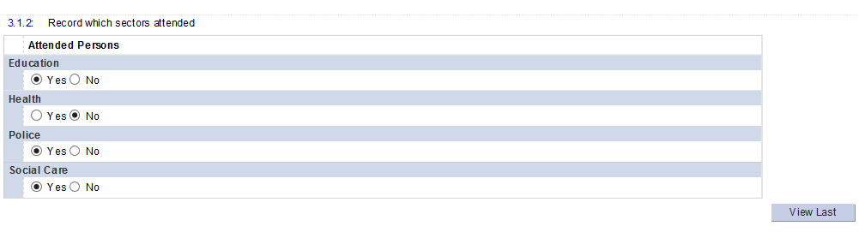
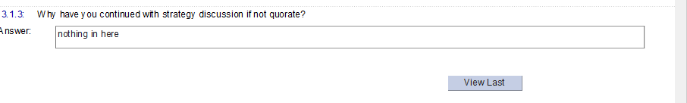
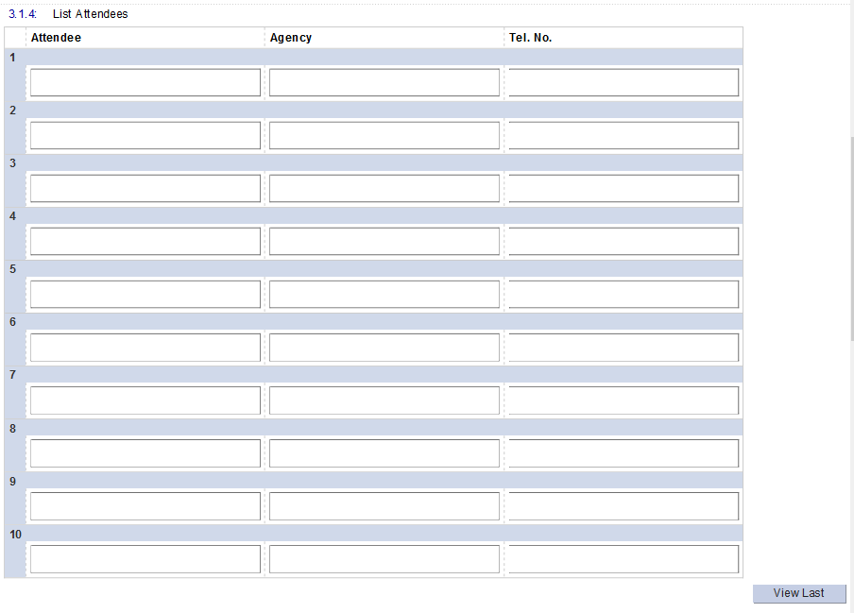
Shared with Outcome S47 form

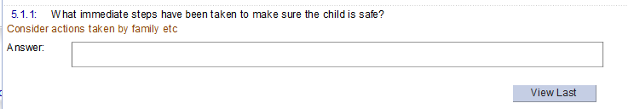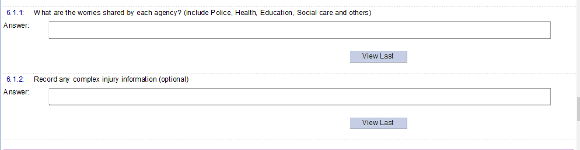

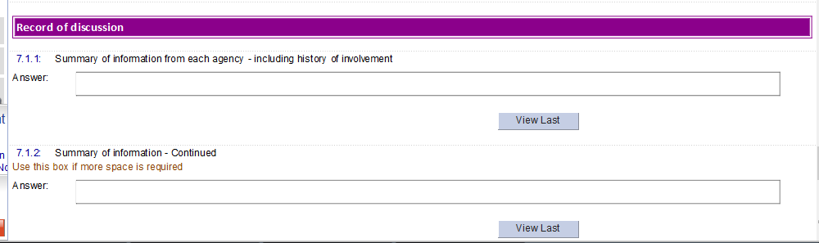

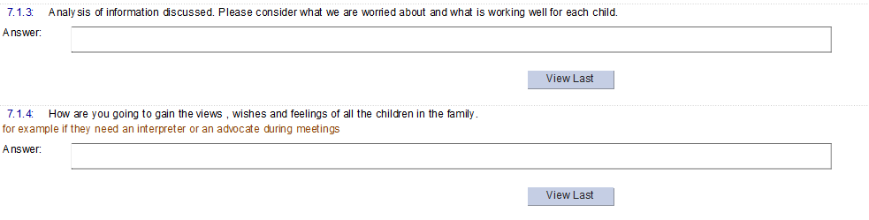

End of Record of discussion TAB

Start of Actions and Decisions TAB

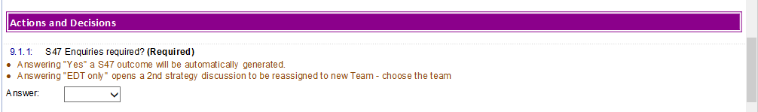

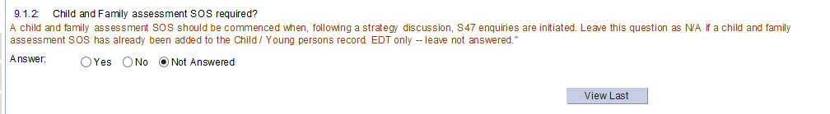
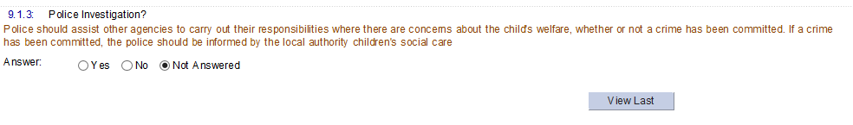
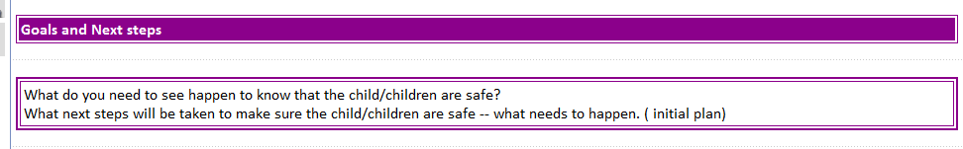

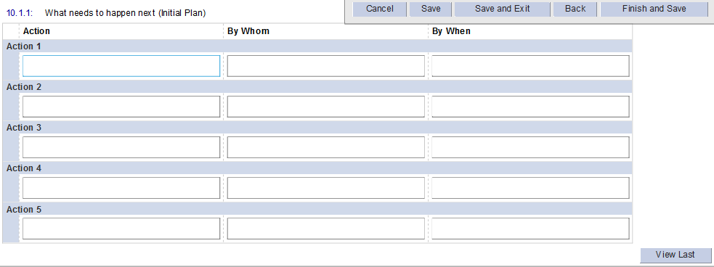
Shared most forms
Shared with Outcome S47 form

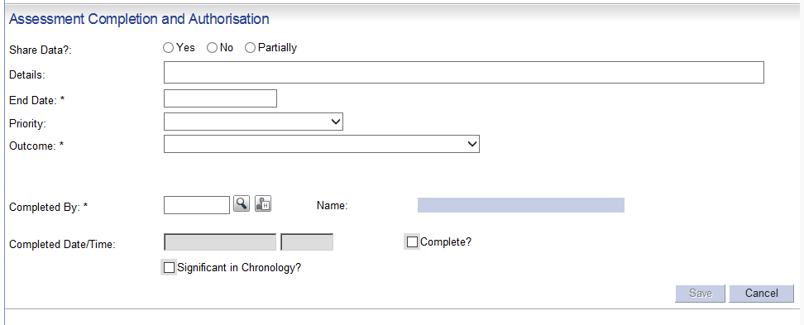
Triggers: - To accommodate the EDT,starting a Strategy Discussion. A 2nd will need to be opened and then the outcome of S47 dicussion form opened by the team handling the case.
Q6.1.1
YES – opens new S47 outcome form. ( used by all)
EDT Only – opens person / org chooser – open 2nd Strategy dicussion form. To be assigned to new team
6.1.2
YES –opens New Child and Family Sos Assessment form.
EDT leave – not answered – as SA is passed to the team who outcome the 2nd strategy discussion.

