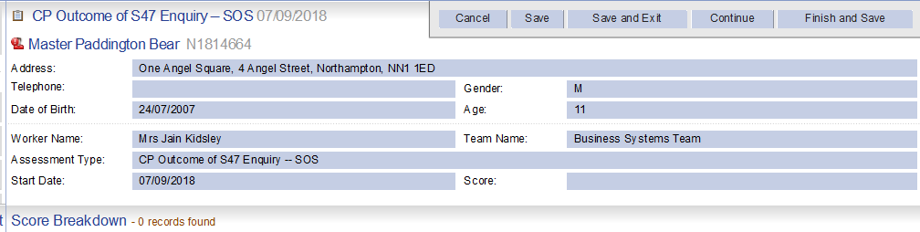
Shared with Strategy discussion formShared with Strategy discussion form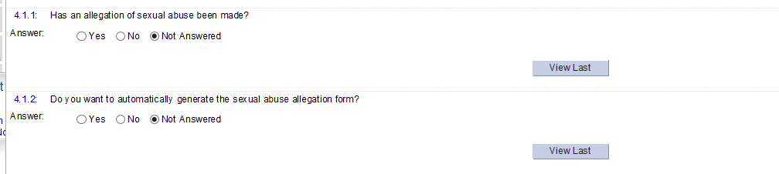
NOTE- q4.1.2 Opens B3 Managing allegations of abuse form.

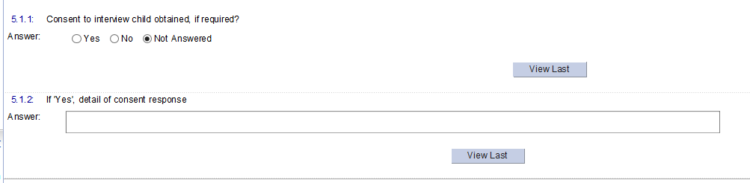

End of Reason Tab.

Start of Background checks tab.
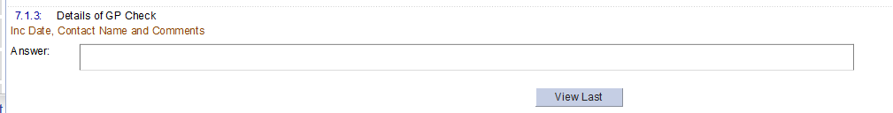
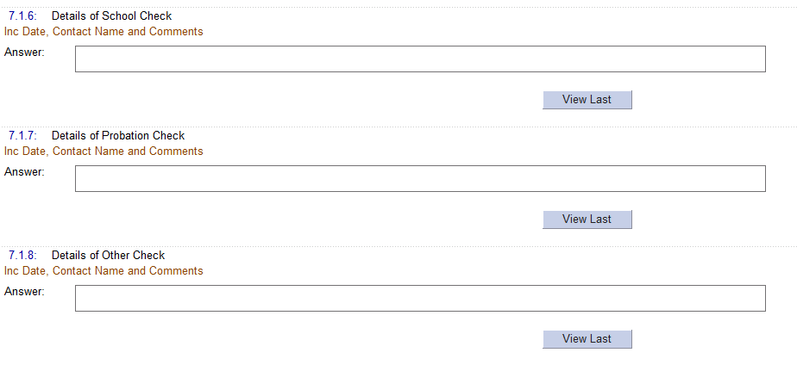

End of Background checks tab.

Start of What are we worried about tab
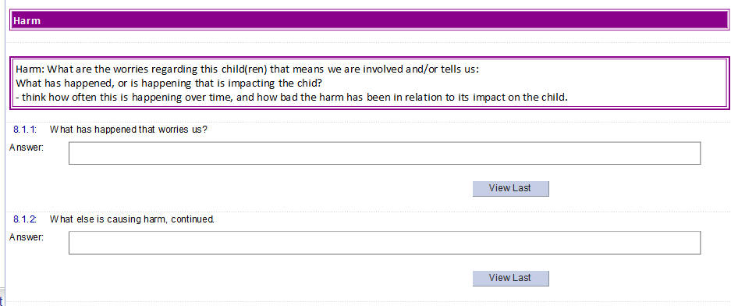
Shared most forms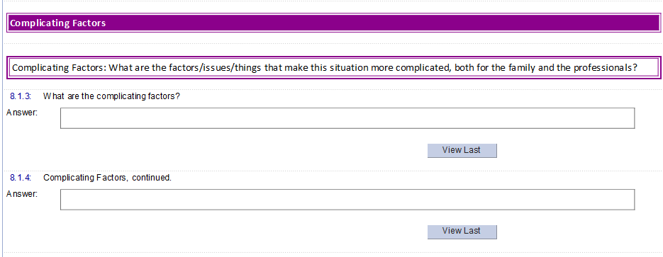
Shared most forms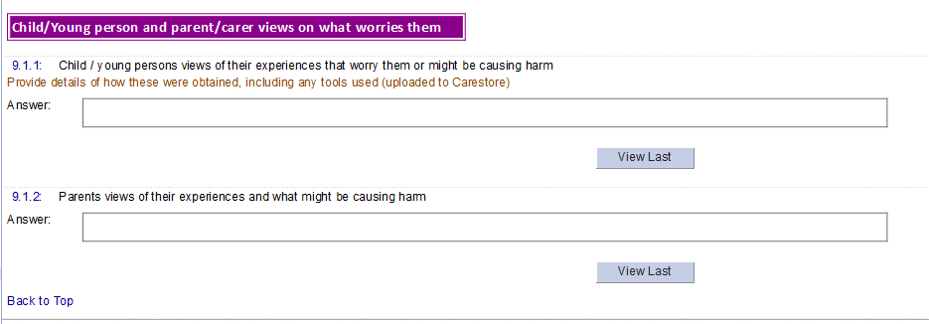
Shared most forms

End of What we are worried about TAB

Start of What is working well TAB.
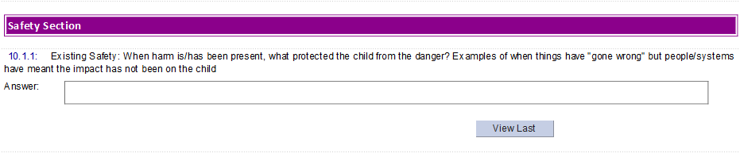
Shared most forms
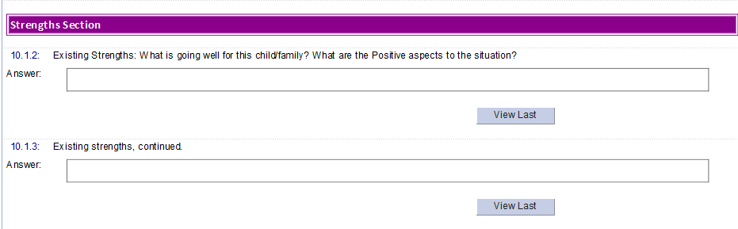
Shared most forms
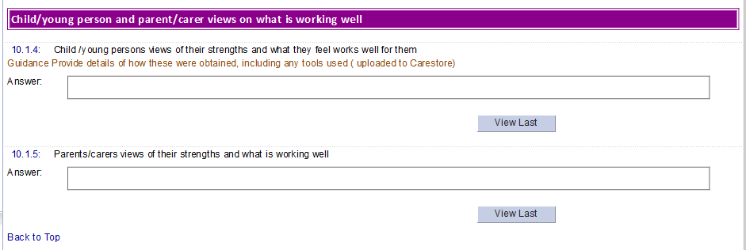
Shared most forms

End of What is working well tab.

Start of next steps tab

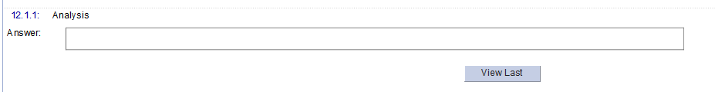

Shared most forms

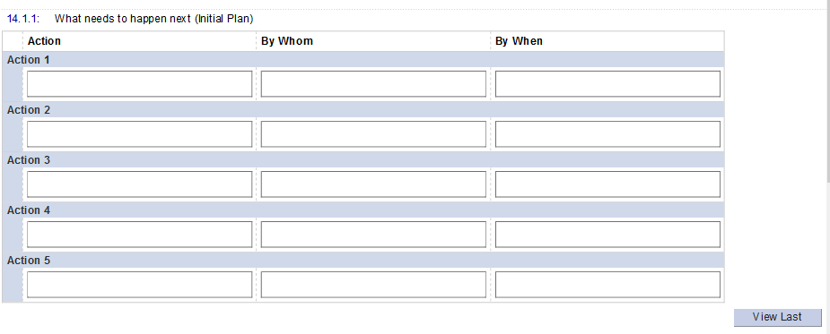
Shared most forms

Shared most forms
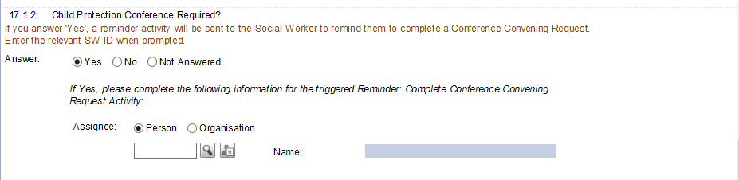
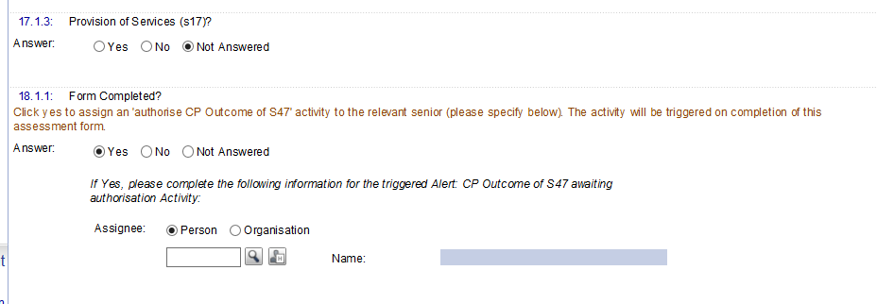
See – Triggers below
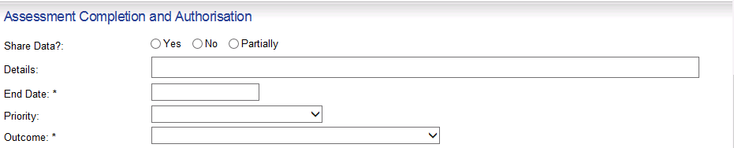

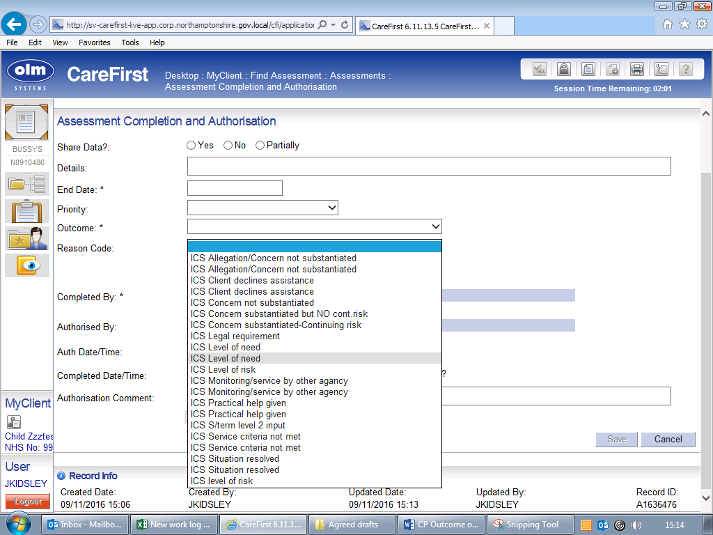
Triggers
q4.1.2 YES - Opens B3 Managing allegations of abuse form.
17.1.2 Name SW Activity – to complete Convening request form
18.1.1 Name – Manager authorisation activity

