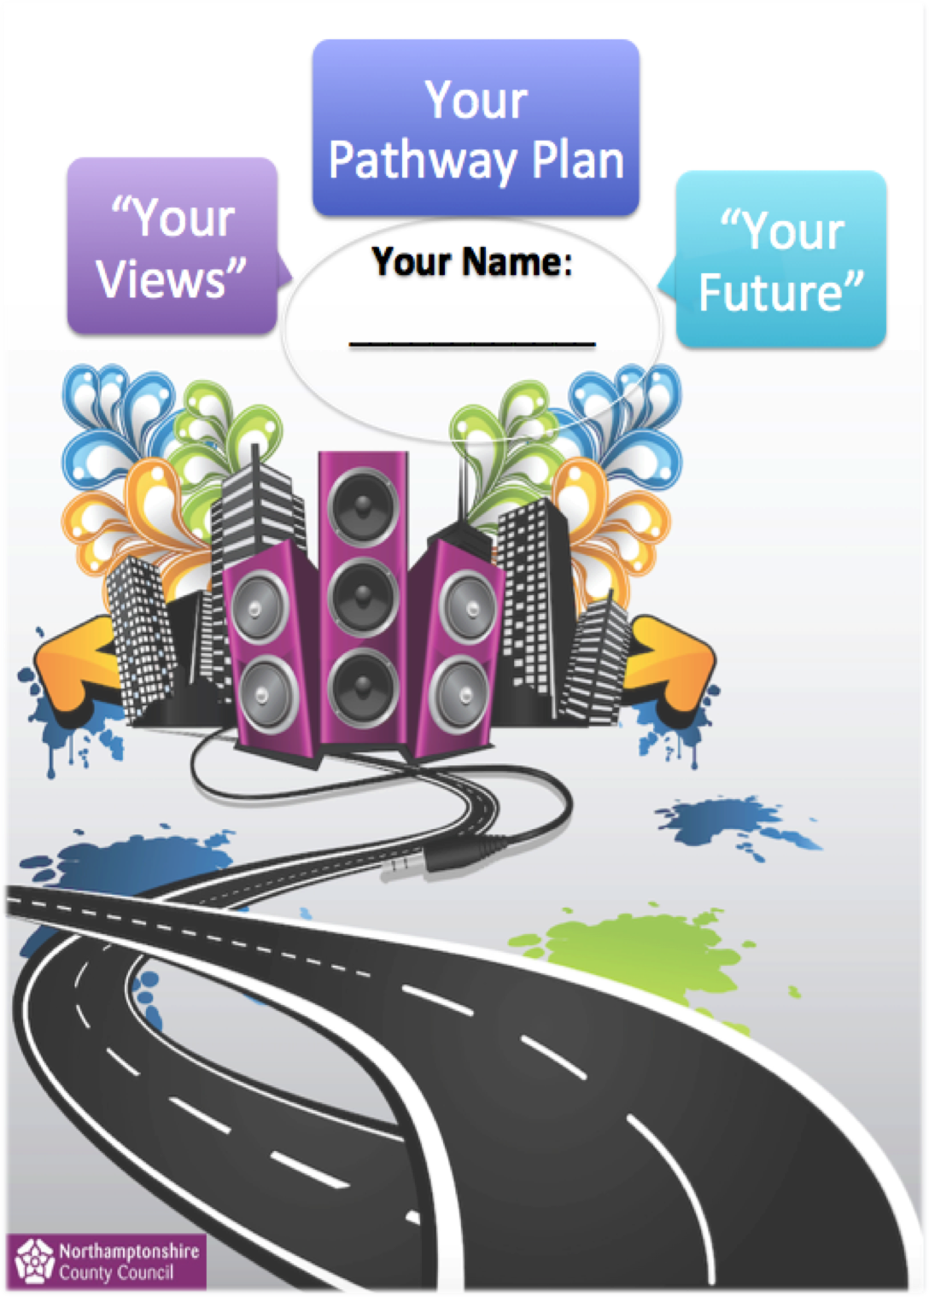

TYPE NAME HERE

KEY INFORMATION SHEET

Name and Address of ‘You’ the Young Person; |  |  |  |  |  |  | Name and Contact Details of Social Worker / Personal Advisor’s work place
Name |  |  |  |  |  |  | Name of Social Worker
 |  |  |  |  |  |  | Tel No
 |  |  |  |  |  |  | Name of Personal Advisor
 |  |  | Post Code
Tel No |  |  | DOB |  |  |  | Tel No

Care First ID: |  |  | Date of Previous Plan
LAC Legal Status |  |  | Date of this Pathway Plan
Leaving Care Status |  |  | Date Pathway Plan will next be Reviewed / Updated:
Immigration Status |  |  | Is the young person in Touch
Ethnicity |  |  | Is the Accommodation Suitable or Unsuitable
Main Language |  |  | Education, Employment, Training [EET]

IMPORTANT CONTACT DETAILS
Relationship / Role: | Name | Address | Tel No
GP
DENTIST
OPTICIANS
HOUSING OFFICER (If Applicable)
EMERGENCY CONTACT
Relationship:
Other (please specify)

CHECKLIST | YES | NO | Does YP have a copy? | Is a copy saved on case file? | Record Details / Number (if appropriate)
Birth Certificate
Bank Account
National Insurance Number
NHS Medical Number / Card
Passport
Home Office Number
Driving Licence
Current CV
Prisoner Number (if applicable)
NHS exemption certificate
Health Passport
ACCOMMODATION SUMMARY OF NEEDS

This section is to help identify any plans or support you may need in your current accommodation or future place of accommodation:
(Please record any significant change of circumstance or other relevant information that has taken place since this Plan was last reviewed):

Date this information was Reviewed: | Update of Information:
Backup Plan:

What will need to happen if you can no longer live in the accommodation you are staying in at the moment?

Young Persons Views

Personal Advisors Views

Social Workers Views

HEALTH SUMMARY OF NEEDS

This section is about your Physical, Emotional and Mental Health and how it may affect your day-to-day life:
(Please record any significant change of circumstance or other relevant information that has taken place since this Plan was last reviewed):

Date this information was Reviewed: | Update of Information:
Backup Plan:

What will need to happen if you have unexpected problems with your health?

Young Persons Views

Personal Advisors Views

Social Workers Views

HOPES,DREAMS & ASPIRATIONS FOR FUTURE EDUCATION, EMPLOYMENT & TRAINING OPPORTUNITIES.
This section is about how you are doing in education, training or employment for the future:
(Please record any significant change of circumstance or other relevant information that has taken place since this Plan was last reviewed):

Date this information was Reviewed: | Update of Information:
Backup Plan:

What will need to happen if you lose your educational placement or job?

Young Persons Views

Personal Advisors Views

Social Workers Views

ETHNICITY / CULTURE / IDENTITY SUMMARY OF NEEDS

This section is exploring how you view yourself and any sense of belonging or values / beliefs that you may have:
(Please record any significant change of circumstance or other relevant information that has taken place since this Plan was last reviewed):

Date this information was Reviewed: | Update of Information:
Backup Plan (where applicable):

Young Persons Views

Personal Advisors Views

Social Workers Views

CIRCLE OF SUPPORT

This section is about how you manage and deal with people in your life:
(Please record any significant change of circumstance or other relevant information that has taken place since this Plan was last reviewed):

Date this information was Reviewed: | Update of Information:
Backup Plan:

What will need to happen if there are unexpected problems with any of your relationships?

Young Persons Views

Personal Advisors Views

Social Workers Views

HOBBIES/SOCIAL/LEISURE

This section including past hobbies / activities as well as any new ones they may wish to explore in the future:
(Please record any significant change of circumstance or other relevant information that has taken place since this Plan was last reviewed):

Date this information was Reviewed: | Update of Information:
Backup Plan (where applicable):

What would need to happen if you were unable to have the opportunity to experience an area of interest?

Young Persons Views

Personal Advisors Views

Social Workers Views

SELF CARE & INDEPENDENT LIVING SKILLS

This section is about how ready you are to live independently, (please incorporate the information ascertained during the Needs Assessment).
- Practical:

- Shopping:

- Cooking:

- Laundry:

- Budgeting:

- Routine:

- Social:

Young Persons Views

Personal Advisors Views

Social Workers Views

FINANCIAL SUPPORT
Income / Money coming in:

Description | Amount | Monthly | Weekly
Wages / Earnings / YPA
Benefits
Student Finance, i.e. (grants / loans / bursaries, etc):
Other
TOTAL

Expenditure / Money going out:

Description | Amount | Monthly | Weekly
Food
Electric
Gas
Water
Rent
Council Tax
TV Licence
Contributions to housekeep (if applicable)
Leisure, i.e. (going out, gym membership, etc):

Other, i.e. (Transport, Smoking, phone / internet, etc).
Debts, i.e. (loans / overdraft, etc).
TOTAL

Savings:

Description | Amount remaining | How / when will this be spent?
Savings

Leaving Care Grant

Other, i.e. (Inheritance / compensation, etc).

How well have you been managing your money? Think about how much money you save or have borrowed from others (friend, family, etc.) and how many times you run out of money before you next get paid.

(Please record any significant change of circumstance or other relevant information that has taken place since this Plan was last reviewed):

Date this information was Reviewed: | Update of Information:
Backup Plan :

What will need to happen if you have no money?

Young Persons Views

Personal Advisors Views

Social Workers Views

YOUR PATHWAY PLAN

Actions from previous plan that have been completed:

Desired goal / Outcome  (WHAT?) | Next step – what action needs to be taken to achieve the identified Goal / Outcome  (HOW?) | Who is going to take this action  (WHO?) | What is the date set for when this action / outcome will be completed or reviewed  (WHEN?)

Actions from previous plan that still need to be completed / carried forward:

Desired goal / Outcome  (WHAT?) | Next step – what action needs to be taken to achieve the identified Goal / Outcome  (HOW?) | Who is going to take this action  (WHO?) | What is the date set for when this action / outcome will be completed or reviewed  (WHEN?)

New Actions identified during this review / update:

Desired goal / Outcome  (WHAT?) | Next step – what action needs to be taken to achieve the identified Goal / Outcome  (HOW?) | Who is going to take this action  (WHO?) | What is the date set for when this action / outcome will be completed or reviewed  (WHEN?)

Overall Views and Comments:

Young Persons overall comments about their updated Pathway Plan:
YOUR COMMENTS:
Print Name | Signature | Date

Parent /Carers/ Key Workers Comments (where applicable) :
Comments:

Print Name | Signature | Date

Comments from Agencies consulted during this plan:
Comments:

Print Name | Signature | Date

Social Workers overall summary / analysis of this updated Pathway Plan::
Comments:

Print Name | Signature | Date

Personal Advisor’s comments of this updated Pathway Plan:
Comments:

Print Name | Signature | Date

Independent Reviewing Officers comments (Where applicable):
IRO comments and Recommendations:
Print Name | Signature | Date

Team / Practice Managers comments
Comments::
Print Name | Signature | Date

