Please note, this Needs Assessment booklet is designed as an interactive tool to guide and assist with gathering of relevant information for young people who require an initial / updated Pathway Plan. Any relevant information / wishes / feelings of the young person that is gathered during this needs assessment should be subsequently transferred to the separate Pathway Plan document.

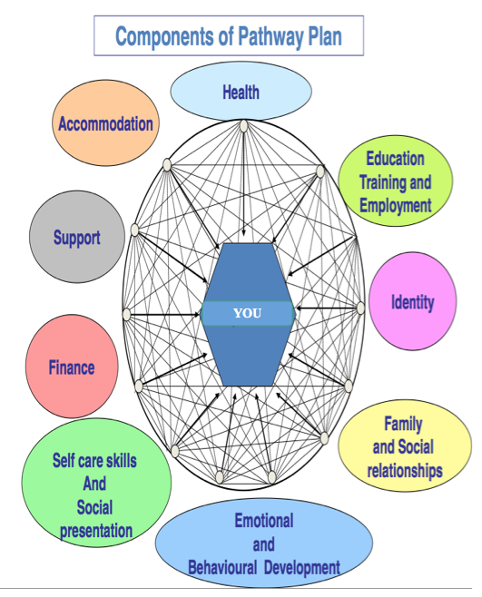

**ACCOMMODATION**

|  |  |
| --- | --- |
| **Date this information was obtained:** | **Details of any relevant Information:** |
|  | **Where are you currently living?**  **What type of Accommodation are you currently living in? i.e.(foster care / semi-supported):**  **Are there any Facilities and Services provided?, i.e. (food / laundry, etc):**  **Is where you live in good condition ? (if not, what needs to be repaired):**  **Do you feel safe where you live?: (If ‘NO’ please explain why in the space below):**  **Do you have to pay anything towards your current accommodation?, i.e. (Service charge):**  **Do you have any thoughts or plans to move on to somewhere else to live in the future?** |

**HEALTH**

***This section is about your Physical, Emotional and Mental Health and how it may affect your day-to-day life.***

**(*Please circle where you view yourself to be on the point scale below, the higher the score the better the you feel you are doing in that category*)**

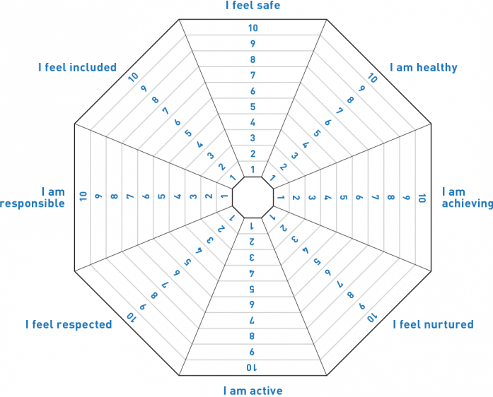

|  |  |
| --- | --- |
| **Date this information was obtained:** | **Details of any relevant Information:** |
|  | * **What things do you do to keep fit and how often**? * **Do you currently Smoke, drink Alcohol or take Drugs**? (if yes please provide more details below, i.e. how often / how much, etc): * **Have you ever been diagnosed with having any physical or mental health conditions**? * **Have you recently self-harmed or had thoughts about hurting yourself**? * **Are you on any prescribed any medication**? (if yes, what is the name of the medication / how often do you take it / do you need any support in this area): * **Is there anything that you are allergic to**? * **Has your Social Worker or Personal Advisor explained to you about your right to receive your Health Passport ?** * **When did you last visit your doctor?**      * **When did you last visit your dentist?**      * **When did you last visit your opticians?** |

**HOPES, DREAMS & ASPIRATIONS FOR FUTURE EDUCATION, EMPLOYMENT & TRAINING OPPORTUNITIES.**

(*Please record your wishes and feelings by writing them in the pyramid below)*

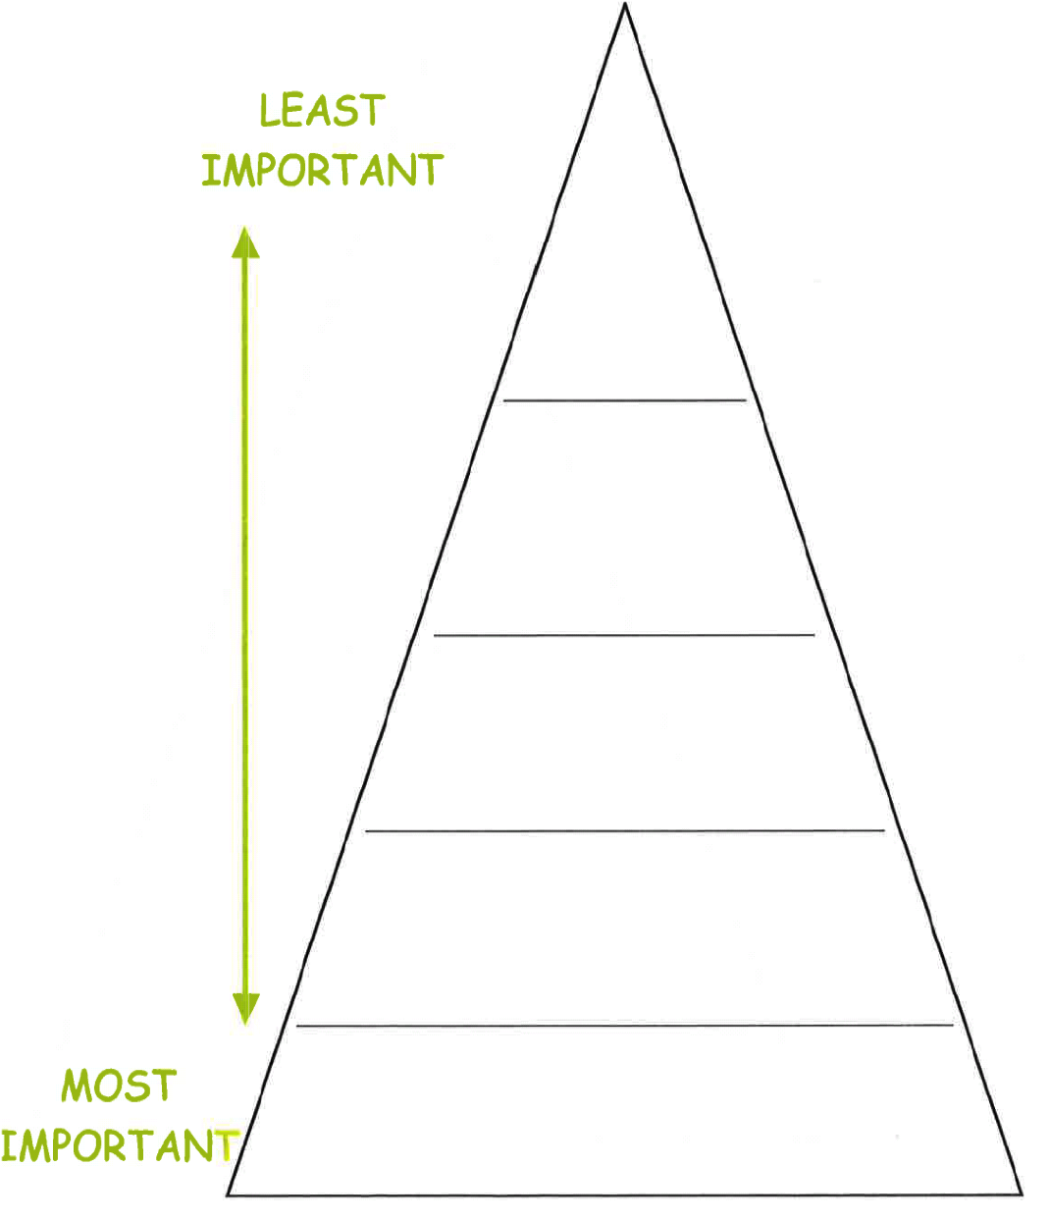

**This section is about how you are doing in education, training or employment for the future:**

|  |  |
| --- | --- |
| **Date this information was obtained:** | **Details of any relevant Information:** |
|  | * **Do you have any previous or current barriers to learning or finding employment**? * **What plans do you have to overcome any barriers that may have been identified**? * **Do you have an up-to-date CV**? |

**ETHNICITY / CULTURE / IDENTITY SUMMARY OF NEEDS**

***(This section is exploring how you view yourself and any sense of belonging or values / beliefs that you may have)***

|  |  |
| --- | --- |
| **Date this information was obtained:** | **Details of any relevant Information:** |
|  |  |

**CIRCLE OF SUPPORT**

**(*Please insert as many names of people or services that you find helpful within the Circle of Support below – this will help us to recognise your support network which will be reviewed every time your Pathway Plan is updated*)**



|  |  |
| --- | --- |
| **Date this information was obtained:** | **Details of any relevant Information:** |
|  |  |

**HOBBIES/SOCIAL/LEISURE**

***Identify as many areas of interest that you can and write them in the pyramid below:***

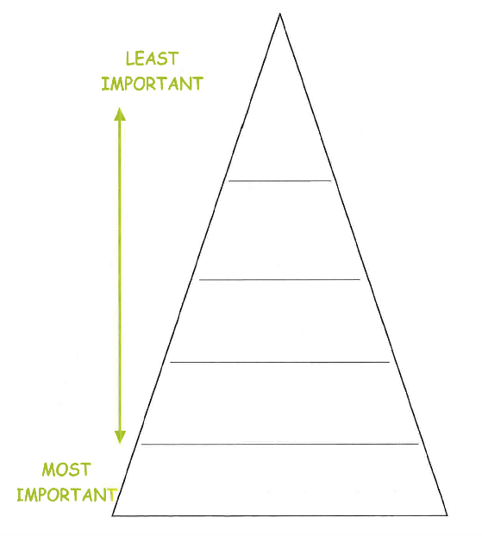

|  |  |
| --- | --- |
| **Date this information was obtained:** | **Details of any relevant Information:** |
|  | **What activities do you enjoy doing in your spare time to relax or have fun**?  **Do you have any hobbies, activities or things that you would be interested in doing in the future**?  **Do you need any support to take up any of the above hobbies / activities?** |

**SELF CARE & INDEPENDENT LIVING SKILLS**

**This section is about how ready you are to live independently, (please score out of 1 – 5 and explain why below each score:**

|  |  |
| --- | --- |
| **Date this information was obtained:** | **Details of any relevant Information:** |
|  | * **Practical:**  * **Shopping:**  * **Cooking:**  * **Laundry:**  * **Budgeting:**  * **Routine:**  * **Social:** |

**FINANCIAL SUPPORT**

**Income / Money coming in:**

|  |  |  |  |
| --- | --- | --- | --- |
| **Description** | **Amount** | **Weekly** | **Monthly** |
| **Wages / Earnings / YPA** |  |  |  |
| **Benefits** |  |  |  |
| **Student Finance, i.e. (grants / loans / bursaries, etc):** |  |  |  |
| **Other** |  |  |  |
| **TOTAL** |  |  |  |

**Expenditure / Money going out:**

|  |  |  |  |
| --- | --- | --- | --- |
| **Description** | **Amount** | **Weekly** | **Monthly** |
| **Food** |  |  |  |
| **Electric** |  |  |  |
| **Gas** |  |  |  |
| **Water** |  |  |  |
| **Rent** |  |  |  |
| **Council Tax** |  |  |  |
| **TV Licence** |  |  |  |
| **Contributions to housekeep (if applicable)** |  |  |  |
| **Leisure, i.e. (going out, gym membership, etc):** |  |  |  |
| **Other, i.e. (Transport, Smoking, phone / internet, etc).** |  |  |  |
| **Debts, i.e. (loans / overdraft, etc).** |  |  |  |
| **TOTAL** |  |  |  |

Savings**:**

|  |  |  |
| --- | --- | --- |
| **Description** | **Amount remaining** | **How / when will this be spent?** |
| **Savings** |  |  |
| **Leaving Care Grant** |  |  |
| **Other, i.e. (Inheritance / compensation, etc).** |  |  |

**How well have you been managing your money?** Think about how much money you save or have borrowed from others (friend, family, etc.) and how many times you run out of money before you next get paid**.**

|  |  |
| --- | --- |
| **Date this information was obtained:** | **Details of any relevant Information:** |
|  |  |