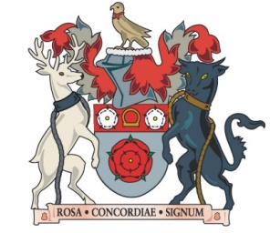
Northamptonshire County Council

Placement Approval Flowchart

Is Young Person aged 14+?
Is Young Person aged 14+ and being accommodated for the first time?
Yes
Consultation with ‘area’ authority (where child is to be placed) to include:
- Plans for the child’s care
- Services to meet educational needs
- Information about plans to meet child’s secondary (specialist) health needs
- Details of any youth justice supervision order
Complete 14+ first accommodation approval form.
Gain views from Education on proposed move
Obtain approval from Assistant Director
Is this a new or subsequent Out of County Move
New
Subsequent
Complete New Out of County placement approval form
Obtain approval from DCS
Obtain approval from Assitant Director
Complete Subsequent Out of County placement approval form
Obtain approval from Assitant Director
Complete 14+ placement approval form.
Yes
Gain views from Education on proposed move
No
No
No
Normal approval required
- New, or additional, additional cost Strategic Manager
- No increased cost: Service Manager
Normal approval required
- New, or additional, additional cost Strategic Manage
- No increased cost: Service Manager
Is placement to be made outside Northamptonshire?
Yes

