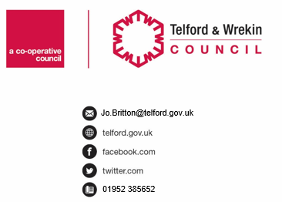
CONFIDENTIAL

Date: |  | Our Ref: |  | Your Ref:

Dear

My name is (…………………..) and I am the Service Delivery Manager for (……………). I am writing to you both as the decision has been made to end the Public Law Outline Process with your family. This means that the Local Authority is not planning to start care proceedings in respect of your children. It also means that the Letter before proceedings meetings that have been taking place, will end.

I wanted to say that this is due to your hard work and I hope that you continue working with the children’s social worker in making sure that your children are safe.

Well Done.

Yours sincerely

Nick Bennison
Service Delivery Manager
Child Protection & Family Support

