What is the Family Circle?
Headline Criteria (2 or more separate criteria required)
Children who need Help
Crime and ASB
Financial Exclusion & Employment
Health
Domestic Abuse
Education
The Family Circle is a tool that enables us to track and measure the impact of services on families against 19 outcome measures by capturing the views of the professional, parents and children routinely throughout the intervention.

1: At crisis point, immediate support required in order to prevent crisis intervention. Not engaged with services (formal action may have started)

2: Immediate concerns still present but family beginning to engage with services.

3: Immediate concerns ongoing but family are engaging and starting to recognise the need for improvement.

4: Family are working well to resolve the issues, though concerns are still present.

5: Family have engaged with services in a meaningful way, improvements are being made.

6: Family have made significant improvements with ongoing support from services.

7: Issues may still be occurring but family are able to recognise and resolve
as they arise with reduced support from services.

8: Family needs are met and may need low level support.

9: Family are able to resolve issues on their own via signposting and accessing universal services where appropriate.

10: Family needs are met, there are no current concerns. Family able to identify their own issues and resolve or seek help (universal services) .

Trigger Point
1-3: We need Support
4-6: Getting Better
7-10: Good
We use a simple traffic light system for the scoring which is underpinned by a more in-depth key relating to each scale point.

Date | Parenting | Mental & Emotional Health (CYP)
01/11/2018 | 5 | 3
01/12/2018 | 6 | 5
01/01/2019 | 7 | 6
01/02/2019 | 7 | 6
- An issue does not need to be triggered in the first family circle – it could be triggered at any point within the intervention.

- The lead professional will need to complete the family circle each time and parents/carers should be encouraged to complete it also.

- At least 3 Family Circles must be completed in order to show progress on the tool.
- Only a score of 6 or below will indicate there is an issue within the family.

- To demonstrate ‘Significant Progress’ scores must move up by at least 2 points by the end of intervention; and

- To demonstrate ‘Sustained Progress’ the scores must be sustained for at least 2 family circles at the end of intervention.

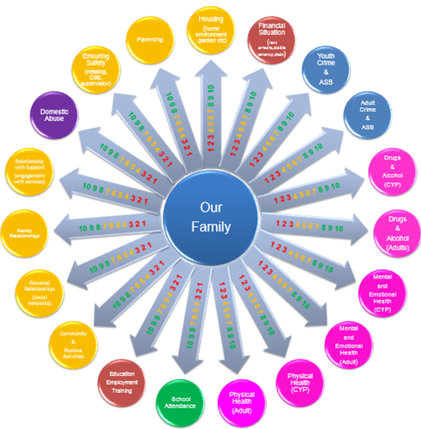
Tracking Progress

