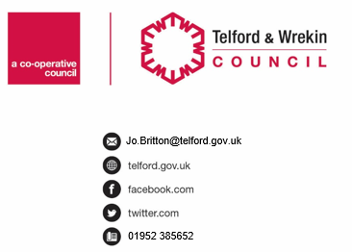
CONFIDENTIAL

Date: |  | Our Ref: |  | Your Ref:

Dear

RE: Child Arrangement Allowance Review

I am writing to inform you that your Child Arrangement Order Allowance has been reviewed and the amount being paid monthly will be £……………..

This will be for a further 12 months and will again be reviewed at that point. Again, you will need to book a meeting with your Admin Finance Team.

Yours sincerely

Nick Bennison
Service Delivery Manager
Child Protection & Family Support

