Nursery Payments - LiquidLogic

Step 1
The Team Coordinator should start a Nursery Payments form from the forms tab of the child’s record.
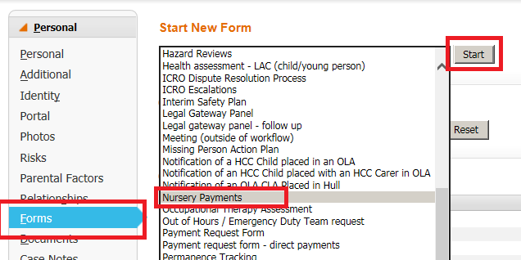
Step 2
Complete the form. A proposed end date must be entered. It cannot be more than 12 weeks after the start date/renewal date. The form will automatically calculate what date the nursery must be given notice that the placement is to end or be renewed. Press ‘Set reminder’ to place a task in your work tray.
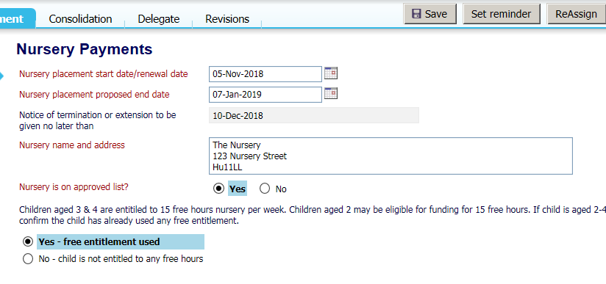
The task’s due date will be the date the nursery must receive notice by, so please ensure this is looked at in advance of the due date.
Step 3
Once notice has been given that the contract will end or be renewed, click the reminder task in your worktray to update the outcome then finalise. If you select ‘continue contract’ you must use the link to start a new Nursery Payments form and place it in your worktray. Complete the details as in step 2 and set a new reminder for the renewed placement.
