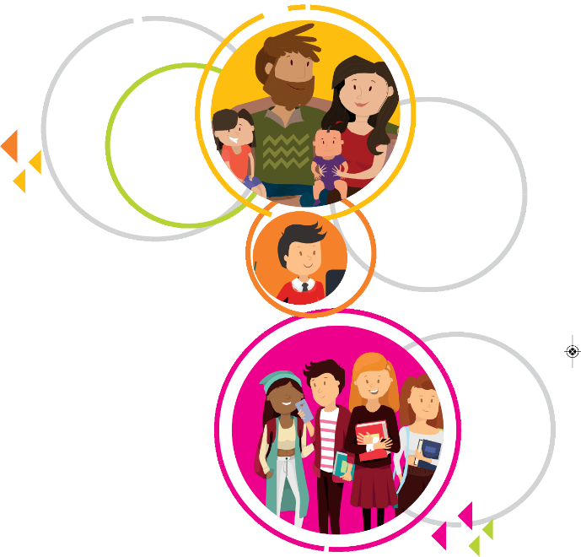

Hull Children First
‘Focusing on the Child’s Voice and their lived Experience.’

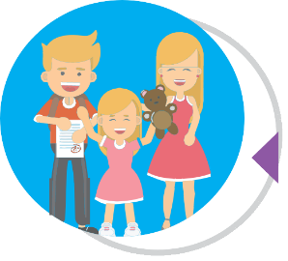

1. Introduction
Hull Children, Young People and Families Services adopted the Reclaiming Social Work (RSW) as a model of frontline practice in 2013. (This document should be ready in conjunction with the Reclaiming Front Line Practice in Hull: Statement of intent, The way we do things here, 2012).
The overall aims were;
- improving risk assessment and decision-making
- providing more effective help
- risk management for children and families
- keeping families together, where appropriate
It consisted of a whole-system reform that aimed to deliver systemic practice in Children’s Services. Key elements included in-depth training, creation of small units (pods) with shared cases and group systemic case discussions, clinicians support, reduced bureaucracy, devolved decision-making and enhanced administrative support.
Between 2014 & 2018, a significant proportion of Hull’s social care workforce was trained in a Systemic Practice model, supported by a Strengthening Families framework for Child Protection Conferences.
Despite considerable investment, the training and practice model did not achieve the impact required on quality of practice and improved outcomes for children. At best, the desired impact of effective evidence based practice was only achieved in pockets and with a very small number of individuals, leaving significant issues around consistency of practice. In April 2018, a big structural change was achieved which created bigger teams and non- case holding Team managers. A consolidation of the practice model was initiated based on evaluation of performance information.

1.1 Pitfalls in Practice Driving Systems Change

It is accepted that child protection can be challenging. The challenges are mainly a consequence of risk not being properly understood and managed. The following seven classic pitfalls where also discovered in our practice prompting change;

- Rule of optimism – comes as a result of not properly understanding the risks children face and practitioners becoming overly hopeful results in leaving children in places of danger;
- Rule of hopelessness – a sense that no change can be arrived at and staff give up seeking positive changes. This can result in avoidable interventions or children left at risk;
- Incident-led responses – seeing only the presenting issue and not the history or context;
- Assessment Paralysis/A focus on the adults – staff aligning themselves with and seeking to assist adults and losing sight of the child. An accurate assessment of risk well managed ensures the needs of children are kept at the heart of the work;
- Assessment Distortion – a position adopted by a multi-agency network that is led by one agency to such an extent that other and potentially opposing views are not voiced or heard;
- Inter-Agency communication failures – key information not being shared either at all or in a timely manner;
- Procedural Compliance – a view in child protection work that risk cannot only be managed but be eliminated through an increasing adherence to and reliance upon procedures. Inherent within this approach is a focus on maximising compliance – from staff and from systems – such that all risk is effectively managed out of the system.

1.2 Consolidation of our Practice Model: Reclaiming Social Work, Hull Children First

The Hull Children First approach to Reclaiming Social work Practice will provide a structure and practice model which ensures continued focus and pace to Hull’s improvement journey. Our practice model will fully integrate structured and evidence based approaches such as strengthening families and signs of safety. By more effectively tackling issues around domestic abuse, substance misuse and adult mental health and effectively managing risk at a child in need level, it is envisaged that resources can be targeted more effectively and in a preventative way, in the following key areas:
- Strengthening Vulnerable Young People Approach and existing youth work to create a locality based support service,
- Extend effective outreach and crisis support for families out of hours through our existing edge of care support,
- Bringing together early help and safeguarding support around localities to enhance local delivery sensitive to local needs and ensuring support across a spectrum for individual families,
- Increasing the focus and intervention on domestic abuse cases through locality- based Domestic Abuse specialist teams.

Our strategy takes as its underlying principle that it is the role of children’s agencies to enable children to live safely at home in their families wherever possible. Therefore, input into families has to focus on identifying, reducing and managing risk to ensure children’s safety at home. Where that is not possible, or cannot be made possible in a timeframe consistent with the needs of the child, then intervention needs to be purposeful and focussed with measurable impact on children’s lives.

1.3 Scope

With our Hull Children First approach, we will re-claim front line work across all elements of the wider Children, Young People & Family Services and the whole Children’s Social Care arena including:

- Social Work Practice (including Fostering & Adoption)
- Residential Units
- Early Years (including Children’s Centres)
- Parenting Support Services
- Community Support
- Family Support
- Youth Support.

2. Our Core Principles
- Understanding risk to the child will be at the centre of our practice
- The child’s voice and lived experience will shape our decision making and care planning
- Our assessments and interventions will be respectful but challenge families and our partners to focus on the child.

3. Purpose

- The purpose of the system we create is to meet the needs of service users by putting the needs of the child at the centre of our practice.
- Everything we do needs to be relevant to the purpose of the system. (What really matters and in line with our shared values).
- The system is designed to actively eradicate ‘wasteful’ systems and processes.
- Brings decision-making closer to the service user.
- Frees professionals up to work with families and make decisions in an authoritative way.
- Frees managers up to develop and sustain a culture of learning.

- Outcome focussed with measurable impact on the child’s lived experience.

4. Shared Values
Having shared values means being really clear at all times about what we stand for and why we are here, how we want to work with families, how we behave towards each other and our partners. Knowing what our values are also helps us to focus on ‘what really matters’ so we can get the best from ourselves, our time and our resources. It helps to identify and understand where we stop wasting time, energy and resources on things that don’t make a difference.

Shared values means having something up front that tells anybody who reads it or who joins the service what we stand for - and it means being readily able to say when we see that something has been said or done that is not consistent with our values - and then remedy it. It needs to be so embedded in our day to day practice that each of us owns it and lives it. In short, it is the way we do things here.

5. Key elements to our practice model
- Application of systemic practice to the identification of risk and subsequent work to reduce risk
- Impact of training measured in order to ensure that practice standards were met
- Ongoing structured practice support to build on training and embed required culture change
- Support and challenge based on evaluation from our quality assurance and performance management framework

6. Core Pillars to Our Practice Model

6.1 Practice Approaches

Our methodology to practice will be systemic approaches based on social learning theory and strengths based interventions. Systemic practice is the generic term given to work with families and individuals that is mindful of, and works with, the relationships between people, across generations and within the context of all the systems within which people live with emphasis on chronologies and genograms as tools for understanding the lived experiences of children.

‘Reclaiming’ is about restoring the central role of effective direct practice in providing high quality services to children and families. The front line role is a challenging one requiring a range of complex skills and a sound knowledge base from which to practice. These include:
- The ability to communicate effectively and forge positive relationships with families and other professionals.
- Implementing evidence-based intervention methodologies with families.
- Understanding both the physical and emotional development of children and young people.
- The skills and knowledge to successfully carry out effective assessments.
- Strong report writing skills and good communication skills including recording and evidencing work

6.2 Authoritative Practice

Our Practitioners will need to be confident, articulate, and have resilience and determination and the ability to challenge self, families and other professionals.
‘The system needs to offer space for sound professional judgement, the skills, support and experience to make these judgements and the ability to assess and learn from the effectiveness of the help provided as a result of these judgements.’

Social workers and fellow professionals will need to attain and hold a ‘balanced position’ and being able to shift that position to reflect changing circumstances for children. A balanced position is often a difficult and challenging one to arrive at - it is a matter of fact that safeguarding children is a complex and multi-faceted task. There will be times when an optimistic and supportive position should take precedence and others when a more explicit scepticism and mistrusting approach is warranted. It is managing this complexity and practitioners being able to adopt this balanced position which is what is meant by ‘authoritative practice’.

“Authoritative practice means that professionals are aware of their professional power, use it judiciously and that they also interact with clients and other professionals with sensitivity, empathy, willingness to listen and negotiate and to engage in partnerships. They respect client autonomy and dignity while recognising their primary responsibility is the protection of children from harm and the promotion of their well-being.”
This means front line workers having enough knowledge to be able to confidently draw upon and use evidence-based practice. Practitioners need to be confident enough about ‘theory’ to be able to draw upon it without it inhibiting the building of positive relationships. Most importantly, practitioners need to have the confidence and competence to use their professional judgement and discretion to best effect.

6.3 Assessment of risk
It is self-evident that risk can only be properly managed if it is properly understood. That means assessments must be focussed on identifying and quantifying risk. ‘Assessment’ is the purposeful gathering and analysis of available information. In the context of child protection, assessment should underpin professional judgements to inform and determine the level and type of intervention with vulnerable children and young people who may have been harmed or are at risk of harm. Interventions should not be delayed until the end of an assessment, but should be determined in accordance with what is required to ensure a child or young person’s safety, taking account of any indications of accelerated risks and warning signs. The type and level of intervention, irrespective of when it is made, should always be proportionate to the evidenced circumstances and risks to the child/ren.
In practice this means practitioners asking the following questions:
- What are we worried about?
- What do we know has happened in the past that has caused harm to the child?
- What are we worried might happen to cause harm in the future?
- What are the things that make it harder for the family to look after their children?
As a relational and strength-based model, we will also ask the following key questions;
- What’s working well?
- What are the family or friends already doing that are keeping the child safe?
- What are the strengths in the family that might help to keep the child safe in the future?

6.4 Supervision
The provision of regular and structured supervision is the core process by which staff are managed and where risks are identified, explored and responded to. The construction of an effective relationship between supervisor and supervisee will enable social workers and other front line staff to be able to voice doubts and concerns, reflect on their practice, identify any of the pitfalls identified earlier and think what they are bringing to bear to any given situation – and from the explicit identification of these themes comes safe practice. Supervision Standards set out our service’s expectations of supervision and training and development opportunities are in place to ensure it is an effective process in the local authority. Our Hull MASA has agreed a set of supervision standards applicable to all agencies regardless of the specific supervisory cultures and processes within their disciplines.

6.5 Learning individuals, learning teams, learning organisation.
Our commitment to our staff is to develop an organisational culture where people can excel. We will do this by recruiting well, providing excellent training, skilled supervision and an enabling system that emphasises learning. We will trust our staff to act as the professionals they are. We will ask our staff to be accountable for the work they do and to always be the best they can be when working with families.

Our structure is about lines of accountability, and ‘who manages who’ etc., but in this context it is about how we organise ourselves to maximise the opportunity to realise our purpose and our strategy. So the structure must lend itself to this enterprise and not mitigate against it.
It is one of the basic systems that really can create the conditions for change - of habits, behaviour, practice, sense of purpose, ambience even. It needs to make sense of the other 6 S’s, be wholly congruent with them, be recognisable to us all as the ‘way we should organise ourselves’ part of the ‘way we do things here’. And then we need to defend it, make it work, not undermine it because it brings new challenges, help others understand it, stick to it, get used to it, and then think about it much less.

We believe that the work we do is complex so it is better to have many heads thinking about what is going on in a family, where everyone is clear about their role, and where necessary, more than one worker helping the family. We also believe that we need a structure where workers are enabled to carry on practising as they progress with their career.

7. Conclusion
Our consolidated Hull Children First approach will strengthen Hull’s existing practice models by providing a directive, structured and family centred approach which achieves timely, sustained and positive change for children and families. Entirely consistent in terms of value base, the tightening of our core values/ principles provides a structured and timely opportunity to support Hull’s transformation programme and goal of effective partnership working, skilled social work and the delivery of the best possible practice.
The work around culture change is well underway and a consolidated approach provides an opportunity to more effectively focus on families’ experience of our collective partnership effort. The re-establishment of our common language and approach, using strengths based techniques, can achieve the outcomes required for children and families in our City.

Claude Madembo
Principal Social Worker
November 2019
Appendix 1: Mc Kinsey’s 7 S Framework

7 S Framework: | Hull Children First: Consolidated Reclaiming Social Work Vision
Strategy | - Reduce the number of Looked After Children  - Accessible, locality based services and support for families  - Support more children effectively as Children in Need
Structure | - Multi-disciplinary teams including adult and children workers supporting families  - Dedicated PSW to support workforce development  - Developed outcome based performance framework
Systems | - Children’s records reflect their story using words which make sense to them  - Improved and integrated recording systems which are intuitive and make sense to families and practitioners  - A focus on impact of interventions with families
Shared Values | - Most children should live with family and their identity is important to them  - A belief that families and can change and know themselves best  - Different perspectives are valued and achieve the best outcomes for families
Staff | - Grow our own through students, ASYE, Step Up & Social work apprenticeships  - A positive learning culture and range of professionals learning from each other  - Embedded practice observation, appraisal and feedback  - Resilient practitioners and teams best support families and each other  - Positive culture through new workers and a range of professional perspectives
Skills | - A structured direct work programme using MI for work with families  - A focus on structured and time limited change work with families  - Needs assessment is understood and carried out in a way which priorities the child’s lived experience and family above process  - Next phase of training – depth & structured, evidence based model
Style | - Reflective and authoritative leadership at all levels  - Robust critical thinking and management oversight  - High quality supervision supported by effective group case discussions

Reclaiming Front Line Practice in Hull: Statement of intent, The way we do things here (2012)

