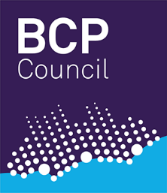

Children’s Services Co- Working Agreement
Guidance for use:
This agreement should be completed in cases where more than one children’s service is working with a child or young person, for example:
Childrens Social Care / Aspire / YOS/ CWD /SEND/ Private Fostering/ Fostering/ Early Help / FRC
The agreement should be completed at the outset of working with the family and should be placed on the child’s file. The lead practitioner will complete with colleagues.
The purpose of this agreement is to ensure all involved with families are :
- Communicating effectively
- Joining up meetings
- Sharing and contributing to interventions and plans and permanence arrangements
- Avoiding overlap and agreeing the ‘messages’
Services need to agree from the outset of a co-working arrangement the responsibilities and roles of each professional involved. This will ensure continuity and avoid confusion for families.
Agreement between:
Name | Role | team

Purpose of intervention for each professional:
Name | Purpose of intervention | Outcome to be achieved

Agreement on frequency of visits:

Communication channels :

Reports and plans to be shared and agreed :

Meetings for invites and contribution needed:

Arrangements should there be a difference in view on a required course of action for a child or young person:

Signed : role: date:
Signed : role: date:

