Our Ref: | 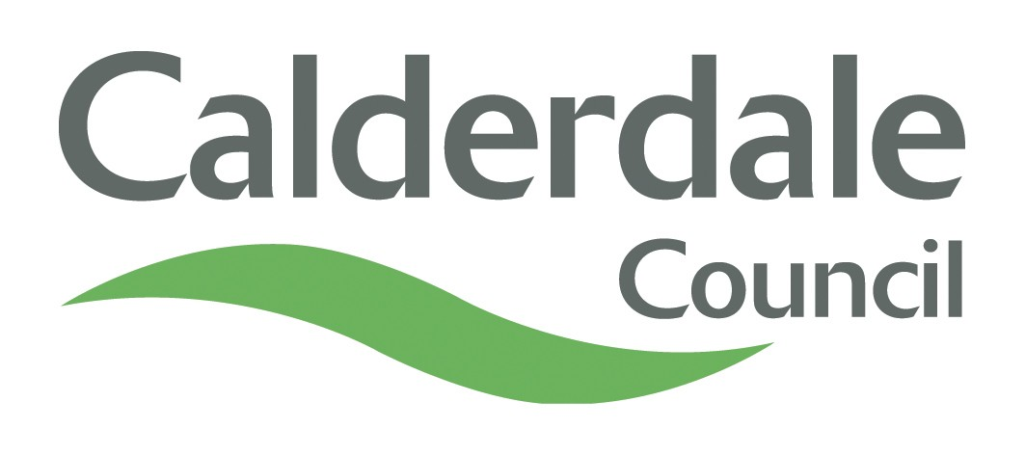  BP Ltr
Please contact:
Telephone: | 01422 256053
Fax: | 01422 266089
E-mail: | @calderale.gov.uk
Date:

Children and Young People’s Services
Children’s Social Care
Adoption Team
The Shay
Shaw Hill
Halifax
HX1 2YT

Dear

Notification under Adoption Agencies Regulations 2005 19(3)
On the DATE the Calderdale Council Adoption Panel considered carefully a potential adoptive family for your DAUGHTER/SON NAME. The Adoption Panel members recommended this match.
On DATE the Agency Decision Maker considered panel’s recommendation and has agreed that the placement of NAME with this family should go ahead.
As an adoptive agency we wish to support you through this difficult time. You will have received a birth family pack from your child’s social worker which includes information about the independent support we provide.
We work with a charity called Pac-Uk who provide an independent advice and support service to birth family members who have been affected by adoption. Please do not hesitate to contact them on 0113 230 2100 or email advice@pac-uk.org.
If you have not received this pack or mislaid it, please do not hesitate to contact the adoption duty social worker on 01422 256053 or email adoption.duty@calderdale.gov.uk who will be pleased to arrange for another pack to be sent out to you. The duty officer is also available to discuss any other concerns or worries you may have about the process.
It is advisable that you discuss this decision with your legal representative.
Yours sincerely,
Julie Jenkins
Agency Decision Maker
Head of Children’s Social Care

