BCP CHILDREN’S SERVICES

Supervision Policy

October 2019

Introduction and scope
BCP Council recognises that the delivery of services is a complex and demanding task and that staff are the key asset within the organisation in delivering high quality services that make a meaningful difference to the lives of children, young people and families. This policy sets out the expectations of how staff should be supervised and guides managers in the key elements needed to supervise staff effectively.
This policy applies to:
- All staff employed by BCP Council Children’s Services working in Social Care and Inclusion and Family Services whether on a temporary, permanent, full time or part time basis;
- Supervisors employed by other agencies or Directorates with BCP Council with responsibility for the supervision of staff within Social Care and Inclusion and Family Services.

The aim of this policy is to provide a framework for the professional supervision of all staff working in BCP Council Children’s Services (Social Care and Inclusion and Family Services). The policy sits alongside the Department for Education Knowledge and Skills Statement for Approved Child and Family Practitioners and the Department for Education Knowledge and Skills Statement for Practice Leaders and Practice Supervisors, which set out the expectations of professional practice and the basis for accreditation within Children and Families Social Work.

The policy is in line with the recommendations of the Children’s Workforce Development Council (1) and the work of Eileen Munro (2) and embeds the Signs of Safety model within supervision practice in BCP. The principal aim is to ensure that it meets the needs of the service, the staff and their supervisors regardless of the area in which they work and sets out the minimum practice standards regarding the organisation’s expectations of supervision.

What is supervision?

Supervision involves talking through the impact the work has on the worker personally, as well as exploring decision-making. It is vital for practitioners’ well-being, professional development, and management oversight. Most importantly, supervision helps the worker to achieve the best possible outcomes for children and families.
Good supervision ……:
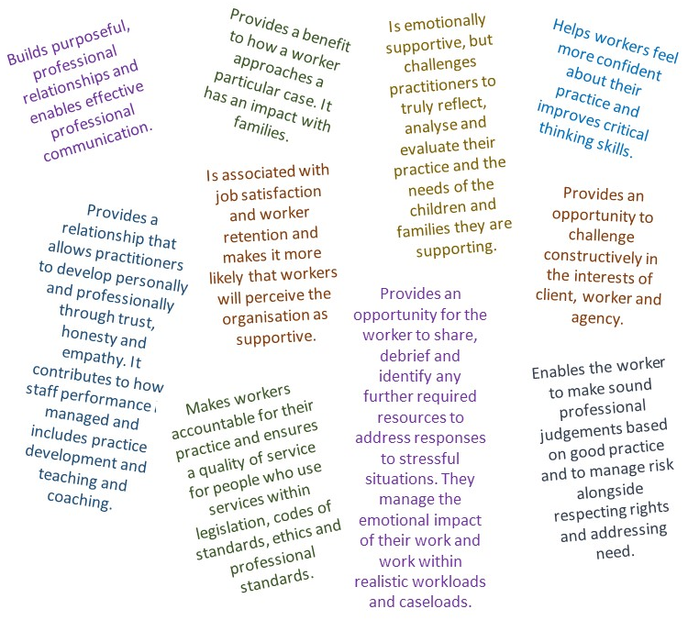

The term ‘supervision’ therefore is a blanket term encompassing four distinct areas:
- Supervision of the employee.

Identify and achieve personal learning, career and development opportunities, provide emotional support and to keep workers safe.

- Supervision of the quality.

Maintain organisational accountability, maintain effective line management, check the quality of the work undertaken, maintain professional standards, ensure outcomes are being achieved.

- Supervision of the casework

Understand the case, identify and address issues related to caseloads and workload management, improve the quality of decision making and interventions with families enabling them to achieve the best outcomes with families.

- Group supervision

To provide a safe and constructive environment to assist practitioners in working from a strength-based, family focused, child-centred and collaborative perspective assisting them in the development of successful safety plans with families.

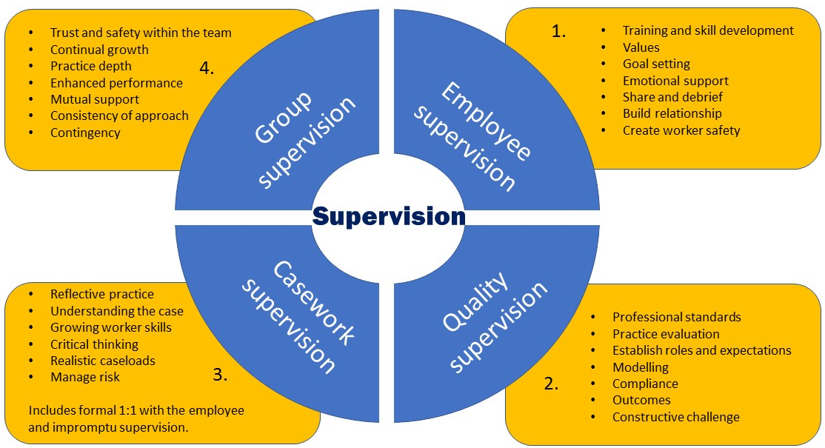

- Employee supervision | 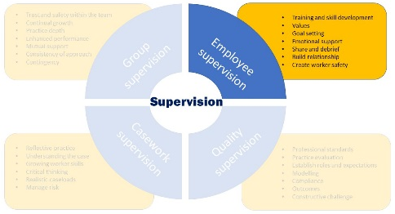

Supervision is part of the Council’s duty of care and links to sickness and absence, flexible working, health and wellbeing, whistleblowing, complaints and worker capability. Good supervisory practice is associated with job satisfaction, career or job retention, emotional health and practice skill. Appropriate emotional support can buffer against anxiety, stress and high workloads. Evidence suggests long term professional development is important to supervisees.

It is important then that employee supervision is an opportunity for the worker to talk to their manager about their personal support and training needs.

The agenda of the supervision should reflect the supportive function of the supervisor and may include:
- Positive feedback; manager to recognise and acknowledge where work has been carried out to a high standard; evidence of positive progress for a service user; contribution to the team or wider service; compliments from service user, family or other agency.

- Health & safety – provision of a safe environment in which to work including policy and procedures and specific support to staff who are subject to any form of abuse either from service users or from colleagues, whether this be physical, psychological or discriminatory;

- Awareness of the equality and diversity policy, local sources of support available for staff with protected characteristics, including Equality, Diversity, Inclusion and Staff Networks.

- Monitor overall health and emotional functioning of the staff member, especially with regard to the effects of stress;

- Stress management and reduction including de-briefing with permission to talk about feelings, especially fear, anger, sadness or helplessness arising from work;

- Reflection on emotional impact of work, recognising that people often experience difficult and distressing situations;

- Exploration of any emotional blocks to effective working;

- Exploration in a safe setting issues about the workers experience of inclusivity within the workplace;

- Reflection on difficulties in colleague relationships and discussion of strategies to assist the worker in resolving conflicts, responding to and addressing bullying and harassment or tackling unjustifiable discrimination;

- Identify where the counselling service may be of benefit to the worker and support the worker to access this should they choose to do so.

Additional supervision should be offered when there are any particular circumstances that apply to the supervisee that mean they may require more frequent supervision e.g. personal difficulties or relationships, performance issues or high levels of stress.

Employee supervision also includes an exploration into how to develop and support confident and safe practice through learning and professional development.

The agenda of the supervision should utilise open and honest discussion which reflects the supervisor's responsibility for promoting the development of the worker and may include:
- Career development: understanding the workers aspirations and goals, providing encouragement to the worker to fulfil their potential, identifying and utilising learning and development opportunities.

- Specific teaching/coaching input to develop knowledge, feedback on practice, consideration of relevant research, implementation of learning into practice;

- Understanding of the theoretical base, skills, knowledge and individual contribution to the organisation;

- Ensuring maintenance of post registration record of CPD and registration (if social worker or other equivalent practitioner);

- Access to consultation and development opportunities in areas outside the supervisor’s knowledge/experience via professional experts and/or clinical input;

- Understanding of the supervisee’s value base in relation to race, gender, etc and its impact on their work;

- Identify development opportunities and agree training and other learning opportunities e.g. shadowing more senior staff, participating in service evaluation and development workshops, linking to special projects, researching areas of specialism and best practice;

- Monitoring of the previously identified and agreed targets within the appraisal process: exploring areas of strength and need identified by the worker themselves;

- Create and maintain the learning and development plan;

- Exploring opportunities for the worker to observe or visit other settings.

- Evaluate the impact of the development opportunities supervisees have received.

The Employee Supervision is an opportunity to reflect on or discuss issues that have arisen from the Annual Appraisal or Performance and Development Review. However, the Annual Appraisal or Performance and Development Review provides a formal opportunity to evaluate progress, whereas a typical supervision session is likely to address more immediate concerns in an informal context.

- Quality supervision | 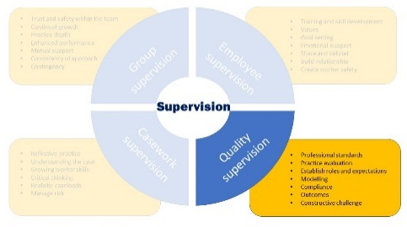

Within the supervisory environment workers should have the opportunity to critically analyse their knowledge, values and skills and their understanding of the work they are undertaking. This forum should also provide a safe place for workers to reflect on their practice, decisions and interventions.
Within statutory work supervisors are reminded of the need to ensure that as part of the supervisory process, a worker’s practice is cross referenced against the competencies outlined in the DfE Knowledge and Skills Statements for Children and Families Practitioners, in line with their role and position in the organisation and that opportunities for ongoing learning and development are identified. A useful link is to support the mapping of this process is Knowledge and Skills Statement for child and family social work: Mapping Resource (Research in Practice).
It is an expectation that at least annually the supervisor will observe each worker undertaking direct practice by way of ‘live supervision’: this is the process of directly observing practice and providing immediate feedback. The frequency of such observation and degree of support offered during these sessions will be dependent on both the experience of the supervisee being observed and the complexity of the work being undertaken. Such sessions provide a unique opportunity to support supervision in all its functions, from managerial oversight of development and practice competence, through to the support and understanding of complex case interventions. In addition to enhancing opportunities for direct feedback, live supervision may also complement the development of skills and learning through agreement to co-work sessions and directly model alternative approaches to practice. It is recommended that live supervision is supported by the understanding and use of established practice frameworks to enable both supervisors and supervisees to get the best out of this shared process.

The agenda of the supervision should reflect the quality monitoring function of the supervisor and should include:
- Identifying individual strengths;

- Providing challenge to achieve personal and professional growth;

- Identifying areas for development in order for supervisees to carry out their job to the required standard and objectives;

- Preparation and feedback for direct observation of practice;

- Case work supervision | 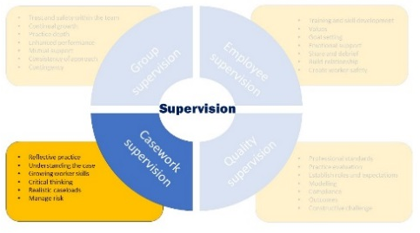

Case work Supervision should not be confined to the formal 1 to 1 supervision arrangements and should be seen as part of a continuum of support and oversight offered to staff.

Impromptu 1:1 supervision

Given the nature of the work undertaken in Children’s Services supervision on specific cases will occur informally on a frequent basis, as staff will have to “check something out” with a supervisor, obtain a decision or gain permission to do something that will not wait for the formal supervision session. It is important to remember that making safe decisions for and with children and their families will require collaborative working, debate and agreement at all levels of practice and managers and supervisors should operate an ‘open door’ approach for staff to seek advice whenever needed. This additional impromptu supervision and consultation with managers and supervisors outside of formal arrangements, ensures staff can quickly respond to the unexpected and complex decisions within their case work or work activity.

Although the nature and spontaneity of impromptu supervision leads to an informality of process, it is essential to remember that it sits within a complementary framework for the oversight and management of the work undertaken with children and their families. As such, all discussions and decisions that are in response to the need for intervention with or on behalf of children, must be formally recorded in the child’s case record as an additional supervision record. This is recorded in workflow or in a case note, dependent on the context, nature, depth of discussion and recording system used. This must be identifiable within the electronic record as a ‘management action’ so that the level of oversight can be reported. Information relating to more than one child in the family should be copied to all the children’s records so that each child has a contemporaneous record of any decisions made which affect the whole family.

The responsibility for recording unplanned and impromptu supervision rests with the supervisor. Any decision made by senior staff with regard to a child or family in which they are not the named supervisor for that case worker must also be clearly recorded in the child’s record. A supervisor may explicitly delegate the recording of the discussion and decision to the supervisee.

Formal 1:1 supervision

Which children and families are discussed and how often?

It is expected that all cases within a worker’s caseload should be discussed at each monthly supervision if there are:
- Safeguarding concerns;
- Ongoing assessments of children, carers and other family members;
- Assessments of alternative care arrangements;
- Plans that need to be driven in order to achieve permanency;
- Ongoing care proceedings;
- Risk that needs urgent preventative strategies
- Court orders in place in relation to a CIN case e.g. Family Assistance Order, Supervision Order.

Professional judgement needs to be made in relation to the frequency of discussion of other types of cases. However, all cases within a caseload should be discussed at least bi-monthly.

For Independent Reviewing Officers and Child Protection Conference Chairs, or other similar workers where the pro rata caseload exceeds 30 cases, the supervisor and supervisee will need to negotiate a method whereby cases for discussion are suitably prioritised and agree a minimum frequency for cases and tracking that does not allow for any cases to omitted.

For language students in private fostering arrangements, where there are no concerns or significant information to discuss, supervision can be every three months. For ‘mainstream’ private fostering cases supervision should be monthly.

For Newly Qualified Social Workers the frequency of supervision should be weekly for the first six weeks of practice, alternated between their line manager and their allocated ASYE assessor/mentor. After six weeks this decreases in frequency to two weekly for up to twelve months, again alternated between their line manager and their allocated ASYE assessor/mentor. At the conclusion of the ASYE assessor/mentor period the formal supervision decreases to monthly and is facilitated by the line manager.

For newly qualified Educational Psychologists (NQEP) the frequency will be one hour per fortnight as a minimum (as recommended by the BPS/AEP). Once a month this will be with the line manager. Trainee Educational Psychologists (TEP) Year 1, 2 and 3 will be allocated to an experienced Educational Psychologist as supervisor. TEPs should receive the equivalent of half an hour of supervision each week for every day that they are on placement (e.g. when placement is 3 days per week, the TEP will receive 1 and a half hours of supervision per week).

For social workers appointed from outside the UK the frequency of supervision should be every two weeks, increased to every three weeks and then monthly if the worker is meeting the required standard of practice. Direct observation of practice must take place before a decision is taken to reduce the frequency of supervisions.

Additional formal supervision should be offered when there are any particular circumstances that apply to the supervisee that mean they may require more frequent supervision e.g. a difficult piece of work, a high level of risk associated with the work or an impact identified in their personal life.

The supervision of part-time staff should follow the same frequency patterns as for full time staff. Agency, sessional or temporary staff should receive supervision in the same way as permanent staff.

For staff who do not have a caseload, such as operational and strategic managers, the expected frequency of supervision is monthly.

Recording

The recording of formal supervision sessions is the responsibility of the supervisor. For all case-work, discussion and recording will be conducted using a Signs of Safety, Signs of Stability or Signs of Wellbeing approach and will consider:
- What we are worried about; the reasons we are worried written in clear simple language. This will include reference to the evidence behind the concerns and what might happen if nothing changes;

- What’s working well; existing strengths and plans, and positive things that have happened which have made a real difference to the danger or worries in the case;

- Success/ Safety Goal; What does good enough look like? What needs to happen for the case to be closed?

- What needs to happen; includes any actions that need to be taken immediately, timeline, trajectory and tasks or next steps to start.

- Scaling; This can be a useful tool for the supervisee and supervisor to record their individual views and their thoughts behind their scaling number. It is important that the scaling description captures the danger/worries from the danger/ worry statement (when describing what a 0 looks like) and the safety or success goal (describing a 10). The supervisor should consider asking the worker what others in the network, including the child, might score if asked the same question.

The detail included in the formal supervision record is a matter of judgement for the supervisor. In general, the record should be detailed enough so that the issue, including the rationale for any decisions taken can be revisited at a later date and still be understood.

It is important that the wishes and feelings of children and families are captured in the recording of supervision and that the opportunity for reflection and reflective thinking is also recorded.

Capturing reflective discussions can be challenging, however the recording of key reflective questions that have been asked and of the exploration that follows, is a good way of evidencing reflective discussions.

All case work discussions, decisions and actions must be recorded on the child’s record within a maximum of one week. For case decisions where the team involved is secondary to the statutory social work team (such as in the fostering service), any matter relating specifically to a child, should be forwarded to the allocated social worker for inclusion in the child’s record.

- Group supervision | 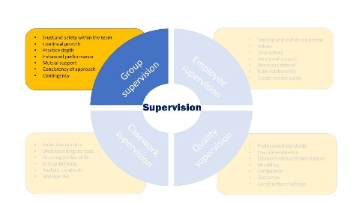
Group Supervision should be viewed as complementary to formal supervision. It involves a group of staff who may or may not have the same or similar tasks, meeting with a named facilitator to discuss issues about their work. This may be done in the context of a regular team meeting but will usually take place as a separate session.
Group supervision should be considered for staff with all levels of experience, as an additional method of delivering professional development, learning and support, of sharing expertise and ideas and for the collaborative mapping of case-work within the Signs of Safety or Signs of Wellbeing practice model that underpins all children’s work in BCP. Within the Signs of Safety and signs of Wellbeing practice model, the shared contribution to case work via Mapping will significantly benefit children and their families.
Group supervision should be utilised flexibly and creatively both within and across teams and services. More experienced practitioners and managers will take responsibility for agreeing the organisation and delivery of group supervision within their service area and according to the needs of their staff and of the children and families with whom they work.

As with other forms of supervision, all discussions that are in response to the need for intervention with or on behalf of children must be formally recorded in the child’s case record. The recording of these discussions and any decisions made are the responsibility of the relevant manager who should ensure that information is recorded clearly on the child’s file.

Individual Supervision Agreements
The negotiation and use of an Individual Supervision Agreement or Supervision Contract is an essential and required part of establishing and reviewing the supervisory relationship. The Supervision Agreement outlines ‘ground rules’ as well as clarifies rights and expectations for both the supervisor and supervisee, thus supporting a safe, secure and effective relationship.
This may include:
- The name of the parties involved
- The professional standards employed within the work undertaken
- What you agree to be the purpose of the supervision
- Agreement about confidentiality
- Frequency
- Duration
- Preparation
- Recording
- Regular agenda items
- What happens if there is a disagreement
The Individual Supervision Agreement will be different for every employee and should be regarded as a “living” document that is reviewed and updated according to the changing needs of the supervisee. As a minimum, the Individual Supervision Agreement should be reviewed annually. The Individual Supervision Agreement should be uploaded into the worker’s file in the team’s secure, access-defined Personal Supervision Folder, see recording process below.

The Allocation of Supervisors
All supervision should occur by a supervisor who is at least one level higher than them in the line management structure. Within statutory social work the supervisor must have HCPC registration. The least experienced workers should be supervised by the most experienced supervisors. New practitioners should not be supervised by newly promoted or inexperienced supervisors, however extensive their experience is.
All staff appointed into a supervisory position will undertake appropriate training to enable them to fulfil their supervisory responsibilities and should be observed annually (either on a peer-review or management basis) to support sound supervision quality.
It is expected that the supervisory workload ratio should be 5 to 7 supervisees per supervisor. The team case-load for each manager should reflect the Authority’s agreed parameters to ensure safe and effective managerial oversight. It is the Service Manager’s responsibility to ensure that supervisors have adequate time and capacity to fully satisfy the embracing nature of supervision in its truest sense and they must assure themselves of both quantity and quality requirements.
It is the responsibility of the Team and Service Managers to ensure that the appropriate level of supervisory experience is matched with the experience, knowledge and skills of the individual members of staff needing supervision. In the event that the allocation aspect of the supervision policy is not followed, this should be clearly recorded in the individual’s supervision file and agreed by the Service Manager.
Where less-experienced practitioners are given the opportunity of shadowing more experienced staff as part of their professional development they should always remain the responsibility of their home team and allocated supervisor.
Assistant Team Managers will not generally supervise qualified social work staff, although suitably experienced Assistant Team Managers who have successfully undertaken supervisory training will supervise ASYE staff; working closely alongside the other supporting workers (Professional Development Officer and Practice Consultant) involved with assisting the ASYE through their first year in practice.

Assistant Team Managers will provide supervision to case holding and non-case holding staff who do not hold a social work qualification.

Records pertaining to Personal Supervision

Purpose
Personal supervision concerns the health, welfare, professional development, performance and other day to day personnel aspects of staff management and support. Records pertaining to personal supervision must be maintained separately from records of supervisory discussion for professional case-work interventions.
The record should detail the monitoring and support of the staff member’s progress and welfare within their role and incorporate relevant aspects of health, welfare and functioning that may have an impact on their ability to undertake work either safely or competently. Equally, it should outline any potential relevant impacts on the staff member of the work being undertaken and why this may be significant, as well as managerial support being offered.
Where there are concerns about functioning or capability, or where the need for other supports are identified (including specific risk assessment for factors such as pregnancy or threats from service users), the support plan should be outlined in the supervision record (cross referenced to risk assessments where appropriate), to ensure clarity of expectation, reassurance and accountability (both re the staff member and the organisation).
Personal supervision records should also track workload and any impact factors, as well as hours worked/TOIL and Annual Leave to ensure that any connected welfare issues are considered and addressed within the organisation’s duty of care. Within this, sickness absence should be understood and monitored to enable its consideration in the context of any possible links to work, capability, coping, etc. and to ensure support and risk assessment is considered where appropriate.
Professional development and career progression should be explored and monitored within personal supervision and plans for progression recorded within the guidelines for BCP’s professional development process.
Celebrated and recognised good practice should be acknowledged and recorded, as should discussion for individual and specific areas of additional practitioner responsibility (e.g. supervision/practice education/lead responsibility of a particular area of practice).

Recording Process
Personal supervision should be typed on a consistent electronic form, (example attached at Appendix 1: Personal Supervision Record Template). The completed form should be uploaded into the worker’s file in the team’s secure, access-defined Personal Supervision Folder, access to this file should be controlled on a ‘need to see’ basis. The member of staff who is subject of the personal supervision file will be able to save and/or print a copy of the record to be kept for as long as they wish.
The supervisee should be offered a draft version of the Personal Supervision Record Template and should be given an opportunity to check, agree or suggest amendments to the document. Any changes should then be agreed by the supervisor before both parties sign the document prior to it being stored.
At the outset of the supervisory arrangement, the staff member should be advised of the system used to record personal supervision and of their right to retain their own copies of these records. They should be encouraged to ensure that in the interests of transparency, records remain unaltered and to safeguard both parties in the eventuality of investigations (e.g. disciplinary or complaints investigations), that they maintain duplicate records within a personally-held and separate file.
The typing of supervision notes can be completed by the supervisor, or delegated to an identified administration officer, although this will need careful consideration in respect of any personal information that should not be shared and should be with the agreement of the supervisee.
All records should clearly detail decisions that have been made and the reasons for these, any agreed actions including who will take responsibility and the timescales for carrying out these actions.
Case information relating to children should not be included in this record unless specifically relevant, either because of defined impact of the involvement on the worker, or because some aspect of the worker’s history or experience is impacting/may impact on their practice. Case information recorded for this purpose must be anonymous and relevant.

Confidentiality and Access
1 to 1 supervision is a private, but not confidential process. This means that the records are the property of the organisation, not the individual. From time to time supervisors will need to discuss the content of supervision sessions with others e.g. their own line managers or records may need to be accessed by senior managers (e.g. for quality assurance purposes), investigating officers (e.g. for disciplinary purposes) or inspectors (e.g. Ofsted). They should however, be accessed only by those who have a ‘need to know’ and with a defined purpose at the time of access. The supervisee should be clear at the outset and within the supervisory agreement as to who might view their records and for what purpose.
Whoever has access, clear agreement between supervisor and supervisee regarding what is being recorded is crucial to confidence and thus, it is advisable that the record only contains information relevant to the professional role and as agreed with the supervisee. Where there is a level of disagreement, but a supervisor feels that it is necessary to record something they have been told (e.g. because of possible practice impact), the rationale should be explained, discussed and considered within supervision and records should document the outcome of those discussions.

Storage and Retention
Personal supervision records, along with the Supervision Agreement, documents relating to Personal Development Planning and appraisal and other relevant information (e.g. correspondence; sickness documents; risk assessments, etc), will be maintained on the staff member’s Personal Supervision File within the secure team supervision folder.
When a supervisee transfers to a new supervisor within their existing team, transfers to a new role within the same team, or transfers to a different service area/team within the same Directorate, records should be transferred with them by changing permissions to the new manager/supervisor and moving the worker’s file where necessary (being sure to remove permissions from previous managers who are no longer involved, to maintain continued parameters of confidentiality).
When a staff member leaves the Directorate or employment within the Authority, records are not transferred to a new employer, but do need to be retained to ensure availability in the event of future queries relating to safeguarding, or the response of the employer to matters of ill-health or welfare.
Personal supervision records held by BCP Council will thus be maintained for a further period of no less than 6 years after an employee has left the employment of the Authority.

Quality Assurance
It is an expectation that at least annually the manager of the supervisor will observe a supervision and offer feedback to the supervisor about areas of strength and areas for development.
Service managers are expected to monitor reports that show the frequency of supervision sessions with employees and take action if necessary.
Service managers will regularly check the supervision records maintained by the team manager and confirm supervision is occurring at the correct frequency and take action if necessary.
Service managers will also talk to staff and ensure that supervision is occurring at the correct frequency and standard.
The quality and standard of supervision will be part of the ongoing Quality Assurance activity.

End

Appendix 1: Example Personal Supervision Record Template

Name of Supervisor: | Date of Supervision:
Name of Supervisee:

The Personal Supervision template should be used to record discussion and progress in respect of the staff member’s professional development and performance; any worries that may be raised about this (including impact issues); what is working well for them; and actions to help facilitate continued progress as well as to outline managerial support. Case information relating to children should not be included in this record unless specifically relevant either because of specific impact of the involvement on the worker or because some aspect of the worker’s history or experience is impacting/may impact on their practice. Case information recorded must be anonymous and relevant.
As this record may be seen by line managers beyond the supervisory arrangement, it is essential that clear agreement is reached as to the content of the personal information included in the record and that it only contains information relevant to the professional role. Where there is disagreement, but a supervisor feels it is necessary to record something they have been told, because of its possible impact, this should be discussed and rationale also recorded.
Both parties should receive a signed copy of the record following completion of the meeting. An electronic copy of the record will be maintained on K-Drive within team supervision records file.

Health and Welfare (relevant personal or health issues; sickness from work/return to work; work-place issues; work-load impact; health & safety; relevant risk assessment)
Discussion/Reflection
(Actions from the last meeting)
Actions/Decisions
(Timescales)

Annual Leave and TOIL/Flexi
Discussion/Reflection
(Actions from the last meeting)
Actions/Decisions
(Timescales)

Practice Progress (general progress and performance; practice to be celebrated; worries; observed practice and audit feedback; reflections on practice strengths and worries; and any personal-practice impact issues)
Discussion/Reflection
(Actions from the last meeting)
Actions/Decisions
(Timescales)

Professional Development (Appraisal; progress against Action-Planning; training/courses; practice and skills development)

Discussion/Reflection
(Actions from the last meeting)
Actions/Decisions
(Timescales)

Specific Areas of Additional Responsibility (including supervision of other staff members)
Discussion/Reflection
(Actions from the last meeting)
Actions/Decisions
(Timescales)

Any Other Business
Discussion/Reflection
(Actions from the last meeting)
Actions/Decisions
(Timescales)

Date of Next Supervision Session:

Signatures
Supervisor: | Date:
Supervisee: | Date:

