**3.4 Advocacy Pathway – Local Guidance**

|  |
| --- |
| **SCOPE OF THIS CHAPTER**  This chapter provides an overview of the services provided by Route1  **RELATED CHAPTER**  [5.2.2 Advocacy and Independent Visitors](http://www.proceduresonline.com/somerset/cs/chapters/contents.html#lac)  **RELATED GUIDANCE**  [National standards for the provision of Children’s Advocacy Services (2002)](http://webarchive.nationalarchives.gov.uk/+/http:/www.dh.gov.uk/en/Publicationsandstatistics/Publications/PublicationsPolicyAndGuidance/DH_4003112)  [Advocacy Services for Children and Young People – A Guide for Commissioners (The Children’s Society)](https://www.childrenssociety.org.uk/what-we-do/resources-and-publications/publications-library/advocacy-services-children-and-young-peop)  [Providing Effective Advocacy Services for Children and Young People Making a Complaint under the Children Act 1989](https://www.gov.uk/government/publications/advocacy-services-for-children-and-young-people)  This chapter was updated in October 2018. |

# Contents

|  |  |  |
| --- | --- | --- |
|  | **Introduction** | 1 |
| 1 | **Advocacy** | 1 |

# 

# Introduction

[Route1](http://www.route1advocacy.co.uk/) is an independent service providing advocacy for any young person who is receiving a service, or is entitled to receive a service, from Children’s Social Care in Somerset.

Its purpose is to enable and empower children and young people to have a voice and participate within any decision-making processes and to ensure that the rights of children and young people receiving services from Somerset Children’s Services are upheld in accordance with:

* Children Acts 1989 and 2004;
* Children and Young Persons Act 2008;
* Children (Leaving Care) Act 2000;
* Care Standards Act 2000;
* Adoption and Children Act 2002;
* United Nations Convention on the Rights of the Child;
* Human Rights Act 1998.

The service is funded by the local authority who has a statutory responsibility to provide this service.

# Advocacy

Route1 offer paid professional advocates (Route1 staff – level 3 advocacy award) as well as independent volunteer advocates (all who have attended a 7-day training programme). All advocates will have a current enhanced DBS certificate.

**Advocacy Pathway**

**How often can a young person have advocacy?**

Each piece of advocacy is a stand-alone piece of work and a new referral should be completed for each meeting. Where possible we will try and allocate the same advocate each time when requested, however this cannot be guaranteed.

Please see [Route1 website](http://www.route1advocacy.co.uk/) for full details, including how to make a referral.

Social workers are invited to include questions they would like the advocate to ask on the referral form. The young person’s wishes and feelings will be recorded and sent to the Social Worker and Independent Safeguarding and Reviewing Officer prior to the meeting (except for Family Group Conferences).

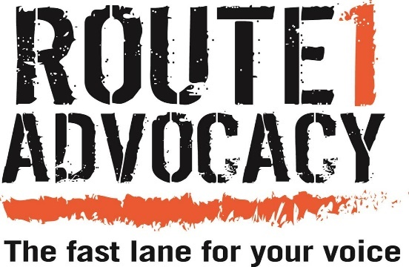

End