**Guide to Child Protection Statutory Visits**

1. **Purpose of the Guide**

This guide is intended to be an easy to read reference tool for social workers on completing and recording child protection statutory visits. It is not intended to replace the social care practice standards and as such should be read in conjunction with the standards.

The aim of this guide is that it will lead to improved performance and once performance targets are achieved, maintain performance.

1. **Practice Standards – A Reminder**

All children should be visited by their social worker at an individually determined level agreed by the social worker and line manager through planning or supervision process which enables the effective delivery of services.

The child’s plan should clearly detail the minimum frequency at which the child is visited by his/her social worker and visits carried out at least in accordance with this minimum level. It is essential that children are seen and spoken to regularly by their social worker and this will often need to be more frequently than the minimum level outlined in the plan. Good social work practice will be guided by professional judgement based on the needs of the child. In order to safeguard children and ensure that minimum standards are in place, the service has determined minimum visiting standards as follows:

* Children subject to protection plans must be visited every 2 weeks (every 14 days, very 10 days when just counting Monday to Friday). 50% of these visits must take place in the home.
* Visits to children with CP plans are every two weeks, 14 calendar day intervals (regardless of Public Holidays). For example: Visit Monday 16th November – Visit day (Monday 16th) is day 0, Tuesday is the first day of the count day 1. Next visit due on day 14 - Monday 30th November. Bank holidays count as working days on the system. Be mindful of this over holiday periods, Christmas and Easter especially as the bank holidays cover several days
* Case records must be up to date within 48 hours that is, visits recorded on CareFirst within this timeframe.

Recordings of the visit must include:

* **Purpose** of the visit
* **Home conditions**
* **Educational issues**
* **Health Issues**
* Who you have seen?
* **Voice of the child**: Have you spoken to the child/ren on their own – what was discussed?
* **Parental views**
* What part of the plan you have been working on?
* **Risk factors** and plans to mitigate
* **So what?** - brief analysis of your visit
* **Actions** to take forward
* Include a **skeleton plan** for the next visit.

The recording does not have to be lengthy but needs to include salient information.

The recording will not be counted as having happened until it is closed. You must finish, save, otherwise the visit remains open and will not show in the data collection and looks from a data collection perspective that a child has not been seen. You must also ensure that you tick whether the child was seen and seen alone otherwise again the visit will not be counted as a statutory visit requires the child to be seen.

1. **Social Workers Top Tips**

These are list of top tips provided by social workers who consistently achieve compliance for CP statutory visits that is visiting and recording within required timescales.

* Stop phone calls and instead arrange visits and diaries for all service users.
* Make it “Meaningful every time”
* Prepare for the visit
* Don’t ever do back to back visits (snowball effect)
* Tell parents how often you will visit: every 10 days – prepare for unannounced visits. on day 7 and planned visits on day 8 and cancel if necessary
* Put yourself a reminder in outlook (day before the due date)
* Don’t delay the low level work, move it towards closure
* Blend difficult with simple work – balance workload
* At the start of every week – write down the minimum of what needs to happen – to do list.
* Book admin time – sit somewhere else (focus space) – 2 x ½ or whole day every week, not when you are on ‘**duty’**
* Break administrative time down i.e. 2 hours emails/2 hours SA’s/1 hour organising/½ day court report etc.
* Use outlook to organise i.e.;
* Visits – Yellow
* CP – Red - when achieved take out colour
* Type up meeting – Orange
* Others minutes – Blue

1. **CareFirst – Completing Visit Assessments Guide**

There are 3 separate visit assessments on the system

* CIN Social Worker Visit
* CP Lead worker Visit
* LAC Statutory Visit

There are key information items which must be completed.

1. Add the case recording; this will update the case recording section on completion.

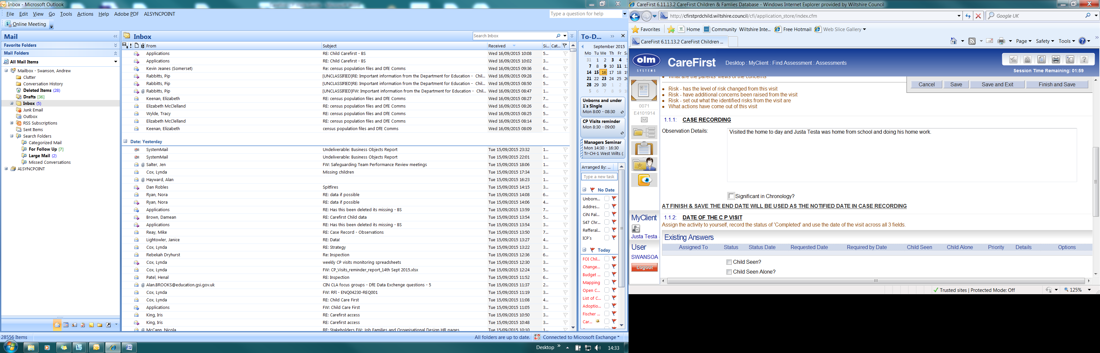

1. Add or update the date of the visit – this will automatically create an activity when you complete the assessment form.

This activity is used to monitor CP / LAC / CiN visit management information.

If this activity is not created then the record of the visit is incomplete

1. Adding the activity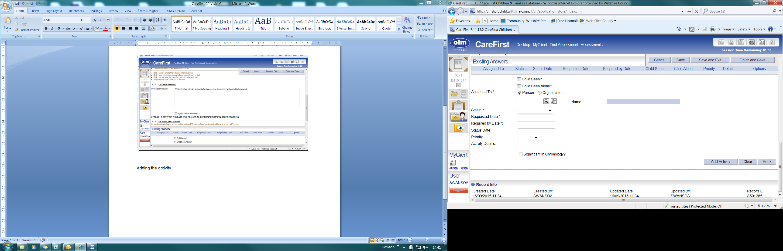
2. First check the tick box ***Child Seen*** - to be ticked in all circumstances when the child has been seen.
3. If the child or young person has been seen on their own tick ***Child Seen Alone.***
4. ***Assigned To\**** Assign the activity to the worker making the visit
5. Change the Status to ***Completed***
6. Unless this activity had been set up previously; enter the date of the visit in the ***Requested date***, ***Required date*** and ***Status date***
7. Click ***Add Activity***

The activity will populate the **Existing Answers**

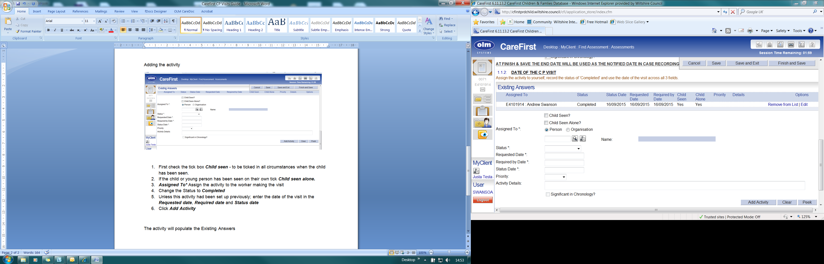

**How to record arranged visits that do not take place.**

If the family are not home for an arranged visit, this should be recorded on the form with the status of the activity as ABANDONED and a note in the activity details field to the effect “ arranged visit no one home “ or similar. Example below

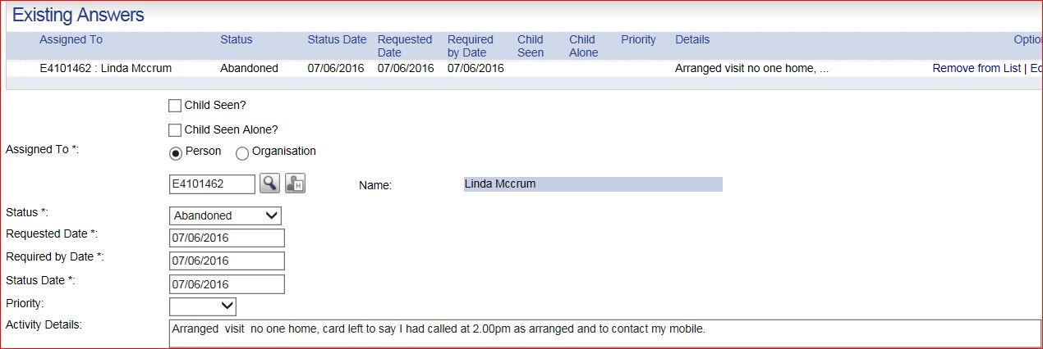

**Select Finish and Save and complete the 3 \***

***IMPORTANT --*** ***THE END DATE WILL BE USED AS THE NOTIFIED DATE IN CASE RECORDING, THIS SHOULD BE THE DATE OF THE VISIT, NOT THE DATE YOU ARE COMPLETING THE ASSESMENT***

***End date***

***Outcome***

***Completed by***

Thenclick *Save.*

Once completed the assessment document can be duplicated to siblings, editing can take place and then each siblings ***assessment document completed***. The case recording will migrate to case recording section and the activity will migrate to activity section.  The actual LAC / CP / CIN visit assessment document will remain in the assessment section which will provide for easier oversight for managers.

WARNING DUPLICATION - ONLY completed assessments will be used to collate management information reports.

If the duplicated assessments are not competed they will look as if the visits did not happen. All duplicated visits must be saved when they are completed and then they are finished and the record complete.

Only completed visits count in data collection terms. If the work has been completed then the data needs to show this.

**5. Management Requirements**

* Social workers must ensure robust arrangements are in place when they are on a planned break. This requires the social worker to identify a ‘buddy’ to undertake the visit on their behalf and inform their line managers of the arrangement. This should not be a duty task.
* When a social worker needs to take unplanned, for example sick ness absence they must ensure they inform their manager of any statutory visits due that day. The manager is then responsible for ensuring alternative arrangements are made to ensure the visit is completed.

Allocated social workers remain the responsible social workers and must take responsibility for ensuring visits take place with the support of their managers. This includes checking on return to work that the visit has taken place.

* Social workers to plan announced and unannounced visits taking due consideration to the needs and response of the specific family.
* Social workers to seek management advice/approval if they deem a CP visit is going to go out of compliance. The manager must record the discussion on CareFirst.
* Managers to discuss statutory visiting requirements with social workers in supervision.
* Social workers to use supervision to discuss cases where there are challenges to achieving compliance.
* Social workers to ensure that they are ticking the seen/seen alone box.
* Managers to ensure all new staff, including agency staff are provided with the practice standards and visiting frequency requirements and this guide.