

A guide to facilitating a Planning Live

Event

(Sep 2019)

Table of Contents

1. Introduction 3

2. What is Planning Live? 3

3. Preparing for Planning Live 5

4. When to run sessions 6

5. Where to run the events 6

6. Facilitation 7

**7. The Process ……………………………………………………………………………….8**

8. Personal Budgets 9

9. Resources needed 9

10. Information to be sent/discussed in advance 9

11. A Planning Live event – step by step 10

* 1. Preparing the space 10
  2. From welcome to good-bye! The role of the lead facilitator 10

12. After the Planning Live event 12

Appendix 1 Posters 13

Poster 1a - The Family Shield 13

Poster 1b - My Business Card 14

Poster 2 - Relationship Maps 15

Poster 3 - About Me 16

Poster 4 - Community Map 17

Poster 5 - Building on My Gifts and Talents 18

Poster 6 - The Right Support for Me 19

Poster 7 - What Would a Good Life Look Like for ME? 20

Poster 8 - Pulling it All Together 21

Poster 9 - Planning into ACTION! 22

**Appendix 2****Posters ‘Routes to Employment’.** 23

Poster R2E 1 – My Dream Job. 24

Poster R2E 2 – Steps to Getting My Job 25

Poster R2E 3 – Getting and Staying in My Job 26

Poster R2E 4 – Future Business Card 26

Poster R2E 5 - Planning into ACTION!………………………………………………………………………………27

**Appendix 3** - Values of Inclusion……………………………………………………………………………………28

**Appendix 4** - Full Overview Checklist……………………………………………………..………………**…29**

**Appendix 5** – The Art of Conversation………………………………………………..30

# Introduction

In 2015 Swindon Borough Council commissioned Paradigm to develop an approach to assist young people with learning disabilities and their families to think about their life. This included a specific emphasis around exploring and developing their Education Health and Care Plans (EHCP). Following initial meetings it was agreed that Planning Live sessions could be a powerful way of achieving this and Planning Live events were facilitated in June 2015. Following an evaluation it was agreed that Planning Live should be rolled out and local people trained as facilitators. In addition, it was agreed that Planning Live should be developed for other groups of young people with additional needs with a specific focus on supporting them to plan for employment (R2E).

Evaluation of the initial pilot work is available.

This booklet is a step by step guide to support facilitators, who have been trained, to set up and run Planning Live in Swindon.

# What is Planning Live?

Planning Live is a person centred planning approach to assist people to think about many aspects of life, often within a group setting.

Person Centred Support Plans are the tools used to free people to live the life they want and need. They can help people, supported by their networks, to escape ‘formal’ service land and achieve inclusion and live good ordinary lives as citizens in their communities. Good support plans break down barriers, find person centred solutions and enable inclusion. They give a person the ability to have more choice and control in their lives. They SHOULD BE practical tools that enable you to design and build a package of support with a person that truly keeps them at the centre, by listening, learning, evolving, mapping and connecting.

Large group approaches to person centred planning were developed and pioneered by John O’Brien, Connie Lyle O’Brien and Beth Mount’s work and rooted in Personal Futures Planning and explored in the Pathfinders project in New York City.[1] In the UK group person centred planning processes were pioneered by Heather Simmons and Steve Coulson with ‘The Big Plan’.[2] Planning Live draws on these approaches to person centred planning.

In the UK it has been used mainly with young people in their transition to adult life. More recently, Skills for People in Newcastle have used this approach with children with disabilities using their personal budgets, Connect in the North have been doing work around housing and Paradigm has used this approach to explore support planning, work and moving into adulthood.

SWINDON is using the concept to support young people with LD with their transition to adult life. The session will aim to create the detail required for an effective Annual Review which will lead into their Education Health and Care Plan (EHCP).

Planning Live will also test the effectiveness of its use regarding the preparation required for Pathway Planning or LAC Reviews for our looked after children including their potential Routes to Employment.

Whatever the focus - large group processes in person centred planning share some key features; the search for gifts and talents, a focus on relationships and community and the belief that people themselves and those who love, know and care about them are best placed to help people figure out what a good life is.



# Preparing for Planning Live

A few bottom lines;

* Need to identify a potential cohort and gather information on the individuals
* Liaise with settings where the cohort is based
* It is ESSENTIAL to have a pre meet with the school/provider to explain fully the concept of Planning Live.
* Introduce relevant professionals to Planning Live and talk about potential dates and invites
* Confirm dates and venues – at least 6 weeks’ notice
* Briefing sessions for facilitators and professionals
* People must be willing participants in Planning Live, the approach is not for everyone
* Families must be visited or at least have a few conversations with the person/people leading the project in Swindon and receive some engaging written information describing:
* the aim of Planning Live
* the creative and supportive approach to planning - it is fun and informal as well as being a great way to gather information and plan
* what the person and their family will take away and what their responsibility involves
* how the young person can choose who they would like to be part of their circle
* how the session will lead to informing the EHCP or Pathway Plan for the young person
* a named contact person who will answer further questions and support the person and their family/friend to come along to the Planning Live event
* confidentiality and consent to share their booklet and have photos taken

Also see information to be sent/discussed in advance later in this document.

# When to run sessions

Think about the timing of the event – does it fit in with and prior to the individuals scheduled Annual Review or Pathway Plan/LAC review session.

Each person will be encouraged to invite people into their planning group who they know, like and that may have useful ideas and practical links to help them plan. This is likely to include family members and friends, so you need to consider when a good time to hold the events will be – it may be that a Saturday would work better than a week day when those people may be at work.

It will be hard to find dates that fit for everyone, but the more people that can make a date, the better – Planning Live is a process for young people and their planning groups to work together, to share and shape ideas so it is important that each young person has a minimum of two people, plus themselves in their Planning Live circle.

# Where to run the events

Depending on how many people you think may take part you need to find a venue that is accessible for everyone coming (think about physical access, hearing loops etc.). The venue needs to be comfortable - crucially, the room needs to be big enough. People will be sat around tables (cabaret style) – one table for each person and their planning group and facilitator.

People will be moving around quite a bit, so they will need room to do that without having to squeeze past and disrupt others.

You may need space for partner organisations and displays where appropriate.

Ideally there should be a quiet space for people to retreat to if they find the event tiring, over stimulating or noisy etc.

Being relaxed and having enough space for the day is more important than having a ‘fancy’ venue – community halls can work as well if not better than posh hotels. The venues don’t need to be posh but people should be welcomed and food and drink should be provided.

On occasion where you will need to run a 121 event for example Out of Borough – think carefully about the venue. Consider the many points above but also think about asking the Young Person where they would feel most comfortable.

The following diagram shows how a Planning Live space should be arranged:

Table facilitator marked in blue.

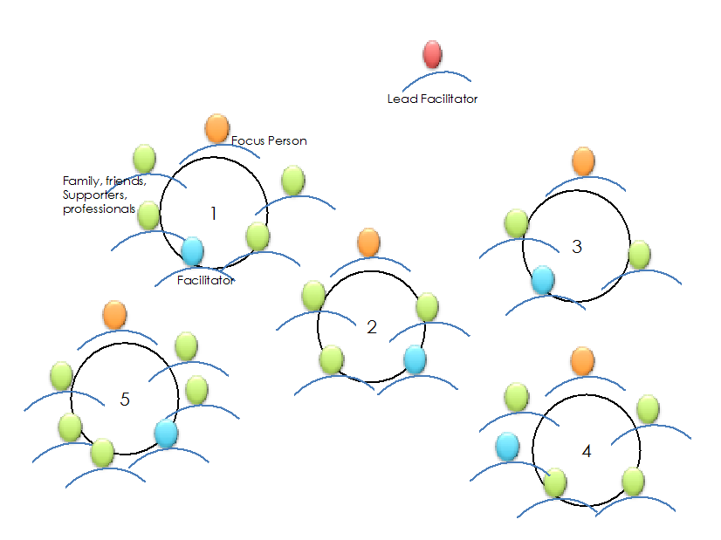

# Personal Budgets

If a young person has a personal budget this can inform Planning Live. The budget MUST NOT limit creative thinking e.g. opportunities in the community etc. but can be taken into account when thinking of the paid support a young person may require.

At the time of writing personal/education budgets had not been allocated to anyone of the focus people involved.

# Resources needed

* Microphone – this is a bit of a luxury but people generally love it when they are sharing their work
* Music – play as people arrive and whilst tables are completing posters
* Projector and screen/white wall
* Flip chart stand, Post It notes and name badges/stickers
* Tablecloths and sweets for tables
* Pre-prepared posters (**Lead facilitator is responsible for these**) and a wide selection of pens
* Poster Tubes to keep people’s work together between sessions
* A digital camera – to photograph people’s work in case they lose it, and to create a booklet record of the sessions
* Prompt Cards for content for each poster
* Refreshments

# Information to be sent/discussed in advance

* What is Planning Live?
* What’s the question/issue we are seeking to address?
* How can Planning Live help?
* A description of the ‘style’ of Planning Live
* How can we make Planning Live work for you, your hopes and fears and practical support you need to get involved in Planning Live e.g. transport, support needs, etc.?
* Who would be helpful to have in your circle?
* Confidentiality and consent to share booklet and have photos taken
* Questionnaire to gather information about current process or feeling of support. Questionnaires can be sent to anyone involved in the event and adapted to suit the individual
* Possible reminder call or text day or two before event

# A Planning Live event – step by step

## Preparing the space

The lead facilitator must, right from the start, work to ensure a welcoming and relaxed atmosphere. Have the room set out as in the diagram on page 7 with;

* table and chairs for each focus person and their guests
* sign with the young person’s name on the table
* paper table cloth on each table (informal look and a place to draw and write ideas!)
* selection of coloured pens on each table
* selection of post it notes
* good quality poster paper if pre-produced poster not available
* selection of biscuits or sweets. (Some people ask for these to be removed if they are not suitable for the focus person – but still offer!)
* music to play at appropriate times

## From welcome to good-bye! The role of the lead facilitator

**The Welcome:**

Right from the time people arrive the lead facilitator should set the scene and feel for Planning Live; people and their families working together, sharing and learning from each other. They will need to:

* give an overview of the planning together process
* explain the question/issue we are seeking to address
* explain Values of Inclusion (see appendix 3)
* give a practical introduction to the exercises used. The lead facilitator explains that they will guide people through a series of questions, each with a poster. At this point they should not go into each one in detail
* suggest ground rules for the day e.g. total respect, no judging, no fixing/solutions, listen, explore and discover
* explain the lead facilitator’s role and introduce the table facilitators

**Guiding people through the day:**

1. The lead facilitator introduces the posters (see appendix 1 and 2) and with the support of the table facilitators creates an atmosphere where discussions take place. People and families are encouraged to question, to think widely and discover as much as possible about the focus person and possible opportunities. Keeping an eye on the timings, the lead facilitator decides when it is time to bring the conversation to a close
2. After each poster discussion the lead facilitator invites people to share a little of what they have learnt and explored. The aim is to stimulate ideas, develop people’s pride in sharing and to spot possible connections e.g. someone is interested in trains and someone from another group says they work in a park with train rides. Young people should feel pressured to share
3. The lead facilitator then goes on to introduce the next poster. This is repeated until the final poster is completed
4. To close the day the lead facilitator welcomes comments, reflections and sharing of posters from participants. It may be worth asking each circle member for one positive comment about the young person and to share the first step they are going to take to put the plan into place.

**Bringing the event to a close:**

At the end of the event people will be tired but also positive about the ideas they have shared and the plans created. It is a good idea to welcome comments and thoughts from participants as you say good-bye. It’s also important to explain what will happen next SO make sure you know!

The last poster – who is doing what – should be highlighted as important and people encouraged to go away and start acting on the ideas. A reminder about all being responsible for action, not just the professional/s is important.

In addition the lead facilitator must:

* Ensure all the posters are photographed for each young person and any doodles/notes on tablecloths etc. (This could be delegated to the table facilitator). A good scanning app on a phone is recommended to ensure good quality images. Back these up as soon as possible to make sure they don’t get lost. The young people take the originals and there is no guarantee they will be seen again if the photo images are lost
* Prepare a post tube for each young person by drawing their name or inviting them to design their own tube design
* Roll up the posters and place them in the poster tube

Finally…..present the posters (in tubes) to each young person with a round of applause and a group commitment to action!

# After the Planning Live event

As you can see Planning Live is about a group of people supporting, in this case, a young person to think about their move into adulthood or to focus on work. The events are designed to encourage honest, creative, person centred conversations and explorations to offer a simple, yet potentially powerful experience and plan.

BUT the plan is just the start. The action is essential. This plan MUST feed into the Education Health and Care Plan, Pathway Plan or on-going support plan for a young person.

There is a real danger that after the event the energy and vision will be lost. Follow up action is crucial.

To maximise the likelihood of action the lead facilitator MUST use the images of a young person’s posters to create a booklet of their plan OR delegate to this responsibility to the table facilitators. Examples of these are available. A format will be agreed by Swindon to assist in this process and to support on-going quality.

The booklet MUST be sent to each young person and their family or support worker if appropriate plus educational establishment within two weeks of the Planning Live event. Booklets can also be sent to identified professionals involved with the young person as agreed and identified by the YP and their support network. Please ENSURE the consent form to share information has been agreed and signed.

As mentioned above in some cases it may be that the table facilitator supports the young person and their group following the event, reminding them about work that needs to be done, sign posting where relevant, generally ‘sticking with them’.

## Appendix 1

## Posters and Questions to guide people through the process of discovery

### Poster 1a - The Family Shield

The lead facilitator introduces the exercise, shares their own example, then people and their families complete theirs at their tables supported by the table facilitator. As this is the first poster families may be slightly uncertain about what is expected so do encourage them to share their good memories, to laugh and be proud. It is often during this conversation that people start to realise that this could be an interesting day truly focused on the young person and their family. PLEASE note that for this exercise we encourage people to list their close, nuclear family. The extended family comes in the Relationship Map.

**NOTE:** This exercise is designed to truly value families and to start from a place of love and of all wanting the best for the child. This is an essential start to the inclusive and creative Planning Live process.

When completed ask families to share their mottos with the whole group – if they are happy to.

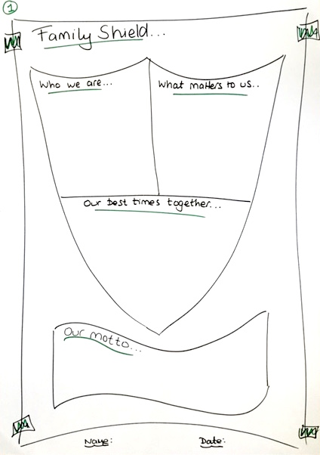

### Poster 1b - My Business Card

This may be a good starting place for a Routes to Employment focused Planning Live event. However the family shield, which brings the family together sharing good times, is important as well. If the young person has no family present they/you may choose not to include the family shield.

People are encouraged to make a poster of their business card with a few good things about them, they may use these to introduce themselves to the wider group – the focus person also introduces the people they have brought along.

‘My Business Card 10 years on’ – is a great idea for helping young people focus on where they want to be. This can be completed here or later in the Planning Live event.

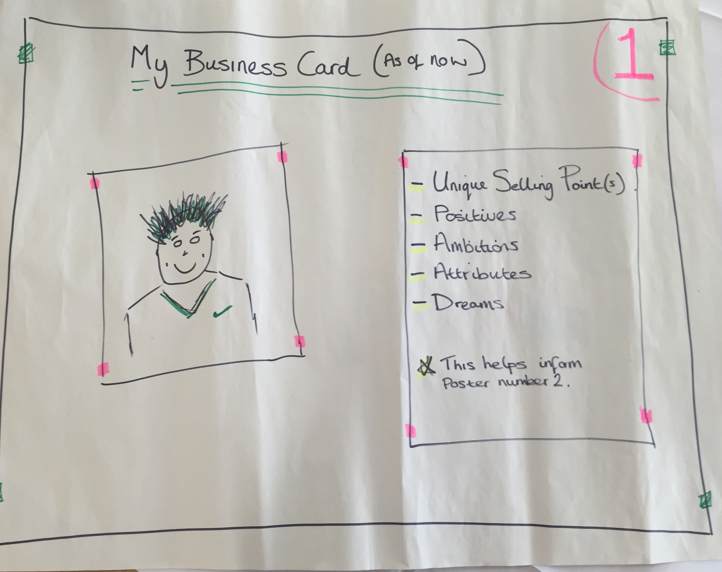

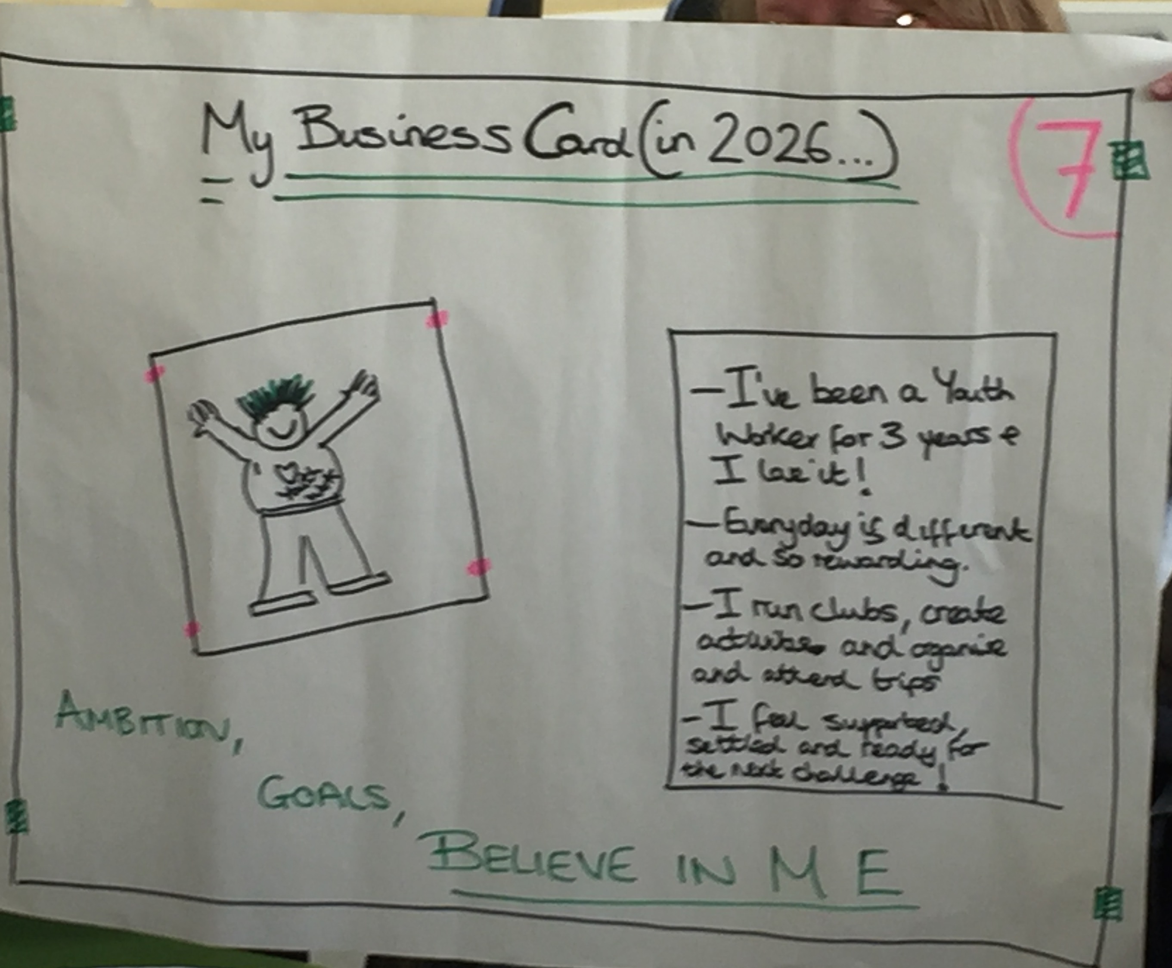

### Poster 2 - Relationship Maps

There are lots of ways to do relationship maps; this diagram encourages people to name three groups of people in their lives. Firstly, people are encouraged to write down all of the people they know, or are close to, people they trust. Then write down next to the names, the job that person does. This is particularity important for Planning Live Routes to Employment as connections for employment may appear. Equally, in Planning Live for the Education Health and Care Plans other connections could be spotted in response to people’s jobs.

People should also be encouraged to consider the ‘role’ they will play in the young person’s life and whether they will be in their life when they leave school.

People are a rich resource in all our lives and should be asked to consider whether key people are missing and if the people in the young person’s life could engage with them in a new way to support them as they move into adulthood/employment.

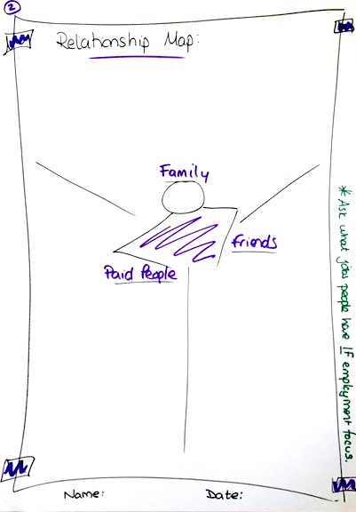

### Poster 3 - About Me

This is a chance to detail all the great things about the focus person, discovering their gifts and capacities. You can also uncover people’s own strengths to harness as a resource and shape possible ideas for further hobbies, learning, community connections and employment.

**Remember:**

* Gifts and talentsare intrinsic, characteristics that make us who we are e.g. Calm in a crisis, always sees the funny side (even in a crisis), funny, strong, will have a try at anything
* Hobbies, interests, passionsare developed in life through opportunity or in response to interests e.g. playing Irish music, baking cakes, riding my bike, spending time with Granddad, the allotment, etc…

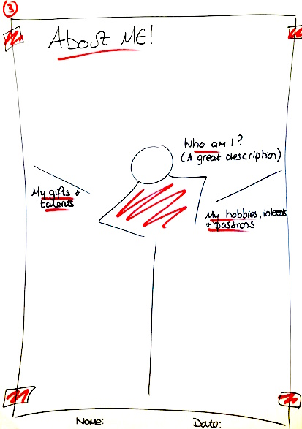

### Poster 4 - Community Map

Community and opportunities beyond service land underpin good person centred work and Planning Live events. Encourage people to think of non-school, college activities. Think of places of worship, parks, friends etc.

When it comes to trying new things, think of the person’s gifts, talents, interests and hobbies and encourage people to let their imagination fly!

If the different groups in the room come from the same area it is really worth encouraging them to share ideas. It’s all about community knowledge and connections!

### 

### Poster 5 - Building on My Gifts and Talents

This exercise turns the gifts exercise into something real. Give time and believe in people to come up with ideas. You will be amazed at the ideas and connections!

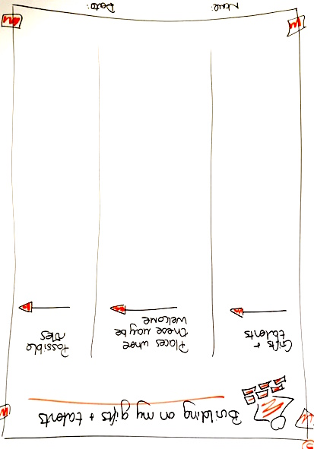

### Poster 6 - The Right Support for Me

We asked people to think about the support they might need in everyday life and also specific to work. It is essential that people think about the different types of support. For example when with a friend at home does the young person need a supporter in the room with them or just someone to call on support for? In reality how often is 1:1 support with a young person required?

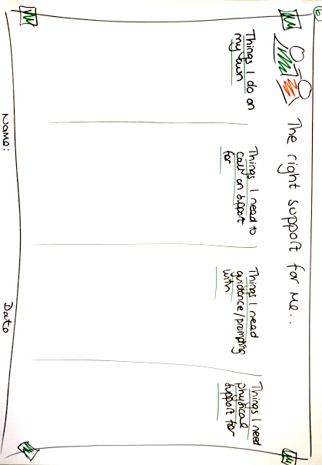

### Poster 7 - What Would a Good Life Look Like for ME?

We asked people to create a vision of what life would be like as an adult perhaps when they were working, to create a picture of possibility and give someone a sense of where they wanted to be. We prompted people to think about different aspects of life, relationships, home, leisure as well as work.

We also asked people to think about an average week now and got them to explore what worked and didn’t work about that week on a weekly planner. Encourage purposeful life vision not just filling the day with activities.

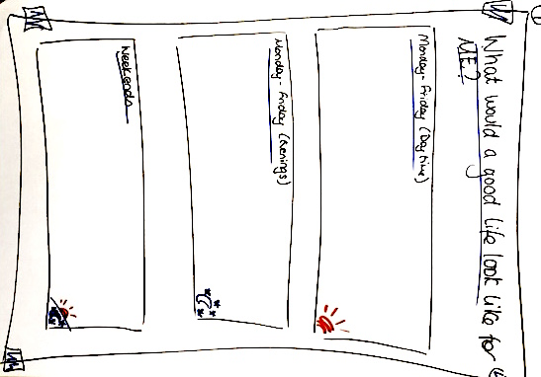

### Poster 8 - Pulling it All Together

We wanted people to leave Planning Live with some concrete ideas and some first steps for action. This exercise really helped – asking people to focus down on one job, think about a few bold steps they needed to take and commit to some easy first steps to get started.

The information gathered in Planning Live have been structured to be comprehensive enough to capture all of the information that would be needed to make a comprehensive support plan for a personal budget.

### 

### Poster 9 - Planning into ACTION!

This poster was added following feedback from the initial Planning Live events in 2015. Some families had expressed a little frustration at the slow progress with the action agreed in their child’s booklet. Whilst it had been stressed that all in a young person’s circle are part of ensuring action - there was a sense the families were still waiting for professionals/the service to lead.

Whilst this is understandable, the reality is that as a young person moves into adulthood the more they and their family are able and encouraged to act for themselves.

This simple poster encourages people to commit to a specific action. No dates are agreed here (although they can be if people want to add them!) but dates MUST be added at the EHCP meeting.

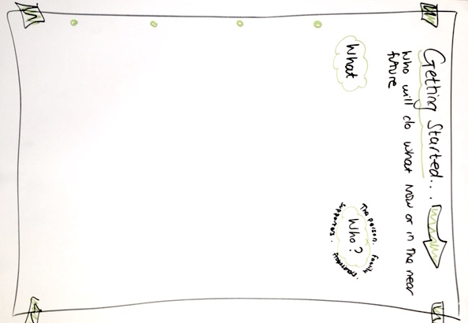

### Appendix 2

### Posters for Planning Live ‘Routes to Employment’.

### In conjunction with relevant posters shown in appendix 1, the following posters can be used when exploring routes to employment.

An example running order may be as follows;

Poster 1b - Business Card (now)

Poster 2 - Relationship Map – reworded if necessary

Poster 3 - About Me

Poster 5 - Building on My Gifts and Talents

Poster R2E 1 - My Dream Job

Poster R2E 2 - Steps to Getting My Job

Poster R2E 3 - Getting and Staying in My Job

Poster 5 - What Would a Good Life Look Like?

Poster R2E 4 - Future Business Card

Poster 9 Planning Into Action

Poster 4 Community Map is also useful as young people can feel isolated from their community.

Use the framework of the following posters, remove the wording and encourage the young person to complete the poster fully.

### Poster R2E 1 - My Dream Job

Firstly, ask the young person what their dream job is and then ask them to explore what interests them about that job, what is important.

We want the young person to have as many options as possible. When thinking about looking for a job pull together the following three elements from previous posters;

* Things I like to do
* Things I am good at
* Things someone will pay me for

Then ask the young person to think about what support they need to get a job, is there anyone in their network who could help, would a piece of equipment help? Some training? A job coach?

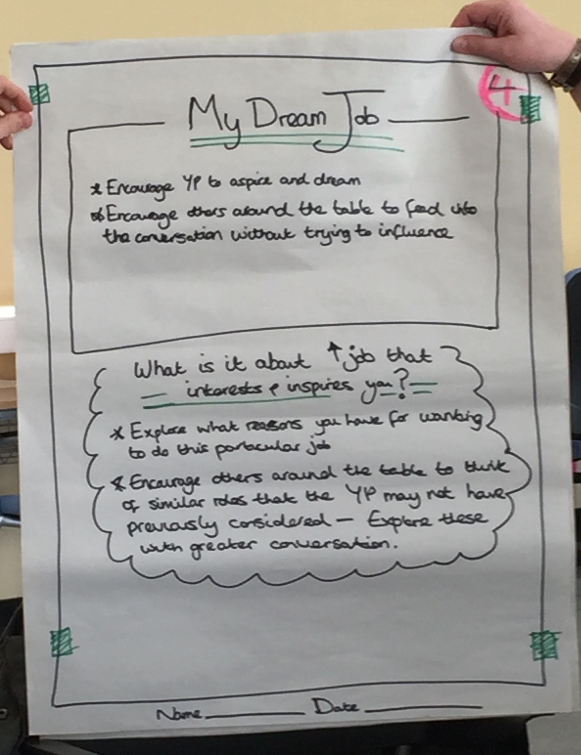

Jobs you’d love to do;

Responsibilities for the job

Type of work pattern it will be

Try not to change people’s minds by putting in too many clarifications

Try to start with the positives

### Poster R2E 2 - Steps to Getting My Job

This poster is designed to encourage conversation relating to the practical steps a young person needs to take to maximise the chance of them getting their dream job.

The photo here gives you an idea of the areas to be considered. REMEMBER…. don’t make the steps too ambitious, this is about the young person being supported to really think about what they are willing/want to do.

What difficulties might the young person face and how might they overcome them to get the job they want?

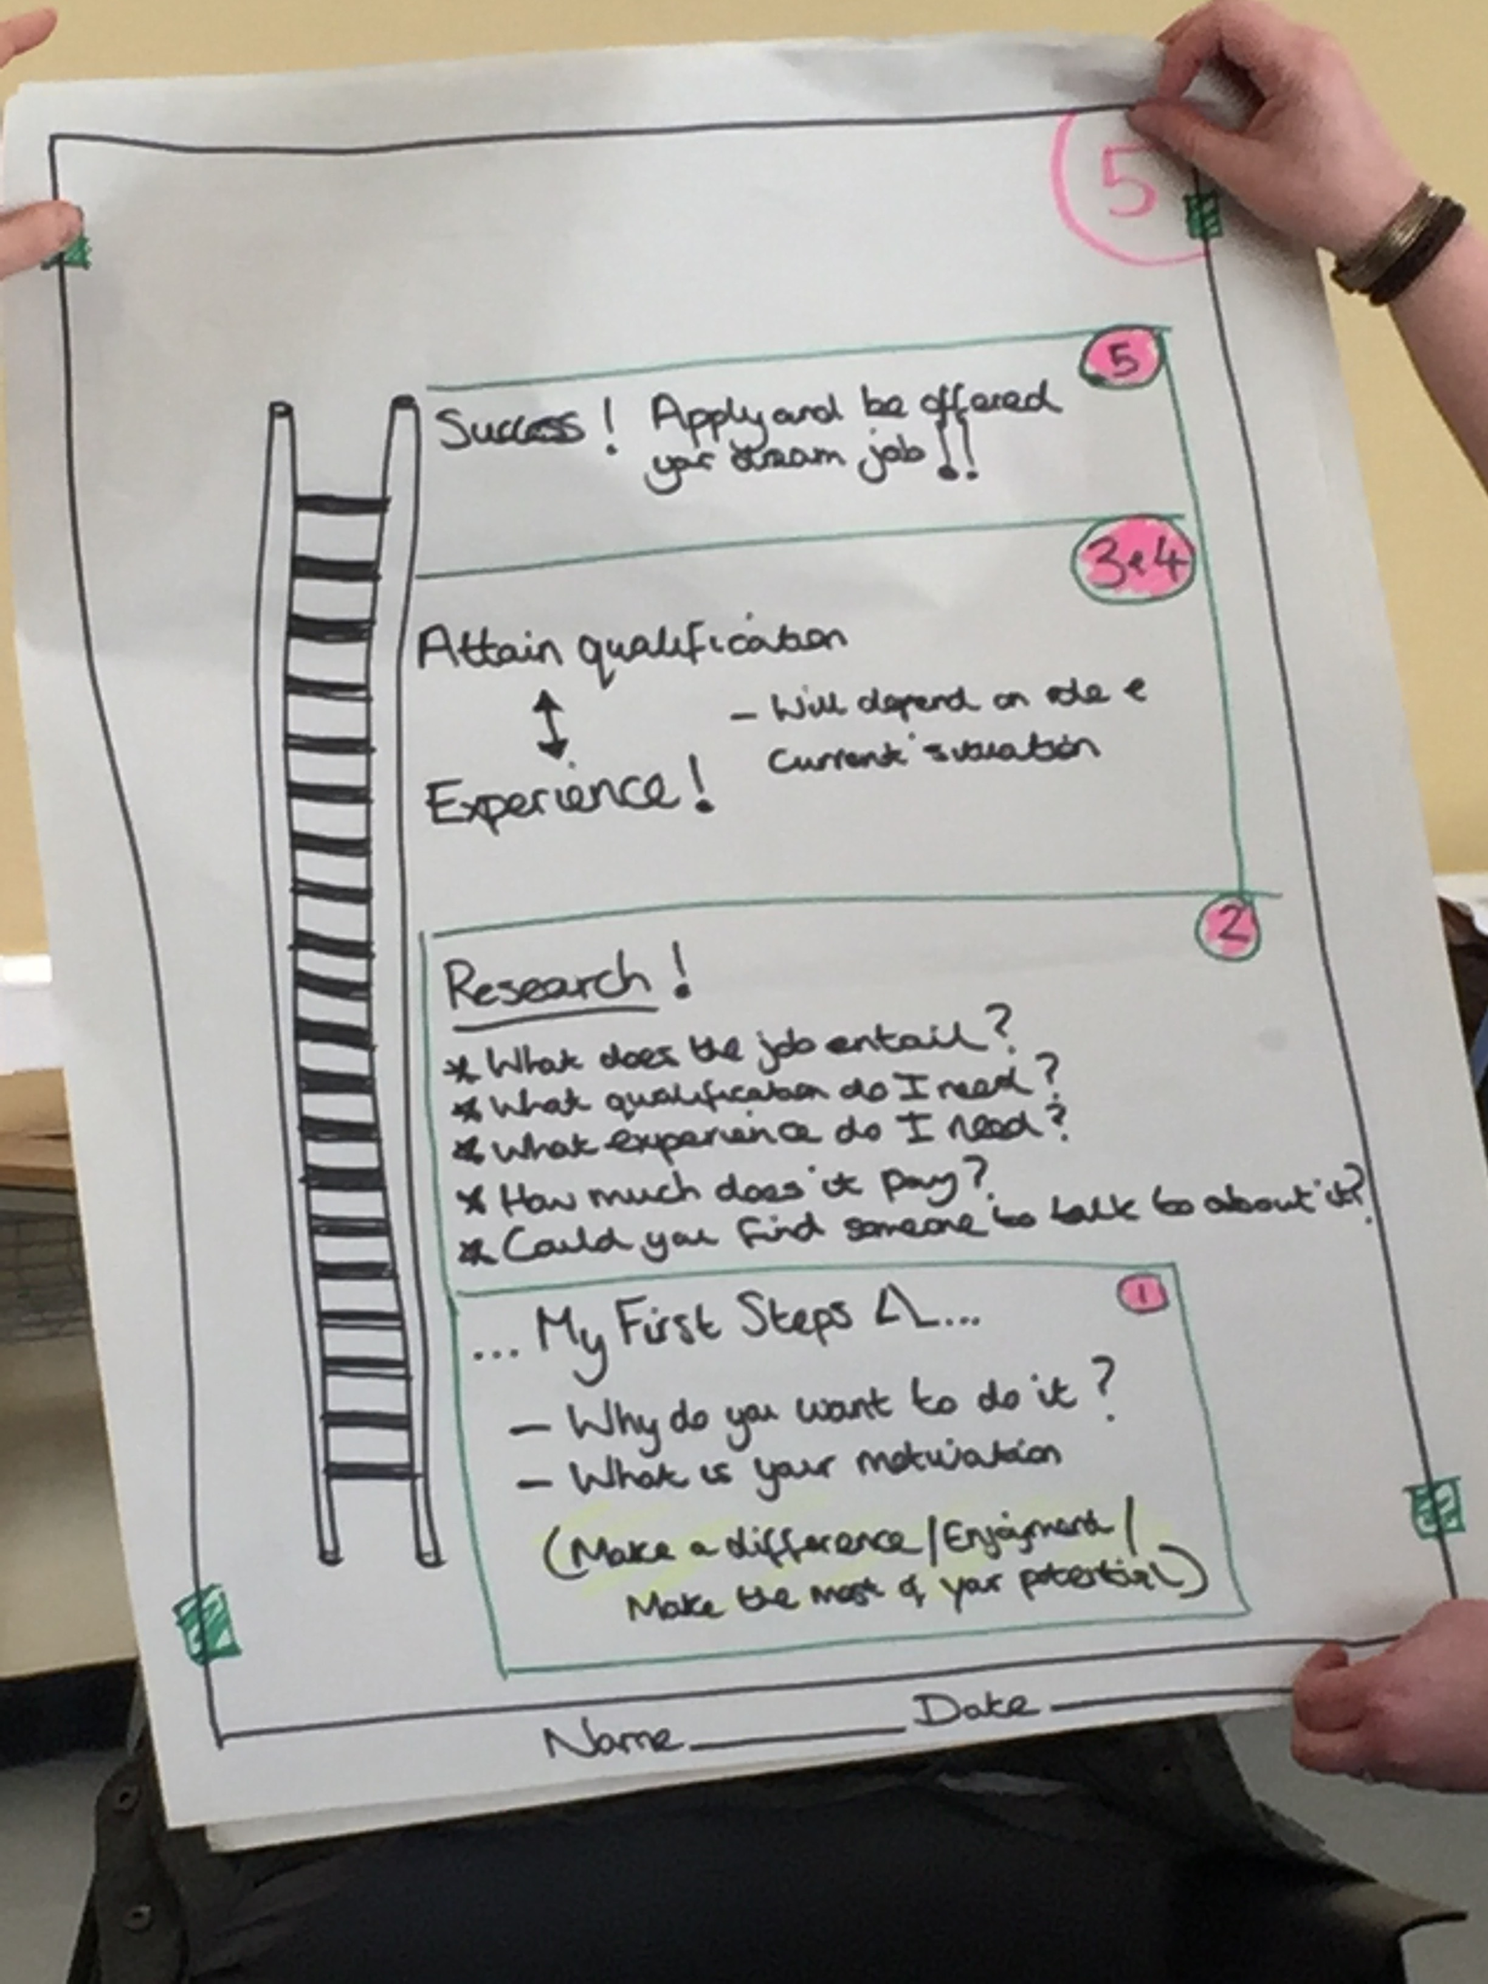

### Poster R2E 3 - Getting and Staying in My Job

If people need support at work, help them to figure this out as well.

Things to think about;

* What kind of routine does the young person have at the moment?
* How might this need to change in order to get and stay in a job?
* What plans might they have to put in place to get to work, finances, lifts, time to get there?
* What support do they need from family, the employer, their professional network?

### 

**Poster R2E 4 Future Business Card** (see Appendix 1, Poster 1b)

Encourage the young person to think about what kind of business card they might be able to write in 10 years’ time.

**Poster R2E 5 Planning into ACTION!** (see Appendix 1, Poster 9)

**Further Adaptions to the Planning Live Concept. One example:-**

**Out of Borough.**

There may be occasions when the generic posters do not suit the individual involved in the session due to personal or family circumstances - for example an Out of Borough Placement (OOB). The posters MUST be created and adapted to suit the Young Person you are working with. The posters shown below were adapted by a Link Worker leading an event with a young man living OOB with complexed behaviour and needs. In this case the Family Shield and Business card introduction posters were not suitable. Another example would be a Young Person placed in foster care.

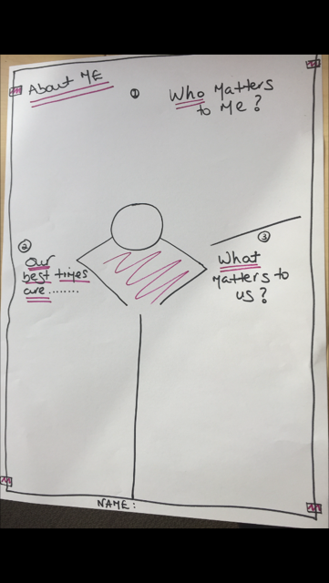 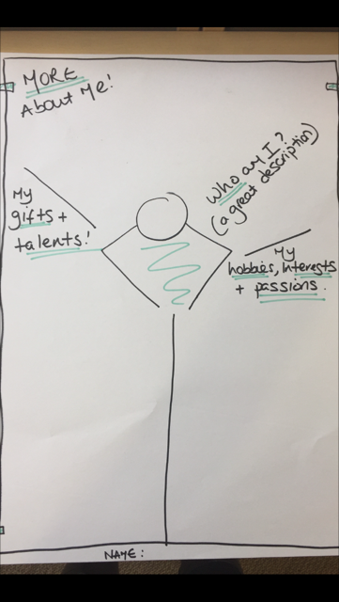

N.b. – Link Worker noted on evaluation that the ‘What a Week Looked Like’ really worked for this particular placement.

### Appendix 3

**Values of Inclusion**

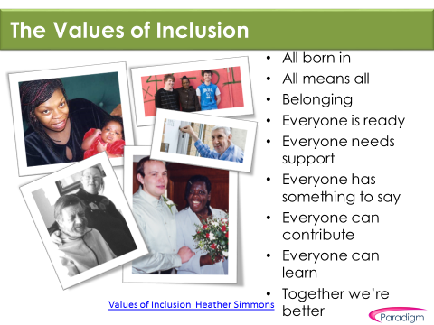

**Appendix 4 Checklist**

**Staff Resources**

|  |  |  |  |
| --- | --- | --- | --- |
| What | When | Who | Resources/Paperwork |
| Attend PL training | Before participating in an event | Potential Lead and Table Facilitators | Pre-read ‘How to Guide’ |
| Observe a PL event (if possible) | Before being a table facilitator at an event | Trained facilitators |  |
| Table facilitate at PL | Within a month following observation | Table facilitators |  |
| Attend Lead facilitator training | When confident and after a couple of table facilitator experiences | Confident/competent table facilitator | Pre –read Lead Facilitator role in ‘How to Guide’ |
| Lead facilitate at PL – with support | Within a month of training | Trained Lead facilitators | See check list ‘Running an event’ |
| Lead facilitate at PL - solo | Ongoing | Confident/competent Lead facilitators | See check list ‘Running an event’ |

**Running an Event**

**What to do before;**

|  |  |  |  |
| --- | --- | --- | --- |
| What | When | Who | Resources/Paperwork |
| Identify a potential cohort | In time for it to fit with their next review process | Specialist Teams | Section 3 & Section 4 |
| Liaise with settings/professionals where the cohort is based | As soon as cohort is identified | Identified PL Event Co-ordinator | Section 3 |
| Introduce relevant professionals to Planning Live and talk about potential dates and invites | As soon as they are identified | Identified PL Event Co-ordinator | Section 3  Professionals Leaflet - What is Planning Live? |
| Confirm date and venue | 6 weeks before event | Identified PL Event Co-Ordinator | Section 5 |
| Briefing sessions for facilitators and professionals | At least 2 weeks before event | Identified PL Event Co-Ordinator | Briefing Sessions Slides |
| Families must be visited or at least have a few conversations with the person/people leading the project in Swindon and receive some engaging written information. | At least a month before! More lead in time the better for planning purposes | Link Workers/PA’s in liaison with PL Event Co-Ordinator | Invite letters  See Section 3 and 10 and letter templates |
| Ensure consent form is signed | Before the event – if not possible, on the day | Person liaising with the family | Consent form template  Section 10 |
| Ensure tool kit is ready | Check kit week before | Lead Facilitator | See section 9, page 9 |
| Produce the posters needed for each young person | 2 days before event | Lead Facilitator | See relevant appendices |

**What to do during;**

|  |  |  |  |
| --- | --- | --- | --- |
| What | When | Who | Resources/Paperwork |
| Prepare the space | Before participants arrive | Lead Facilitator | See section 11.1 |
| Initial welcome and direct to refreshments and their table | On arrival | Lead Facilitator and Table Facilitators |  |
| Welcome at start of event, guiding through the event and closing the event | Throughout | Lead facilitator | See Section 11.2 |
| Facilitate the conversation, support participants and encourage positive discovery | Throughout | Table Facilitators |  |

**What to do after; Section 12**

|  |  |  |  |
| --- | --- | --- | --- |
| What | When | Who | Resources/Paperwork |
| Debrief the event | Week after | Identified PL Event Co-Ordinator Lead & Table Facilitators |  |
| Replenish tool kit for next event | As soon after event as possible | Lead & Table Facilitators | See section 9, page 9 |
| Create booklet and send to family and relevant professionals | Two weeks after the event | Lead facilitator | See example booklet |
| Follow up with family to look at ‘Getting Started’ points in booklet | Two weeks to tie in with booklet being sent. | Table Facilitators | Getting Started poster in the young person’s booklet |
| Continued contact with family | As agreed based on outcomes of follow up meeting above | Professionals identified in follow up meeting |  |

**Appendix 5 – The Art of Conversation.**

1. **Facilitate real conversations focused on ordinary lives**

The skill of planning with a person truly at the centre is essential to Planning Live, and conversation (verbal or non-verbal) is the foundation of this exploration with each person. Our responsibility when supporting people is to make a commitment to continually listen to and learn with the person. This includes striving to facilitate conversations in creative ways (pictures, film, objects, sounds, touch, etc) and involving people who are important to that person to support their communication. In this way, we can ensure that each person can direct their own life, interact with us and other people, and make their contribution as equal citizens.

Intentional listening is the foundation of any conversation. Listening with all our  senses, not to what others or we as professionals want to hear, but truly to what people are communicating. People are liberated when we show we have truly heard and acted on what people have communicated. Confidence grows and people’s belief in possibilities develops.

A conversation is an opportunity to encourage a person to explore thoughts, feelings, options and facts through:

·      gaining clarity, understanding and perspective XXlooking at issues from different points of view

·      provoking deeper or alternative thinking

·       challenging current thinking

·      encouraging a person to evaluate themselves and their situation

·      planning and taking action.

As explained earlier, Planning Live is a conversation NOT an assessment.  Don’t sit with a person with a pre-prepared list of questions.  Your conversation will be dictated by the person and the response you get.

·      **THINK** about how you ask a question to encourage a person to share with you

·      **LISTEN** to the response you get AND THEN

·      **SHOW** you have listened by developing the conversation through each response THEN

·      **AGREE** what next.

This booklet is based on the work of Paradigm and developed with Swindon as part of the Planning Live Train the Trainer.

<http://www.paradigm-uk.org/?s=planning+live>

For more information contact Paradigm

[www.paradigm-uk.org](http://www.paradigm-uk.org)

tel: 020 8870 8643



Produced: September 2016

Reviewed: December 2016

Review Date: December 2017

1. Implementing Person Centred Planning – *Voices of Experience* - John O’Brien and Connie Lyle O’Brien eds 2002 Inclusion Press
2. The Big Plan – A Good Life After School by Stephen Coulson and Heather Simmons 2006 Inclusion Press