Children in Care Team
Swindon Borough Council
Civic Annexe
Euclid Street
Swindon
SN1 2JH

Thursday, 09 January 2020

Dear (name)
Invitation to take part your own Planning Live event.
What is it?

The Children in Care team would like you to be as prepared for your transfer to the Leaving Care team as possible. At your Planning Live event, you will have the opportunity to meet with your new social worker and personal adviser and set the path for your relationship with them that might last until you are 25.

This is a fun event that is all about YOU. It is a time to get together with the important people in your life and talk about your STRENGTHS, not your weaknesses. It is a chance to talk about your skills, talents and hopes for the future - and how you might achieve them.

Events can be used to discuss:
- Independent Living (including future housing and support options)
- Employment (including education and training to prepare for employment)
- Good Health (keeping healthy and well, access to Adult Health Services)
- Being part of the community (friends, relationships, activities, hobbies etc.)
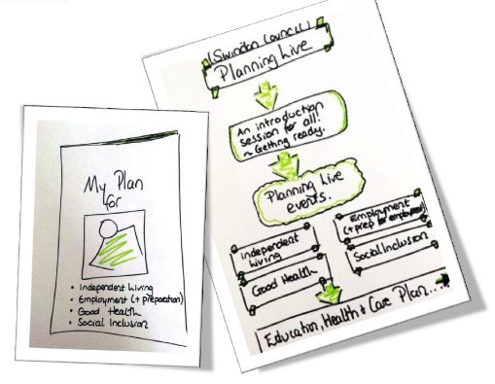
We create a space but you set the agenda for the conversation, in search of what a good life might look like as you approach adulthood. Focussing on your strengths, you will be empowered to think positively and creatively about your options, whilst identifying support that you might need to achieve these ambitions.
You can invite family members and friends along with anyone else who plays an important role in your life to support you at the event.
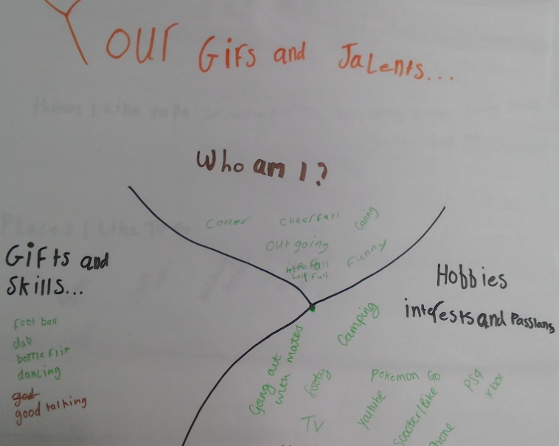
What will happen after the event?

The conversations that take place will help your support workers know exactly what you want to achieve, helping them give you the support you need.
You can be sure that when your new Care Plan, EHCP or Pathway Plan is written or updated it will include relevant and realistic goals, that are right for you.
You will receive a printed booklet as a record of your event that can be kept and shared with whomever you want, so that you do not have to repeat yourself over and over again. We will agree with you exactly who you are happy with us to share this with.
Some comments from young people who have taken part in Planning Live:
“I think the whole day went well – it helped my understanding”
“It helped me find out more about myself and what I can do on my own”
“These sheets will really help me in the future”
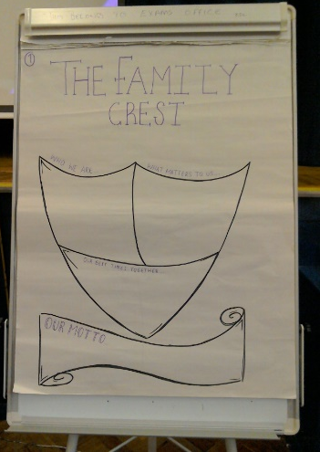
We hope that by having these conversations now, your experience of dealing with different teams/services and the transition to turning 18 will be smoother and less scary for you.
We will be asking you and other participants to give us feedback on the event. What we learn from this event will help us to do it better in future.

If you have any questions or would like to take part in the Planning Live project please complete and return the attached form, or speak to your social worker or personal adviser.
Please post or email your responses to (social worker’s email address?) or mgumm@swindon.gov.uk. Or call (CiC team/ social worker) on (01793 ?) or Matthew Gumm on 07867358760.
We look forward to hearing from you
Planning Live
Response Form
September 2019 – August 2020

Please return to (CiC address?)

Or (social worker’s email address?)

Your name

We will be running events throughout the year.
We will usually aim to start at 10.00am and will be finished before 13.00pm. We will provide refreshments, i.e., water, squash, tea and coffee and biscuits.
We suggest you can bring between 3 – 5 people. This could be family members, friends, support workers, other professionals etc.
Name of person | Relationship to you and/or service they are from

