Disabled Childrens Team
Swindon Borough Council
Saltway Centre
Pearl Road
Swindon
SN5 5TD

Thursday, 12 September 2019

Dear (name)
Invitation to take part your own Planning Live event.
What is it?

If you are 16 or older and are receiving support from the Disabled Childrens Team, Leaving Care Team, or Transitions Team, then you should have the chance to take part in a Planning Live event.

This is a fun event all about YOU. It’s time to get together with people in a similar situation and the important people in your life. A chance to talk about your skills, talents and hopes for the future, and how you can be helped to achieve them.

Events can be used to discuss:
- Independent Living (including future housing and support options)
- Employment (including education and training to prepare for employment)
- Good Health (keeping healthy and well, access to Adult Health Services)
- Social Inclusion (friends, relationships, activities, hobbies etc.)
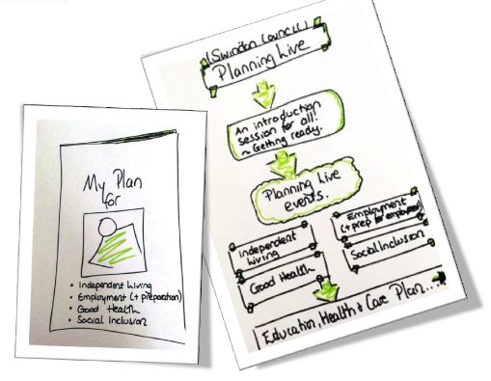
We create a space where young people set the agenda for a conversation about them, in search of what a good life might look like as they approach adulthood. Focussing on a young person’s strengths and abilities, they are empowered to think positively and creatively about their options, whilst identifying the support that they might need to achieve these ambitions.
You can invite family members and friends along with anyone else who plays an important role in your life to support you at the workshop.
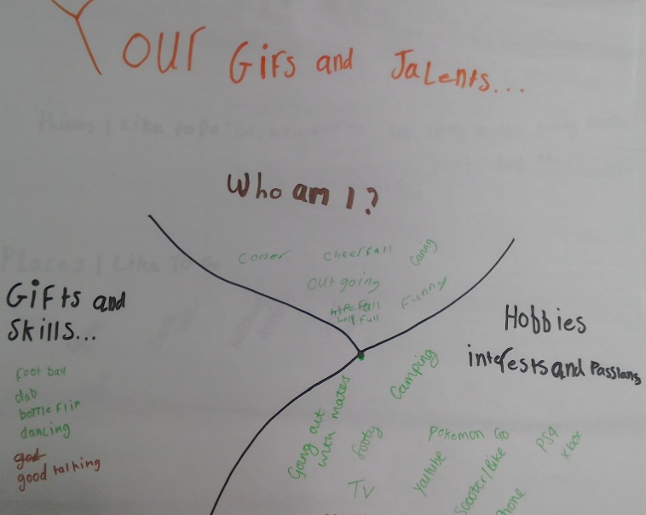
What will happen after the workshop?

The conversations that take place will help your support workers know exactly what you want to achieve, helping them give you the support you need.
You can be sure that when your new Care Plan, EHCP or Pathway Plan is written or updated it will include relevant and realistic goals.
You will receive a printed booklet as a record of your event that can be kept and shared with whomever you want, so that you do not have to repeat yourself over and over again. We will agree with you exactly who you are happy with us to share this with.
Some comments from young people who have taken part in Planning Live :
“I think the whole day went well – it helped my understanding”
“It helped me find out more about myself and what I can do on my own”
“These sheets will really help me in the future”
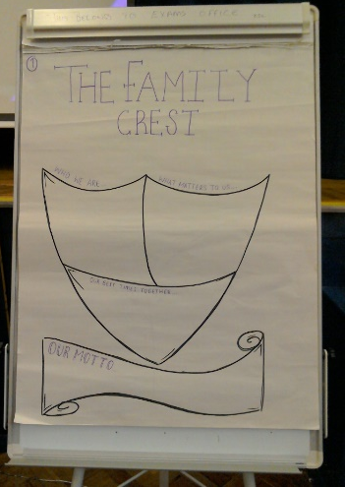
We hope that by having these conversations now, your experience of dealing with different teams/services and transition to turning 18 will be smoother and less scary for you.
We will be asking you and other participants to give us feedback on the event. What we learn from this event will help us to do it better in future.

If you have any questions or would like to take part in the Planning Live project, please complete and return the attached form, or speak to your support worker.
Please post or email your responses to aedwards3@Swindon.gov.uk or mgumm@swindon.gov.uk. Or call Alexis Edwards on 01793464031 or Matthew Gumm on 07867358760.
We look forward to hearing from you
Planning Live
Response Form
September 2019 – August 2020

Please return to Disabled Childrens Team, Swindon Borough Council, Saltway Centre, Pearl Road, Swindon, SN5 5TD

Or aedwards3@swindon.gov.uk

Your name

We will be running events throughout the year.
We will aim to start at 10.00am and will be finished before 13.00pm. We will provide refreshments, i.e., water, squash, tea and coffee and biscuits.
We suggest you can bring between 3 – 5 people. This could be family members, friends, support workers, other professionals etc. Your child’s keyworker will be with you on the day.

Name of person | Relationship to you and/or service they are from

